Paul Rand: Defining Design Outline

Welcome

Part of being a designer is looking for inspiration, and that’s exactly what I found when I discovered the work of Paul Rand. The whimsical charm, visual simplicity, powerful communication and thoughtful writing completely changed the way I viewed my role as a designer and what the term “design” truly means.

His work is known around the world, and just about everyone on the planet has seen it. If you’ve ever shipped a package (UPS), watched television (ABC) or used a computer (IBM), then you’ve seen his work.

The books and articles he has written on the subject of design are not as well known, but no less powerful. The first time I read A Designer’s Art I was amazed at how well Mr. Rand was able to translate and illustrate complex ideas on subjects like aesthetics, content and form so effortlessly. Even though the books are out-of-print (his first was published in 1947), his thoughts on the subject are still just as relevant today as they were nearly 70 years ago.

It is my hope that as you view his work and read his words, you are as enlightened about art, aesthetics, color, typography, humor, form, content… as I was.

Enjoy, be inspired, continue to learn, and continue sharing your own thoughts on design.

— Daniel Lewandowski
Curator and founder of paul-rand.com

Striped Wall Quotes

Should we attribute each of these quotes to Rand? It might seem redundant, but will people realize that he’s talking? Also, shouldn’t we include the date that each book was published?

I was just doing what they were doing in Europe. I didn’t claim that this was any great, original stuff, because it wasn’t. It was influenced by Surrealism and Picasso.
Interview with Steven Heller 1988

To design is to transform prose into poetry.
Design Form and Chaos 1993

The principal role of a logo is to identify, and simplicity is its means.… Its effectiveness depends on distinctiveness, visibility, adaptability, memorability, universality, and timelessness.
Design Form and Chaos 1993

A style is the consequence of recurrent habits, restraints, or rules invented or inherited, written or overheard, intuitive or preconceived.
AIGA Journal, “Good Design is Good Will”, 1987

I started reading because of a remark of Moholy Nagy… I remember, Moholy asked me, “Do you read art criticism?” And I said, “No.” The only thing he said was, “Pity.”
Interview with Steven Heller 1988

Functionalism does not preclude beauty, but it does not guarantee it either.
Print January/February 1960

Ideally, beauty and utility are mutually generative. In the past, rarely was beauty an end in itself.
Thoughts on Design 1946

I always steered towards humorous things. People who don’t have a sense of humor really have serious problems.
Interview with Steven Heller 1988

Sentimentality provides only a momentary response to a work of art; nostalgia provides a momentary escape from reality.
From Lascaux to Brooklyn 1996

I hate words that are abused, like “creativity.”
Interview with Steven Heller 1988

I just always was interested in art. It’s like asking me how do I have breakfast; you know, you just have it.
Lecture, A Paul Rand Retrospective, Cooper Union, Oct 3 1996

Ideas may also grow out of the problem itself, which in turn becomes part of the solution.
Paul Rand: A Designer’s Art 1985

Without the aesthetic, the computer is but a mindless speed machine, producing effects without substance, form without relevant content, or content without meaningful form.
From Lascaux to Brooklyn 1996

You’re not doing museum stuff; whatever you’re doing should communicate, so the guy on the street should know what the heck you’re trying to sell.
Interview with Steven Heller 1987

There is no science in advertising.
Interview with George Lois, 1986

…the plethora of bad design that we see all around us can probably be attributed as much to good salesmanship as to bad taste.
Paul Rand: A Designer’s Art 1985

Ideas are fuel for the imagination; they are the unique response to a meaningful question.
From Lascaux to Brooklyn 1996

Without play, there would be no Picasso. Without play, there is no experimentation. Experimentation is the quest for answers.
Graphic Wit “Paul Rand: The Play Instinct” 1991

Introduction

“Paul Rand is an idealist and a realist, one who uses the language of the poet and the businessman. He thinks in terms of need and function…but his fantasy is boundless.”
- L. Moholy-Nagy

Design is in everything around you—the cereal box at breakfast, the ads you read, the websites you surf, the car you drive, the building you work in, the paintings you admire, the phone you talk on—everything.

However, “design” is so much more than what something looks like—its color, its texture, its shape—which makes it that much more difficult to define. But when all the pieces come together in just the right way, the results can be magical. And what are the qualities that make those things stand out from others and be considered “art”? Paul Rand was able to distill his definition of what “design” means to simply:

“The synthesis of form and content.”

Inspired by the European modernists Klee, Picasso, Calder, Miró and others, Rand developed a new avant-garde style based on restrained minimalism, focused ideas, cut paper, photographic collage, and the timeless principles of form and aesthetics. His playful layouts underscored a deep understanding of design principles, which allowed his work to be memorable and effective.

For his entire career, Rand continued to search for that magical quality of “good work” and shared his thoughts in his articles and books. Each of his four critically acclaimed books are written in a short and direct style that distill and examine complex subjects—the relation of graphic design to art, form to content, typographic expression, humor, and more—into accessible, insightful prose.

It is the combination of his work and his writing that made Rand so unique. And it is that very combination that this exhibit is based on. Even though he died in 1996, his works—and especially his words—are still as insightful today.

With design being recognized as a powerful tool for business and continuing to be an outlet for self-expression, designers of any medium will gain a new perspective on what is means to create work worthy of the accolade “art”.

Exhibit Overview:

1 Design Primer
Rand constantly wrestled with why some objects are considered art while others are not. The introduction from Lascaux to Brooklyn is a quick primer in aesthetics and timeless beauty.

2 Timeline
A macro view of global and design-related events that help put Rand’s life and evolution into perspective.

3 Main Gallery
Explore Rand’s work organized together based on his articles and chapters of his groundbreaking books and presented in his own words.

4 iPads
Continue your exploration with full access to Rand’s books, videos, articles and the official website www.paul-rand.com.

5 Movies & Interviews
Listen and learn from Mr. Rand himself explain his thoughts on design through a collection of video interviews.

Preface:

The premise on which this [exhibit] is based draws no distinction between the so-called fine arts and the applied arts or artifacts. Even the terms art and design, artist and designer are used interchangeably. Unlike the practitioners of l’art pour l’art, I believe what determines the status of art is not genre but quality.

Thus, a beautifully designed advertisement, poster, or piece of printed ephemera, assuming that it is both utilitarian and aesthetically satisfying, is as much a part of the genus art as is a painting or sculpture. In fact, as I see it, if a printed piece focuses only on the aesthetic, ignoring the practical, it does not qualify as art.

[This exhibit] is my attempt to define, as best I can, aesthetics and the aesthetic experience as they affect the designer, the student, the marketer, and the researcher and to help designers articulate some of their problems.

REWRITE: In his 1996 book, Laxcaux to Brooklyn, Rand argued that there is no essential difference between the fine arts, the applied arts, and artifacts and that what determines the status of art is not genre but quality. He wrote:

…a beautifully designed advertisement, poster, or piece of printed ephemera, assuming that it is both utilitarian and aesthetically satisfying, is as much a part of the genus art as is a painting or sculpture.

Rand then went on to demonstrate how the same aesthetic principles that guide the creation of the fine arts affect the designer, the student, the marketer, and the researcher. He reinforced his idea that aesthetic principles are universal by comparing the ancient cave paintings of Lascaux to other works of art and design.

Lascaux Horse:

The cave of Lascaux was discovered in September 1940 by four boys roaming through the woods near Montignac in the Dordogne (France). Among the many drawings of ibex, oxen, bison, and antelope is the sophisticated drawing of a wild horse, sometimes referred to as the Chinese horse because it seems to have been transplanted from an old Chinese print. Leroi-Gourhan’s chronology for paleolithic art places the images in the ancient Magdalenian period, circa 15,000 b.c.

The great lesson of the cave paintings of Lascaux is that art is an intuitive, autonomous, and timeless activity and works independently of the development of society.

REWRITE: The Paleolithic paintings in the cave of Lascaux were discovered in 1940 by four boys roaming through the woods in the Dordogne region of France. Dating to about 15,000 BC, the paintings depict ibex, oxen, bison, and antelope, but the most celebrated of the images is that of a wild horse, sometimes referred to as the Chinese horse, because it seems to have been translated from an old Chinese print.

In From Lascaux to Brooklyn, Rand wrote: “The great lesson of the cave paintings of Lascaux is that art is an intuitive, autonomous, and timeless activity and works independently of the development of society.” He also used the cave paintings to demonstrate his idea that art is an intuitive, autonomous, and timeless activity and to link principles of aesthetics to the practice of design.

Timeline

Questions...

Q. What do the cave paintings of Lascaux have in common with…
…The Tower of Pisa?
A Romanesque campanile on the Arno, built in the twelfth century of white marble, 293 steps to the top. Its oblique orientation, for which it is famous, is 14 feet off the perpendicular.
Ironically, it is this very aberration that produces so dynamic a composition in relation to its surrounding buildings. But is it the formal composition, the relations between diagonal and vertical elements, or the perception of impending disaster that is so arresting? The element of tension is no small factor when one first experiences this building.
The tower, a study in the harmony of heterogeneous elements — cylinders, semicircles, and oblongs — is also a study in negative and positive space, light and shade; in addition, it is a fine example of rhythmic animation, contrasting textures, and the hypnotic repetition of elegant arches — multiple miniatures of the leaning tower.
“In the visual arts all content and forms depend on optical, tactile and motor sensations—the first are dominant in painting, the second in sculpture, and the third in architecture.”
Like the paintings on the walls of the caves of Lascaux, the tower of Pisa evokes all three.
Max Raphael,
The Demands of Art
(Princeton, 1968), 215

REWRITE: The Tower of Pisa, a Romanesque bell tower, was built in the 12 century along the Arno River in the city of Pisa, Italy. The tower, built of white marble, is most famous for its slanted orientation, which began during construction. Rand points out that the unintended tilt of the tower is in dynamic contrast to the buildings surrounding it. The tension of this composition creates an exciting experience for the viewer.

Rand also notes the harmony of geometric shapes, combination of negative and positive space, contrasting textures, and repetition. All of these elements work together to create a beautiful and visually stimulating arrangement.

…Cézanne’s Apples?
Cézanne’s still life is not three apples poised on a white dish but the effect of three apples on the interested spectator. His brush strokes are formal means of pulsating contrasts.
The colors are not the subject’s but the painter’s; they are complementary effects, the vibrancy of paint, not the imitation of things.
“One must not reproduce it,” said Cézanne, “one must interpret it; by means of what?
by means of plastic equivalents and color.”
“No one who has a real understanding of the art of painting,” said Roger Fry, “attaches any important to what we call the subject of a picture—what is represented.
To one who feels the language of pictorial form, all depends on how it is represented, nothing on what. Cézanne, who most of us believe to be the greatest artist of modern times, expressed some of his grandest conception in pictures of fruit and crockery on a common kitchen table.”
Fry’s statement about form is as applicable to the paintings of Lascaux as it is to Cézanne’s apples. The lasting intrigue of the cave paintings is due not only to what they depict but to their astonishing skill and arrangement.
John Reward,
Paul Cézanne
(New York, 1948), 180
Roger Fry,
The Artist and Psychoanalysis
(London, 1914), 6

Paul Cézanne
Still Life with Apples
National Gallery of Art, Washington, D.C.
Charles A. Loeser

REWRITE: In Paul Cezanne’s Still Life with Apples, Rand observes that although this is a conventional subject the beauty is in the skill with which Cezanne has interpreted the scene. The effects of complementary colors, the vibrancy of the paint and brushstrokes demonstrate the true skill of the artist.

…The Baptistry of Florence?
Simple geometric shapes—rectangles, squares, diamonds, and half circles of dark green marble—embellish every surface, a Euclidian inventory of abstract images. The structure, an octagon covered by a pyramidal roof, with each facet enveloped by three dramatic arches, is a model of the geometer’s art.
One quickly realizes that simplicity and geometry are the language of timelessness and universality.
REWRITE: Built in Florence, Italy between 1059 and 1128, the Baptistry of Florence is one of the oldest buildings in the city. The structure is composed of simple, geometric forms. Each facet of the octagonal tower contains three dramatic arches. The façade is ornamented with rectangular carvings and the building is topped by a pyramid roof. Rand eloquently states, “One quickly realizes that simplicity and geometry are the language of timelessness and universality.”

…Brueghel’s Children’s Games?
The texture of Brueghel’s pictures is a complexity of contrasts, movements, and expressions united in a symphony of light and shade, curves, angles, and emotions—the whole gamut of conflicting phenomena.
In Brueghels’ Children’s Games, sturdy buildings serve as visual backdrops for frolicking kids; the passive and the active, simplicity and complexity are in harmony.
In the end one experiences the collective joy of children, colors, and forms at play.
Pieter Brueghel
The Children’s Games
Kunsthistoriches Museum
Vienna
REWRITE: The Children’s Games by Flemish Renaissance painter Pieter Brueghel the Elder is according to Rand “a complexity of contrasts, movements, and expressions united in a symphony of light and shade, curves, angles, and emotions – the whole gamut of conflicting phenomena.” The artist creates contrast between the sturdy buildings and the playing children, “(T)he passive and the active, simplicity and complexity are in harmony.” The viewer can perceive the joy experienced by these children.

…Romanesque Capitals?
These capitals, where ornaments, animal, and rider are treated as isolated fragments in an imaginary space, share a kinship with children’s art.
“I learned from poetry that art is best derived from artless things.”
This is what one senses experiencing Romanesque art.
The same universal qualities of naiveté and simplicity that characterize the work of all primitive cultures are in he rent in this art. Even the means of expression by the great painters of our time is related to Romanesque art.
Léger’s equalization of animate and inanimate things in this pen and ink drawing is equivalent to the way the horse, rider, and surrounding ornaments cohere on the Dintorni capital.
Jimmy Carter,
Always a Reckoning
(Times Books, 1995)
Fernand Léger
Pen and ink drawing, 1944
Author’s collection

REWRITE: Rand argues that these capitals share similar qualities to a variety of different styles of art. The ornamental subject matter – animals and riders – are similar to that found in children’s art. “The same universal qualities of naivete and simplicity that characterize the work of all primitive cultures are inherent in this art. Even the means of expression by the great painters of our time is related to Romanesque art.”
Used to convey religious subject matter to the illiterate???

…The Fountains of the Alhambra?
Geometry, which has always played a significant role in Muslim art, permeates the design of the Patio de los Leones in Grenada, from its twelve silent lion sentinels to its dodecahedron base and basin.
The highly simplified, delicately carved lion details contrast dramatically with the elaborate arches in the background.
Even water was considered a sculptural elements; it hangs as if frozen in mid-air. The toylike stylization and simplification of the twelve lions hint at a more than cursory understanding of formal relations among the different components.

REWRITE:

…The Parthenon?
Ictinus, the architect of the Parthenon, was not the only practitioner who applied the principles of Greek geometry to his structures. Yet the magnificence of the Parthenon outshines similar buildings of the period.
The beauty of any artifact cannot be attributed solely to its proportions.
FOOTNOTE: Diagrams shows one of many constructions of the golden section (1.618)
constructed on a right-angle triangle and two contiguous circles.

REWRITE:
...African Sculpture?
The exaggerated body and facial features of this sculpture are typical of the art of African sculpture. Furthermore, the artist managed to preserve the spontaneity, imagination, and unselfconscious vision of the child’s world.
Its creator understands that emotions can best be expressed visually by overstatement rather than by literal depiction.
Was what attracted Picasso, Braque, and others to African art not what it stood for but what it looked like, its for, much more than its mysterious content? Is this the same impulse that motivates us to adorn our walls with African art?
“Every work of art,” said Coleridge, “must have about it something not understood to obtain its full effect.”
African art played more than a passing role in the art of Cubism. Freedom of expression, simplicity, imagination, fantasy, spontaneity, and innocence were part of its formal language.
REWRITE:

...Katsura Palace?
Serenity and order crown the splendor of this enchanted summer palace. Coleridge's unity in variety is everywhere. To experience Katsura is to experience perfection…
The variety of patterns made possible simply by moving the shoji (rice-paper screens) is endless — a tribute to the architect's sensitivity and the craftsman's ingenuity.
Here, “form followed function long before Horatio Greenough and Louis Sullivan voiced their beliefs. Mondrian's aesthetics were there long before Mondrian.”
Master of yin and yang, Katsura Palace is a skillful integration of contrasts and rhythms: horizontal facades, vertical posts, diagonal roofs; dark and light, long and short, wet and dry; water, stones, grass, wood, and paper — a haven of tranquility and beauty.
The poetry of Zen is embodied in the gardens and architecture of Katsura.
The wild horse of Lascaux, also called the Chinese horse, evokes this Zen-like quality as well.

...Fisherman’s Buoys?
Modest subject matter, modest means, and modest talent do not always prevent an artifact from offering an aesthetic experience to the viewer.
These buoys, clearly the product of loving hands, are made by fishermen or craftsmen who know their job.
Their colors, arbitrary or not, may have come from paint cans lying around a boat yard.
It is the effect that matters.
The arrangement and juxtaposition of objects is not accidental; in fact, it is the contrast of the casual and the careful that is meaningful in the end.
What of they share are the virtues of economy, simplicity, and modesty of means.
This is a useful object lesson for designers who believe that mundane subject matter, like soap or soup, is a hindrance to creativity.

...Gorgan Pitcher?
The decor of this Gorgan pitcher defines its personality; sensitivity, subtlety, and simplicity determine its form.
The swelling blue stripes embellishing the belly of the vessel accentuate its profile and, like blue veins, impart life to an otherwise lifeless object.
Decoration, often given a pejorative gloss is the essence of this object. Without decoration, the pitcher would appear less interesting, almost naked, to the viewer.
Form fixes the appearance of things, what things look like. Matter is what it shares with other objects.
Grace, dignity, passion, and pleasure signal the presence and suffuse the atmosphere of anything worthy of the accolade art; a persuasive poster, a painting, an elegant room, a Gothic cathedral, or a simple utensil.
“Art changes our whole attitude to life, not merely our understanding of it but also our evaluation of it, in fact, all our perspective.”

...Tipu’s Tiger?
This wooden effigy, a kind of non-musical hurdy-gurdy that simulates growls of a tiger and the cries of his victim, is at first disturbing.
But its expression and scale are so toylike, its color so brilliant, that the impression is merely startling.
A tragic event treated in a lighthearted manner combines to create the humorous effect of this giant (about one meter long) toy.
The gold-leaf pattern that embellishes the animal’s body is an ingenious evocation of the tiger’s natural habitat. The delicate handling of the decoration and the fanciful form of the tiger make a dramatic foil to the deadly nature of the occasion depicted.
This is an interesting example of form mollifying content.
The spirit that permeates this sculpture is similar to that which is evoked by the fountain of lions — a quality it shares with objects designed to entertain.

...A Photograph of Nature?
A work of art is a dialogue, a picture filtered through the mind and then transformed. Lyrical understanding of the subject, trained observation, special feeling for patina, an eye for revealing detail, and poetic content comprise what Walker Evans describes as the photographer’s magic.
A work of nature is not a work of art. Hegel referred to natural beauty as “the prose of the world.” The photo of this cactus is artistic only to the extent that the photographer has selected and interpreted the subject.
The quality of a picture is measured not by how much it adheres to nature but how far it departs from it.
When one encounters a beautiful landscape, suggested André Malreaux, one is possibly experience that landscape as the work of a great painter like Constable, or Monet, or…
“Artistic beauty stands higher than nature, for the beauty of art is beauty that is born — born again, that is — of the mind, and by as much as the mind and its products are higher than nature and its appearances, by so much is the beauty of art higher than the beauty of nature.”
Examples to use
Image | Label | Owner | Cost
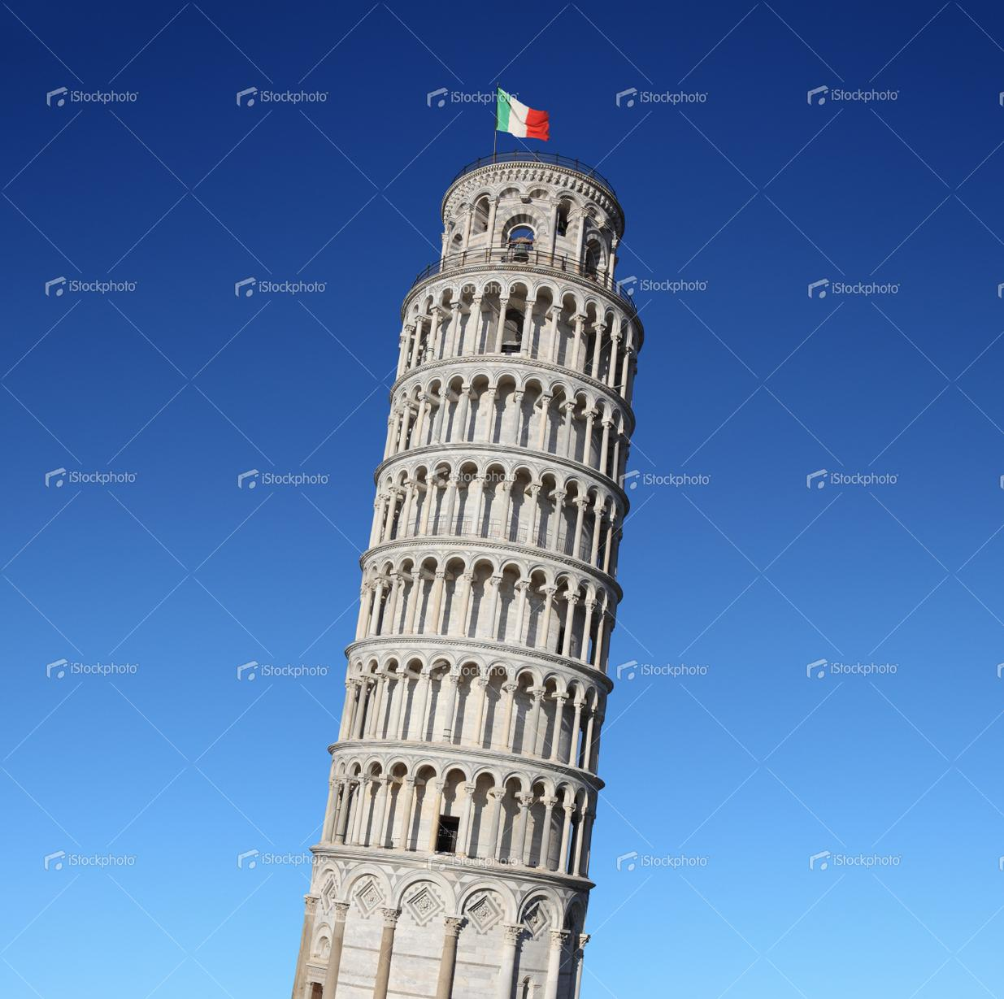 | Leaning Tower of Pisa | istockphoto.com  Leaning tower of Pisa  File #18174209  XXXLarge  5268 x 5229 px @ 300 dpi  25.37 MB  55 Credits | $55
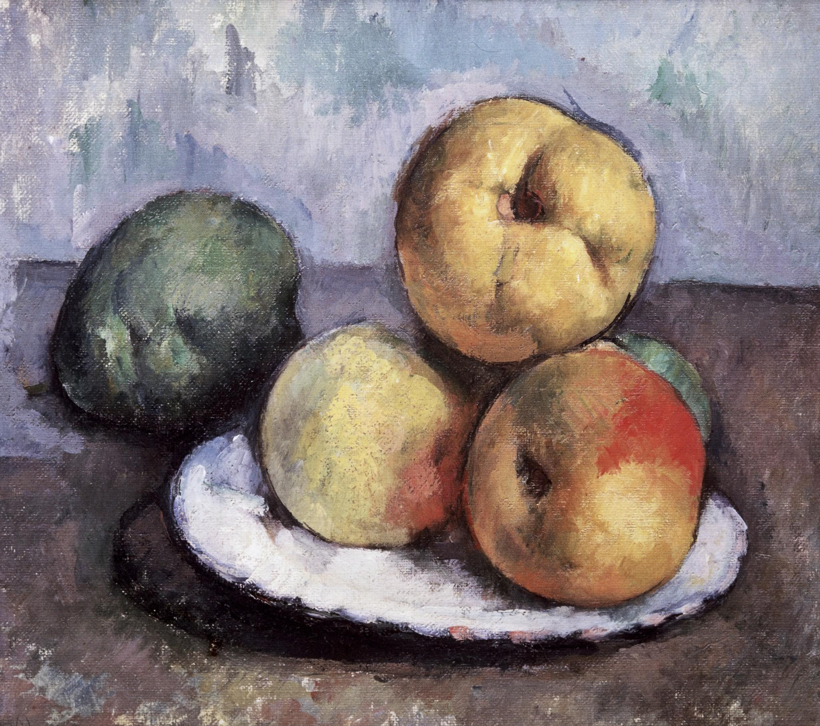 | Cezanne’s Apples | White House Historical Association | $75
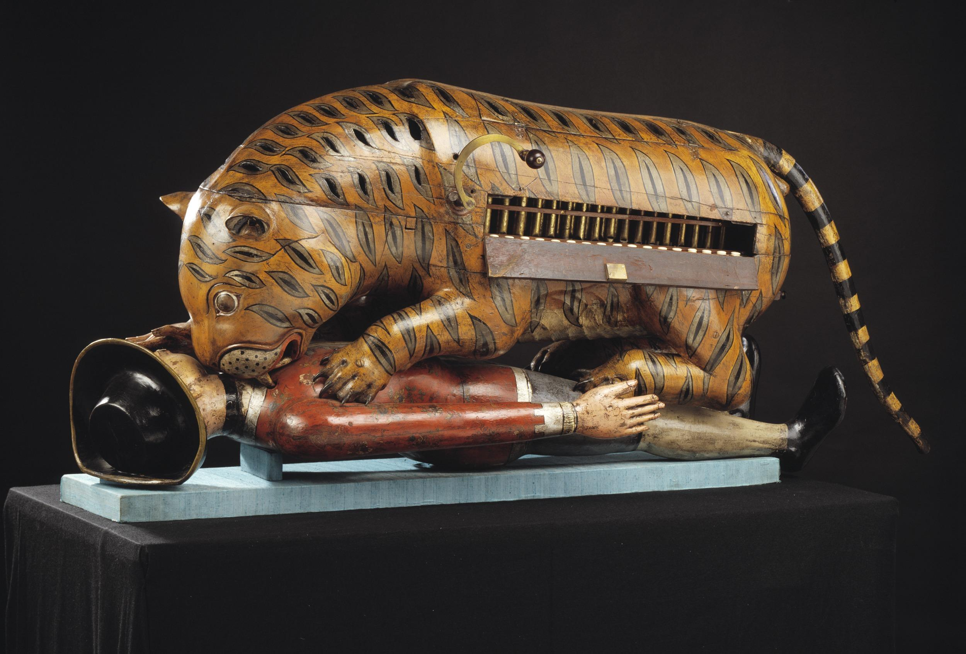 | Tipu’s Tiger | Victoria & Albert Museum
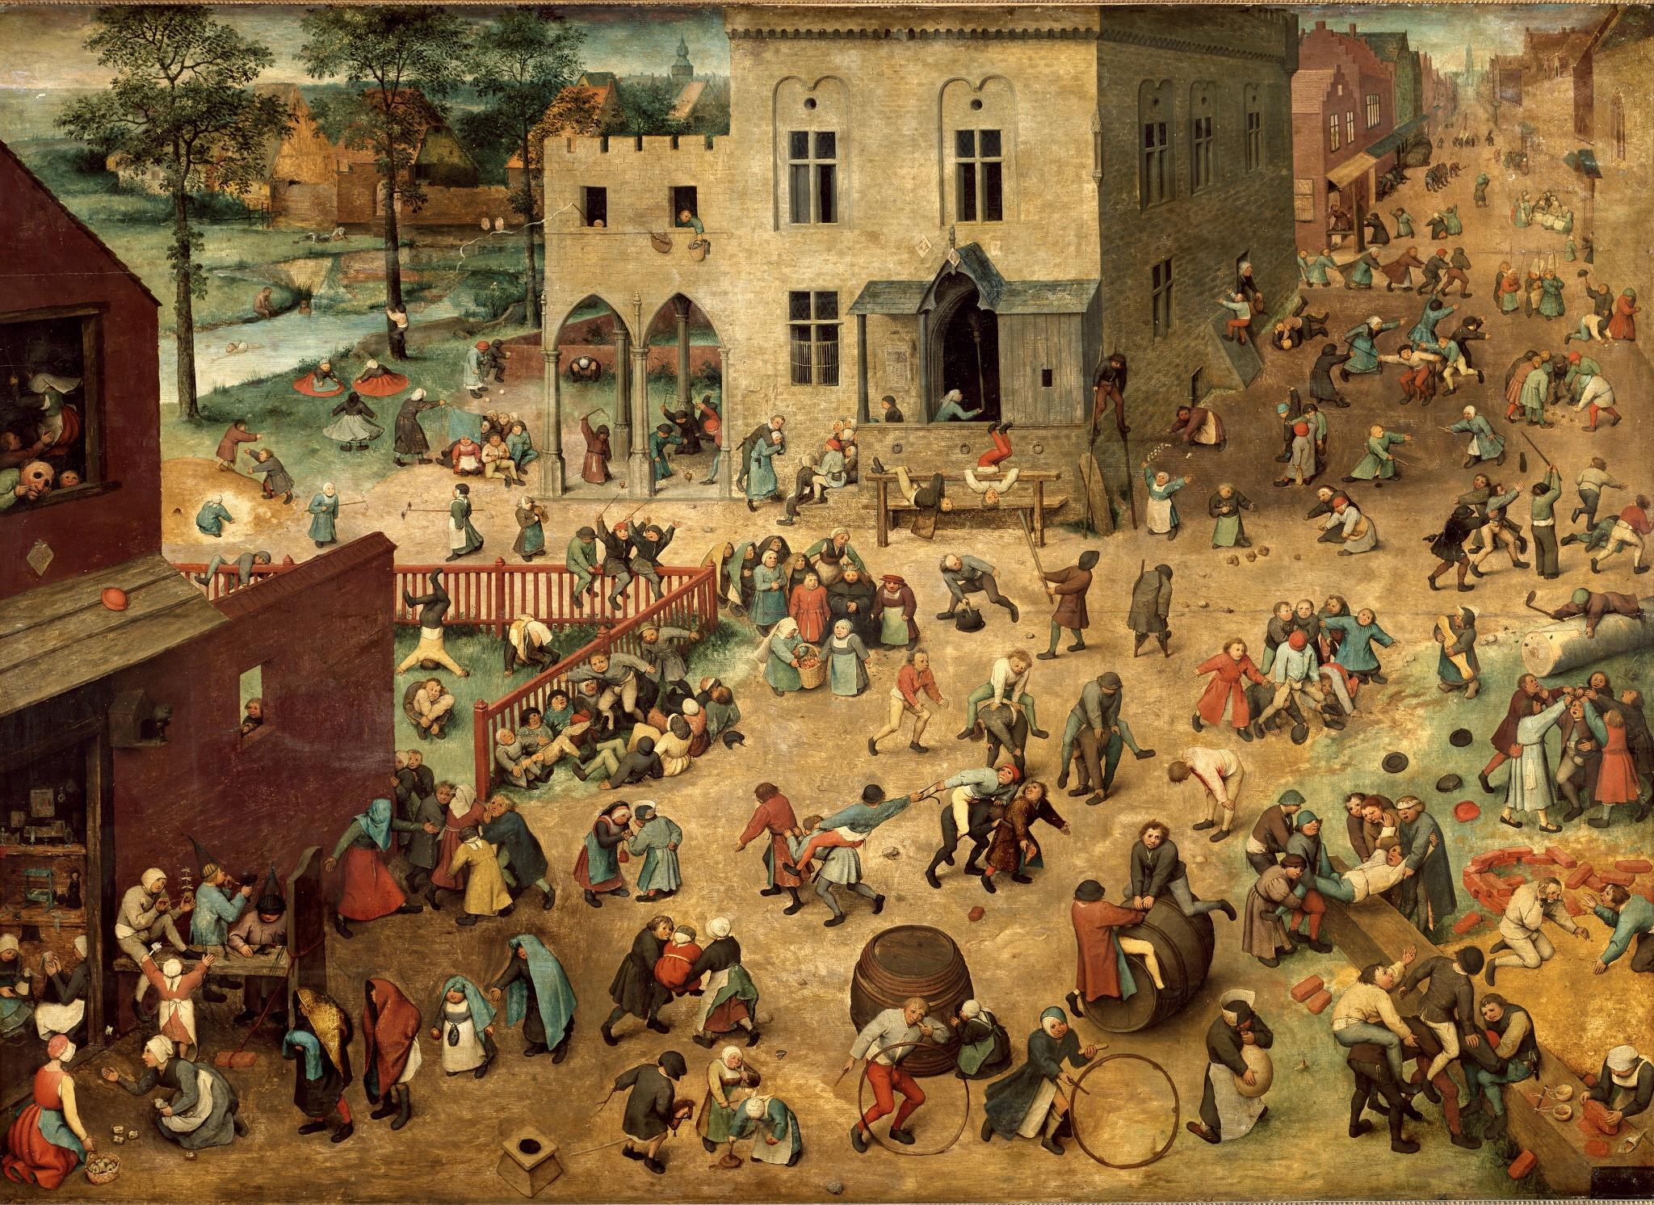 | Breughel’s Children’s Games | Kunsthistorisches Museum | €50
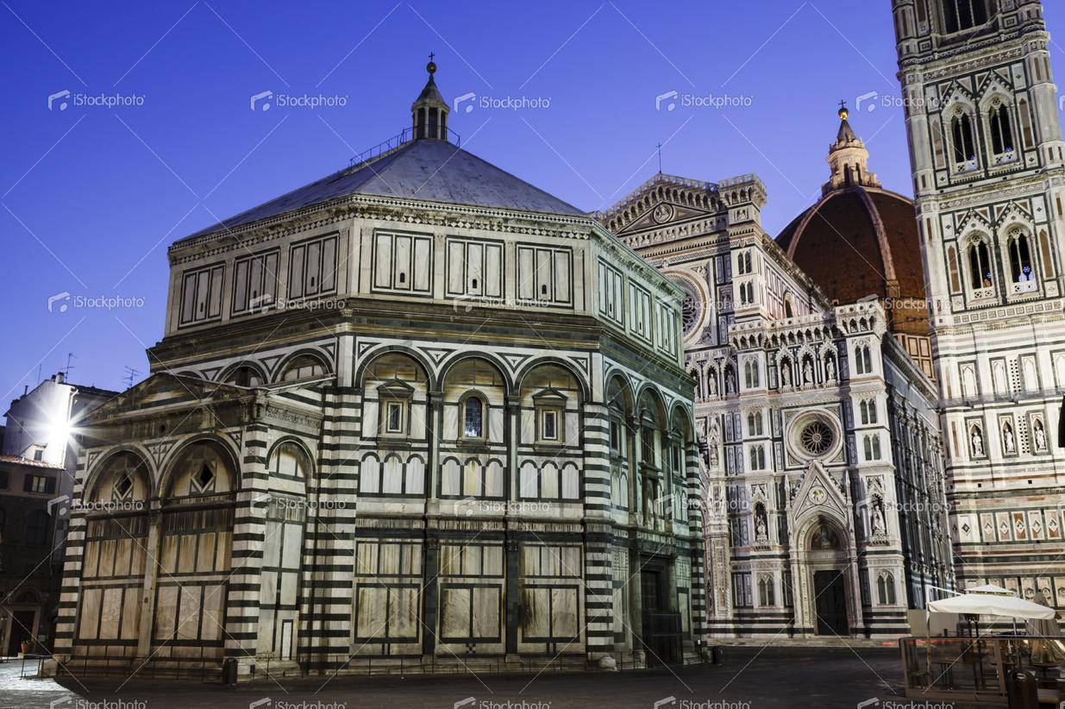 | Baptistry of Florence | istockphoto.com  File #23394682  XXXLarge  5616 x 3744  17.64 MB  18 Credits | $18
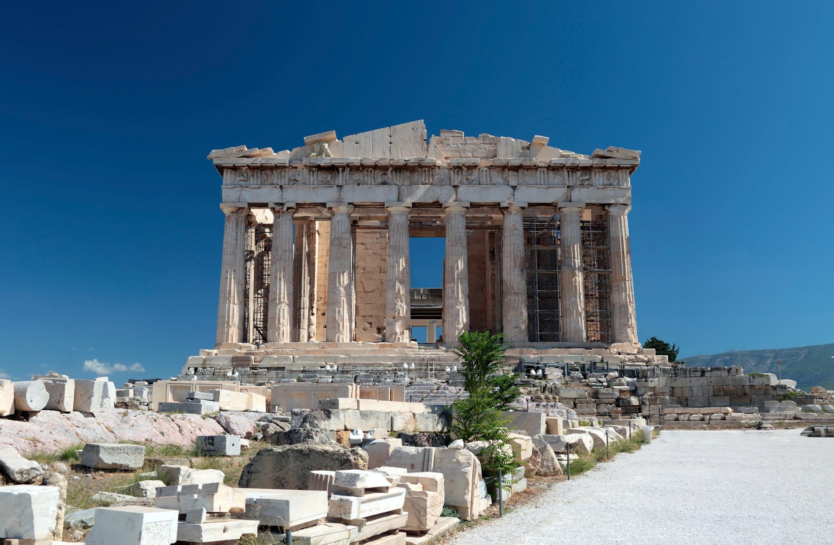 | The Parthenon
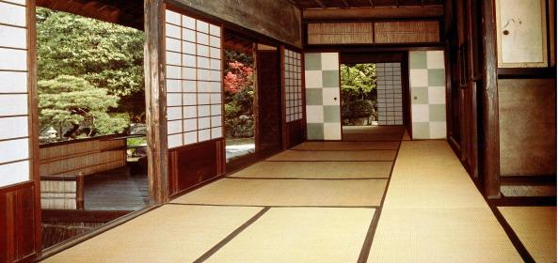 | Katsura Palace
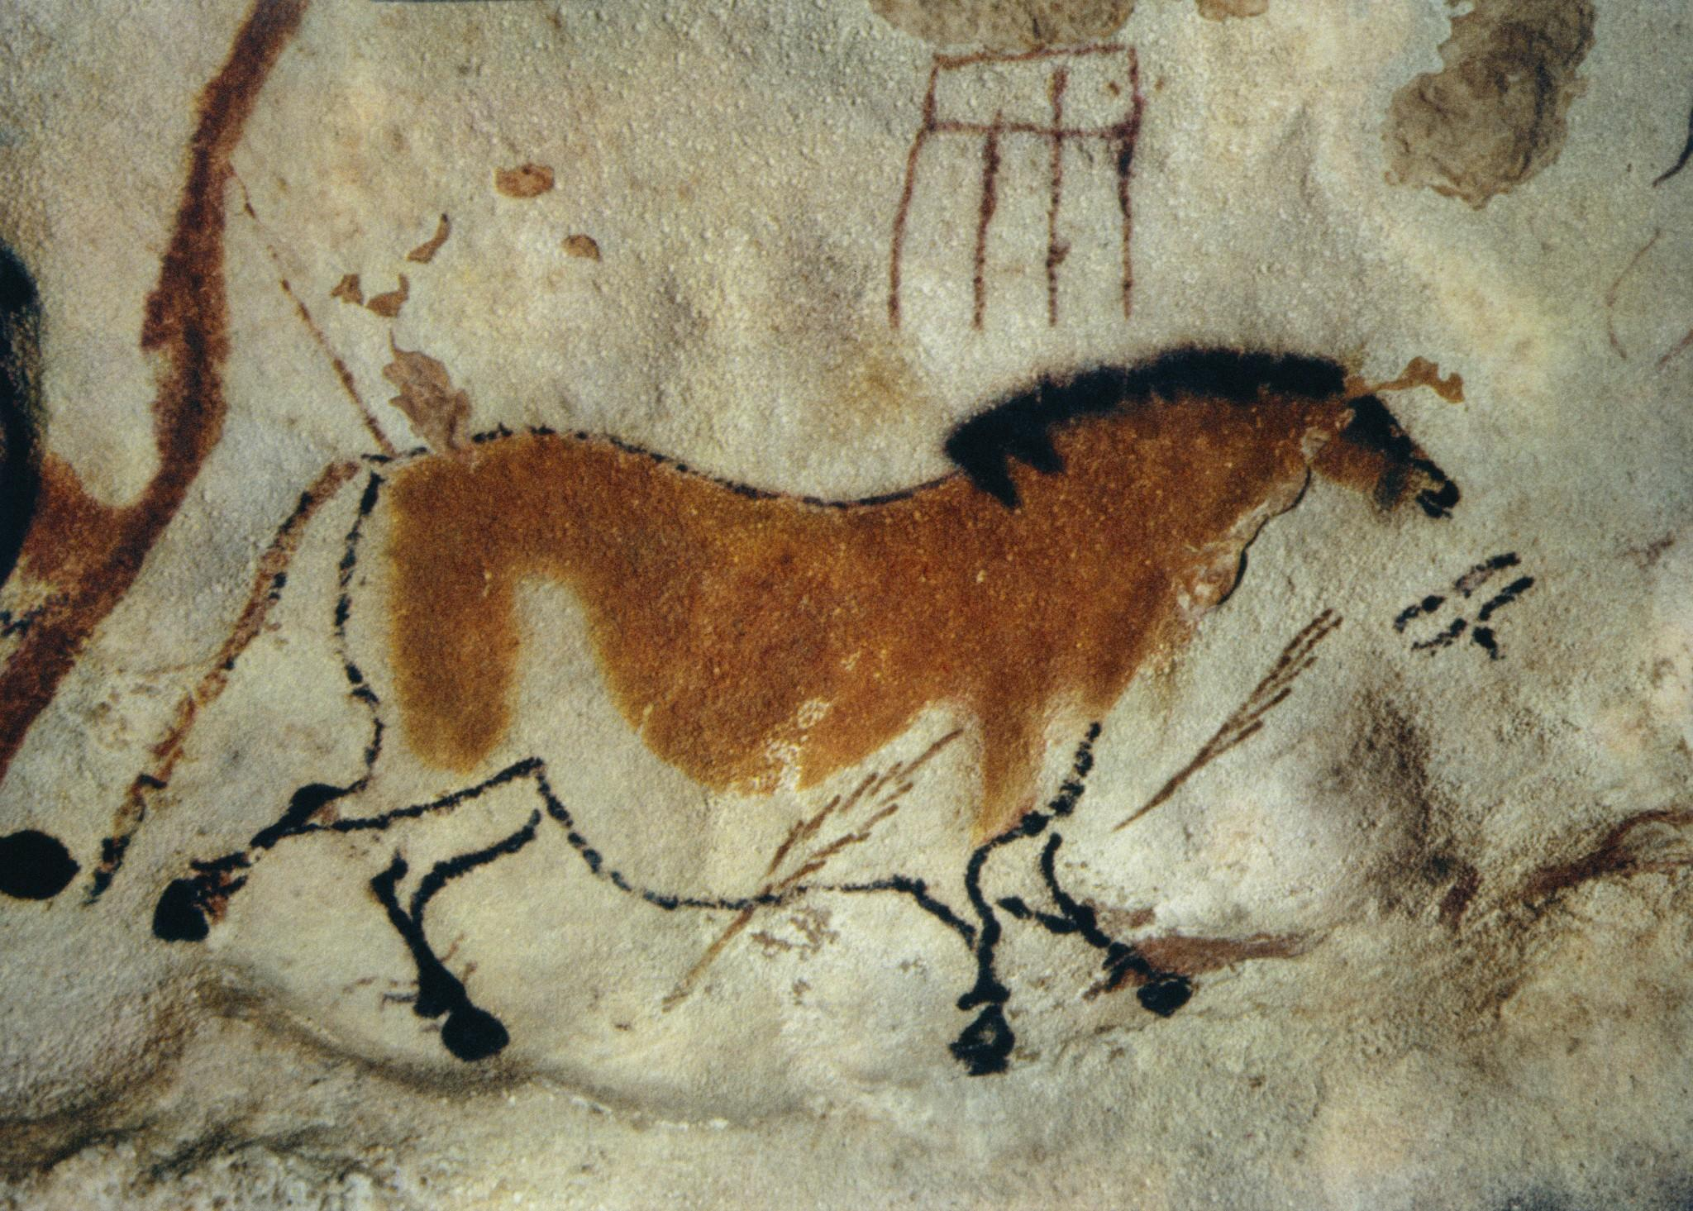 | Lascaux Cave Horse Painting | Corbis  42-18372237  or  University of York | $332  $0?
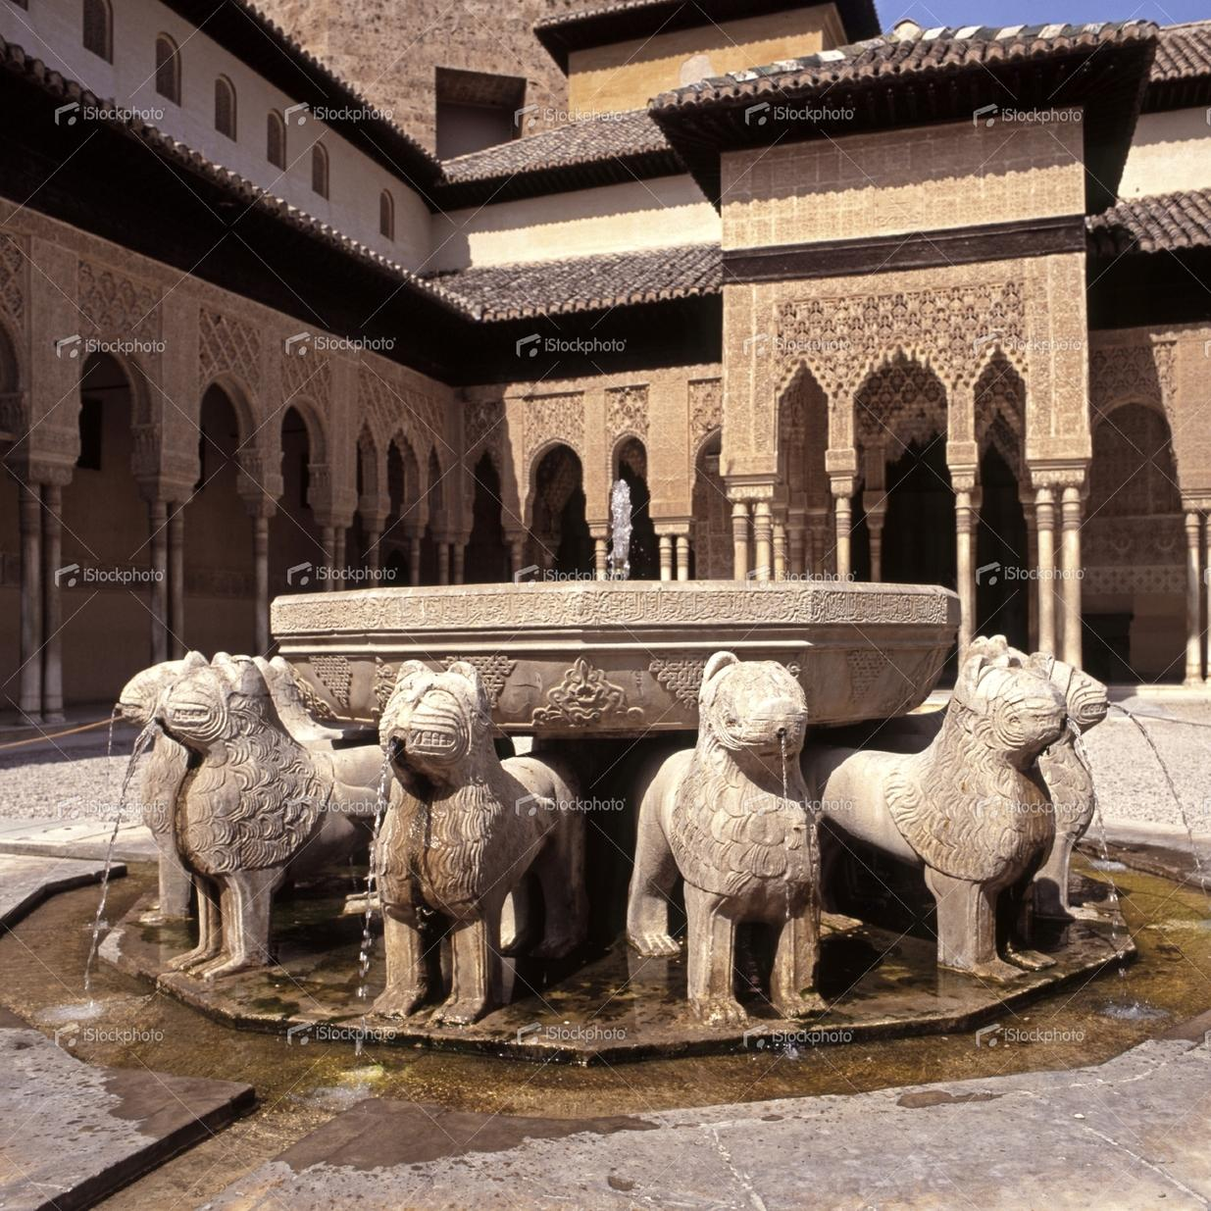 | Lion fountain, Alhambra Palace, Granada, Spain. | istockphoto.com  File #22129042  Large  3000 x 3000 px @ 300 dpi  6.22 MB  10 Credits | $10

Answers

A.

The cave paintings of Lascaux are objects of aesthetic experience, irrespective of time, place, purpose, style, or genre.

Aesthetics is the standard by which a work of art is judged. It is essentially the study of the successive or simultaneous interaction of form and content.
How skillfully these components are fused will determine the aesthetic quality of the work in question.
There are two parts to this hypothesis. One relates to the artist, who, unlike the spectator, is intensely involved — intuitively, emotionally, and perceptually; the other, to the object, which possesses a plastic unity that differentiates it from the ordinary artifact.
“It is at least arguable that the purely formal element in art does not change; that the same canons of harmony and proportion are present in primitive art, in Greek art, in Gothic art, in Renaissance art, and in the art [and design, traditional or trivial] of the present day.”
To this one may add the canons of:
order, unity, variety, contrast,
grace, symmetry, asymmetry,
rhythm, rhyme, regularity,
movement, interval, coherence,
dissonance, balance, tension,
space, scale, weight,
texture, line, mass, shape,
light, shade, color,
ad infinitum.
These are among the tools of form —by design, by chance, by improvisation.
The endless conflicts between
the spiritual and material,
between ends and means,
form and content,
form and function,
form and facture,
form and purpose,
form and meaning,
form and idea,
form and expression,
form and illusion,
form and habit,
form and scale,
form and style
need to be resolved.
It is the merging of these conflicts that determines the aesthetic quality of a painting, a design, a building, a sculpture, or a printed piece.

A work of art, then, is the resolution of conflicting relations. It is a unity of opposites, a series of steps reflecting Hagel’s dialectics:
thesis, the subject;
antithesis, the conflict;
and synthesis, the resolution.
Whatever one’s belief, art is commentary, art is revelation, art is the culmination of the creative process.
It is a by-product, not a goal, a point of view about a particular object that rises above and it’s topical source.

It is not just a facsimile
but an opinion expressed visually in a distinctive way.
Art is reality enhanced.

The Designer’s Problem
Paul Rand: Thoughts on Design, 3rd Edition, 1970

An erroneous conception of the graphic designer’s function is to imagine that in order to produce a “good layout”¹ all he need do is make a pleasing arrangement of miscellaneous elements. What is implied is that this may be accomplished simply by pushing these elements around, until something happens. At best, this procedure involves the time-consuming uncertainties of trial and error, and at worst, an indifference to plan, order or discipline.
The designer does not, as a rule, begin with some preconceived idea. Rather, the idea is (or should be) the result of careful study and observation, and the design a product of that idea. In order, therefore, to achieve an effective solution to his problem, the designer must necessarily go through some sort of mental process.²
Consciously or not, he analyzes, interprets, formulates.
He is aware of the scientific and technological developments in his own and kindred fields.
He improvises, invents or discovers new techniques and combinations.
He co-ordinates and integrates his material so that he may restate the problem in terms of ideas, signs, symbols, pictures.
He unifies, simplifies, and eliminates superfluities.
He symbolizes — abstracts from his material by association and analogy.
He intensifies and reinforces his symbol with appropriate accessories to achieve clarity and interest.
He draws upon instinct and intuition.
He considers the spectator, his feelings and predilections.

Examples to use
Image | Label | Owner | Cost
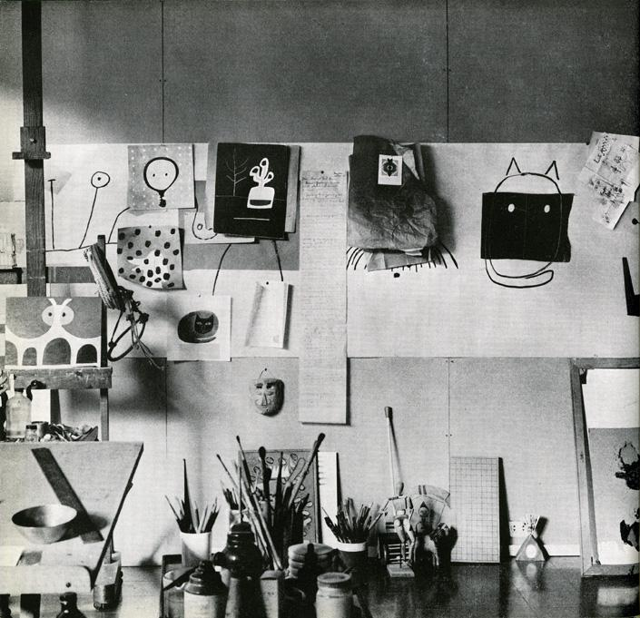 |  | Yale/Rand Estate

The Symbol in Advertising/Versatility of the Symbol

LARGE QUOTE ON WALL “Good design adds value of some kind, gives meaning, and, not incidentally, can be sheer pleasure to behold; it respects the viewer’s sensibilities and rewards the entrepreneur.”
Design Form and Chaos

The Symbol in Advertising
Paul Rand: A Designer’s Art, 1985
It is in symbolic, visual terms that the designer ultimately realizes his perceptions and experiences; and it is in a world of symbols that man lives. The symbol is thus the common language between artist and spectator.
Words like simplified, stylized, geometric, abstract, two-dimensional, flat, non-representational, non-mimetic are commonly associated, sometimes incorrectly, with the term symbol.
In essence, it is not what it looks like but what it does that defines a symbol. A symbol may be depicted as an “abstract” shape, a geometric figure, a photograph, an illustration, a letter of the alphabet, or a numeral. Thus, a five-pointed star, the picture of a little dog listening to his master's voice, a steel engraving of George Washington, or the Eiffel Tower itself—are all symbols!
… In these illustrations the form is intensified by dramatic narrative association. The literal meaning changes according to context; the formal quality remains unchanged.

Versatility of the Symbol
Paul Rand: Thoughts on Design, 3rd Edition, 1970
The same symbol is potentially a highly versatile device, which can be used to illustrate many different ideas. By juxtaposition, association, and analogy, the designer is able to manipulate it, alter its meaning, and exploit its visual possibilities.
The circle as opposed to the square, for instance, as a pure form evokes a specific esthetic sensation; ideologically it is the symbol for eternity, without beginning or end. A red circle may be interpreted as the symbol of the sun, the Japanese battle flag, a stop sign, an ice-skating rink, or a special brand of coffee…depending on its context.

Examples to use
Image | Label | Owner | Cost
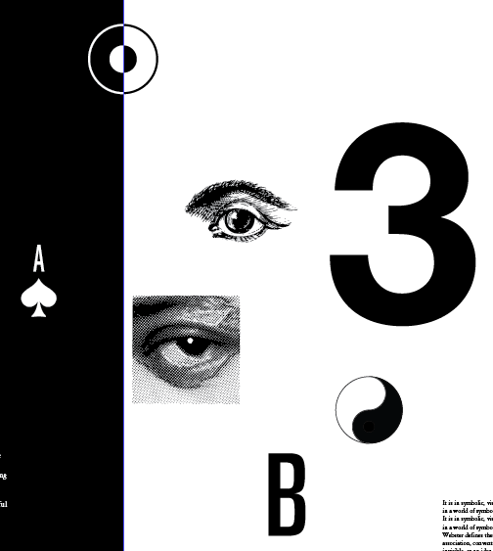 |  | Yale/Rand Estate
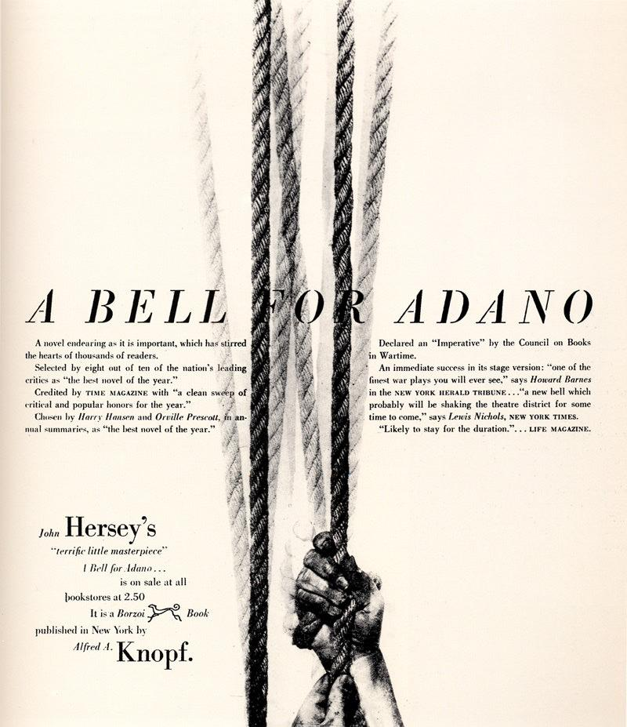
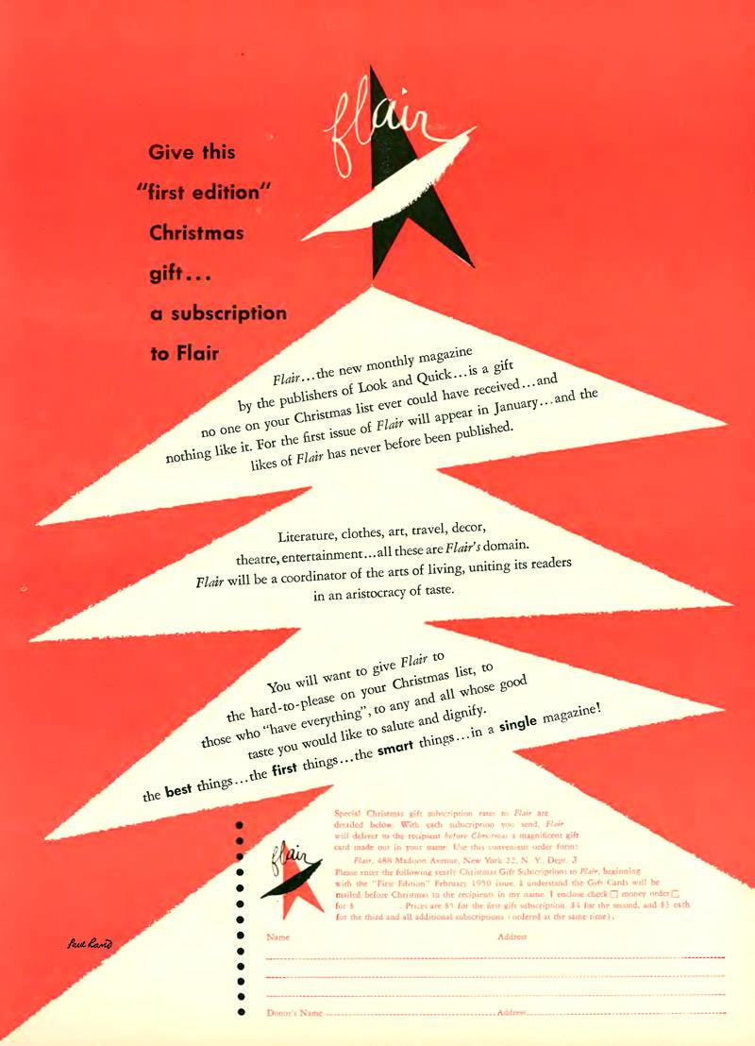
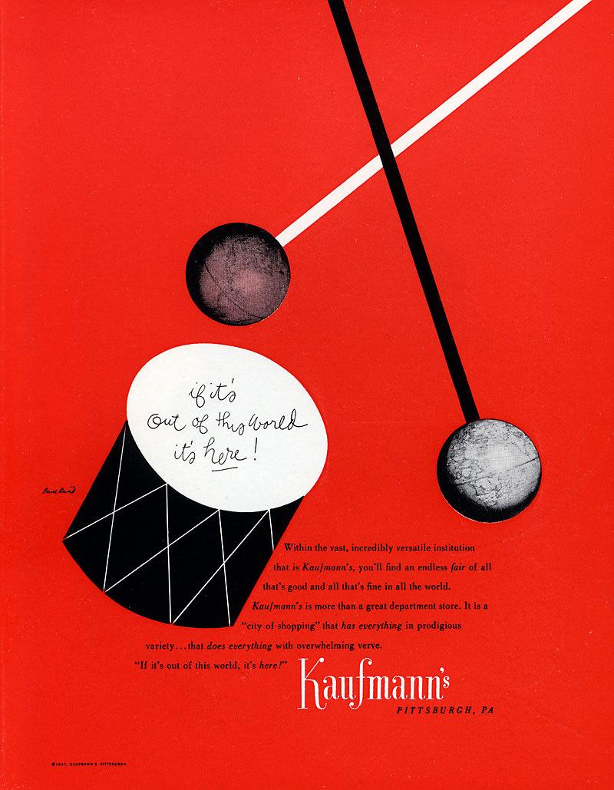
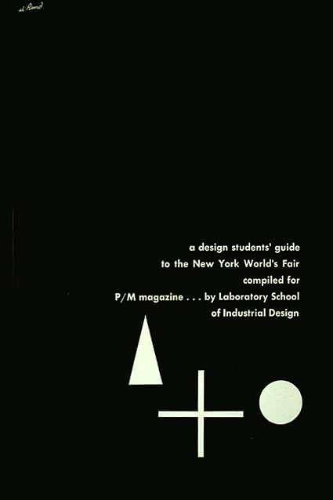
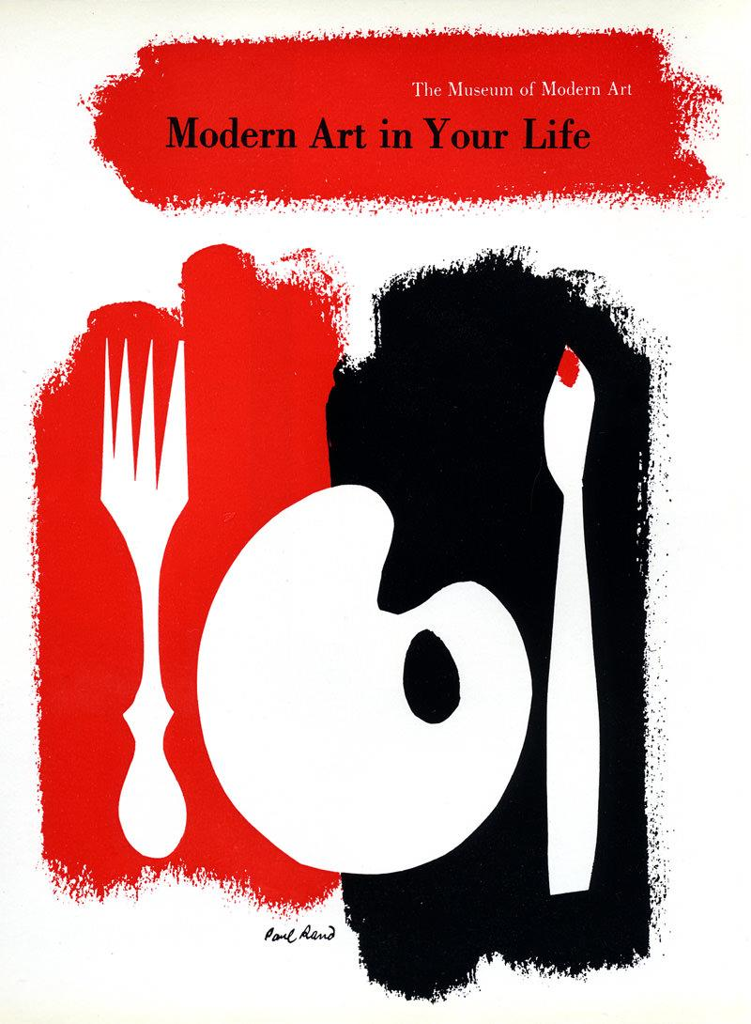
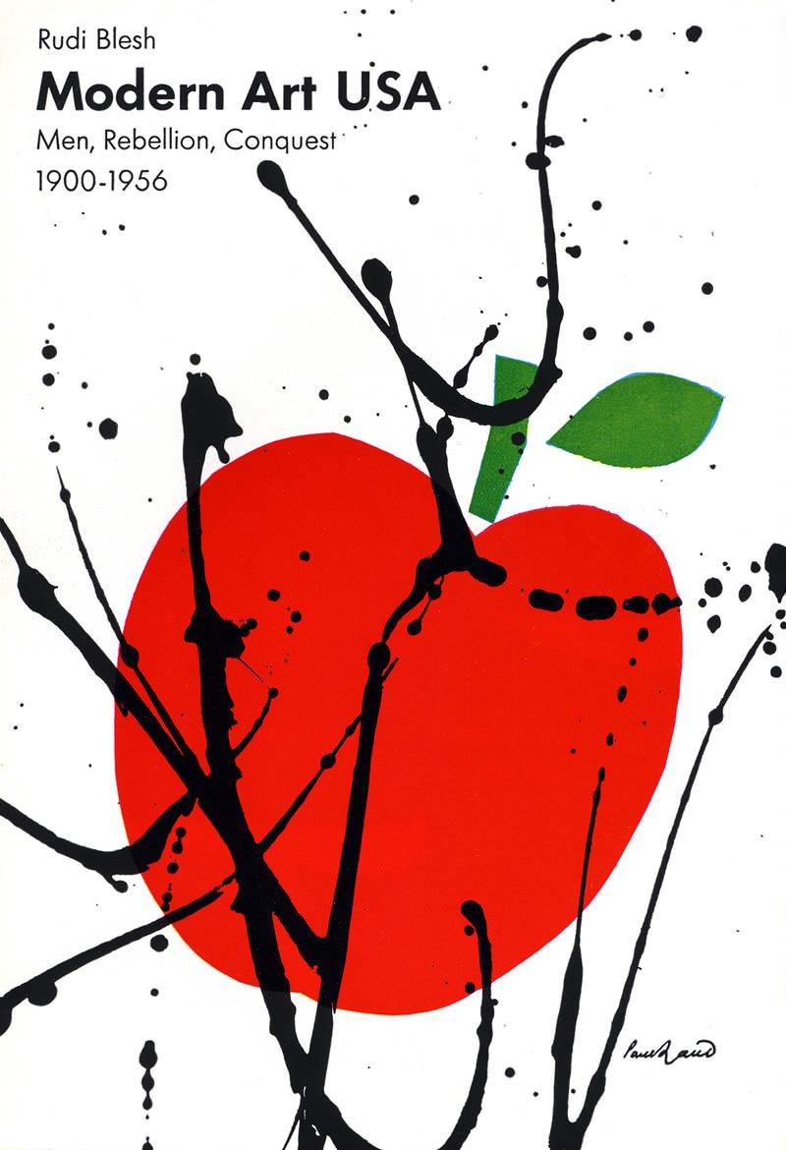
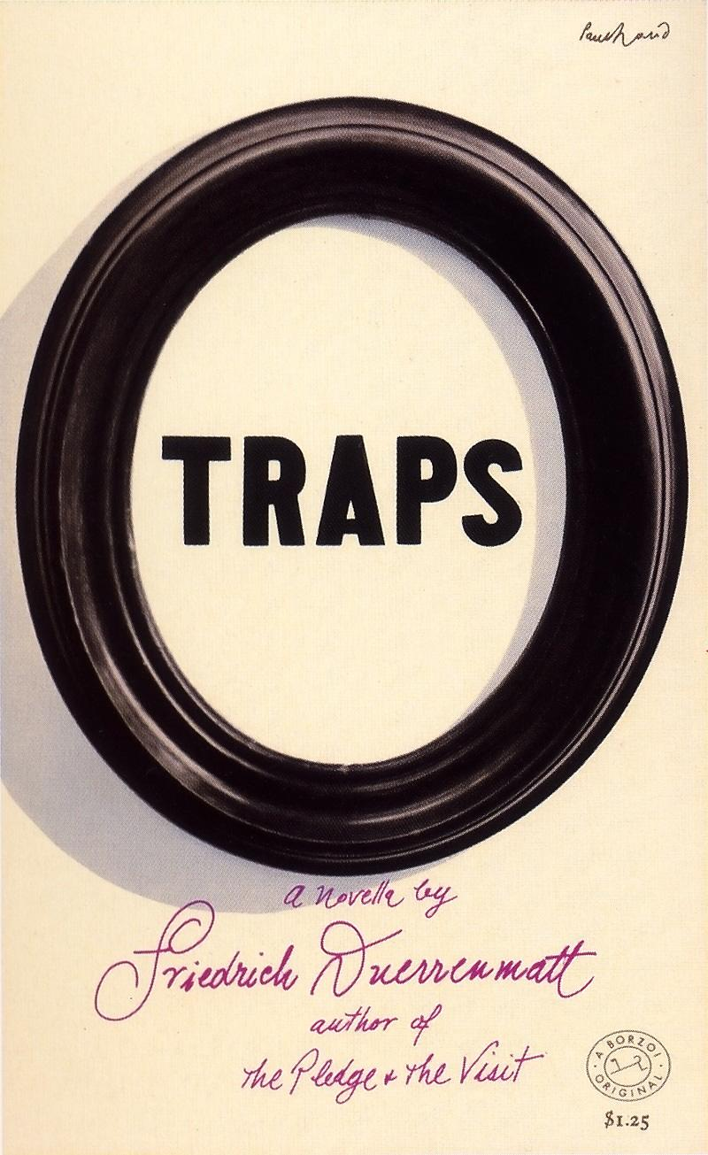
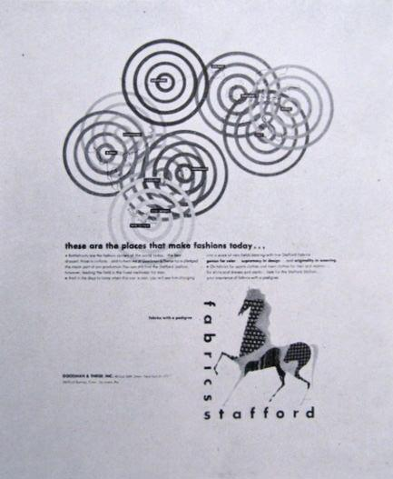
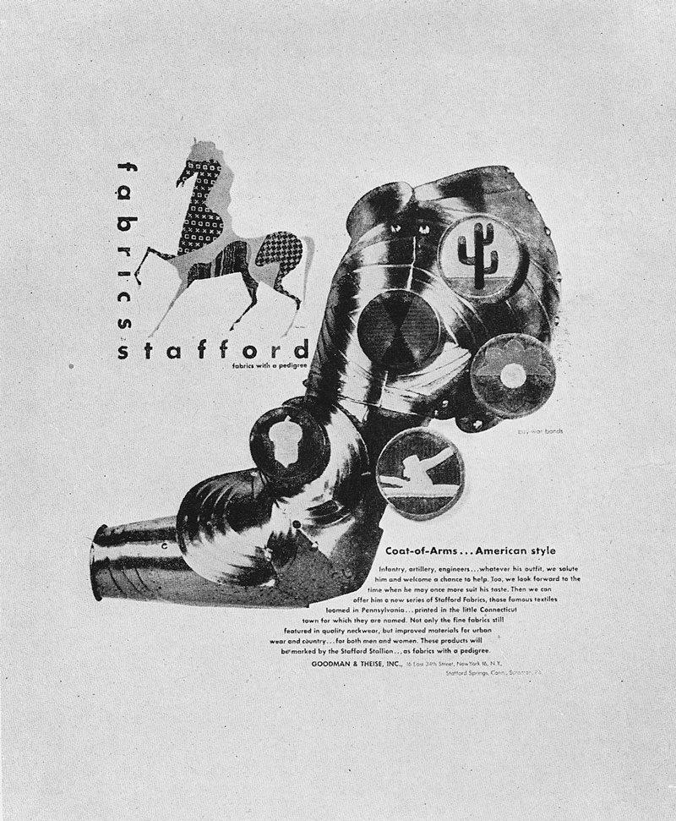
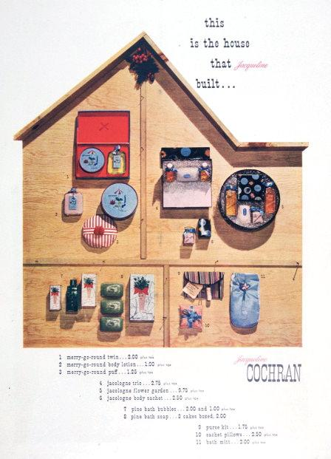
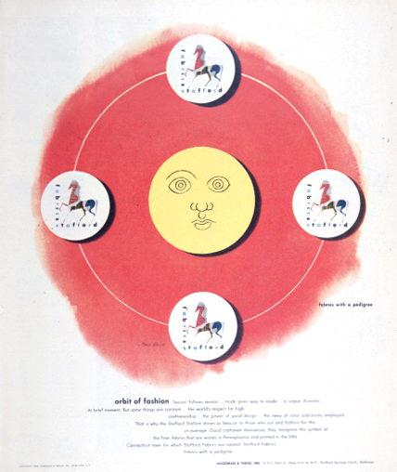
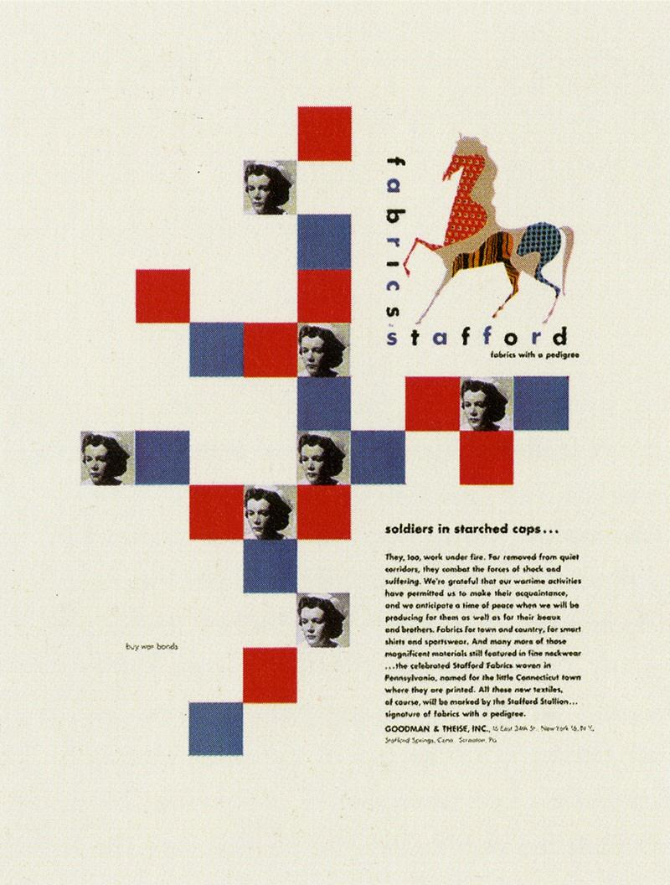
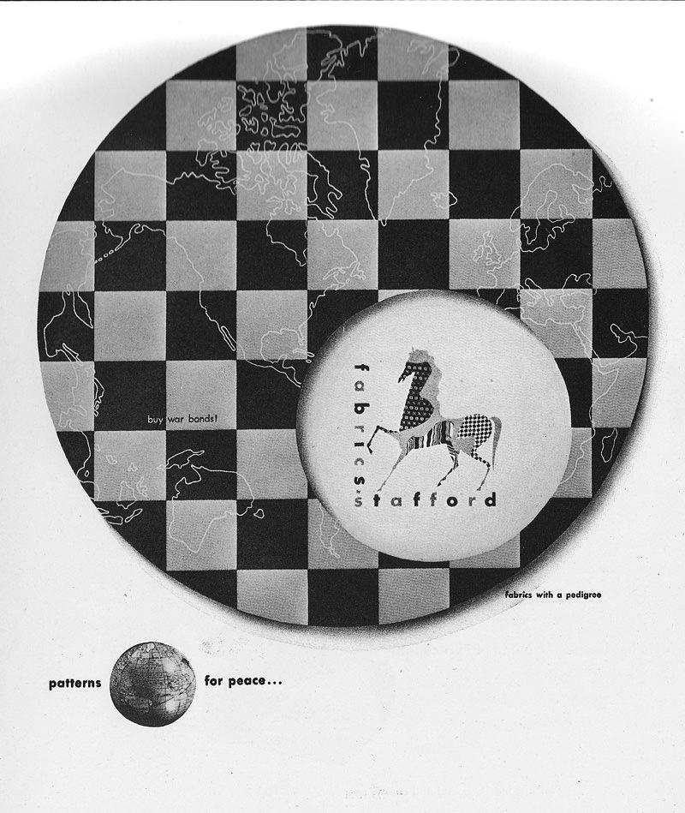

Collage and Montage
Paul Rand: A Designer’s Art, 1985

It is a truism that the fundamental problem of the advertiser and publisher is to get the message into the readers mind. Commonplace images and unimaginative visualization afford the spectator little reason to become engrossed in an advertisers product.
Collage and montage permit the integration of seemingly unrelated objects or ideas in a single picture; they enable the designer to indicate simultaneous events or scenes which by more conventional methods would result in a series of isolated pictures. The complex message presented in a single picture more readily enables the spectator to focus his attention on the advertisers message.
In one sense montage and collage are integrated visual arrangements in space, and in another sense they are absorbing visual tests that the spectator may perceive and decipher for himself. He may thus participate directly in the creative process.
Examples to use
Image | Label | Owner | Cost
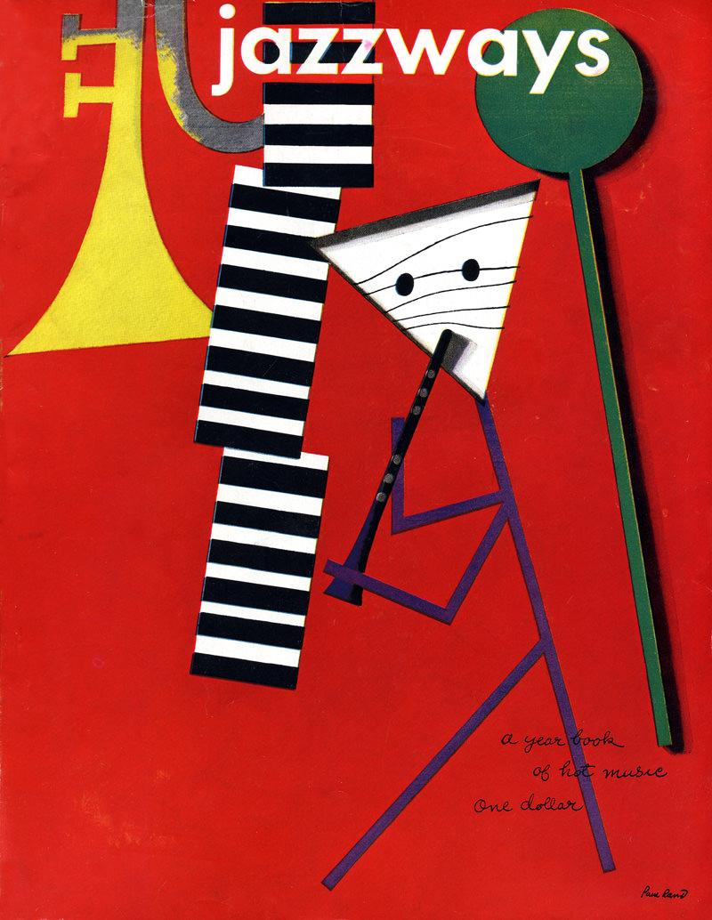 | Jazzways Cover | Danny | $0
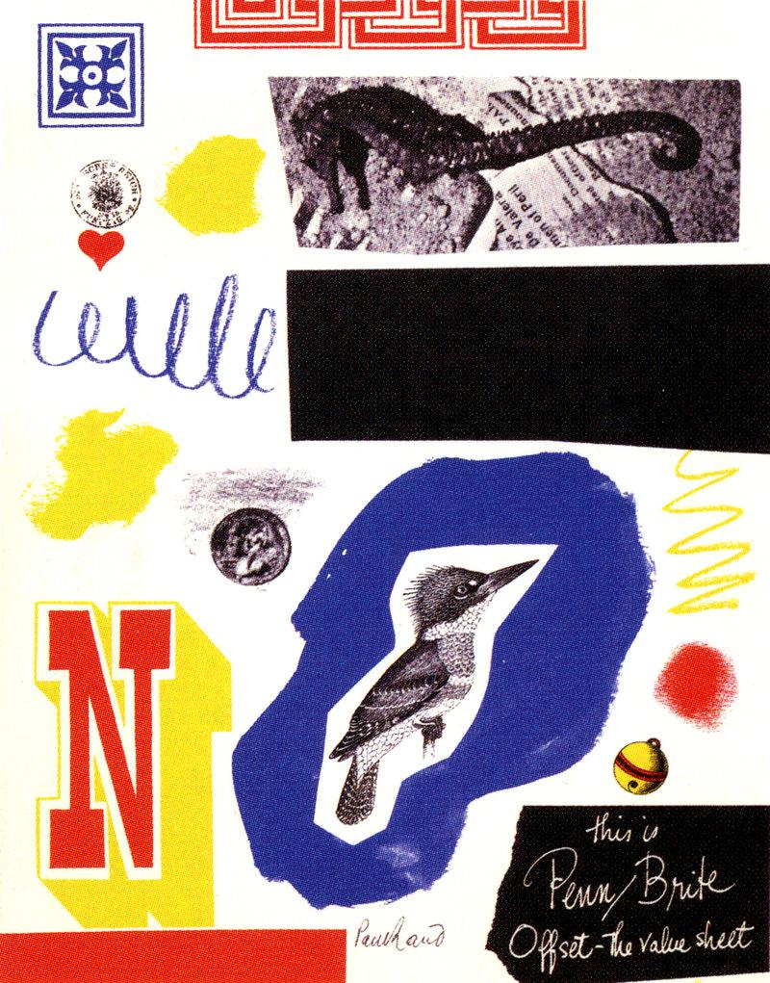
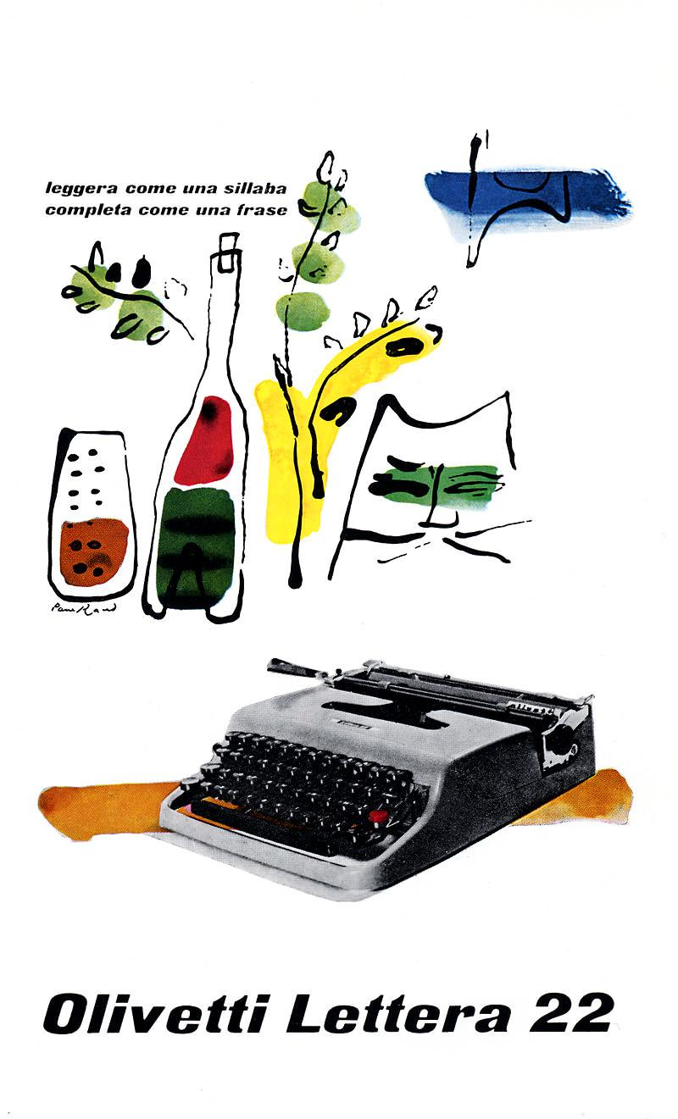
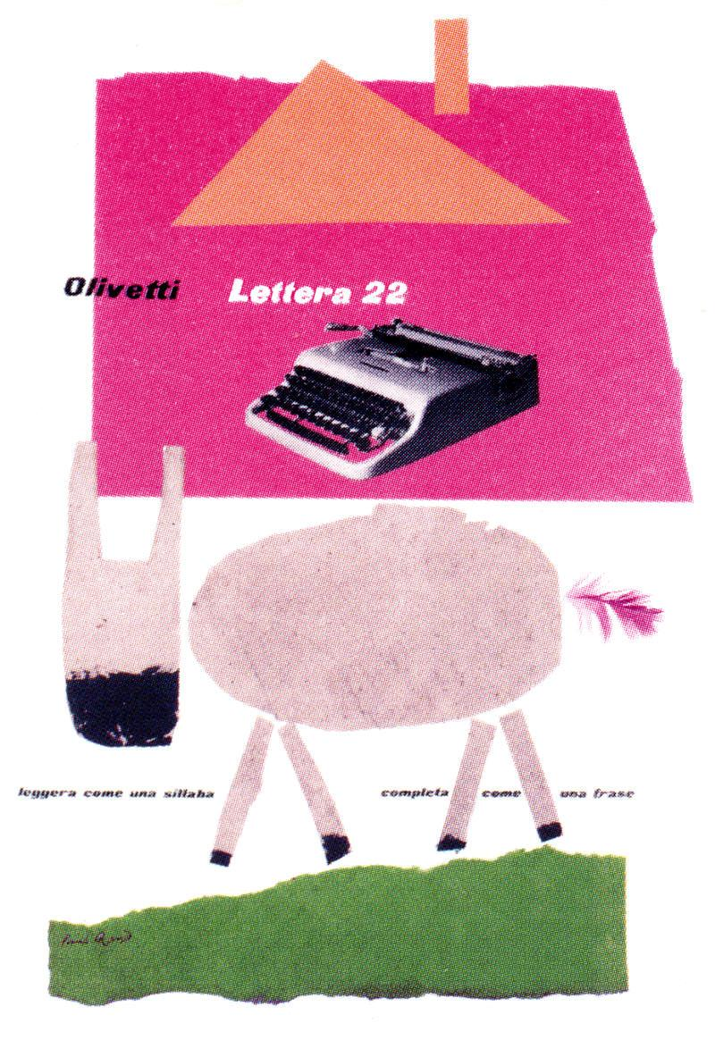
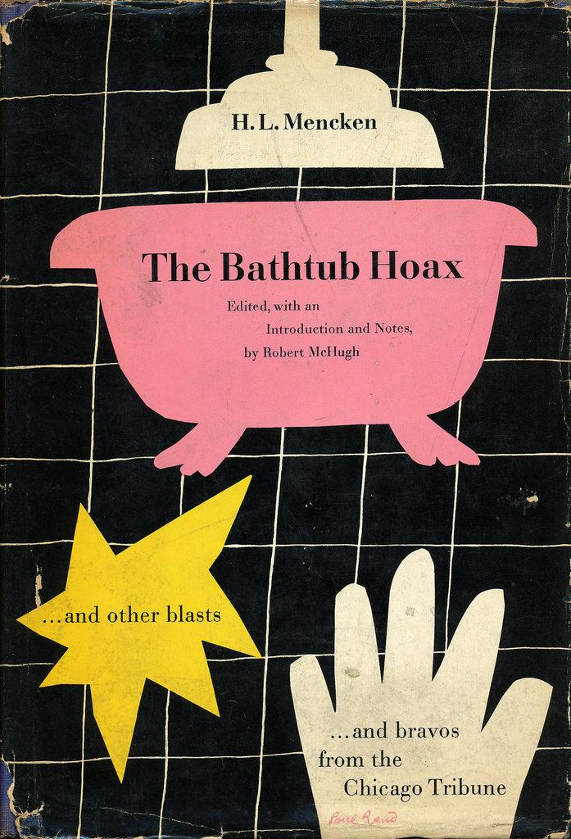
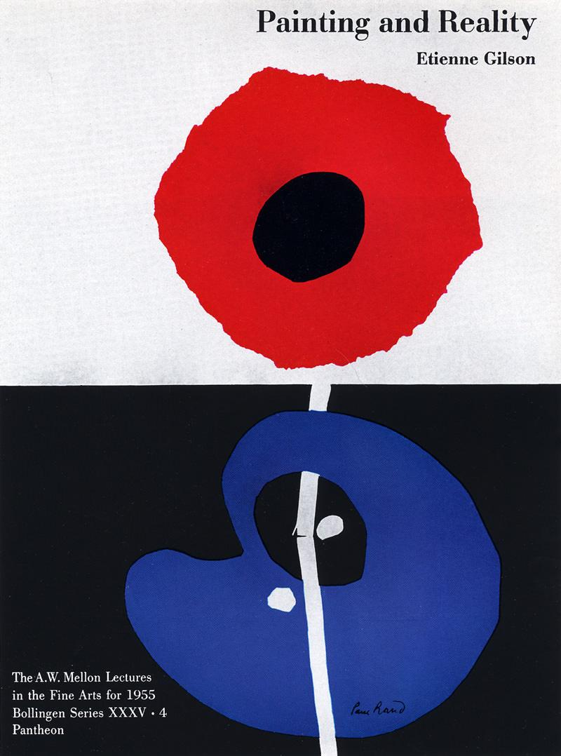
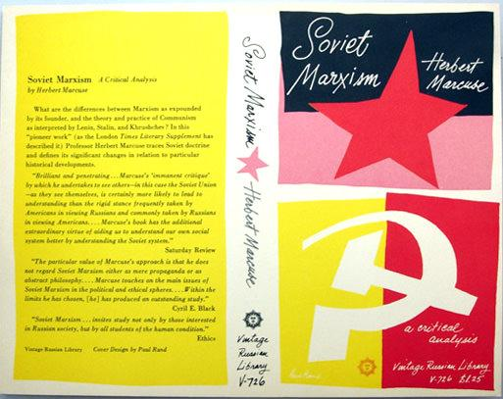
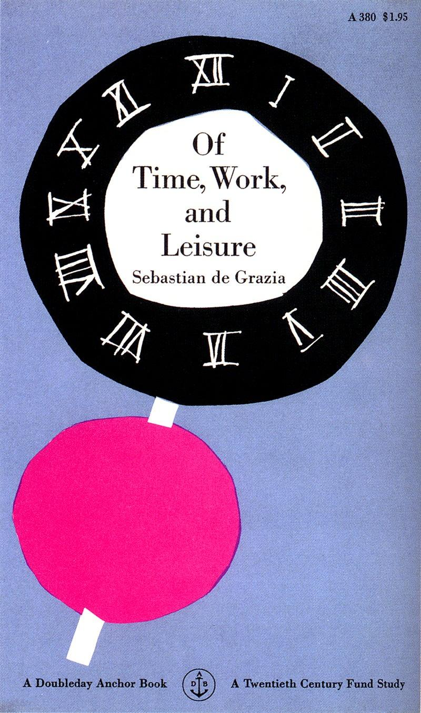
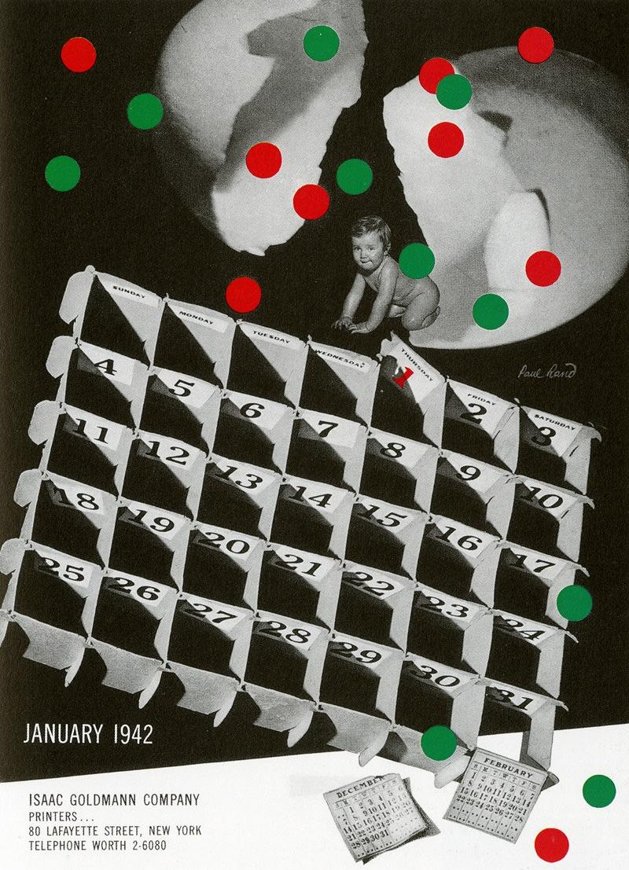
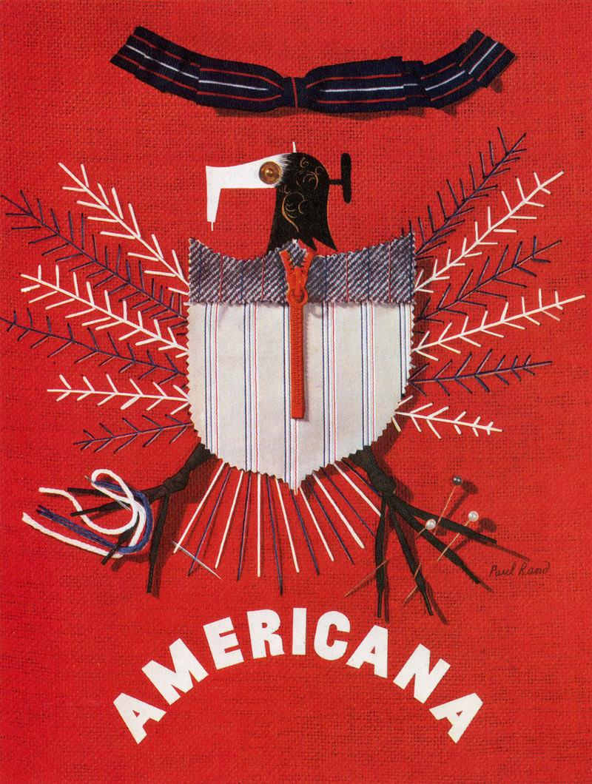
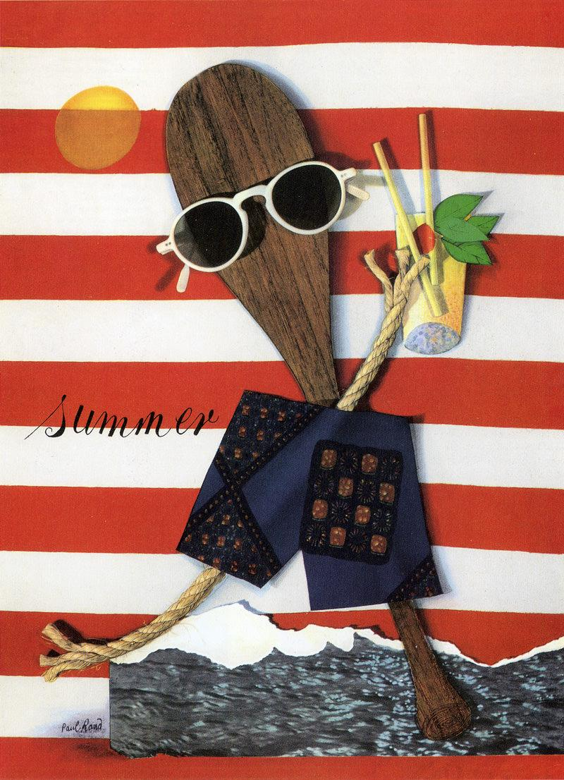
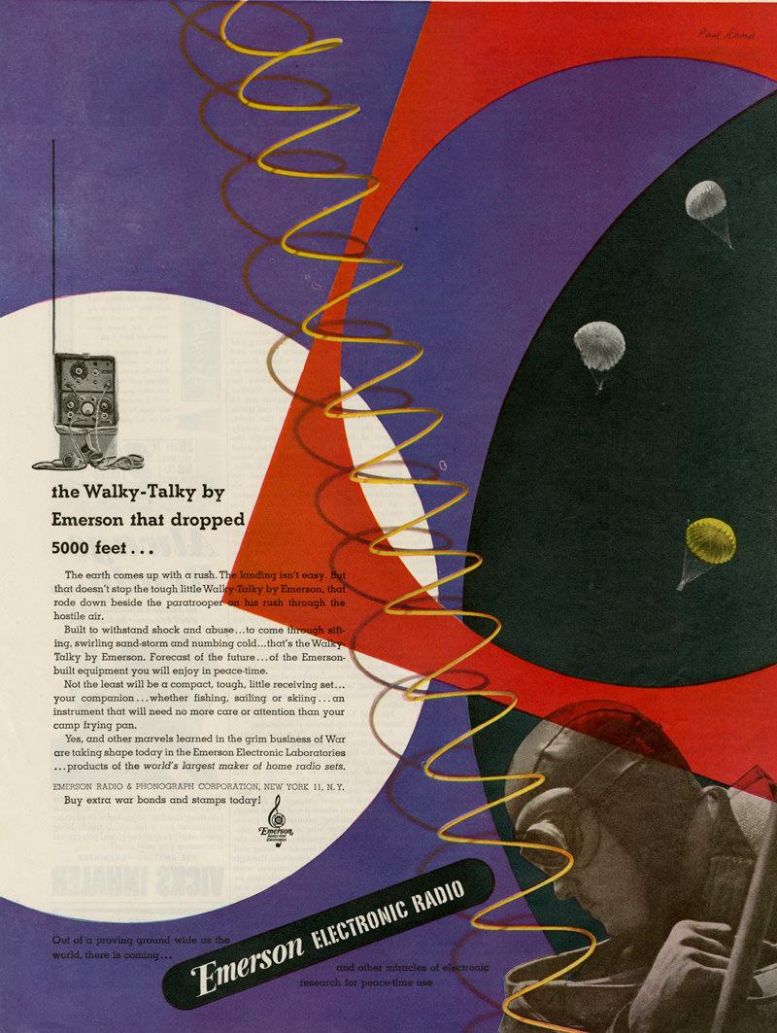

Ideas About Ideas
Paul Rand: A Designer’s Art, 1985

The source of the creative impulse is a mystery. Where do ideas come from?
The artist takes note of that which jolts him into visual awareness. Without the harvest of visual experience he would be unable to cope with the plethora of problems, mundane or otherwise, that confronts him in his daily work. Ideas may also grow out of the problem itself which in turn becomes part of the solution.
This profile with a staring eye, which I recalled seeing in a book on Etruscan art, prompted the idea for the illustration of this 1946 Container Corporation advertisement. The haunting eyes are germane to the message the advertisement is designed to convey.
Examples to use
Image | Label | Owner | Cost
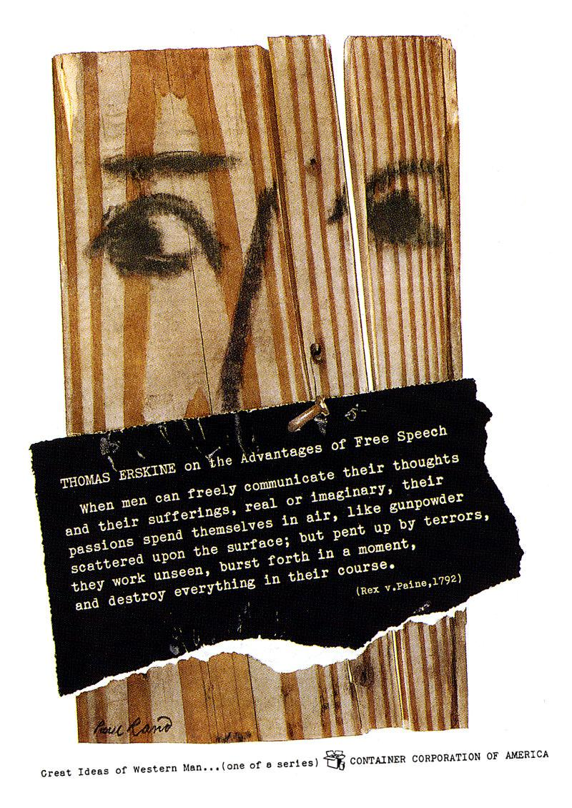

Integrating Form and Content
Paul Rand. Thoughts on Design, 3rd Edition, 1970.

“Originality is a product, not an intention.”
Graphic Wit “Paul Rand: The Play Instinct” 1991
What we commonly understand as “originality” depends on the successful integration of the symbol as a visual entity with all other elements, pointed to a particular problem, performing a specific function consistent with its form. Its use at the proper time and place is essential and its misuse will inevitably result in banality or mere affectation. The designer’s capacity to contribute to the effectiveness of the basic meaning of the symbol, by interpretation, addition, subtraction, juxtaposition, alteration, adjustment, association, intensification, and clarification, is parallel to those qualities that we call “original.”

In the examples that follow, the abstract, geometric forms (attention-arresting devices) tend to dominate, while the representational images play a supporting role. The complementary relationship between these two types of images is dramatized when human expression is introduced.
OBJECT LABEL: The Coronet Brandy advertisements are based on a common object-the brandy snifter in animated form. The dot pattern of the soda bottle was designed to suggest effervescence; the dotted background is a visual extension of the bottle; the waiter is a variation of the snifter glass; the oval tray individualizes for Coronet the silver tray we used to see in liquor advertisements.

OBJECT LABEL: The dividing line between representational and nonrepresentational images is often very slim. In this advertisement for Ohrbach’s the window shade acts as a formal as well as a poignantly suggestive image (1946).
OBJECT LABEL: Occasionally purely nonrepresentational images function even more effectively without the support of explanatory illustrations which tend to confine an idea and limit the imagination. The spectator is thus able to see more than is actually portrayed.

Examples to use
Image | Label | Owner | Cost
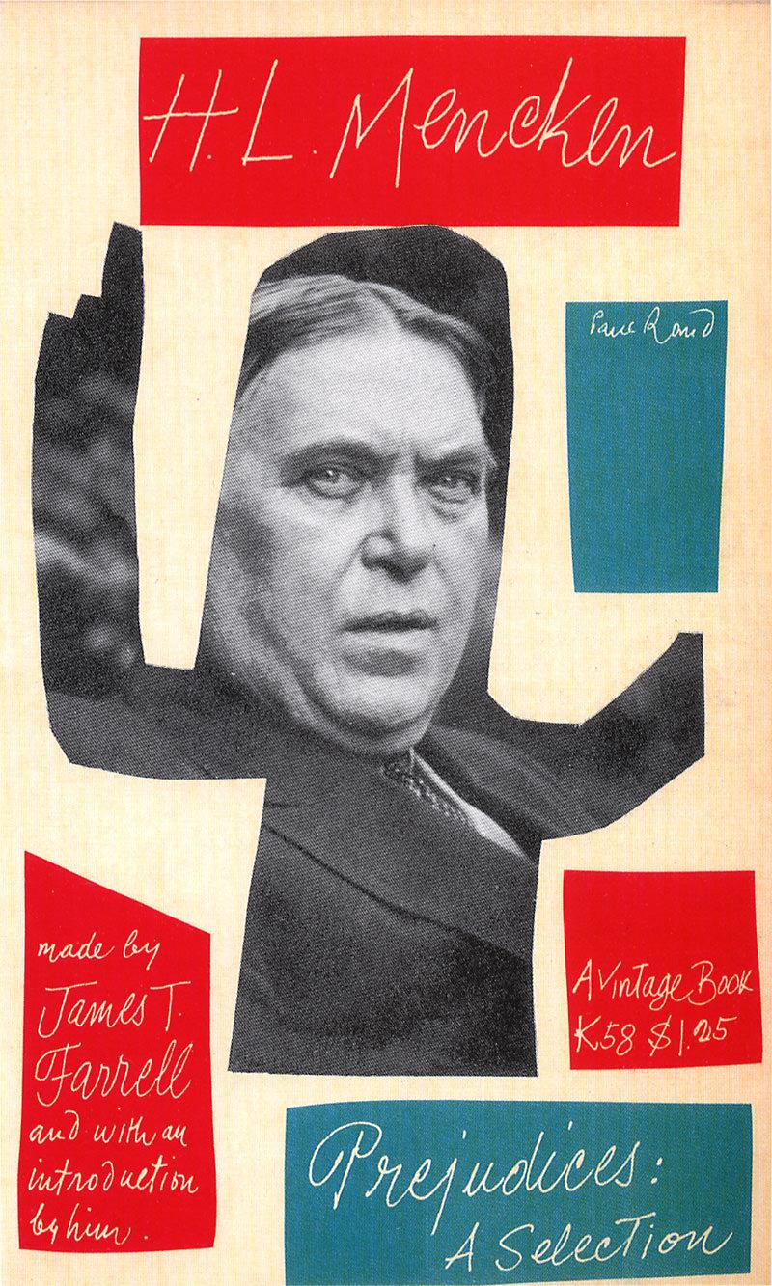

Seeing Stripes
Paul Rand. A Designer’s Art, 1985.

Nature has striped the zebra. Man has striped his flags and awnings, ties and shirts. For the typographer, stripes are rules; for the architect they are a means of creating optical illusions. Stripes are dazzling, sometimes hypnotic, usually happy. They are universal. They have adorned the walls of houses, churches, and mosques. Stripes attract attention.
The stripes of the IBM logo serve primarily as an attention getting device. They take commonplace letters out of the realm of the ordinary. They are memorable. They suggest efficiency and speed. The recent spate of striped logos in the marketplace attests to their effectiveness.
Visually, stripes superimposed on a cluster of letters tend to tie them together. This is especially useful for complex groupings such as the letters IBM, in which each character gets progressively wider, thereby creating a somewhat uncomfortable, open-ended sequence.
Examples to use
Image | Label | Owner | Cost
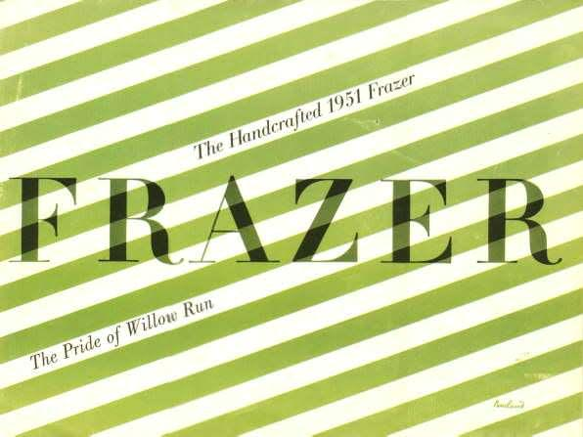
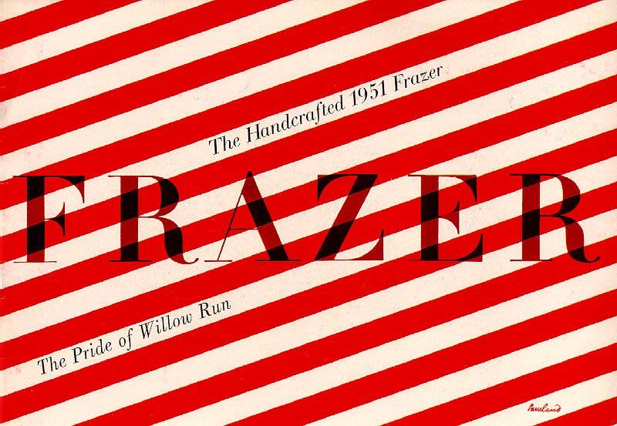
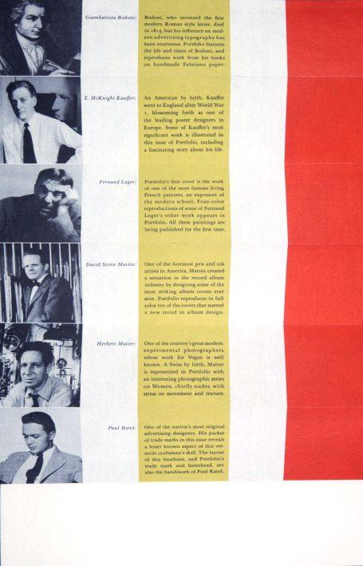
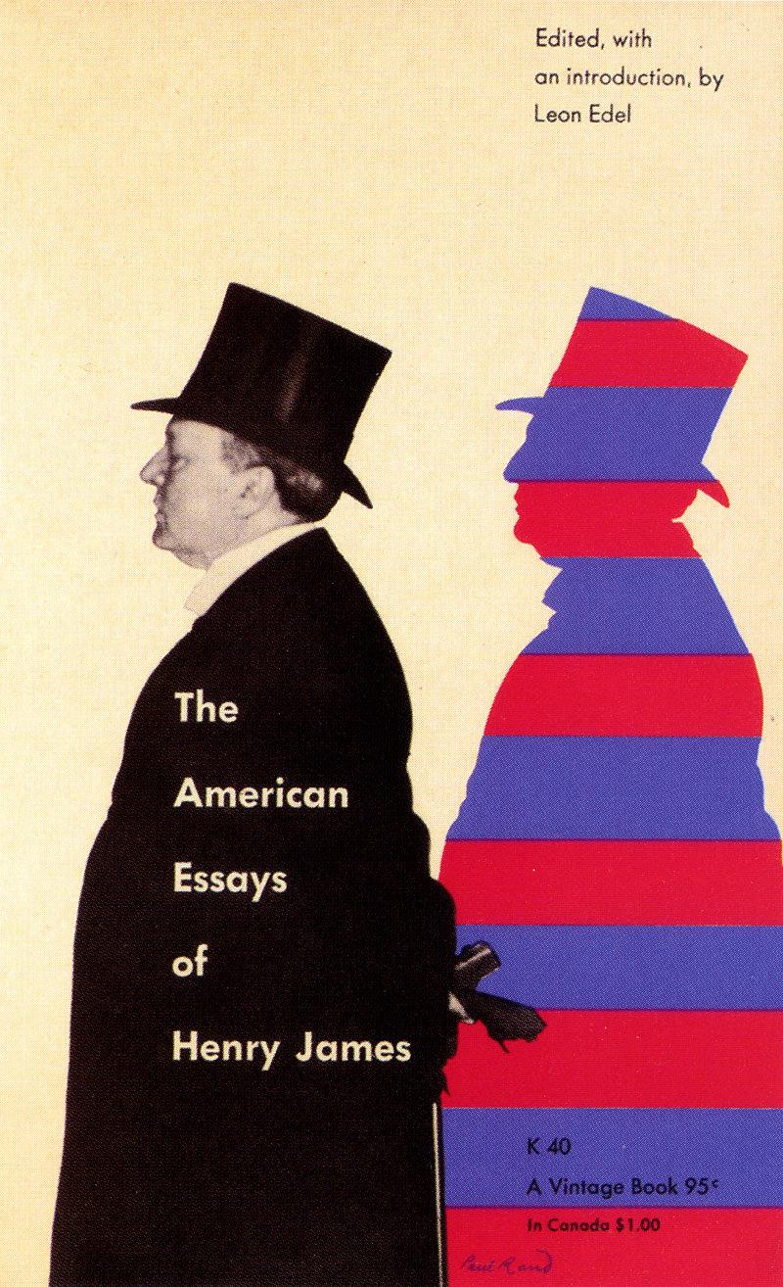
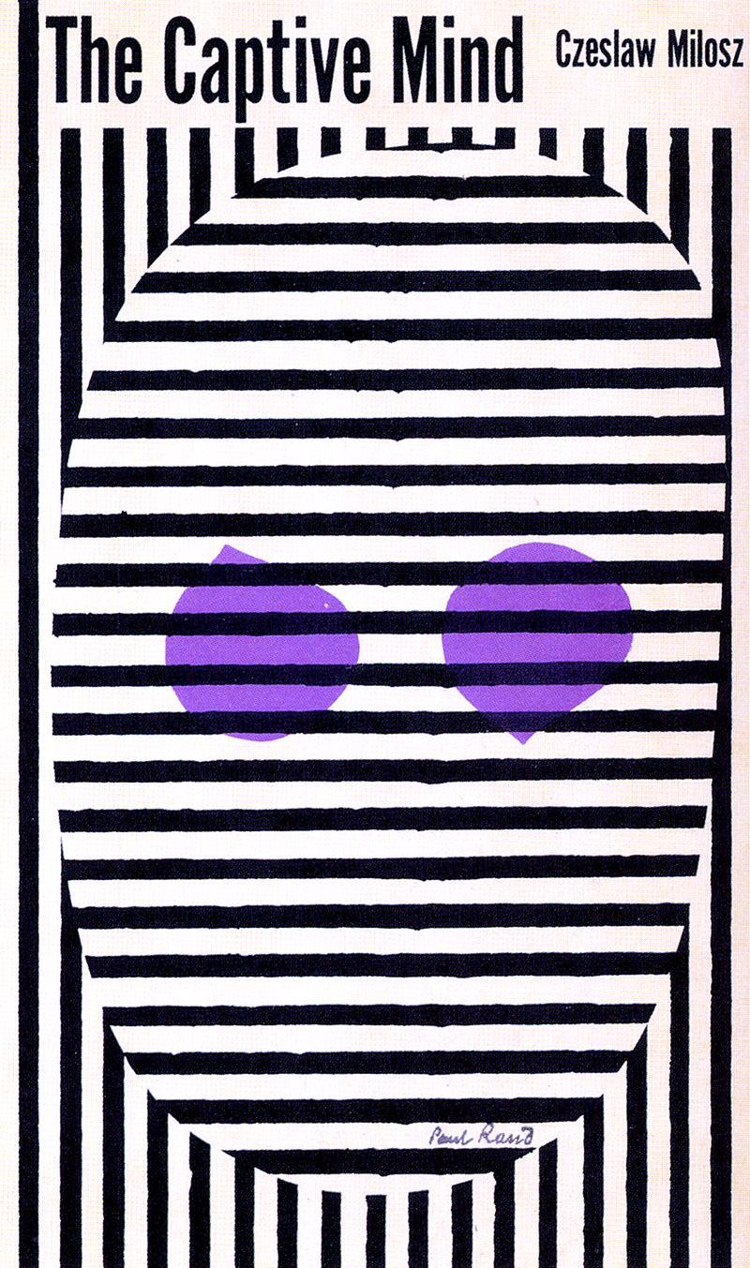
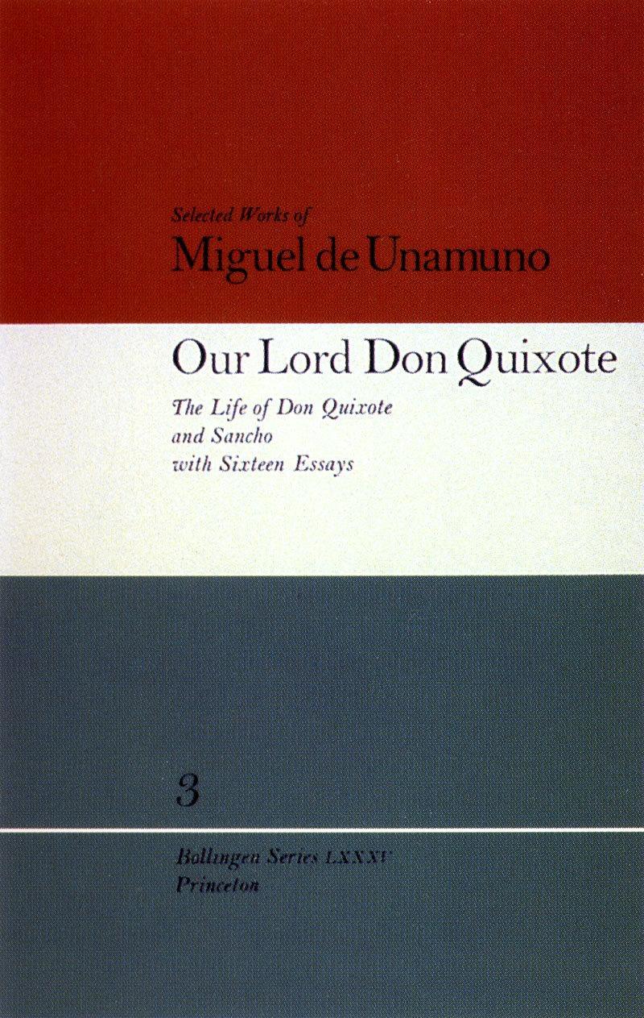
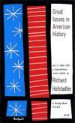
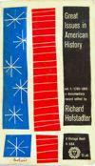
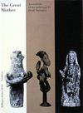
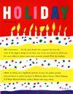
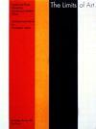
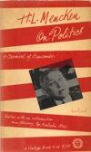
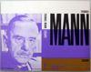
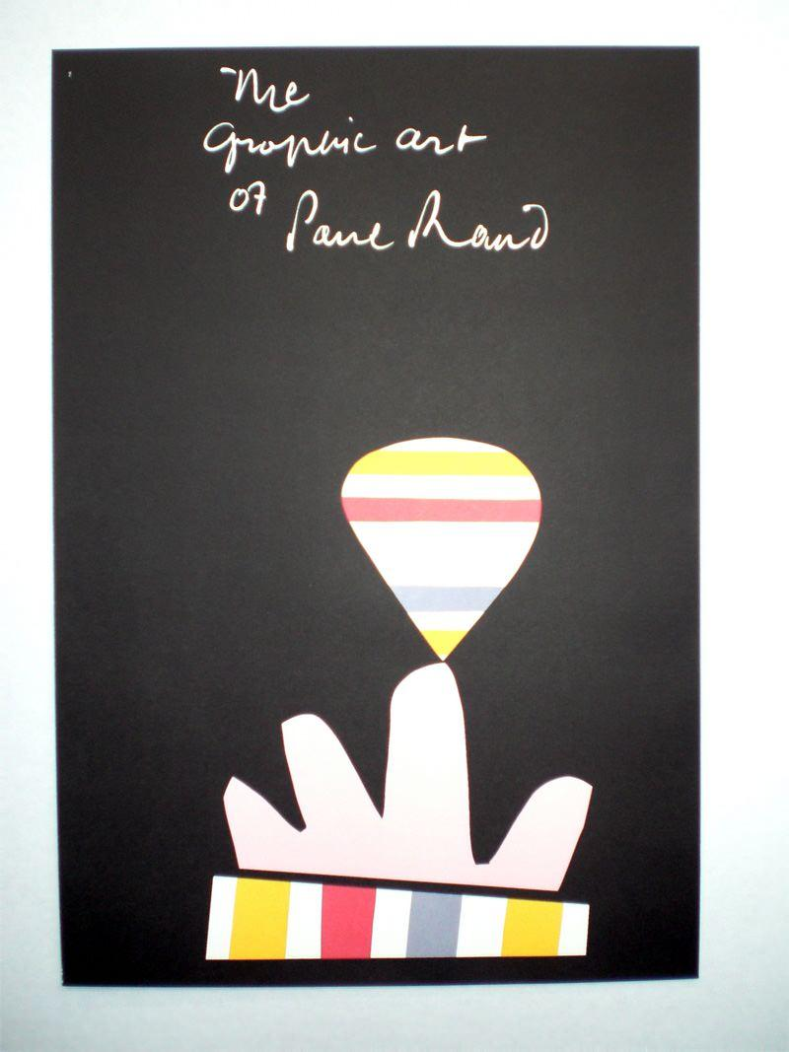
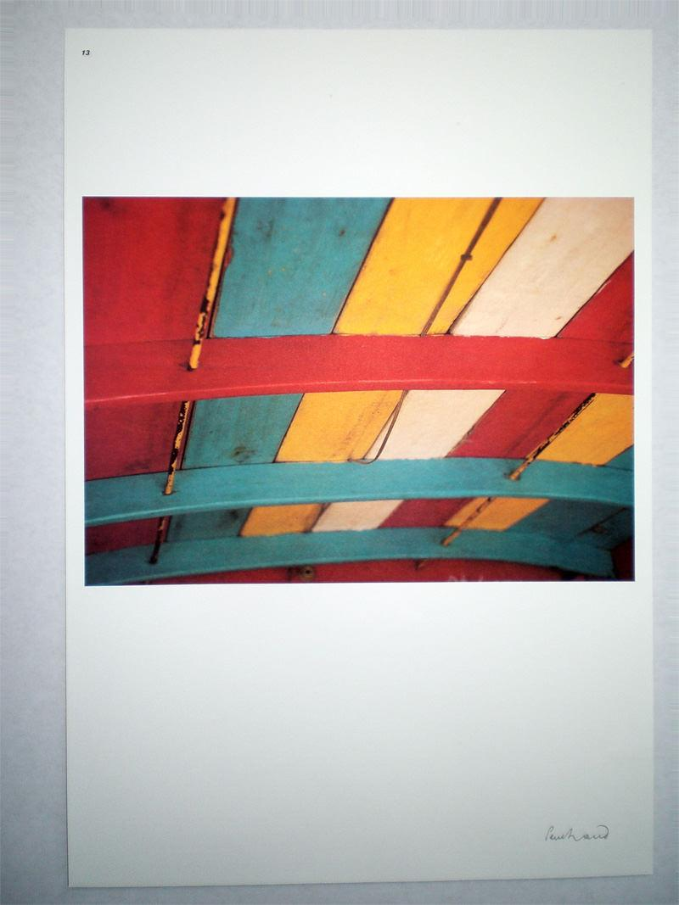
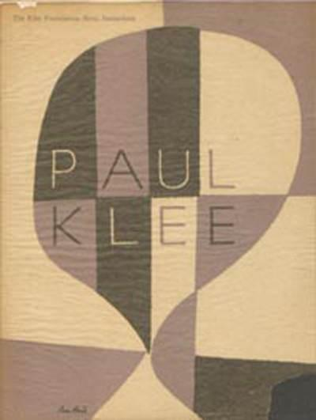
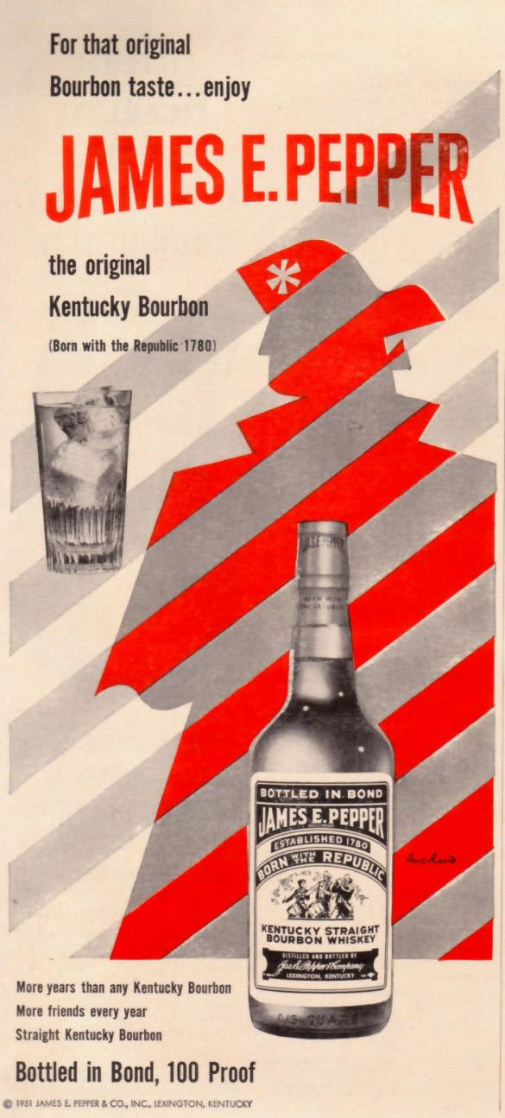
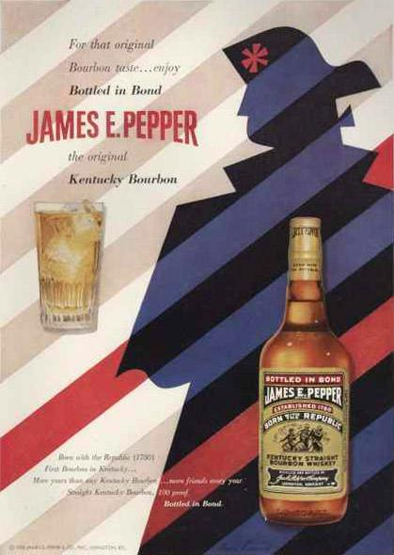

The Meaning of Repetition
Paul Rand. A Designer’s Art, 1985.

The emotional force generated by the repetition of words or pictures and the visual possibilities (as a means of creating texture, movement, rhythm, indicating equivalences of time and space) should not be minimized. The possibilities of repetition are limitless. Repeat patterns are only one familiar form. There is repetition of color, direction, weight, texture, dimension, movement, expression, shape, and so on. Repetition is an effective way of achieving unity.
Repetition also means remembrance. The efficacy of a trademark, for example, is dependent less on its design than on its repeated exposure to public view. Familiar things, as well as a touch of humor, are effective mnemonic devices.

Examples to use
Image | Label | Owner | Cost
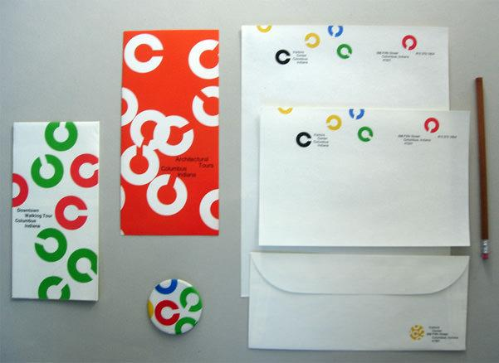
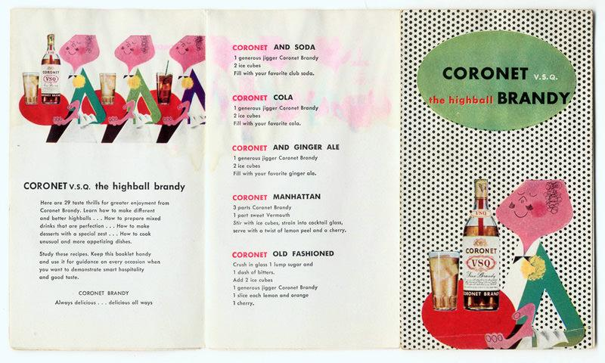
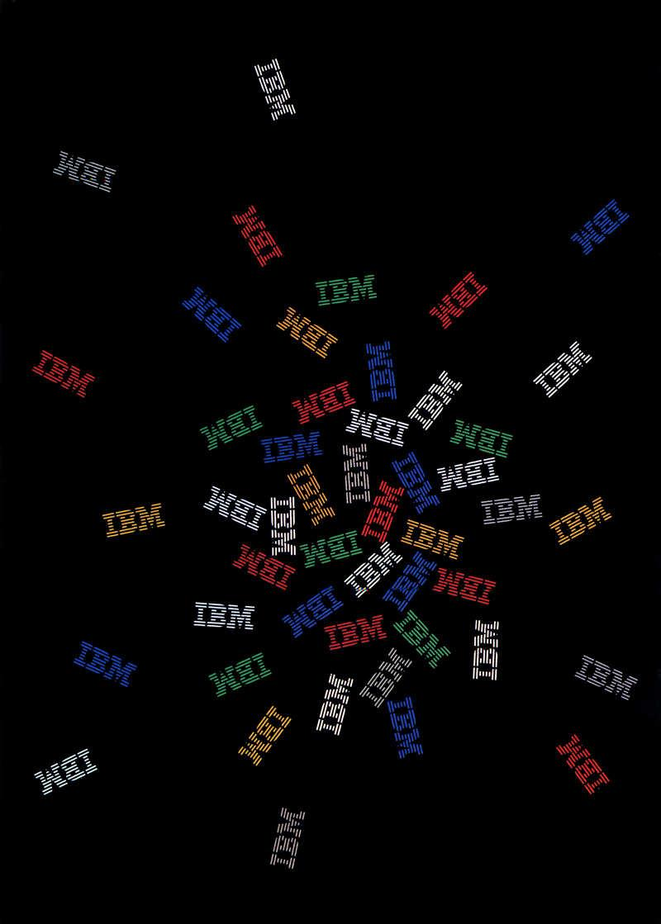
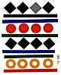
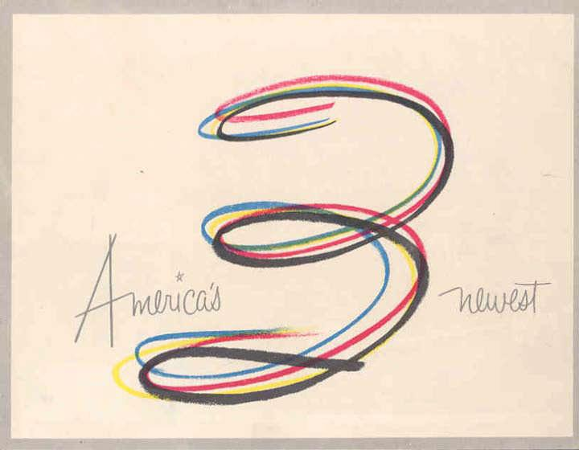
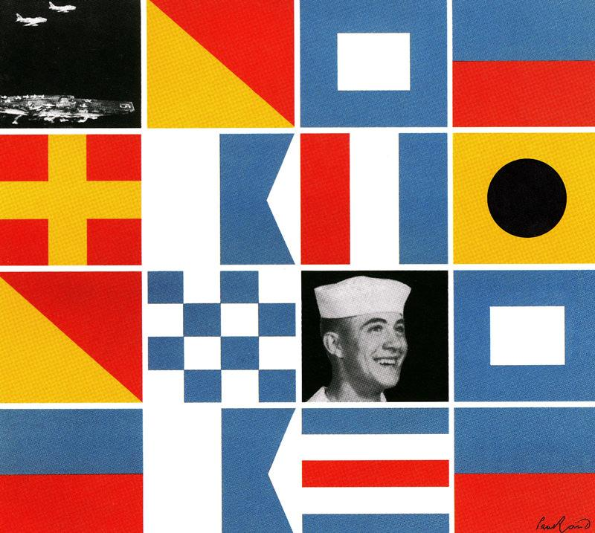
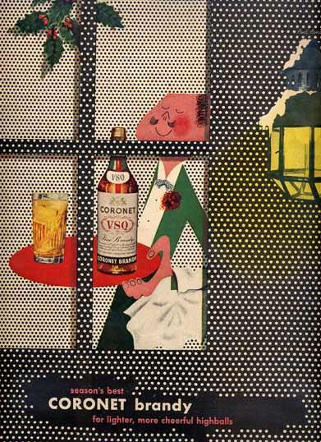
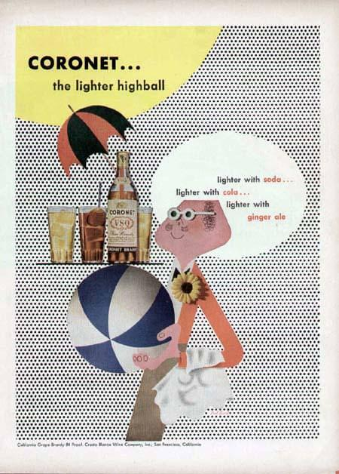
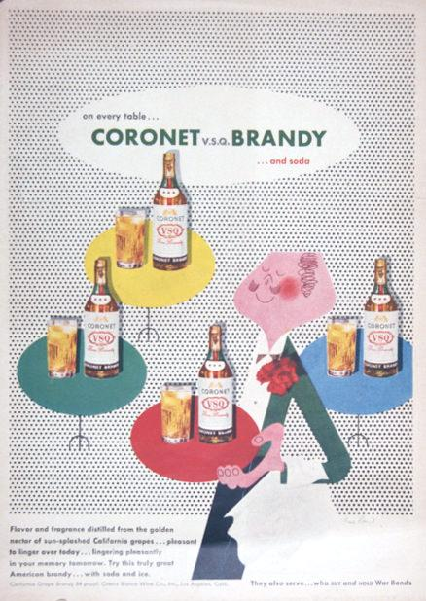
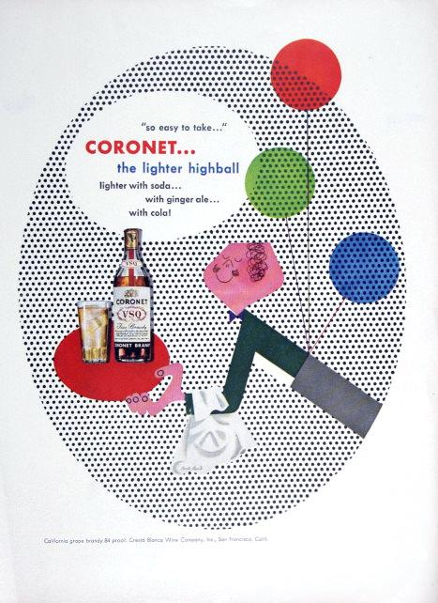
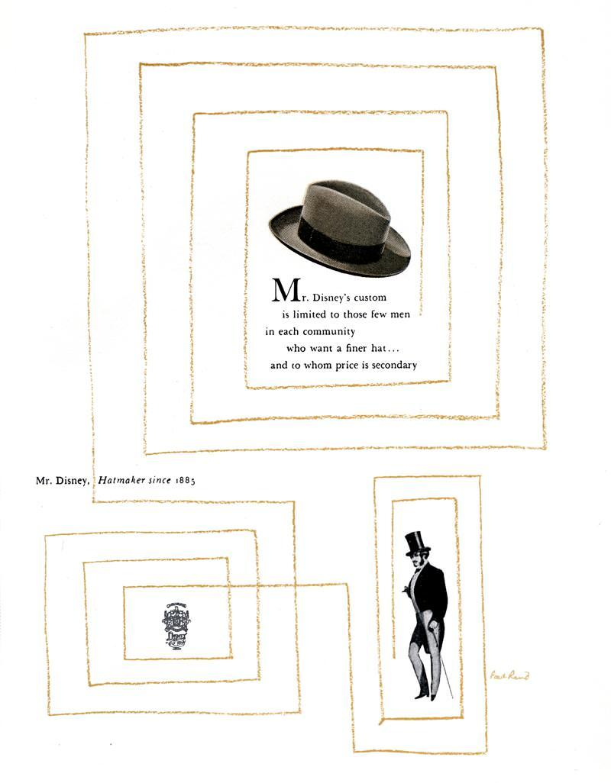
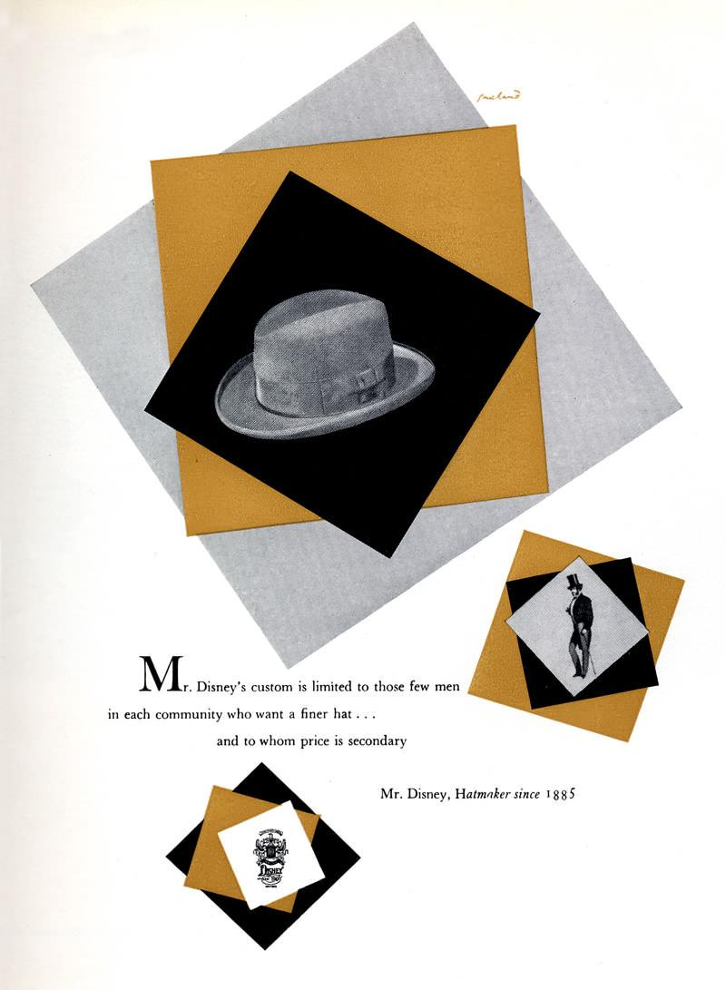
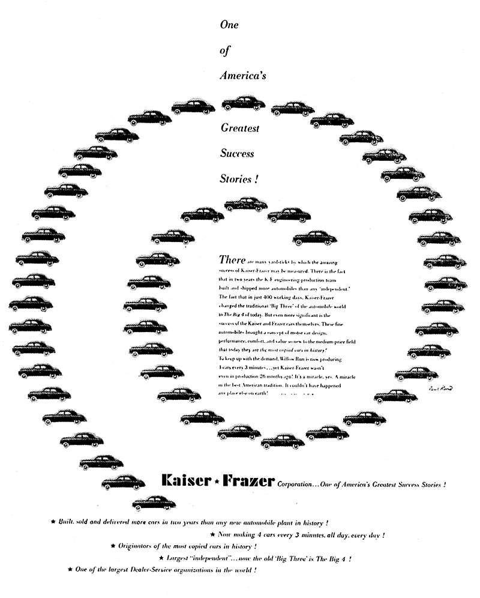
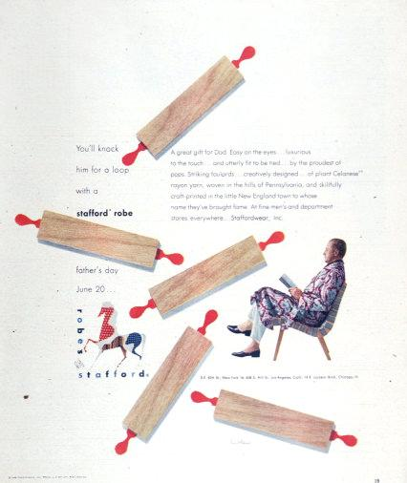
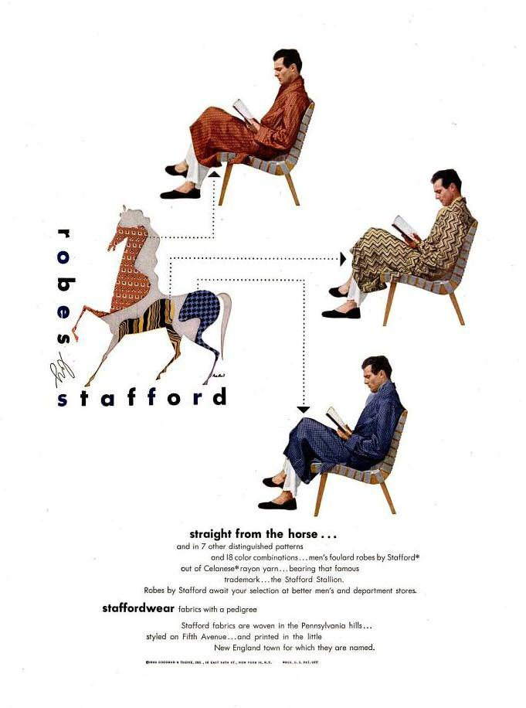
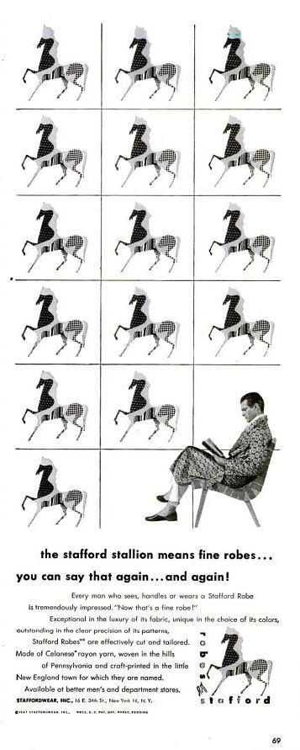
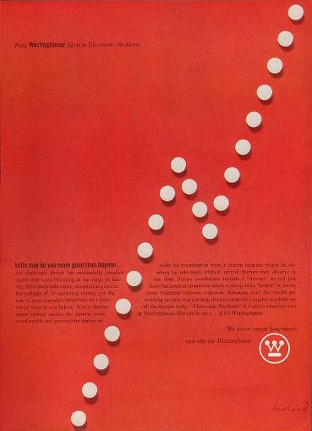

The Rebus and the Visual Pun

A single letter says more than a thousand words. The dual reading is what makes such images memorable. They amuse as they inform. The U symbol is an experiment in visual puns, as is the cover design for AIGA, which combines a rebus (the eye for the letter l) and a collection of letters to produce a mask. Of the twenty-six letters of the alphabet, the letters B and l are clearly the most graphic and least subject to misinterpretation. The rebus is a mnemonic device, a kind of game designed to engage the reader and, incidentally, lots of fun.
The development of any visual image must begin with some tangible idea, conscious or otherwise. It should come as no surprise that, more often than not, creative ideas are the product of chance, intuition, or accident, later justified to fit some prevailing popular theory, practical need, or formal obsession.

Eye-Bee-M Rebus Poster
(OBJECT LABEL FOR REBUS POSTER)

In 1981, Rand design this image of the IBM logo as a poster giveaway to the design staff during an in-house IBM event, the Golden Circle Award. It has become an historic example of how a company’s humanity and personality can be represented through the combination of a single idea captured in a unique form.

However, it was met with great resistance by management who thought that the image was damaging to the IBM brand and would open the door for others to change the logo however they’d like. After years of resistance, the image was resurrected in the poster you see here, with the addition of the text in the bottom left corner to explain the meaning of each symbol.

In the end, good design prevailed and the rebus is now a cornerstone of Rand’s design legacy. It has also found a permanent place in the IBM lexicon and has been used on everything from coffee mugs to stuffed animals.

Examples to use
Image | Label | Owner | Cost
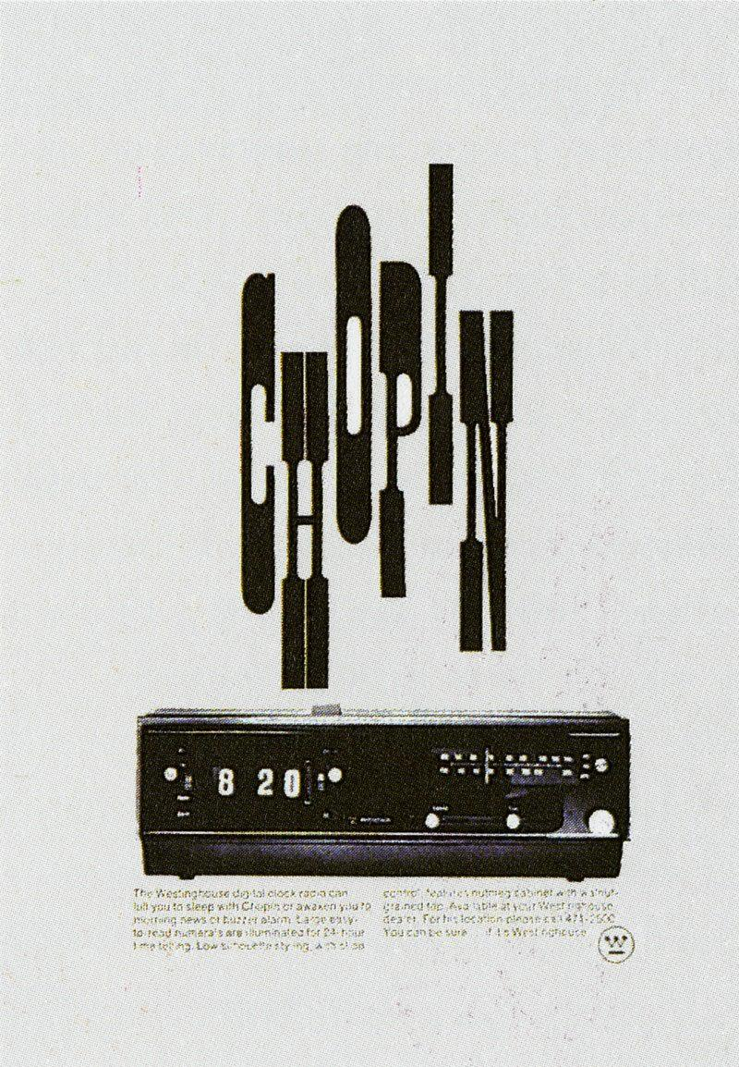

The Role of Humor
Paul Rand: A Designer’s Art, 1985

“I just like things that are playful;
I like things that are happy;
I like things that will make the client smile…
Lecture, A Paul Rand Retrospective
Cooper Union, October 3rd, 1996

Readership surveys demonstrate the significance of humor in the field of visual communication. The reference is not principally to cartoon strip advertisements or to out-and-out gags, but to a more subtle variety, one indigenous to the design itself and achieved by means of association, juxtaposition, size, relationship, proportion, space, or special handling.
The visual message that professes to be profound or elegant often boomerangs as mere pretension; and the frame of mind that looks at humor as trivial and flighty mistakes the shadow for the substance. In short, the notion that the humorous approach to visual communication is undignified or belittling is sheer nonsense. This misconception has been discredited by those entrepreneurs who have successfully exploited humor as a means of creating confidence, goodwill, and a receptive frame of mind toward an idea or product.
1. Printers’ Ink, December 28, 1946.
2. Roger Fry, “Some Aspects of Chinese Art, Transformations, 79 81.

Examples to use
Image | Label | Owner | Cost
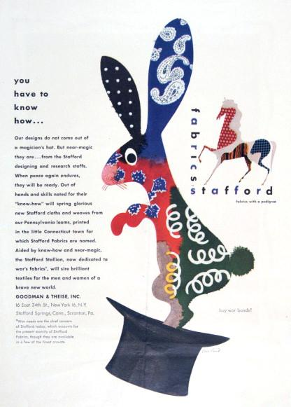
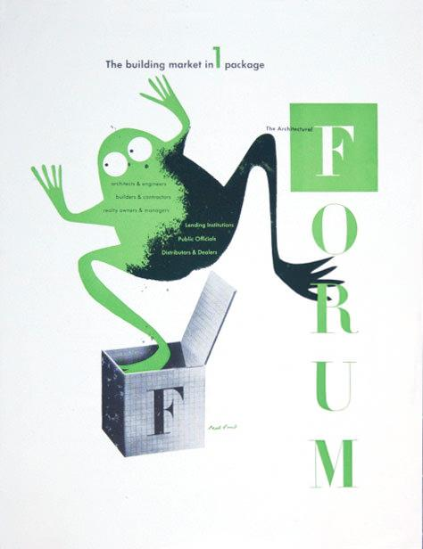
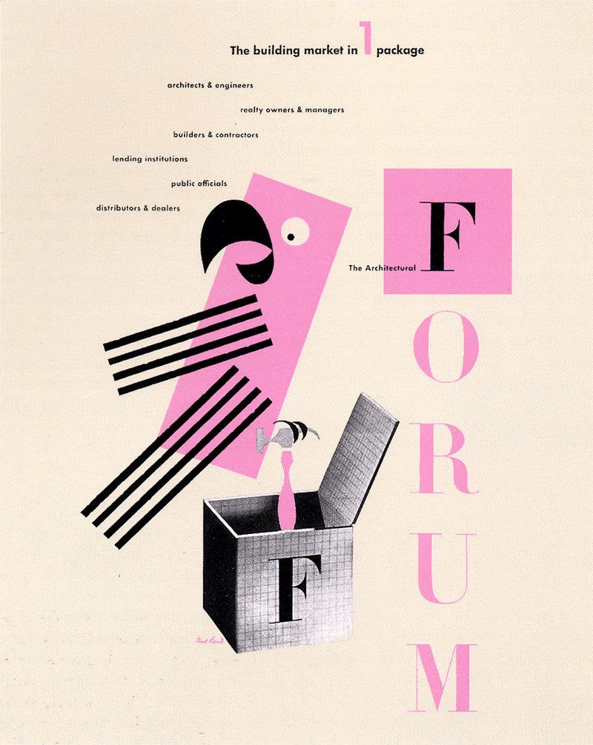
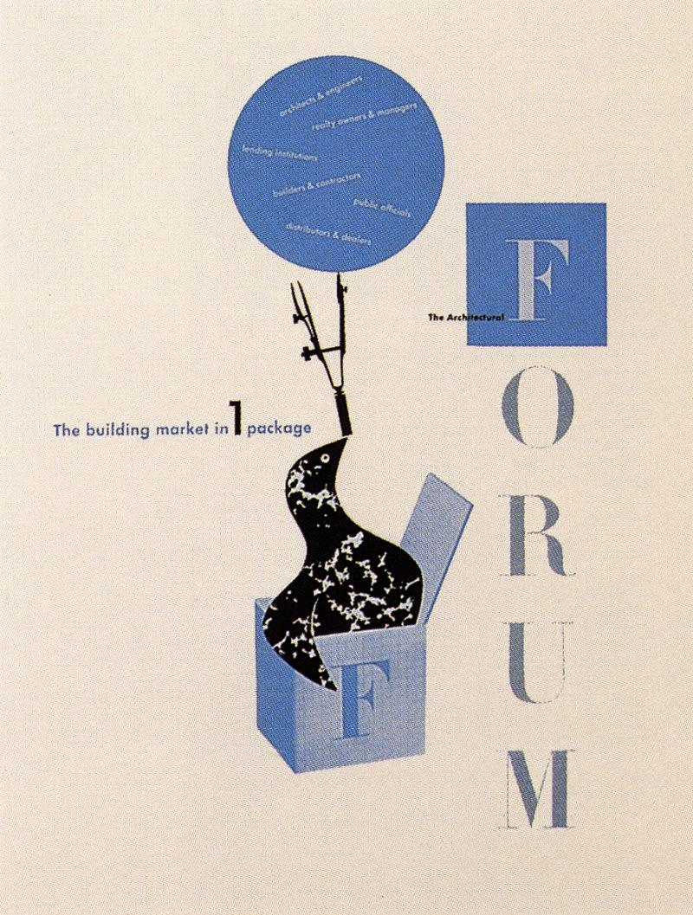
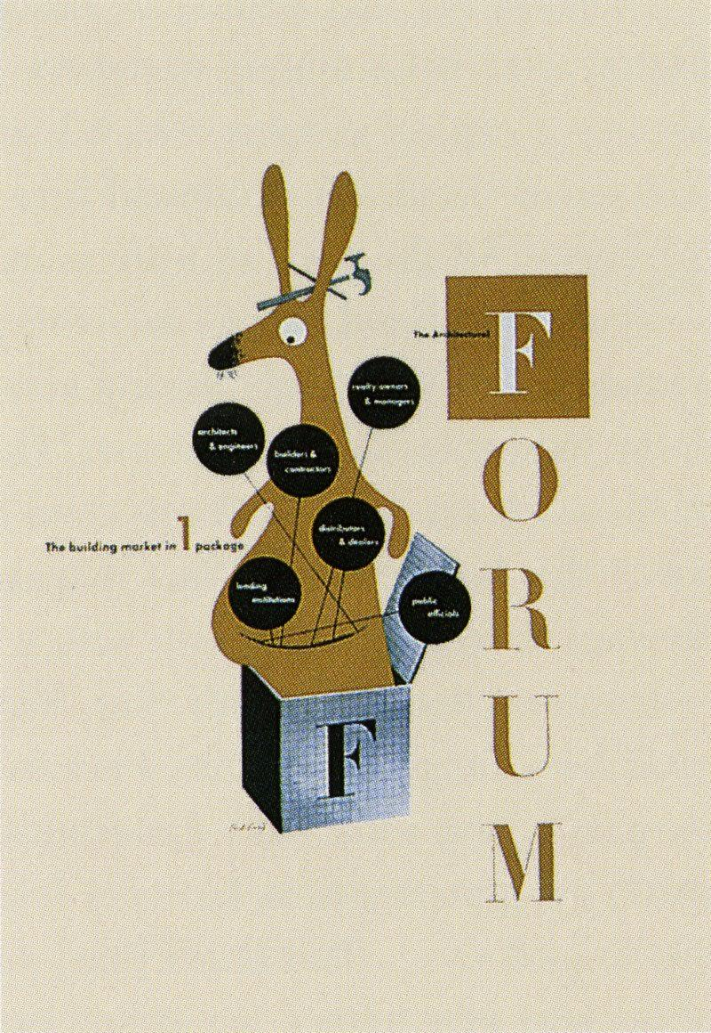
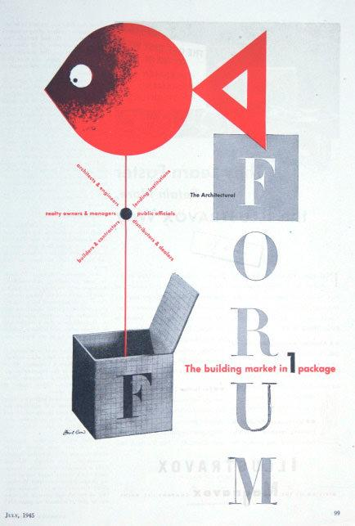
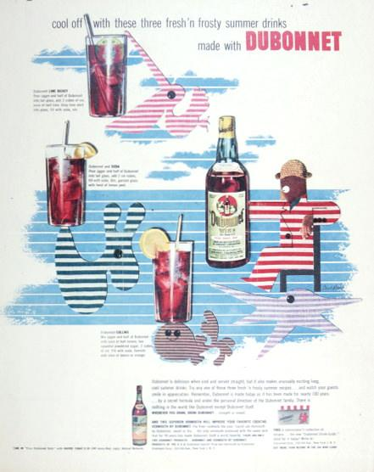
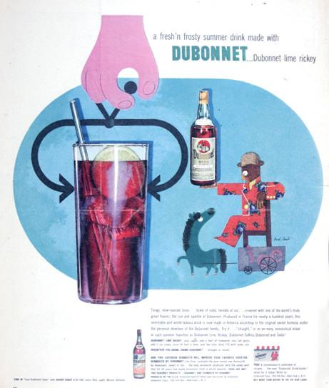
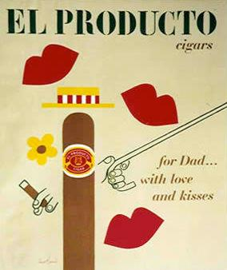
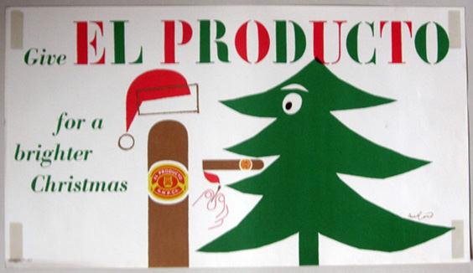
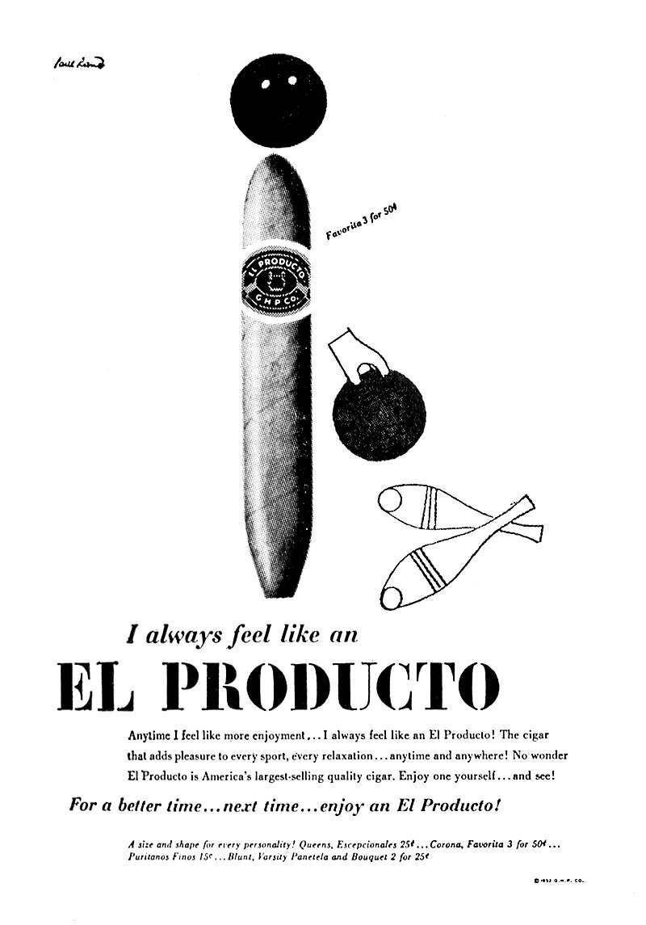
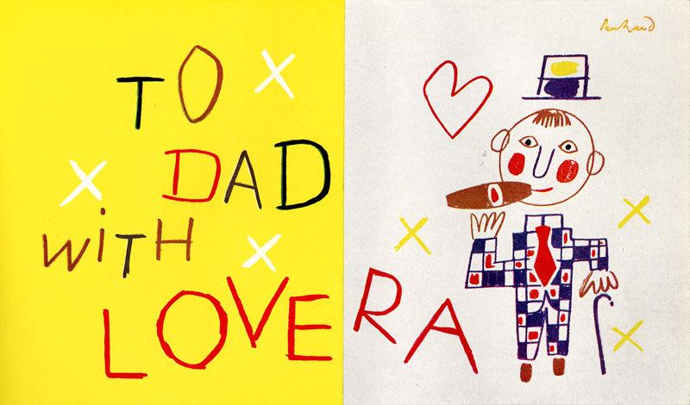
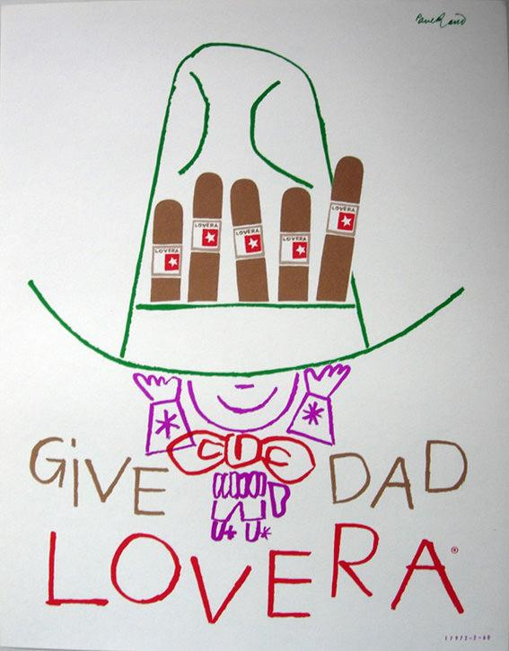

The Trademark
Paul Rand: A Designer’s Art, 1985

“The principal role of a logo is to identify, and simplicity is its means… Its effectiveness depends on distinctiveness, visibility, adaptability, memorability, universality, and timelessness.”
Design Form and Chaos

A trademark
is a picture.
It is a symbol
a sign
an emblem
an escutcheon
…an image.
There are
good symbols…
like the cross.
There are others…
like the swastika.
Their meanings
are taken
from reality.
Symbols
are a duality.
They take on
meaning
from causes
…good or bad.
And they give
meaning
to causes
…good or bad.
The flag
is a symbol
of a country.
The cross
is a symbol
of a religion.
The swastika
was a symbol
of good luck
until
its meaning
was changed.
The vitality
of a symbol
comes
from effective
dissemination…
by the state
by the community
by the church
by the corporation.
It needs attending
to get
attention.
The trademark
is a symbol
of a corporation.
It is not
a sign of
quality…
it is a sign of
the quality.
The trademark
for Chanel
smells
as good as
the perfume
it stands for
This
is the blending
of form
and content.
Trademarks
are animate
inanimate
organic
geometric.
They are letters
ideograms
monograms
colors
things.
Ideally
they do not
illustrate
they indicate
…not represent
but suggest…
and are stated
with brevity
and wit.
A trademark
is created
by a designer
but made
by a corporation
A trademark
is a picture
an image…
the image
of a corporation.
OBJECT LABEL (WESTINGHOUSE): The symbol for Westinghouse (1960) as it appears today is an adaptation of an earlier trademark. The problem was to transform an existing lackluster emblem, consisting of a circle, a W, and an underscore, into something unique. Updating and modernization were a byproduct and not the focus of this program. The final design, which comprises a circle, a series of dots, and lines, was intended to suggest a printed circuit.

OBJECT LABEL (ABC): The need for simplicity is demonstrated in the blurred image of the ABC trademark. How far out of focus can an image be and still be recognized? A trademark, which is subject to an infinite number of uses, abuses, and variations, whether for competitive purposes or for reasons of “self-expression,“ cannot survive unless it is designed with utmost simplicity and restraint – keeping in mind that seldom is a trademark favored with more than a glance. Simplicity implies not only an aesthetic ideal, but a meaningful idea, either of content or form, that can be easily recalled.

Examples to use
Image | Label | Owner | Cost
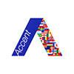
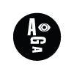
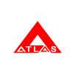
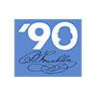
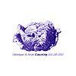
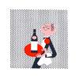
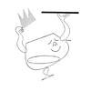
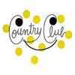
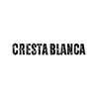
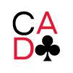
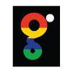
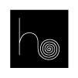
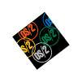
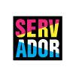
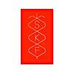
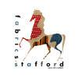
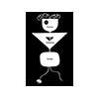
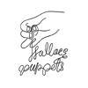
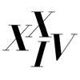
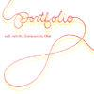

Typographic Form and Expression
Paul Rand: A Designer’s Art, 1985

One of the objectives of the designer who deals with type matter involves readability. Unfortunately, however, this function is often taken too literally and overemphasized at the expense of style, individuality, and the very effectiveness of the printed piece itself. By carefully arranging type areas, spacing, size, and color, the typographer is able to impart to the printed page a quality that helps to dramatize the contents.
With asymmetric balance, he is able to achieve greater interest. Bilateral symmetry offers the spectator too simple and too obvious a statement. It offers little or no intellectual pleasure, no challenge. The pleasure derived from observing asymmetric arrangements lies partly in overcoming resistances which, consciously or not, the spectator has in his own mind, and in thus acquiring some sort of aesthetic satisfaction.

OBJECT LABEL: Two letters from a Cresta Blanca Wine logotype (1943) demonstrate how the simple addition of ornament changes a commonplace letter (associated more with bold newspaper headlines than with delicate vintage wines) to a memorable image. Here, contrast plays a significant role.

OBJECT LABEL: By contrasting type and pictorial matter, the designer is able to create new combinations and elicit new meanings. For instance, in the Air-Wick newspaper advertisement, the old and the new are brought into harmony by contrasting two apparently unrelated subjects – nineteenth-century wood engravings and twentieth-century typewriter type.
OBJECT LABEL: The surrounding white space helps to separate the advertisement from its competitors, and produces a sense of cleanliness and freshness.

OBJECT LABEL: The numeral possesses many of the same qualities as the letter. It can also be the visual equivalent of time, space, position, and quantity; and it can help to impart to a printed piece a sense of rhythm and immediacy.

OBJECT LABEL: The isolated letter affords a means of visual expression that other kinds of imagery cannot quite duplicate. Letters in the forms of trademarks, seals, and monograms-on business forms, identification tags, athletic jerseys, and even handkerchiefs-possess some magical quality. They serve not only as status symbols but have the virtue of brevity as well.

Examples to use
Image | Label | Owner | Cost
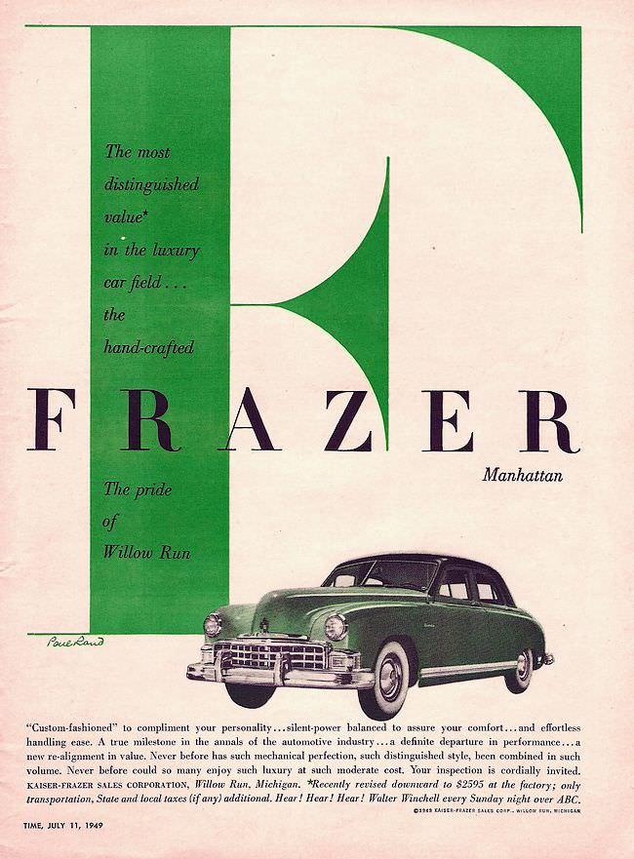
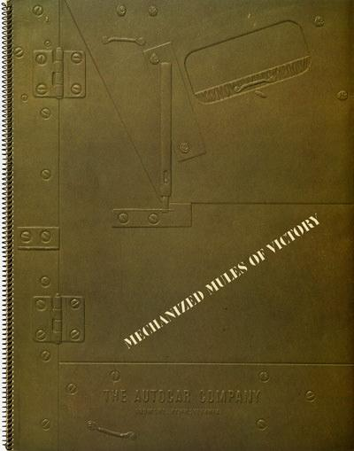
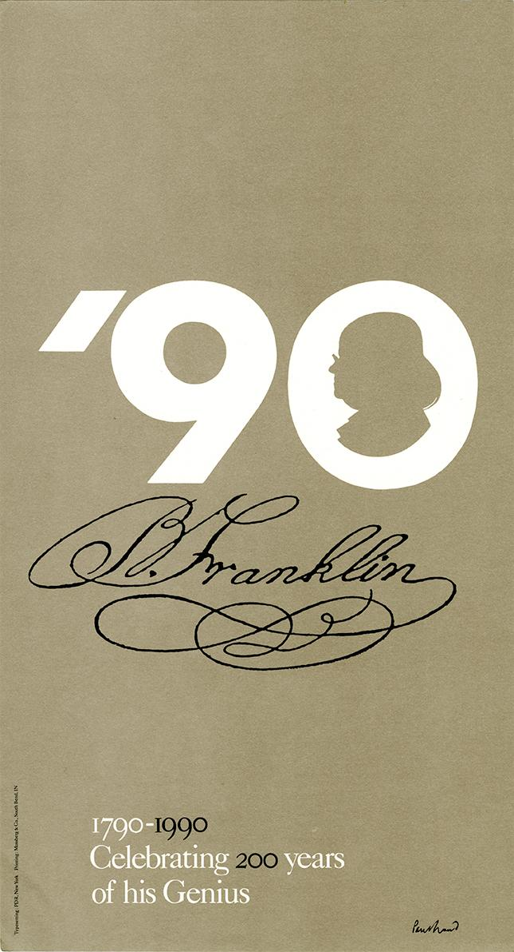
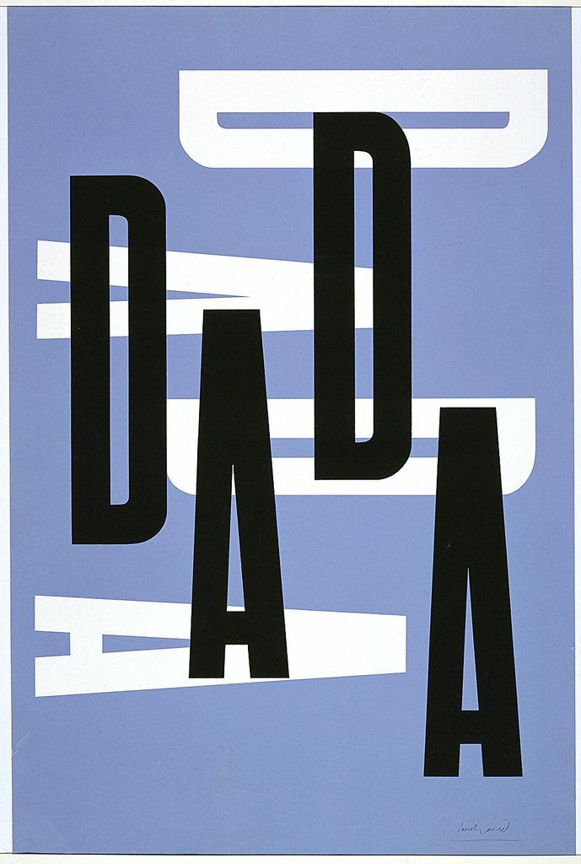
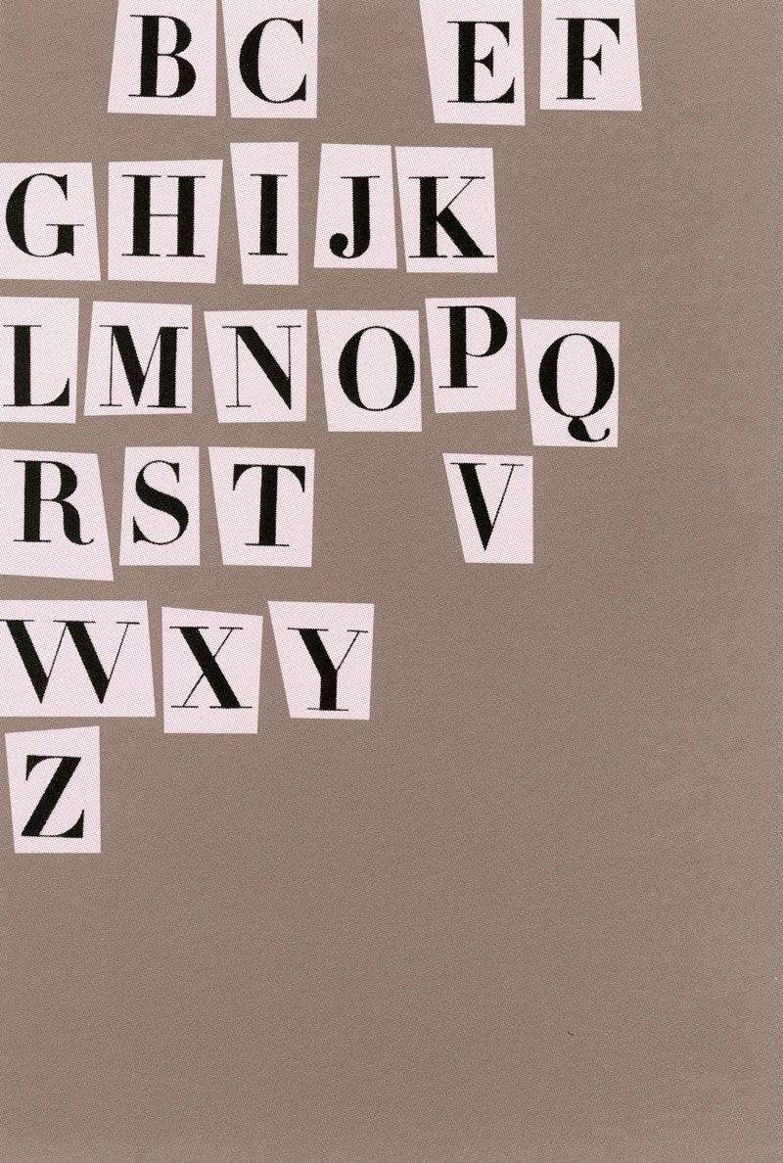
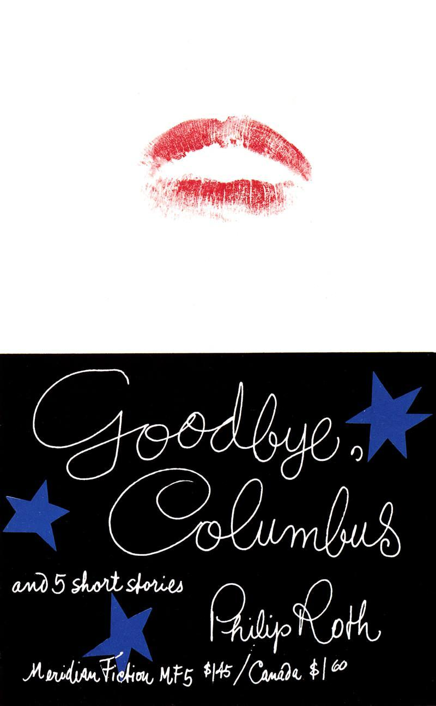
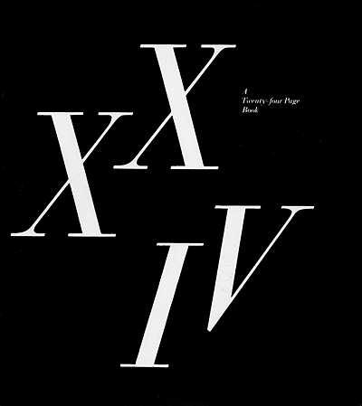
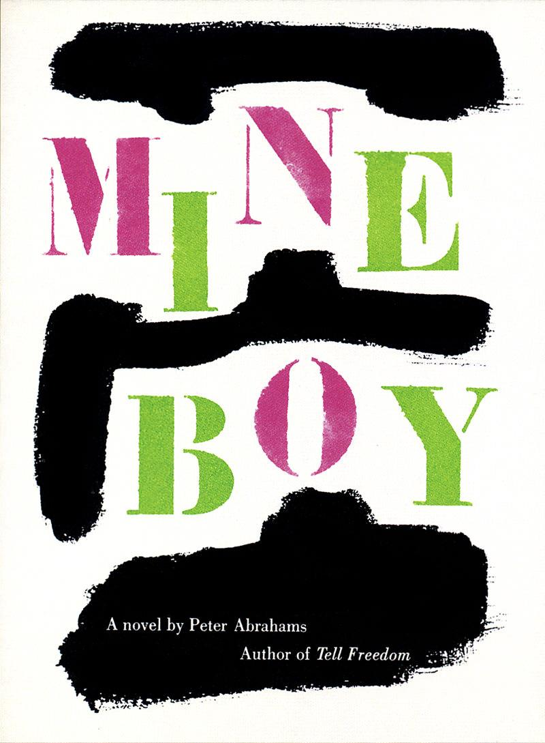
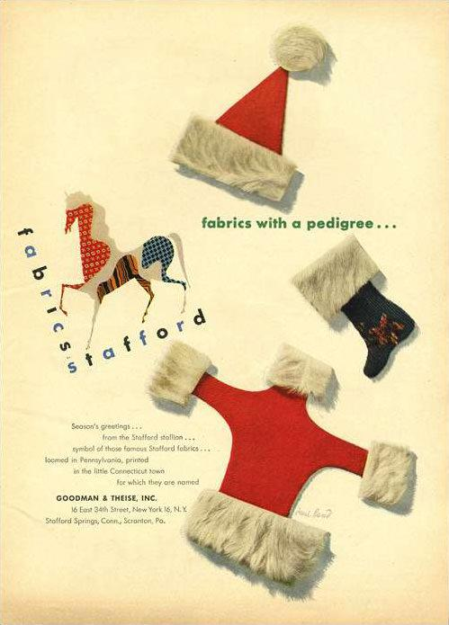
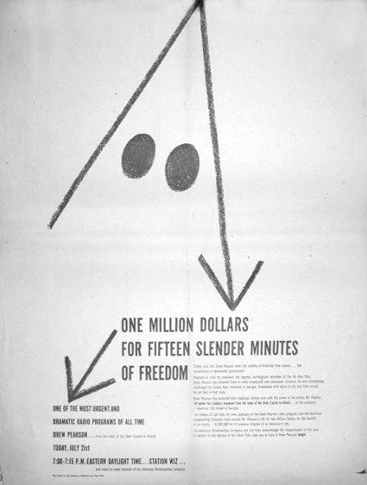
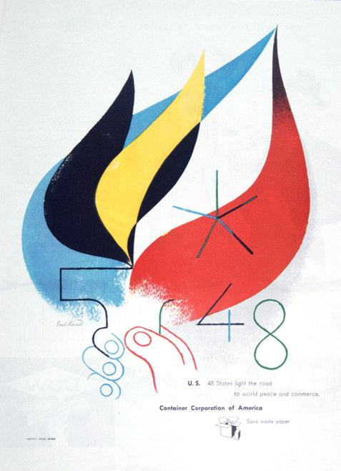
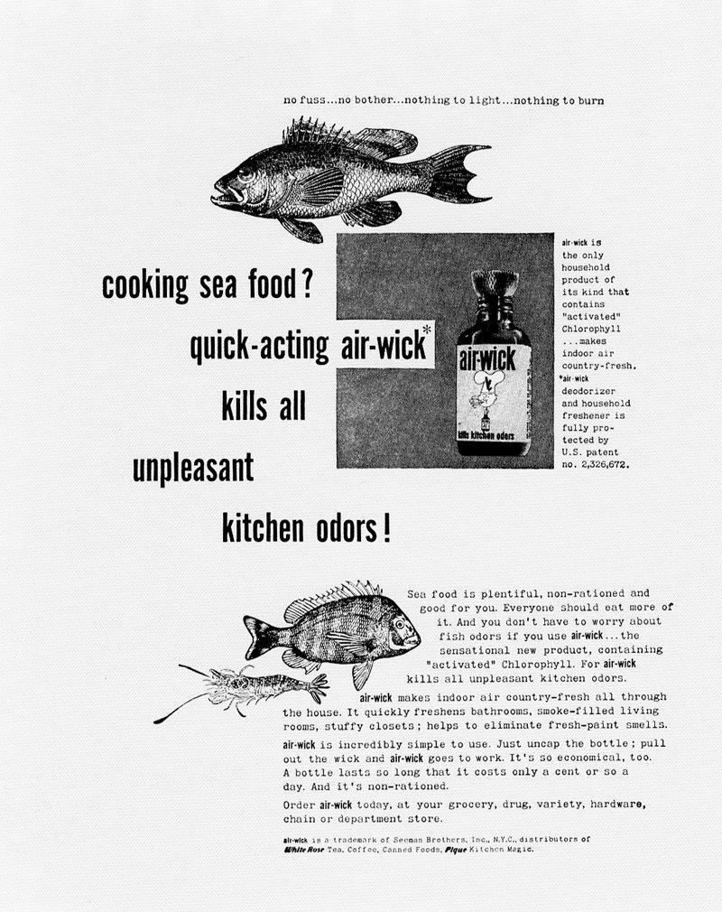

A House to Live With
From Esquire, August 1953
A man who knew the secrets of living, Henry David Thoreau, once wrote: “I sometimes dream of a … house, standing in a golden age, of enduring materials, and without gingerbread work…containing all the essentials of a house, and nothing for housekeeping…”
Ann and Paul Rand wanted such a house, too, an enduring, essential house, built for beauty and privacy, security and shelter, peace and an intimacy with its surroundings. So they designed theirs as if this were the first house ever built.
Within commuting distance of New York City, the compact and spacious modern home of Paul and Ann Rand takes issue with Connecticut’s rustic traditions.
The Rand home is set in wooded Connecticut acreage, and by coincidence meets the formula of the ideal setting defined by the Japanese; a hill to the north, a brook to the east, a road to the west, looks to the south. Compact, spacious, it neither tosses the inhabitants out into the open by too much “picture-window” exposure, nor shuts them off from the outdoors by conventional barriers.

Examples to use
Image | Label | Owner | Cost
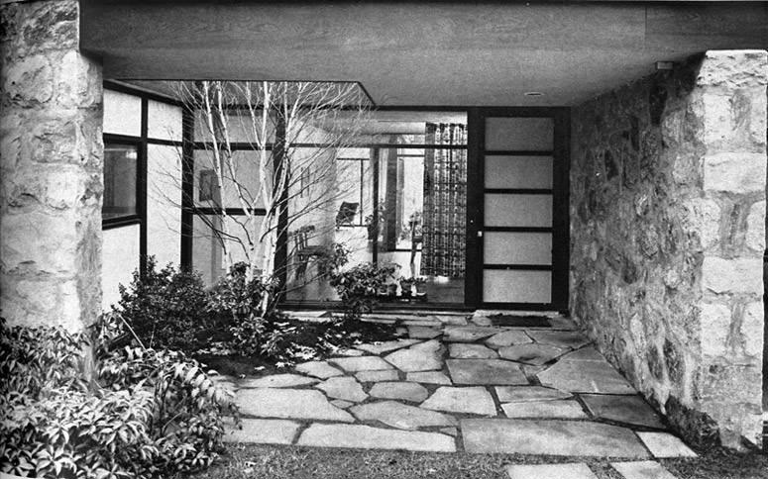
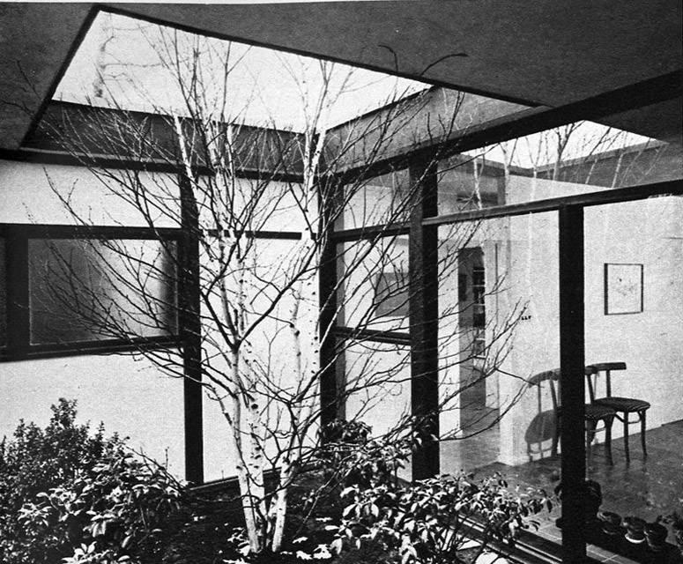
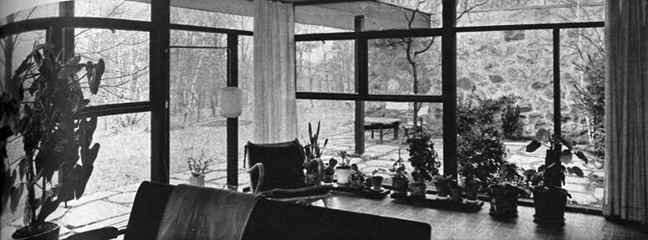
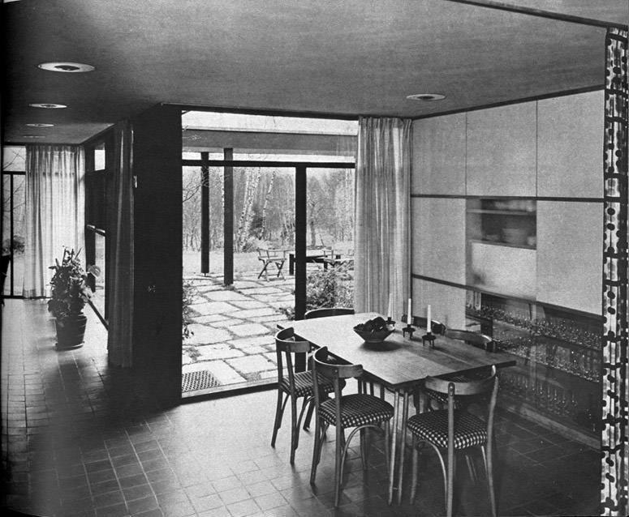
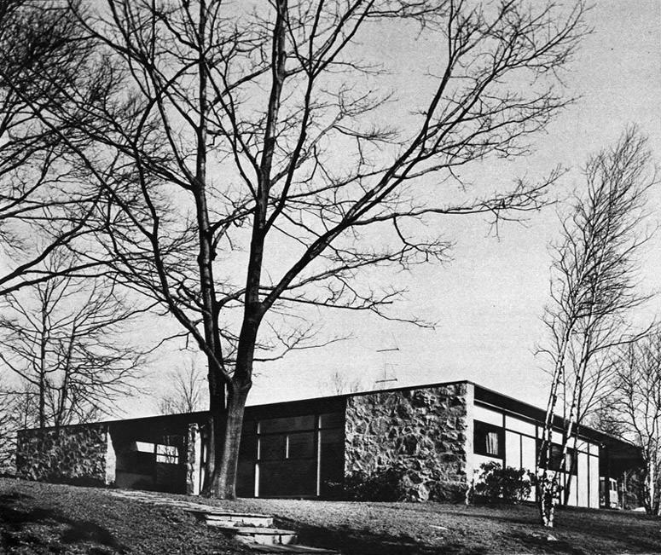
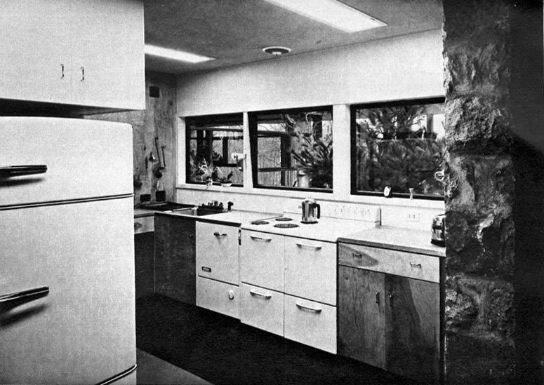
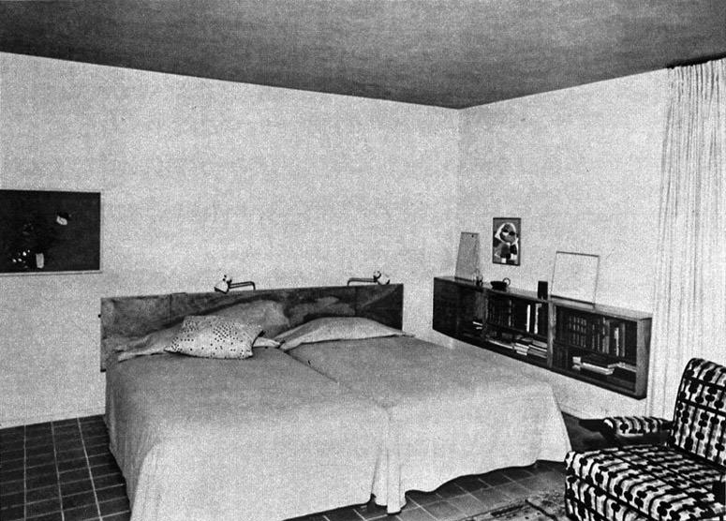
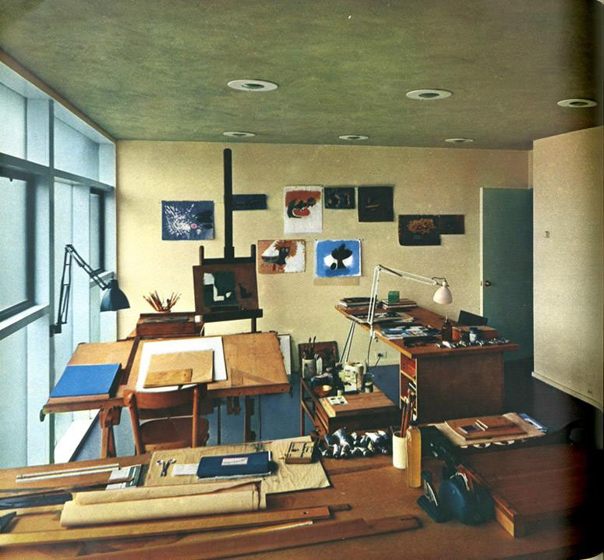
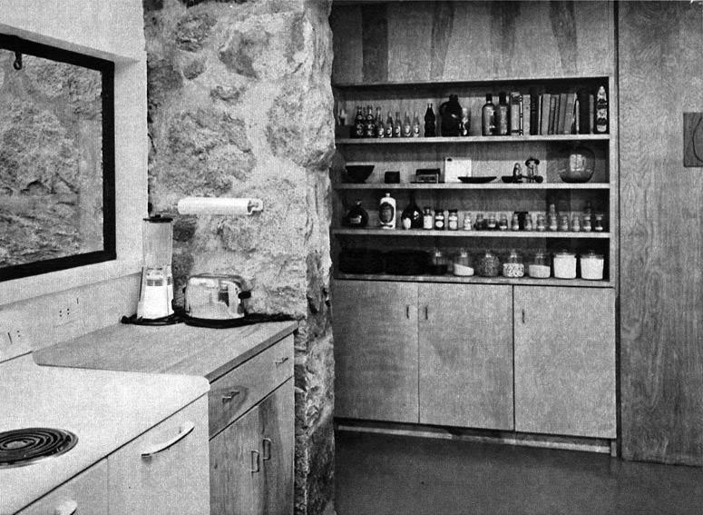

Presentation
Paul Rand: Design, Form, and Chaos, 1993

Canned presentations have the ring of emptiness. The meaningful presentation is custom designed — for a particular purpose, for a particular person. How to present a new idea is, perhaps, one of the designer’s most difficult tasks. This is not only a design problem, it also pleads for something novel. Everything a designer does involves presentation of some kind — not only how to explain (present) a particular design to an interested listener (client, reader, spectator), but how the design may explain itself in the marketplace. Not all assignments are equally interesting. The designer is expected to be inspired by the most mundane subject matter, no less by a dead fish than by a beautiful race horse. But subject matter in itself is not always inspirational. The relevant idea and its formal interpretation become the decisive factors.
The following brochures were designed for the purpose of presentation. They follow a simple pattern, with generous use of white space and color to establish certain rhythms and to leave room for necessary pauses and logical transitions. White space is used as a functional not as an arbitrary device. It indicates timing and pacing and may be a determining factor in a given presentation. Its purpose is to help dramatize — a kind of backdrop separating one scene from another. To encourage reading, text is kept as brief and as readable as possible, with no attempt to confuse the reader with picturesque, typographic trickery. If type is shown in color, it is for reasons of emphasis, not theatrics.

LARGE QUOTE: A presentation is the musical accompaniment of design. A presentation that lacks an idea cannot hide behind glamorous photos, pizzazz, or ballyhoo. If it is full of gibberish, it may fall on deaf ears; if too laid back, it may land a prospect in the arms of Morpheus.

Examples to use
Image | Label | Owner | Cost
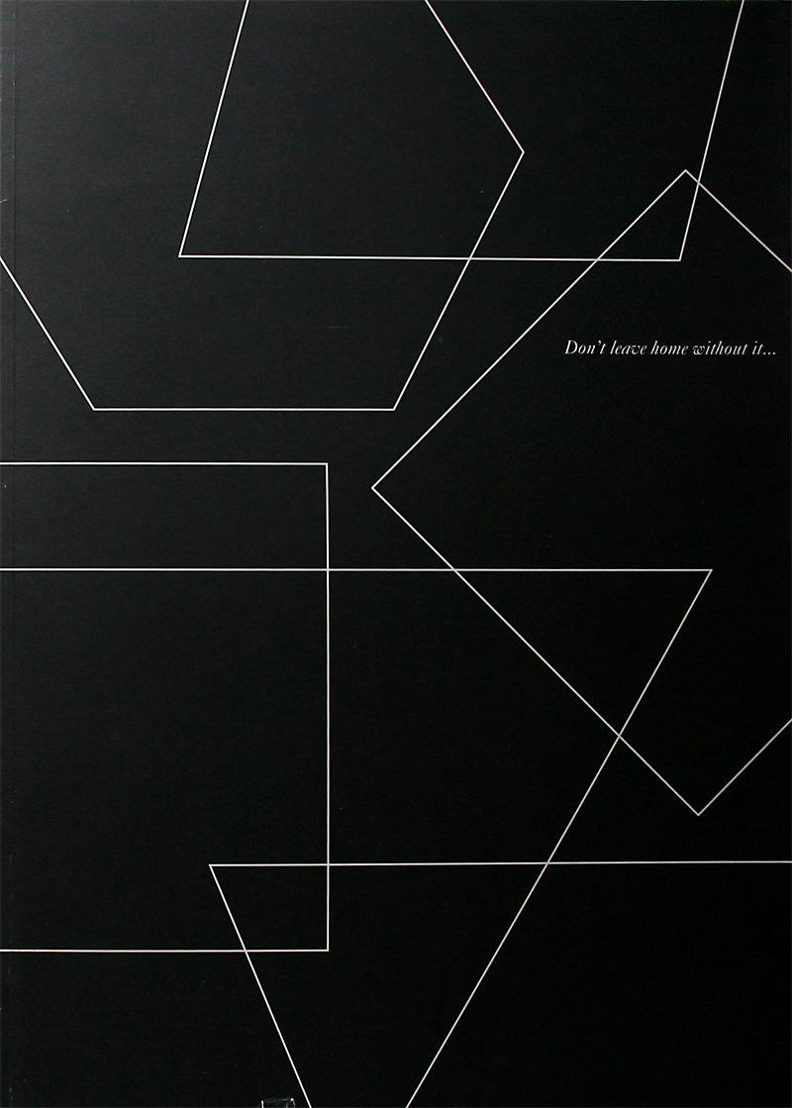
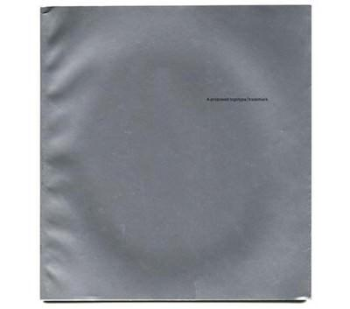
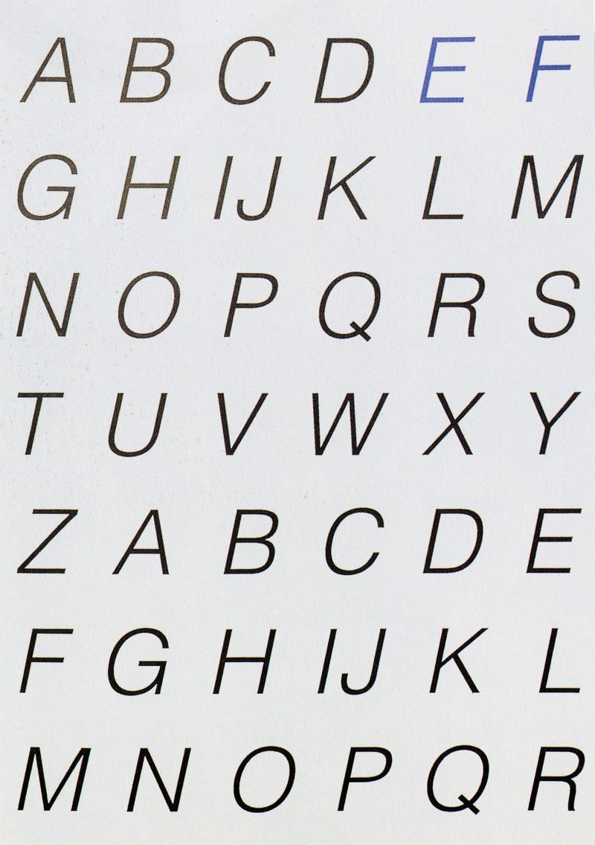
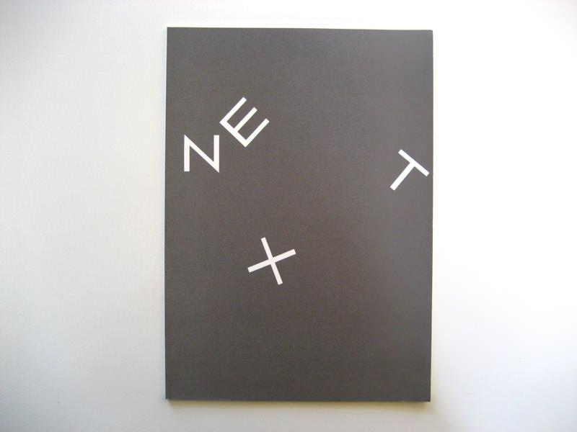
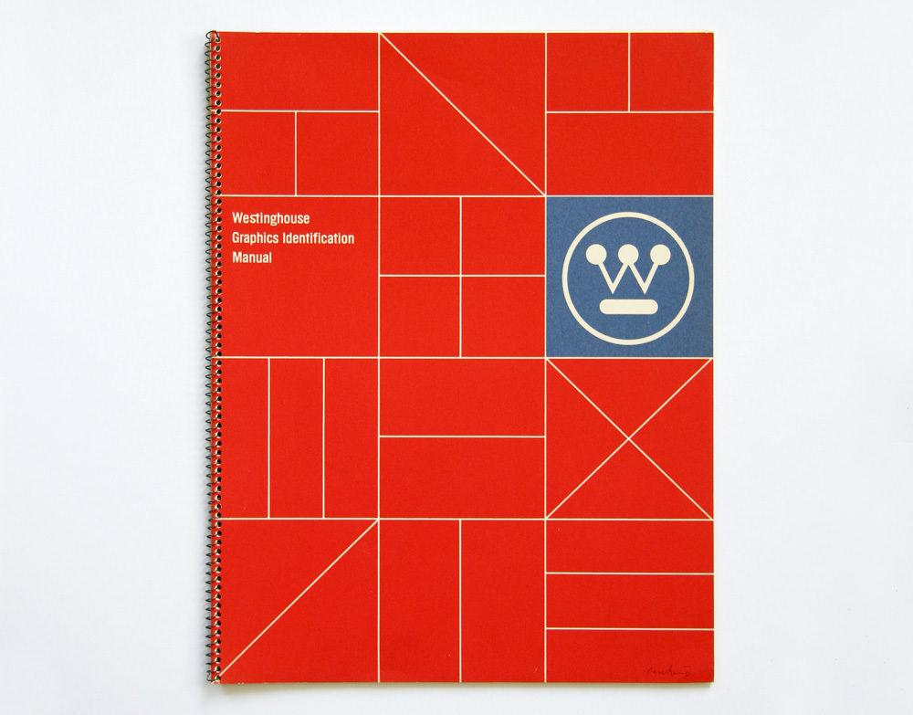

Writing

Lorem ipsum dolor sit amet, consectetur adipiscing elit. Vivamus luctus urna sed urna ultricies ac tempor dui sagittis. In condimentum facilisis porta. Sed nec diam eu diam mattis viverra. Nulla fringilla, orci ac euismod semper, magna diam porttitor mauris, quis sollicitudin sapien justo in libero. Vestibulum mollis mauris enim.
Examples to use
Image | Label | Owner | Permission | Cost
 | This is…the Stafford Stallion  1944 | Michael | Y | $0
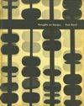 | Thoughts on Design  1947, 1950 & 1970 | Danny | Y | $0
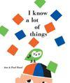 | I Know A Lot of Things  1956 | Danny | Y | $0
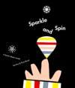 | Sparkle and Spin  1957 | Danny | Y | $0
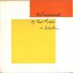 | The Trademarks of Paul Rand  1960 | Michael | Y | $0
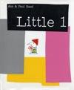 | Little 1  1962 | Danny | Y | $0
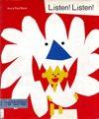 | Listen! Listen!  1970 | Danny | Y | $0
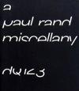 | A Paul Rand Miscellany  Design Quarterly  1984 | Danny | Y | $0
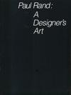 | Paul Rand: A Designer’s Art  1985 | Danny | Y | $0
 | Good Design is Good Will  1987 | Danny | Y | $0
 | Some Thoughts… and Some Logos  1991 | Danny | Y | $0
 | Some Thoughts… and Some Tribulations about the Design of a Logo  1991 | Danny | Y | $0
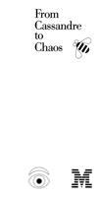 | From Cassandre to Chaos  1992 | Danny | Y | $0
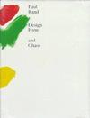 | Design Form And Chaos  1993 | Danny | Y | $0
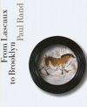 | From Lascaux to Brooklyn  1996 | Danny | Y | $0

Direction Magazine

Direction was a groundbreaking magazine that dealt with artistic, social and political issues and featured many famous contributors including architect Le Corbusier and artist William Gropper. It was published and edited by Marguerite Tjader Harris from 1938-1945, between the time of the invasion of Czechoslovakia, and the end of World War II.

In 1938, a 24-year-old Rand was asked to design the covers of Direction, and did most for free in exchange for complete creative control. “In a country that was used to decorative work, the common sense way to have what I was doing accepted was to do it for free,” he explained.¹ Working with little or no budget, he used his own handwriting along with other found elements to create images that were engaging and immediate.

Each of the covers represented major themes of the time. For his first cover, a geometric pair of scissors cuts through a map of Czechoslovakia, symbolizing the Nazi invasion tearing the country apart. Another is the 1940 “Merry Christmas” cover. Using a photograph of barbed wire (representing ribbon) and red dots created by a hole punch (representing spilled blood), these simple elements combined to create a powerful symbol of oppression.

Rand was the first to confess that these breakthrough covers were not entirely unique.
“I never claimed that this was great original stuff,” he confided. “Other guys in Europe were doing this kind of thing.²

Between a limited budget and unlimited creative freedom, he was able to uniquely combine many of the timeless design principles of symbolism, contrast, texture and others with the subject matter of the moment to create a collection of some of his finest works.

1, 2. “Direction”, Design Literacy, Allworth Press, 1997, Steven Heller

Examples to use
Image | Label | Owner | Permission | Cost
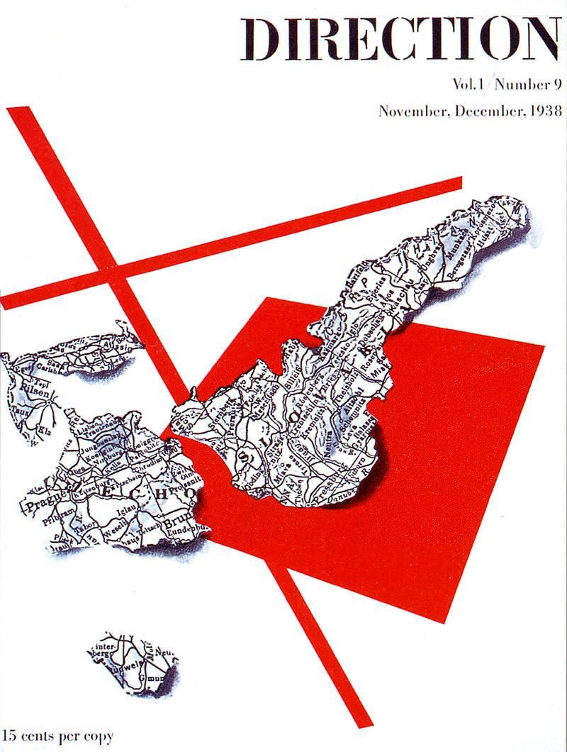 | November/December  1938 | Danny | Y | $0
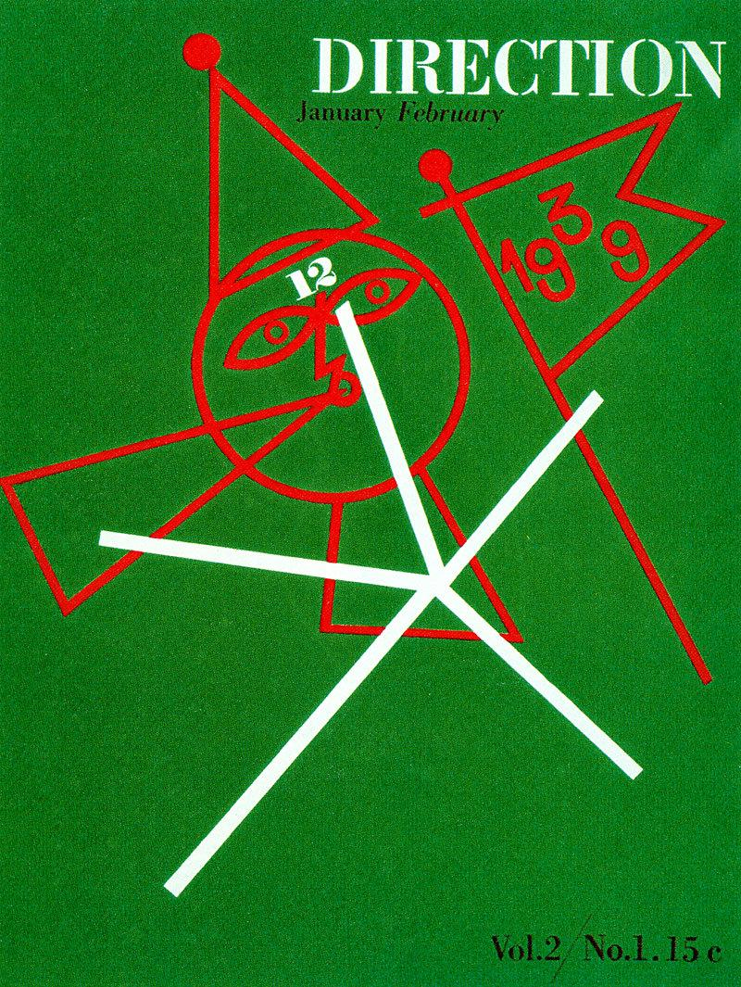 | January/February  1939 | Danny | Y | $0
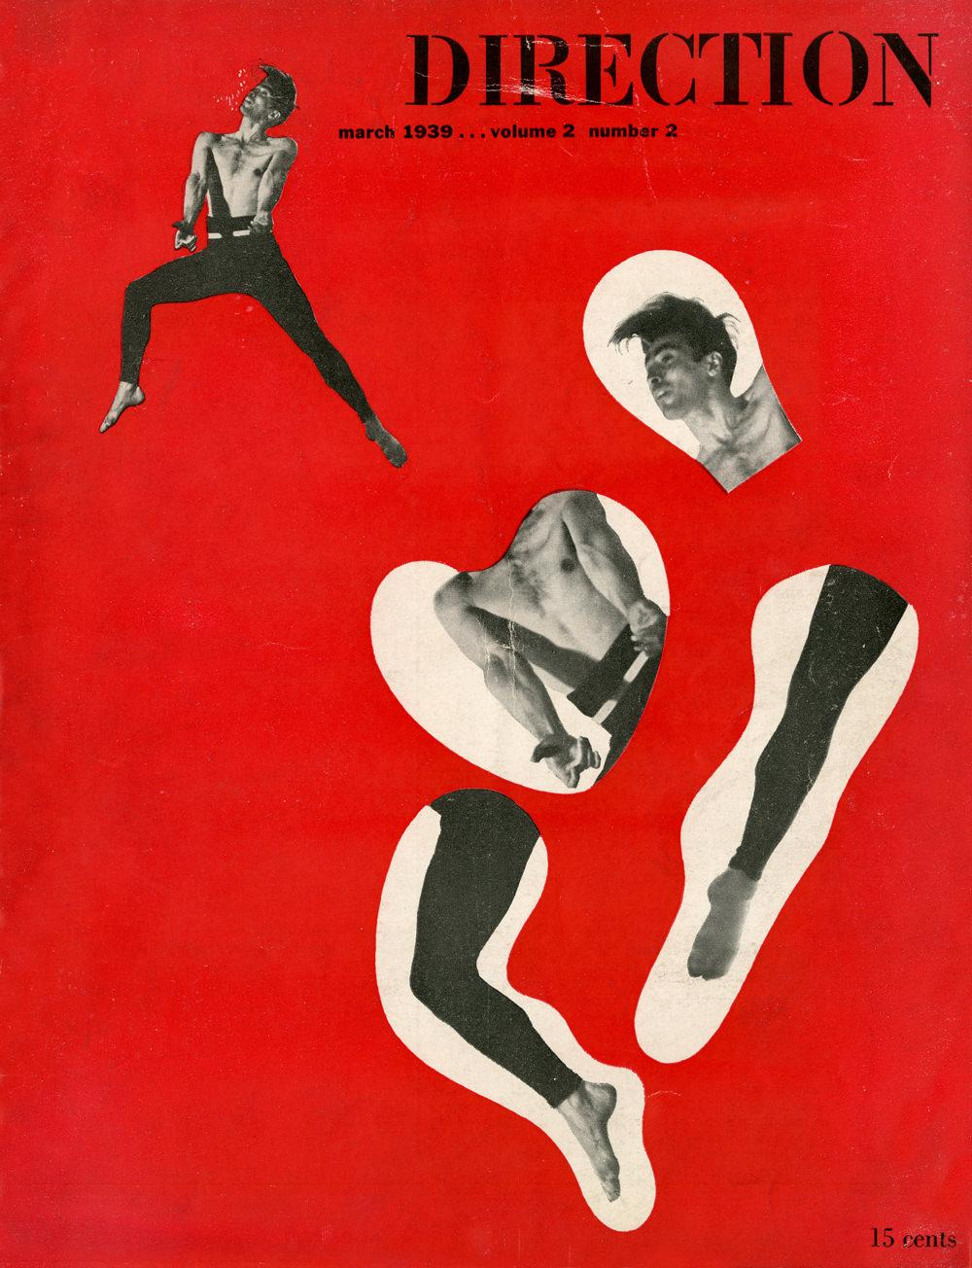 | March  1939 | Danny | Y | $0
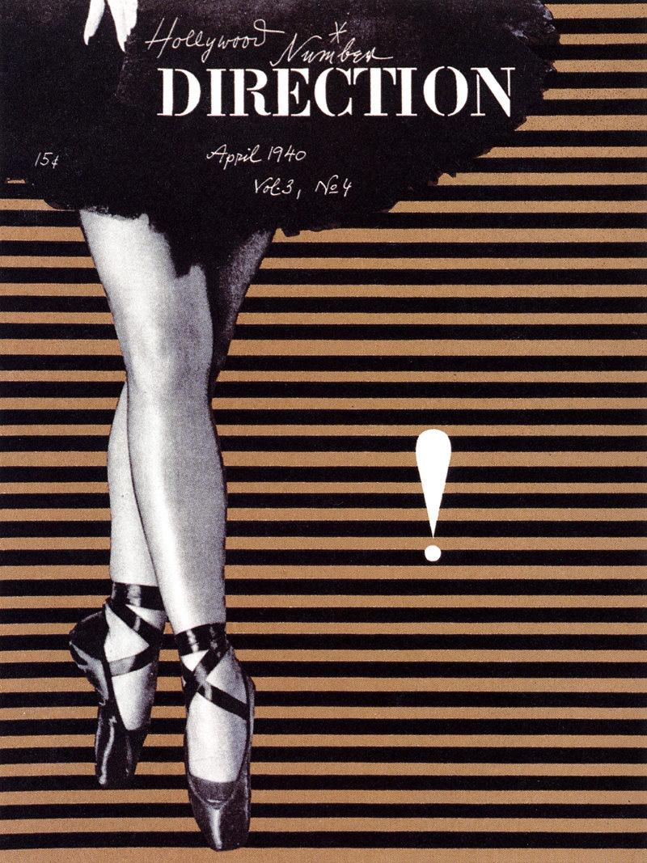 | April  1940 | Danny | Y | $0
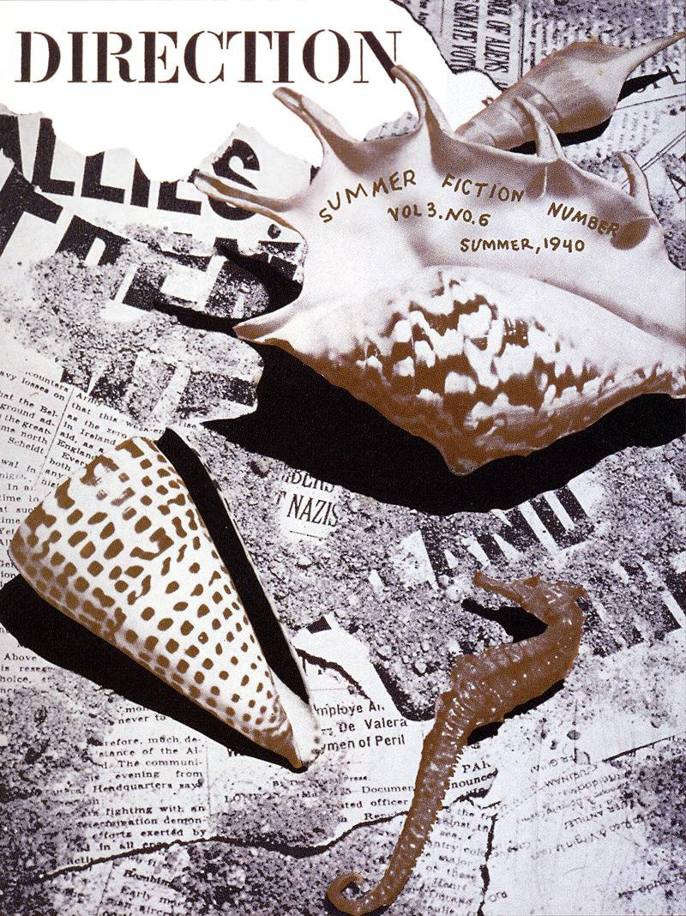 | Summer  1940 | Danny | Y | $0
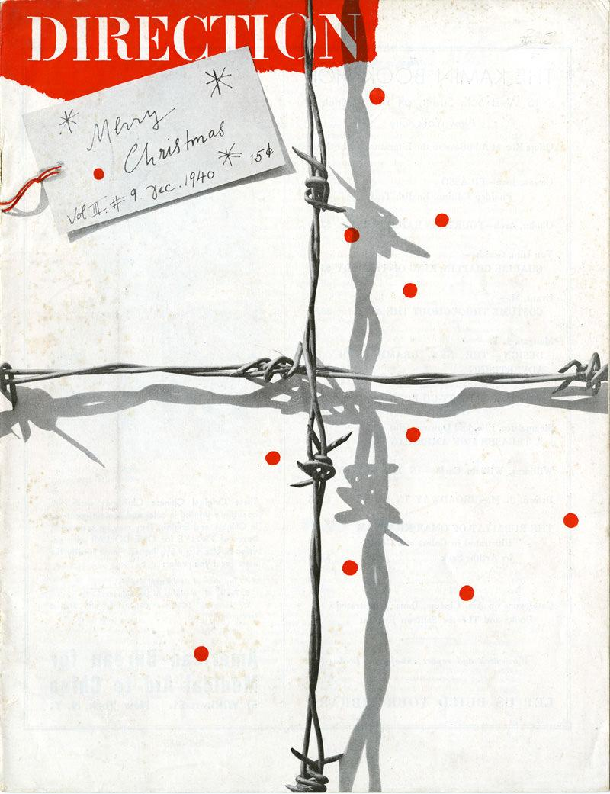 | December  1940 | Danny | Y | $0
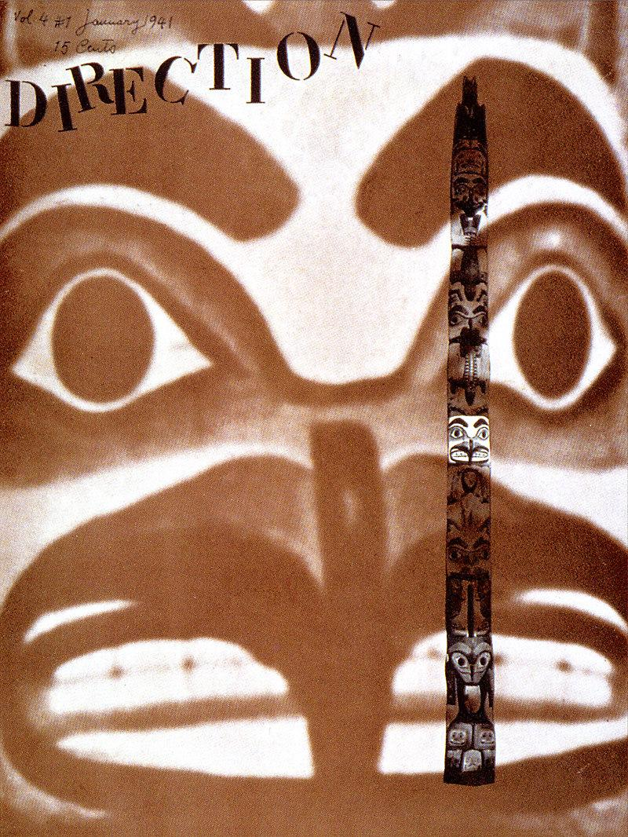 | January  1941 | Danny | Y | $0
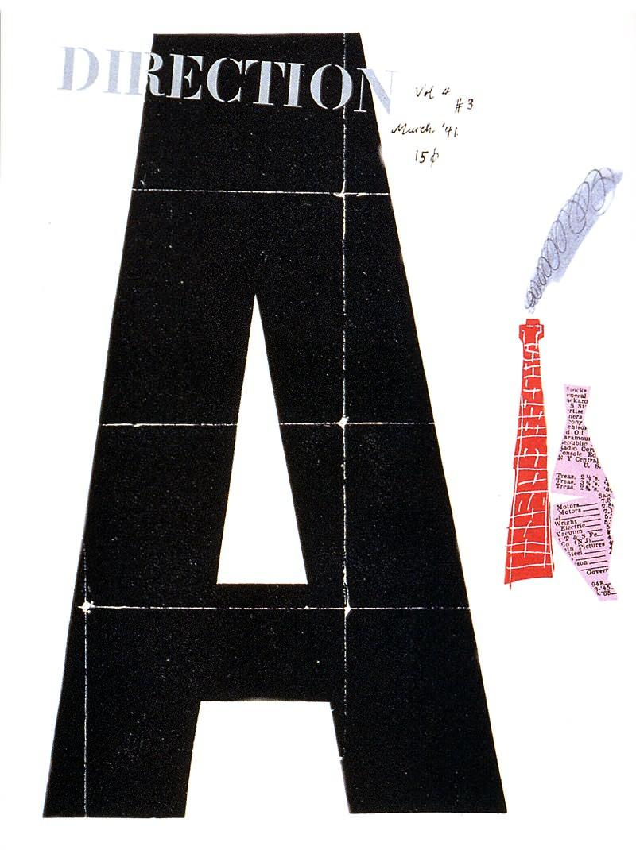 | March  1941 | Danny | Y | $0
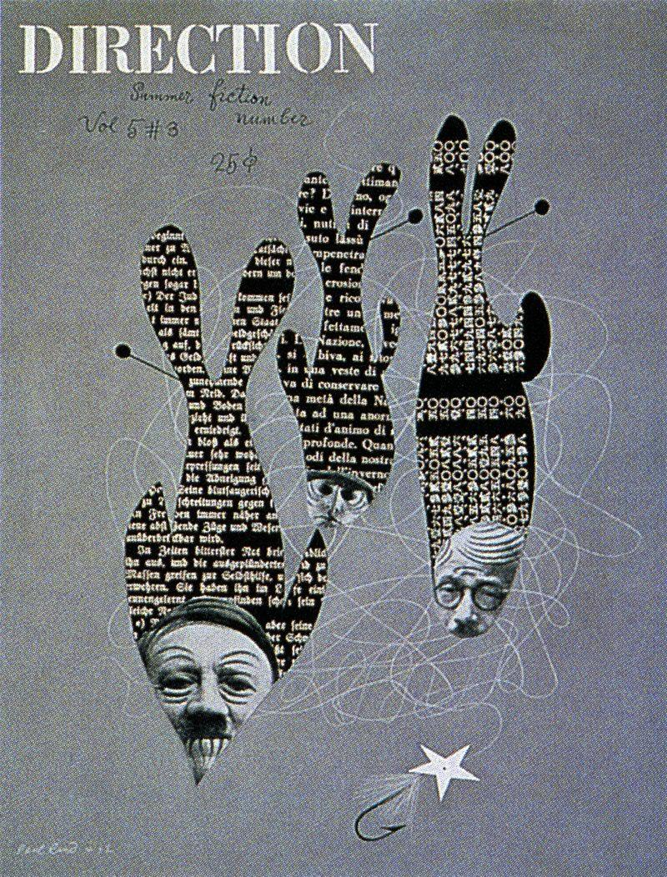 | Summer  1942 | Danny | Y | $0
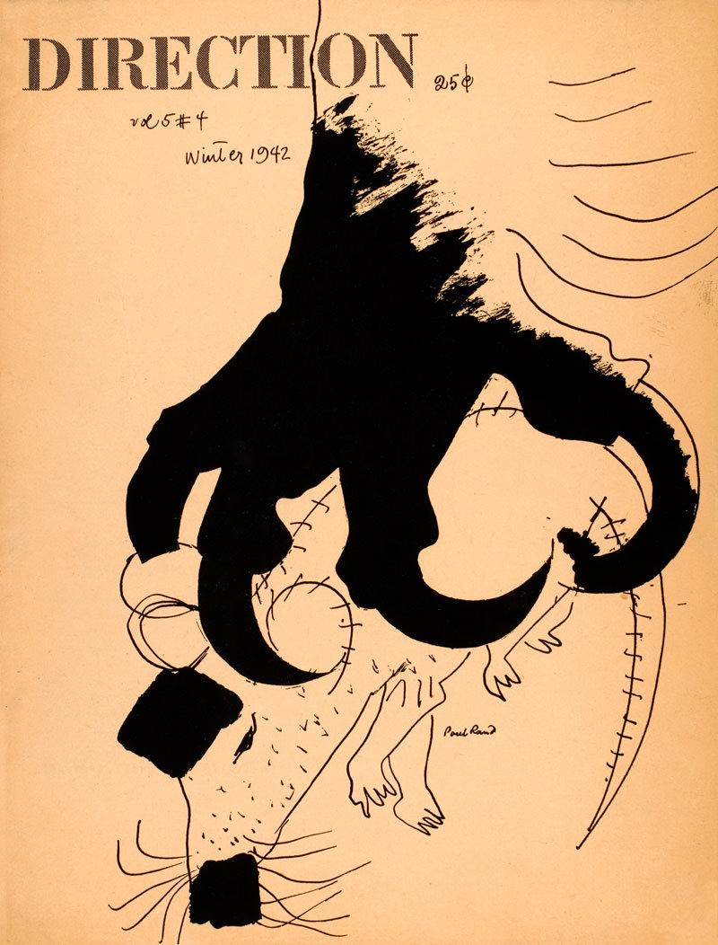 | Winter  1942 | Danny | Y | $0
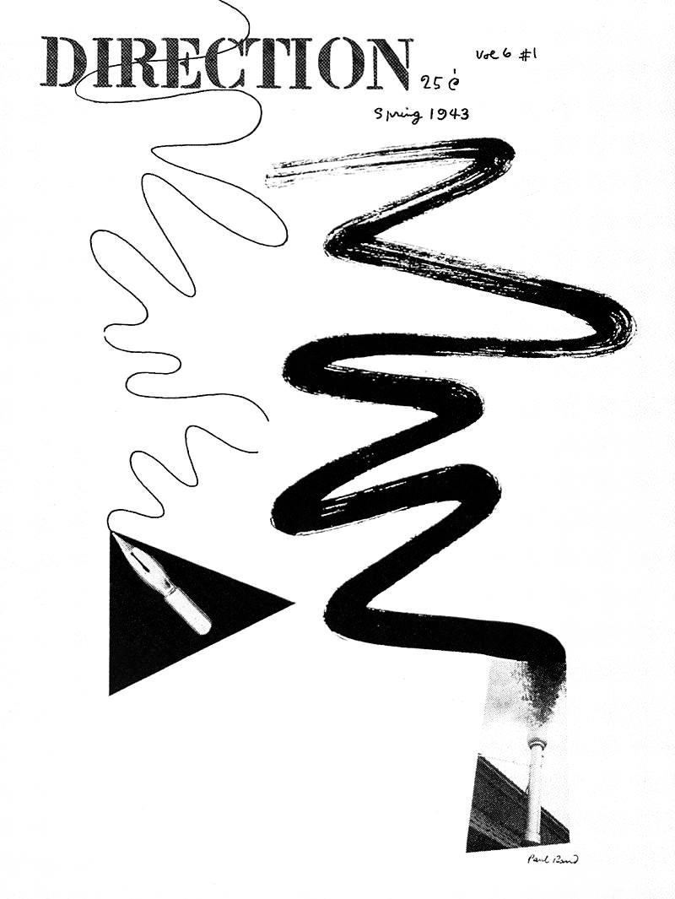 | Spring  1943 | Danny | Y | $0
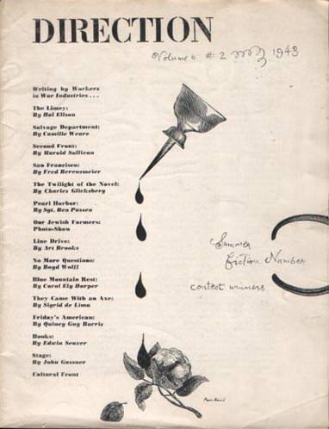 | Summer  1943 | Danny | Y | $0
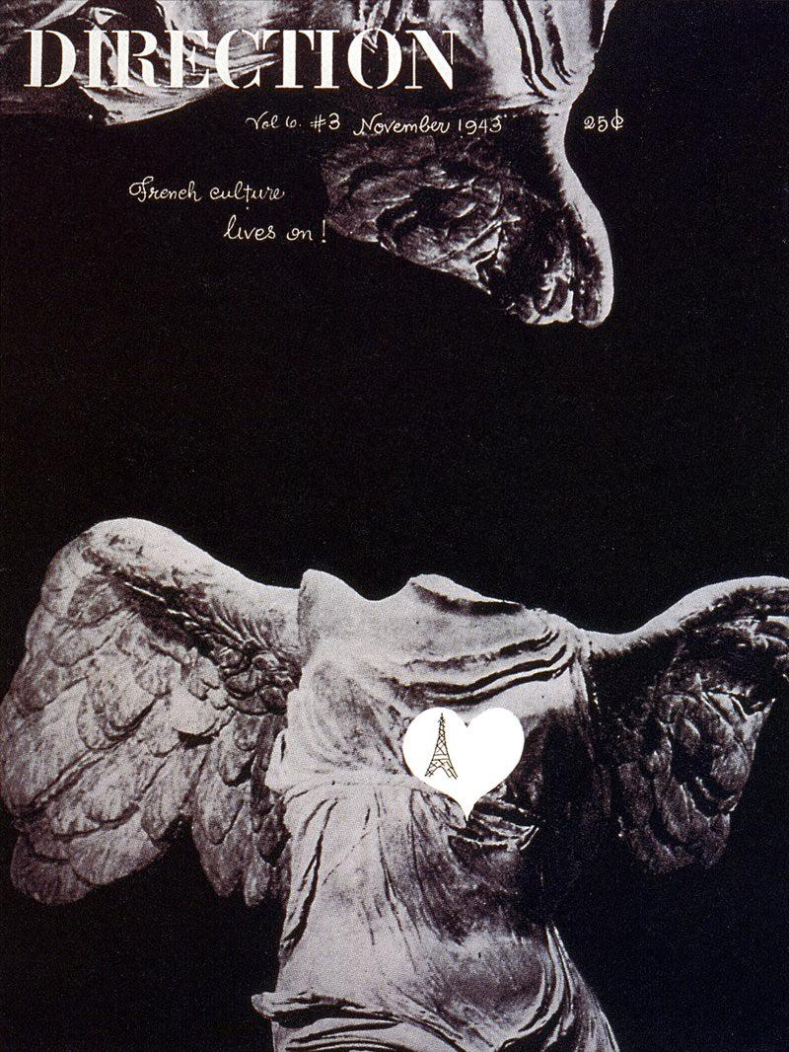 | November  1943 | Danny | Y | $0
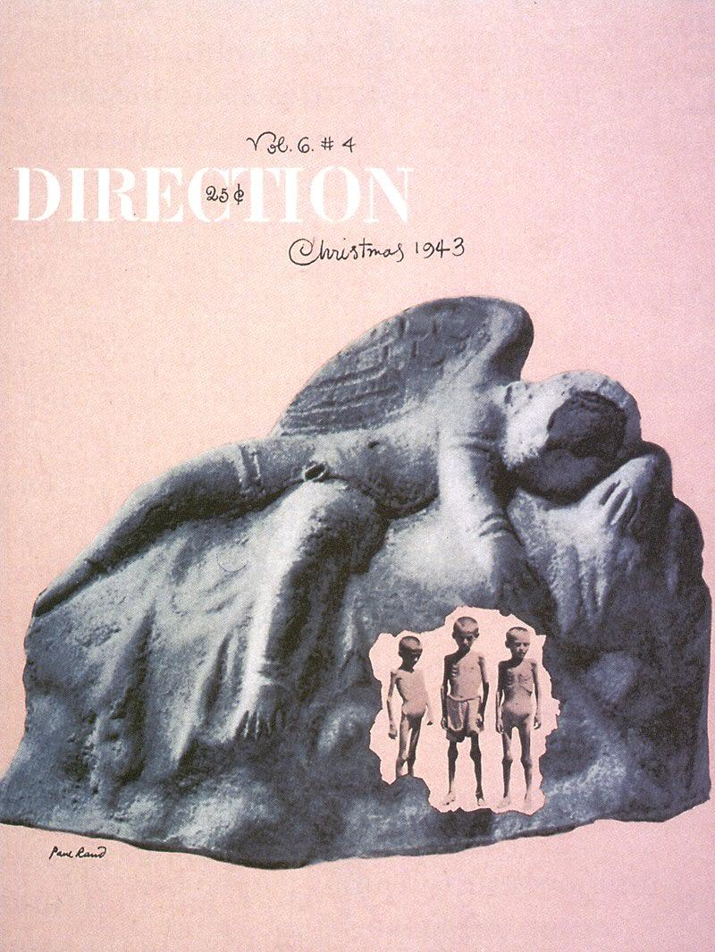 | December  1943 | Danny | Y | $0
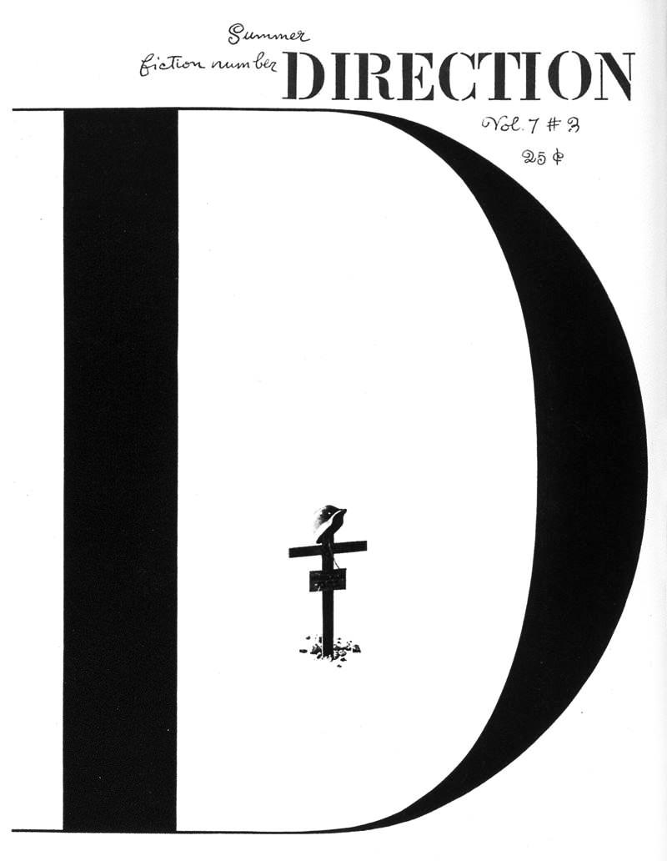 | Summer  1944 | Danny | Y | $0
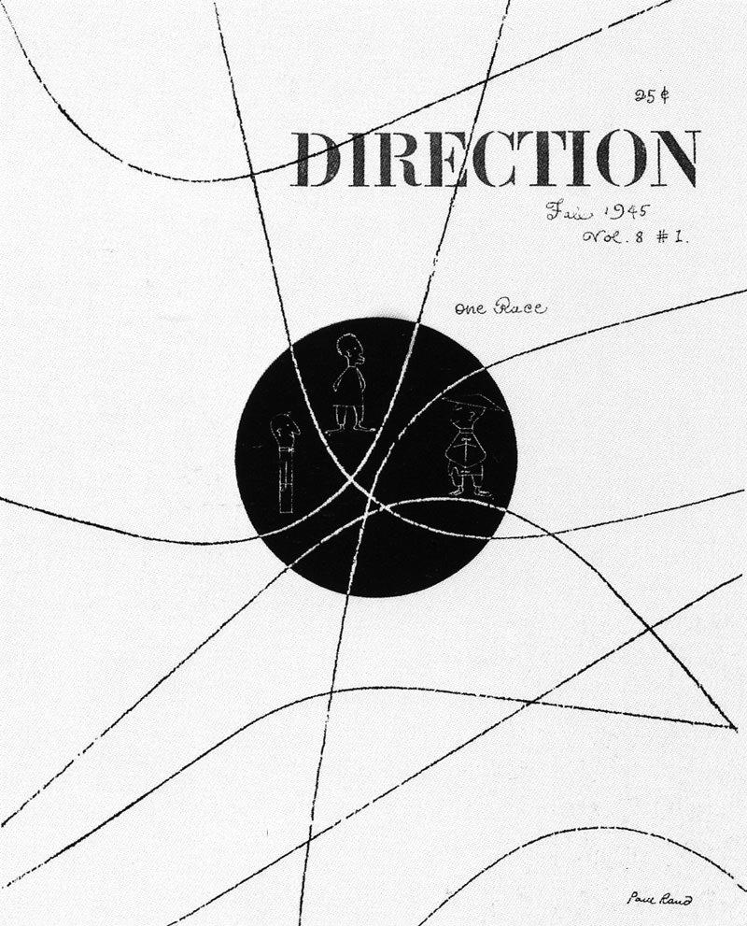 | Fall  1945 | Danny | Y | $0

On the RCA Ad

“Design is a way of life, a point of view. It involves the whole complex of visual communications: talent, creative ability, manual skill, and technical knowledge. Aesthetics and economics, technology and psychology are intrinsically related to the process.”
Graphis “Politcs of Design” 1981

“The Design Concept”, Allen Hurlburt, 1981

Our account department had learned that the lucrative RCA advertising business might be up for grabs, and the agency decided to run an ad to make a pitch for the account. That was on Monday and the ad had been scheduled to appear on Thursday so we were in our usual rush situation. Nothing much came out of the morning meeting of the plans board, and the afternoon brainstorming was equally unproductive. As was so often the case, I took the problem home to Weston, Connecticut, with me.
The more I analyzed the problem the more I became convinced that General Sarnoff was the key. I knew that while a million eyes might see that copy of the Times, the only eyes that mattered were his. I knew that his career in radio had begun as a wireless operator with Marconi, and somewhere I had heard that his proudest moment was when he was one of the first to pick up the distress call from the Titanic. This brought me to the Morse code. The letters SOS might have made an arresting headline in code, but I didn’t think RCA or the agency would appreciate the connotations. It was then that I decided to try RCA in code. My dictionary provided the symbols of the International code, and I knew I had the foundation of an idea.
The next morning on the 8:05 heading for the office I began putting the pieces together. In the convenient white space of someone else’s ad in my morning paper, I began to sketch out the layout. From the beginning the use of Caslon typography seemed right to me. It not only had the ultimate contrast with the boldness of the dots and dashes, but it had the proper earnest tone derived from its years of association with fine books.
My first sketch was slightly top-heavy and the ad signature seemed weak. It was while I was pondering this problem that the added twist that the idea needed came to me. Almost automatically I noted that the dot and dash of the last letter in my headline became a perfect exclamation mark when it was turned on end. It was only later that I realized that the A in advertising related to the symbol. Later when the layout was submitted in finish form to the agency, the usual flack developed, and it was only when our television director joined in its defense that the idea was approved.
Did the advertisement work? If attracting a lot of attention means anything it was a big success. On the morning the ad appeared, when I arrived at the Saugatuck station, the first thing I noticed was a group gathered around a man with his copy of the Times open to my ad, and on the trip into New York I overheard a lot of comment. But what happened on the executive floor of the RCA Building? General Sarnoff must have seen it, because there was a call from his office later that morning to set up a meeting with our agency people. In the end the agency didn’t get the RCA business for reasons unrelated to the ad and its objectives.

TO WRITE:

No Way Out Poster blurb?

IBM wall text

Use “Imagination and the image” somewhere?

