Paul Rand: Defining Design Outline

Welcome

Part of being a designer is looking for inspiration, and that’s exactly what I found when I discovered the work of Paul Rand while studying design at the Portfolio Center in Atlanta. Rand’s whimsical charm, visual simplicity, powerful communication and thoughtful writing completely changed the way I viewed my role as a designer and redefined the term “design” for me.

Rand’s work is known around the world – just about everyone on the planet has seen it. If you’ve ever shipped a package (UPS), watched television (ABC) or used a computer (IBM), then you’ve seen his work.

The books and articles he has written on the subject of design are not as well known to the general public, but they are no less powerful than the corporate identities he created. The first time I read his book, A Designer’s Art, I was amazed at how effortlessly Rand was able to expound upon complex ideas such aesthetics, content and form. Even though Paul Rand’s books are now out-of-print (his first was published in 1947), his thoughts on design are as relevant today as they were when he first began publishing nearly 70 years ago.

It is my hope that as you view Rand’s work and read his words, you become as fascinated about the ways in which art, aesthetics, color, typography, humor, form, content inform design as I am.

Enjoy, be inspired, continue to learn, and share your own thoughts on design.

— Daniel Lewandowski
Curator and Founder of Paul-Rand.com

Striped Wall Quotes

Can we put some kind of titling in the blue strip at the top, i.e. Paul Rand on Design or something like that?

I was just doing what they were doing in Europe. I didn’t claim that this was any great, original stuff, because it wasn’t. It was influenced by Surrealism and Picasso.
Interview with Steven Heller, 1988

To design is to transform prose into poetry.
Design Form and Chaos, 1993

The principal role of a logo is to identify, and simplicity is its means.… Its effectiveness depends on distinctiveness, visibility, adaptability, memorability, universality, and timelessness.
Design Form and Chaos, 1993

A style is the consequence of recurrent habits, restraints, or rules invented or inherited, written or overheard, intuitive or preconceived.
AIGA Journal, “Good Design is Good Will,” 1987

I started reading because of a remark of Moholy Nagy… I remember, Moholy asked me, “Do you read art criticism?” And I said, “No.” The only thing he said was, “Pity.”
Interview with Steven Heller, 1988

Functionalism does not preclude beauty, but it does not guarantee it either.
Print Magazine, January/February 1960

Ideally, beauty and utility are mutually generative. In the past, rarely was beauty an end in itself.
Thoughts on Design, 1946

I always steered towards humorous things. People who don’t have a sense of humor really have serious problems.
Interview with Steven Heller, 1988

Sentimentality provides only a momentary response to a work of art; nostalgia provides a momentary escape from reality.
From Lascaux to Brooklyn, 1996

I hate words that are abused, like “creativity.”
Interview with Steven Heller, 1988

I just always was interested in art. It’s like asking me how do I have breakfast; you know, you just have it.
Lecture, “A Paul Rand Retrospective,” Cooper Union, October 3, 1996

Ideas may also grow out of the problem itself, which in turn becomes part of the solution.
Paul Rand: A Designer’s Art, 1985

Without the aesthetic, the computer is but a mindless speed machine, producing effects without substance, form without relevant content, or content without meaningful form.
From Lascaux to Brooklyn, 1996

You’re not doing museum stuff; whatever you’re doing should communicate, so the guy on the street should know what the heck you’re trying to sell.
Interview with Steven Heller, 1987

There is no science in advertising.
Interview with George Lois, 1986

…the plethora of bad design that we see all around us can probably be attributed as much to good salesmanship as to bad taste.
Paul Rand: A Designer’s Art, 1985

Ideas are fuel for the imagination; they are the unique response to a meaningful question.
From Lascaux to Brooklyn, 1996

Without play, there would be no Picasso. Without play, there is no experimentation. Experimentation is the quest for answers.
Graphic Wit “Paul Rand: The Play Instinct,” 1991
Introduction

“Paul Rand is an idealist and a realist, one who uses the language of the poet and the businessman. He thinks in terms of need and function…but his fantasy is boundless.”
- L. Moholy-Nagy Gutenberg & Family, Vol. 1, No.2, October 1985

Paul Rand (1914-1996)
Design helped to create everything that is around us—the cereal boxes on our breakfast tables, the ads we read, the websites we surf, the cars we drive, the buildings we work in, the paintings we admire, the phones we talk on—design shapes everything.

Design, however, is much more than the color, the texture, and the shape of the objects and images that are part of our everyday lives—a fact that makes the concept of design quite difficult to define.

Nonetheless, defining design is the task that the American graphic designer Paul Rand (1914-1996) pursued throughout his long career as he sought to understand and to enumerate the visual elements that combined to make some works of design stand out from others. Though he recognized that achieving the right combination of visual elements was quite difficult, Rand defined design quite simply, saying that it is:

“The synthesis of form and content.”

Born in Brooklyn and educated at the Pratt Institute, Rand found inspiration in the works of European modernists like Paul Klee, Pablo Picasso, Alexander Calder, Joan Miró and others. Study of the modernists led Rand to develop a new avant-garde style for graphic design that was based on restrained minimalism, focused ideas, cut paper, and photographic collage. He first made a name for himself by designing playful layouts for such publications as Apparel Arts and Directions Magazine, creating memorable and effective pages that reflected his deep understanding of design principles.

Rand is best known for the corporate identities he designed in the 1950s and 1960s for such firms as IBM, ABC, Cummins Engine, UPS and Enron. In these and in all his designs, he sought to achieve that sythesis of form and design that he called “good work.”

A prolific writer, Rand documented his theory of design through articles and in four critically acclaimed books, all of which are written in a short and direct style and which examine complex subjects, namely the relation of graphic design to art, the relation of form to content, typographic expression, and humor, in design.

It is the combination of practice and theory that made Rand so unique and it is that very combination that informs this exhibition. Throughout the galleries, Rand’s own writings are juxtaposed with examples of his work, demonstrating the interrelationship of theory and practice that informed his definition of design.

Exhibit Overview:

Lobby – Video by… Collage w/ colorforms…

Design Primer
Rand constantly wrestled with the question of why some objects are considered to be art, while others are not. The hall gallery features selections from the introduction of his book, From Lascaux to Brooklyn, which provides a primer in aesthetics, demonstrating the timelessness of the design principles that enable visual communication.

Timeline
Also located in the hall gallery, this macro view of global and design-related events place Rand’s life and the evolution of his career as a designer and a writer into context.

Gallery 3
Continue your exploration of Rand’s writing on design and explore samples of his corporate presentations and logos, which laid the foundation for corporate branding. You’ll also find the answer to the question of why some objects are considered art, while not others.

Gallery 2
In this gallery, Rand’s work is presented in his own words through his articles and chapters of his ground breaking books. Continue your exploration by browsing the official website www.Paul-Rand.com and listen as Rand himself explains his thoughts on design through a collection of video interviews. Lesson from Rand’s teaching …..

Preface:

In his 1996 book, From Lascaux to Brooklyn, Rand asserted that there is essentially no difference between the fine arts, the applied arts, and artifacts. Rather, he argued, what determines the status of art is not genre but quality:

…a beautifully designed advertisement, poster, or piece of printed ephemera, assuming that it is both utilitarian and aesthetically satisfying, is as much a part of the genus art as is a painting or sculpture.

As is demonstrated in the hall gallery, Rand then went on to reveal how the same aesthetic principles that guide the creation of the fine arts affect the designer, the student, the marketer, and the researcher. He reinforced his idea that aesthetic principles are timeless and universal by comparing the ancient cave paintings of Lascaux to other works of art and design.

Lascaux Horse:

The Paleolithic paintings in the cave of Lascaux were discovered in 1940 by four boys roaming through the woods in the Dordogne region of France. Dating to about 15,000 BC, the paintings depict ibex, oxen, bison, and antelope, but the most celebrated of the images is that of a wild horse, sometimes referred to as the Chinese horse, because it seems to have been translated from an old Chinese print.

In From Lascaux to Brooklyn, Rand wrote: “The great lesson of the cave paintings of Lascaux is that art is an intuitive, autonomous, and timeless activity and works independently of the development of society.” He gave evidence in support of this argument by comparing the Lascaux Horse to other works of art and to objects of everyday use, demonstrating the aesthetic principles they share and linking those to the practice of design.

Timeline

Question...

Q. What do the cave paintings of Lascaux have in common with…
…The Tower of Pisa?
The Tower of Pisa, a Romanesque bell tower, was built in the 12th century aside the Arno River in the city of Pisa, Italy. The tower, constructed of white marble, is most famous for its unintended tilt to one side, which began during construction. Rand points out that the unintended tilt of the tower is in dynamic contrast to the buildings surrounding it. The tension produced by this juxtaposition creates an exciting experience for the viewer.

Rand also notes that the harmony of geometric shapes, the alternation of negative and positive space, and the contrasting textures, and repetition work together to create a beautiful and visually stimulating arrangement.

…Cézanne’s Apples?

Paul Cézanne
Still Life with Apples
National Gallery of Art, Washington, D.C.
Charles A. Loeser

In Paul Cezanne’s Still Life with Apples, Rand observes that a conventional subject is made especially beautiful by the skill with which Cezanne has interpreted the scene creates vibrancy through color and brushstroke.

…The Baptistery of Florence?
Built in Florence, Italy between 1059 and 1128, the Baptistery of Florence is one of the oldest buildings in the city. The structure is composed of simple, geometric forms. Each facet of the octagonal tower contains three dramatic arches. The façade is ornamented with rectangular carvings and the building is topped by a pyramid roof. Rand observes: “One quickly realizes that simplicity and geometry are the language of timelessness and universality.”

…Brueghel’s Children’s Games?
Pieter Brueghel
The Children’s Games
Kunsthistoriches Museum
Vienna
According to Rand, The Children’s Games,by Flemish Renaissance painter Pieter Brueghel the Elder, is “a complexity of contrasts, movements, and expressions united in a symphony of light and shade, curves, angles, and emotions – the whole gamut of conflicting phenomena.” The artist creates contrast by placing the playing children in a cityscape filled with sturdy buildings, but that contrast is not jarring. Rather, all the elements are brought into harmony because Brueghel balances passive and active elements, as well as those simple and complex, allowing the viewer to focus on the joy of the children.

…Romanesque Capitals?

Rand argues that these Romanesque capitals, created in xxxx in xxx place (or that once embellished some building) and sculpted with images and ornament, are characterized by a simplicity that is also often seen in children’s art because of its ability to communicate clearly with the viewer.

…The Fountains of the Alhambra?
Geometry, which has always played a significant role in Muslim art, permeates the design of the Fountain of the Lions that is at the center of a 14th century courtyard in the Alhambra, a Moorish citadel in Grenada, Spain. The dodechahedron basin of the fountain is supported by twelve lions carved of white marble that rest on the 12-sided base of the structure.
Contrast is at play in this environment as well: the highly simplified and delicately carved lions contrast dramatically with the elaborately carved arches in the background, while the water that flows in the fountain acts as another kind of sculptural element.

…The Parthenon?
Ictinus, the architect of the Parthenon, was not the only practitioner who applied the principles of Greek geometry to his structures. Yet the magnificence of the Parthenon outshines similar buildings of the period.
The beauty of any artifact cannot be attributed solely to its proportions.
FOOTNOTE: Diagrams shows one of many constructions of the golden section (1.618)
constructed on a right-angle triangle and two contiguous circles.

REWRITE:
...African Sculpture?
The exaggerated body and facial features of this sculpture are typical of the art of African sculpture. Its creator understood that emotions can best be expressed visually by overstatement rather than by literal depiction.

...Katsura Palace?
Serenity and order crown the splendor of this enchanted summer palace built just outside Kyoto, Japan in the 16th century. The shoji (rice-paper screens) incorporated into the interior of the building can be moved to create an endless variety of patterns, contrasts, and rhythms that turn the building a haven of tranquility and beauty: horizontal facades, vertical posts, diagonal roofs; dark and light, long and short, wet and dry; water, stones, grass, wood, and paper

The wild horse of Lascaux, also called the Chinese horse, evokes this Zen-like quality as well.

...Fisherman’s Buoys?
Rand believed that modest subject matter, modest means, and modest talent do not always prevent an artifact from offering an aesthetic experience to the viewer.
These buoys, are made by fishermen or craftsmen and are painted in such a way as to convey economy, simplicity, and modesty of means. This is a useful object lesson for designers who believe that mundane subject matter, like soap or soup, is a hindrance to creativity.

...Gorgon Pitcher?
The decor of this Gorgon pitcher defines its personality: the swelling blue stripes that embellish the belly of the vessel accentuate its profile and, like blue veins, impart life to an otherwise lifeless object by giving it sensitivity, subtlety, and simplicity.
Grace, dignity, passion, and pleasure signal the presence and suffuse the atmosphere of anything worthy of the accolade art; a persuasive poster, a painting, an elegant room, a Gothic cathedral, or a simple utensil.
“Art changes our whole attitude to life, not merely our understanding of it but also our evaluation of it, in fact, all our perspective.”

...Tipu’s Tiger?
This 18th century wooden automaton created in India a mechanical toy that simulates growls of a tiger and the cries of his victim, is at first disturbing. But its expression and scale are so toy-like, its color so brilliant, that the impression is merely startling.

This is an interesting example of form mollifying content.

...A Photograph of Nature
A work of art is a dialogue, a picture filtered through the mind and then transformed. Lyrical understanding of the subject, trained observation, special feeling for patina, an eye for revealing detail, and poetic content comprise what Walker Evans describes as the photographer’s magic.
The photo of this cactus is artistic only to the extent that the photographer has selected and interpreted the subject.
The quality of a picture is measured not by how much it adheres to nature but how far it departs from it.
“Artistic beauty stands higher than nature, for the beauty of art is beauty that is born — born again, that is — of the mind, and by as much as the mind and its products are higher than nature and its appearances, by so much is the beauty of art higher than the beauty of nature.”
Examples to use
Image | Label | Owner | Cost
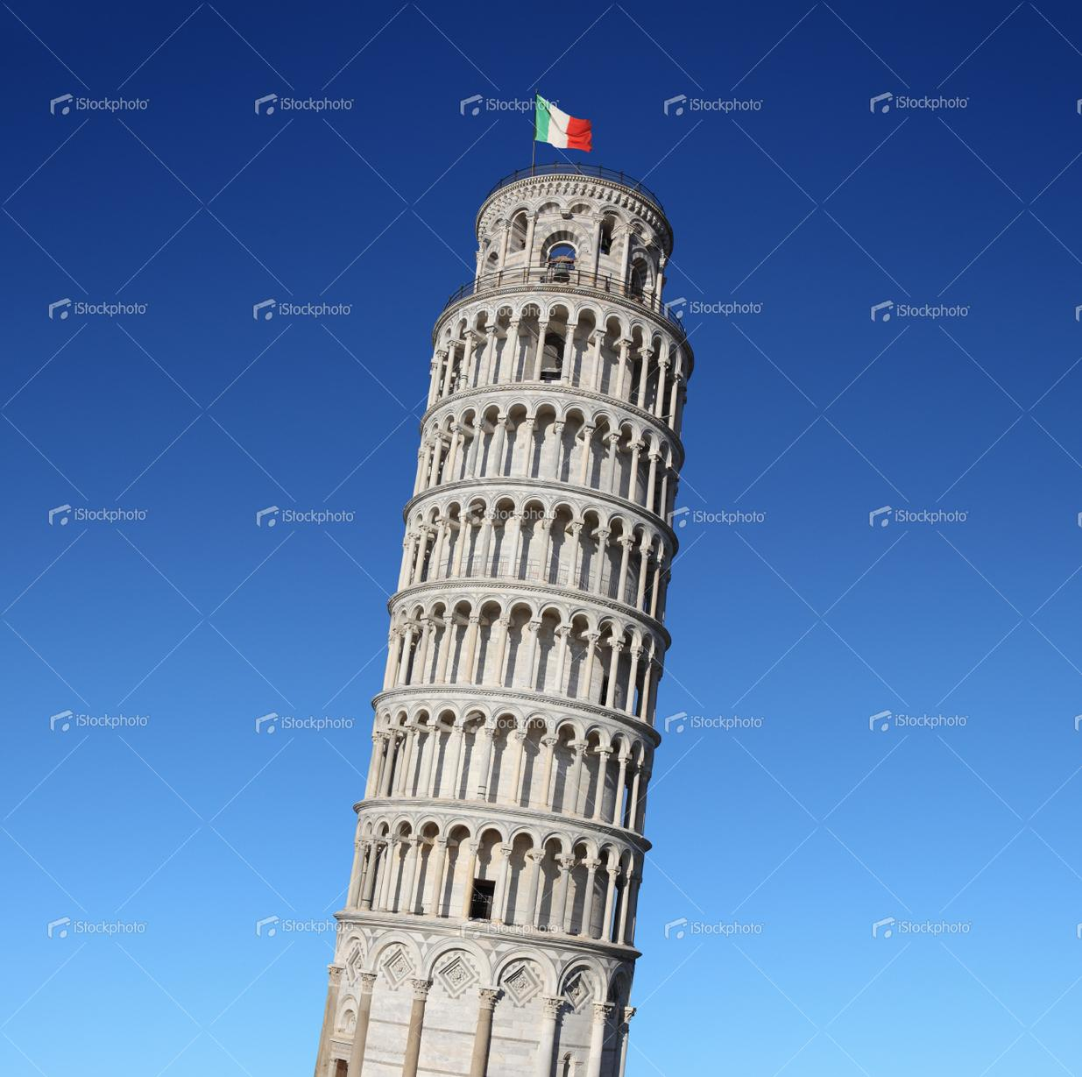 | Leaning Tower of Pisa | istockphoto.com  Leaning tower of Pisa  File #18174209  XXXLarge  5268 x 5229 px @ 300 dpi  25.37 MB  55 Credits | $55
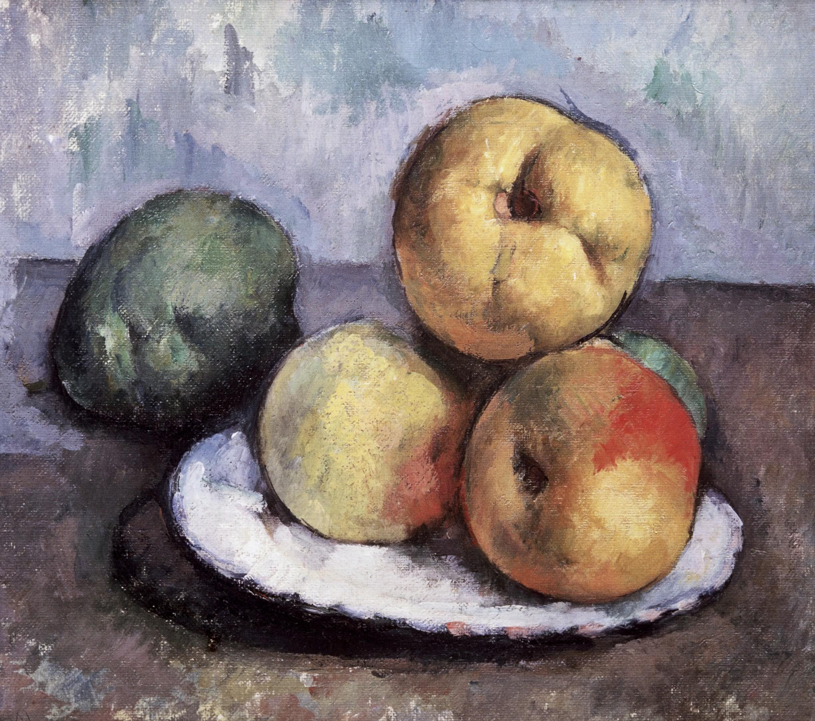 | Cezanne’s Apples | White House Historical Association | $75
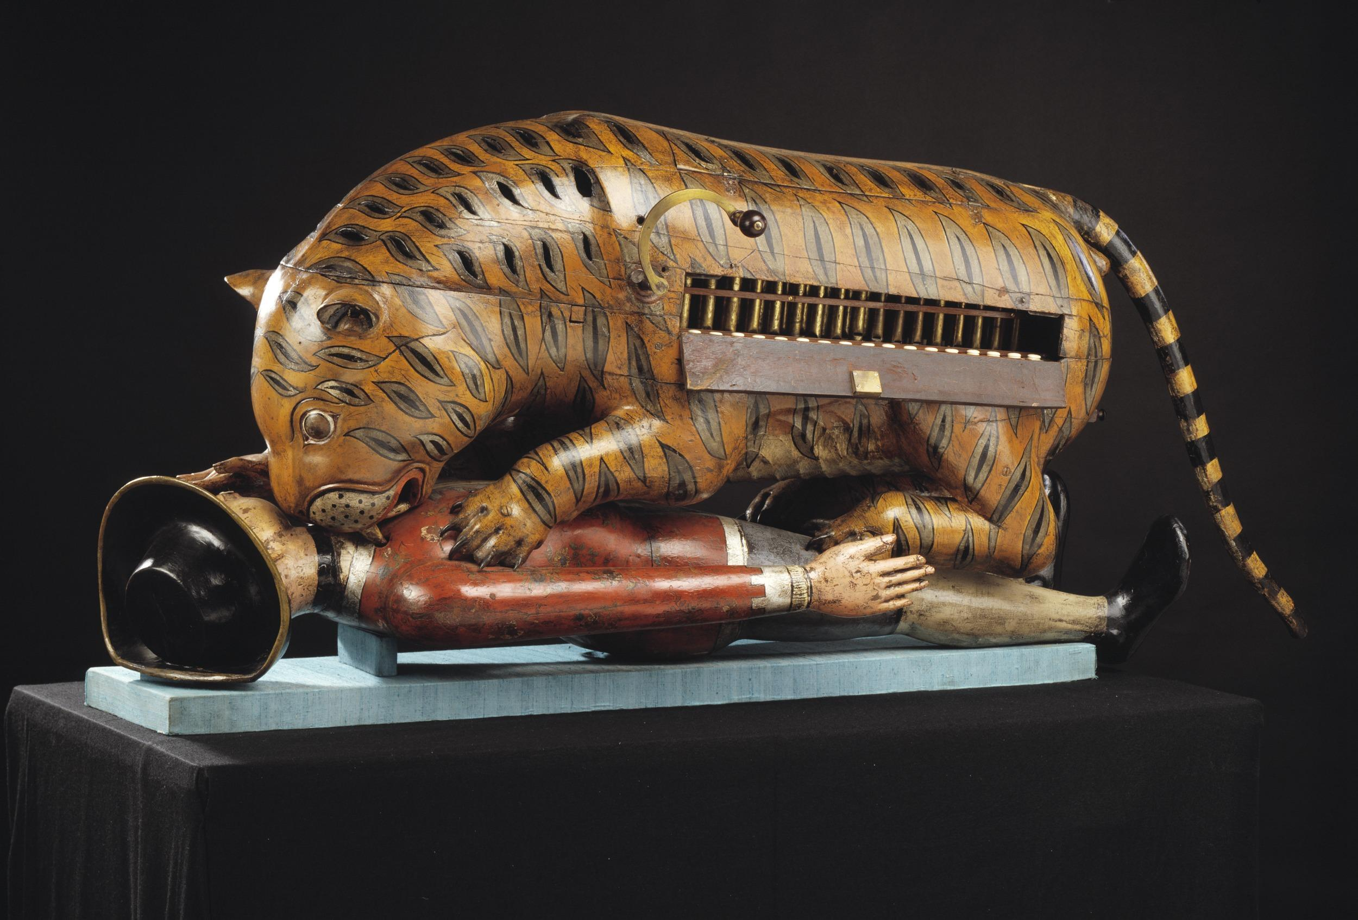 | Tipu’s Tiger | Victoria & Albert Museum
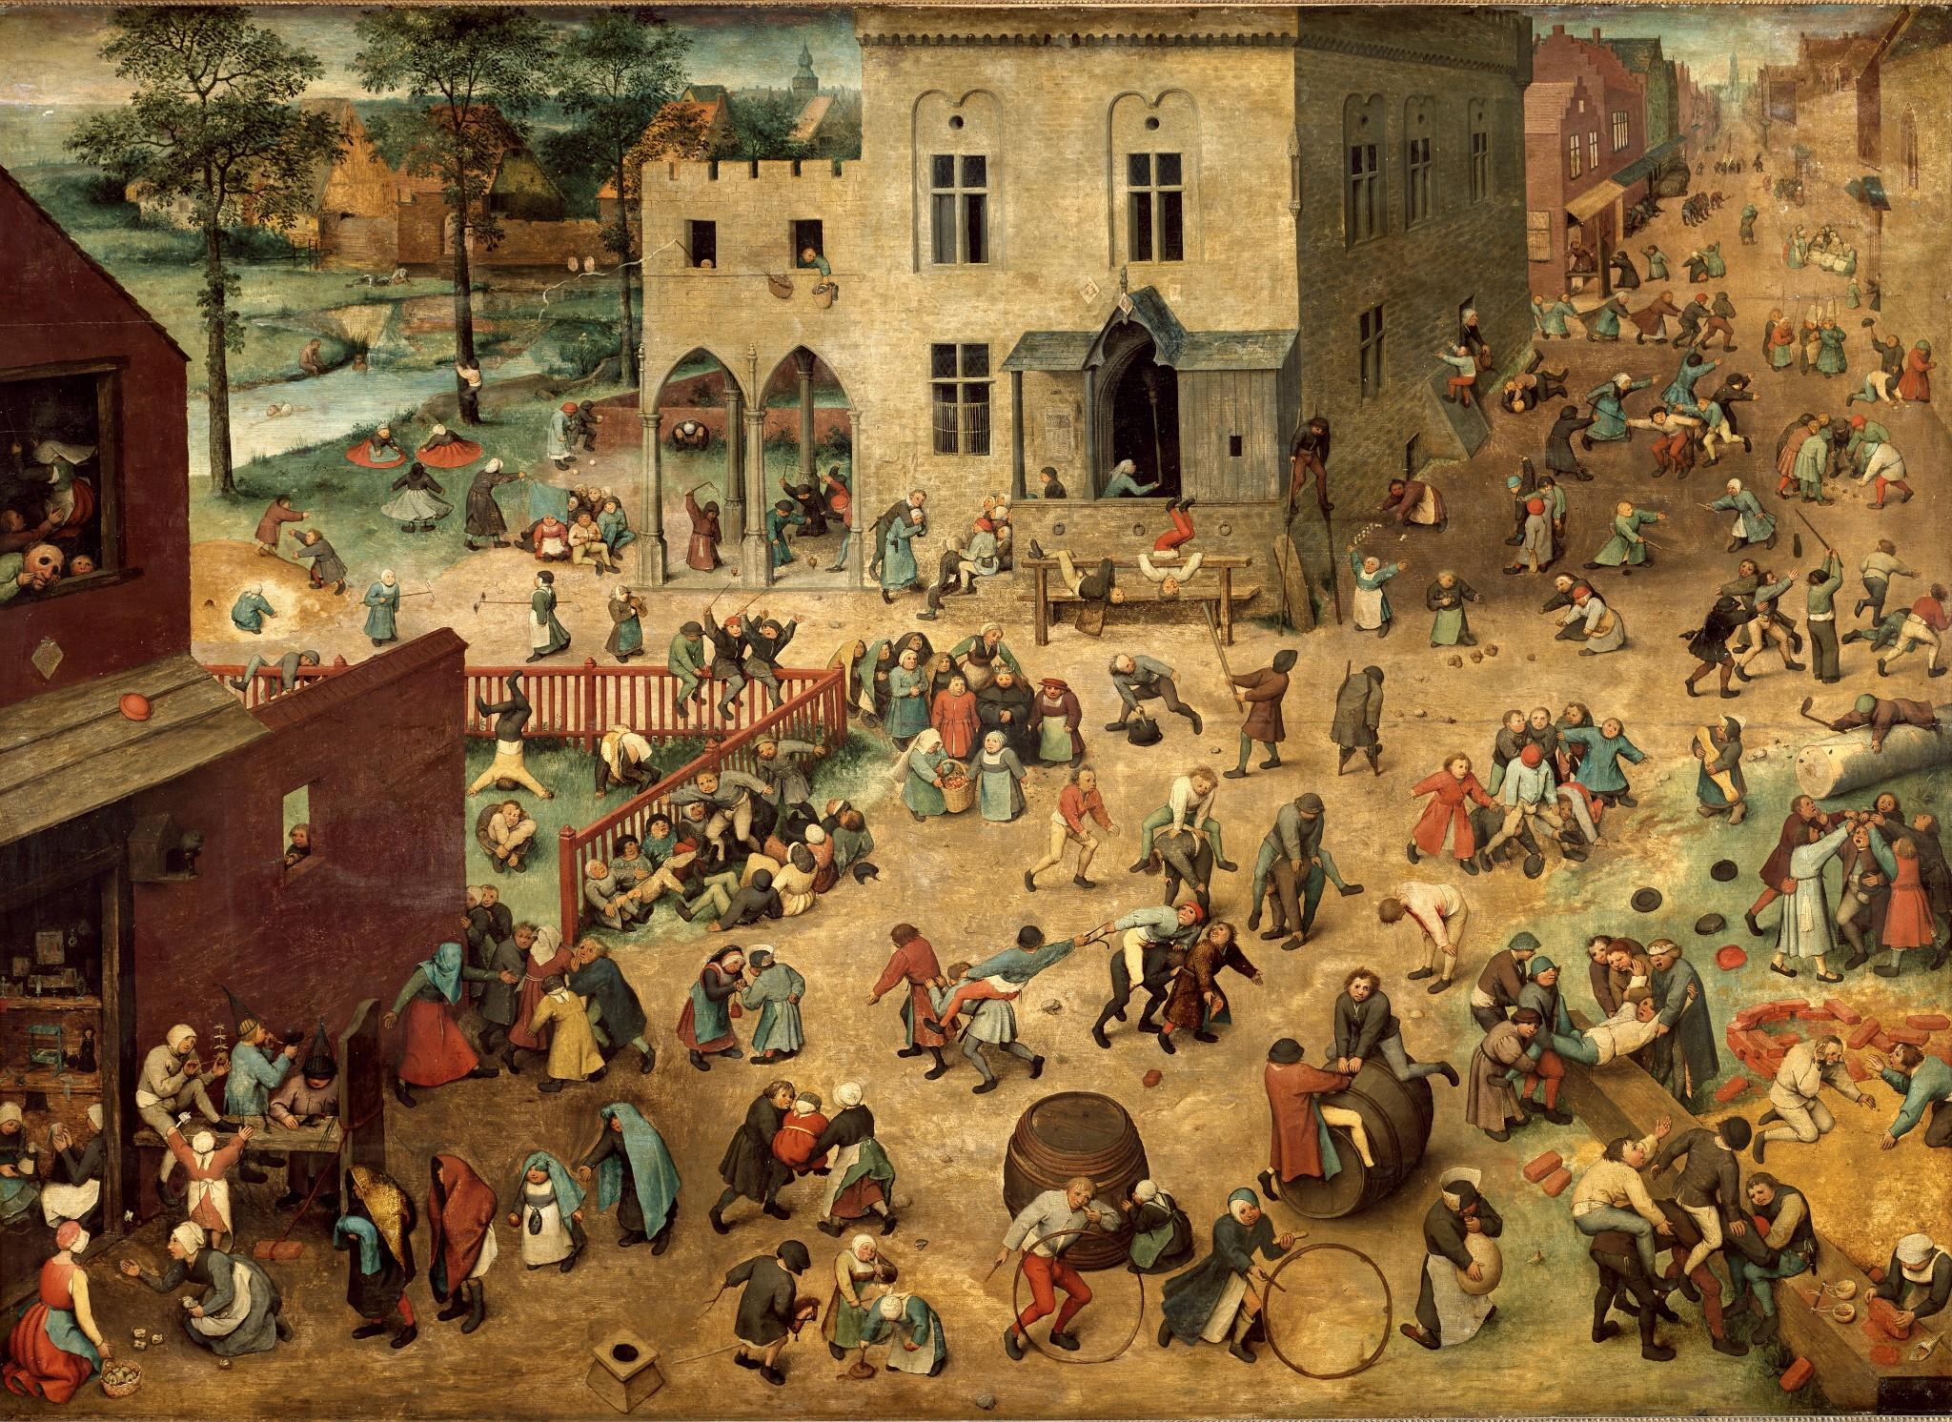 | Breughel’s Children’s Games | Kunsthistorisches Museum | €50
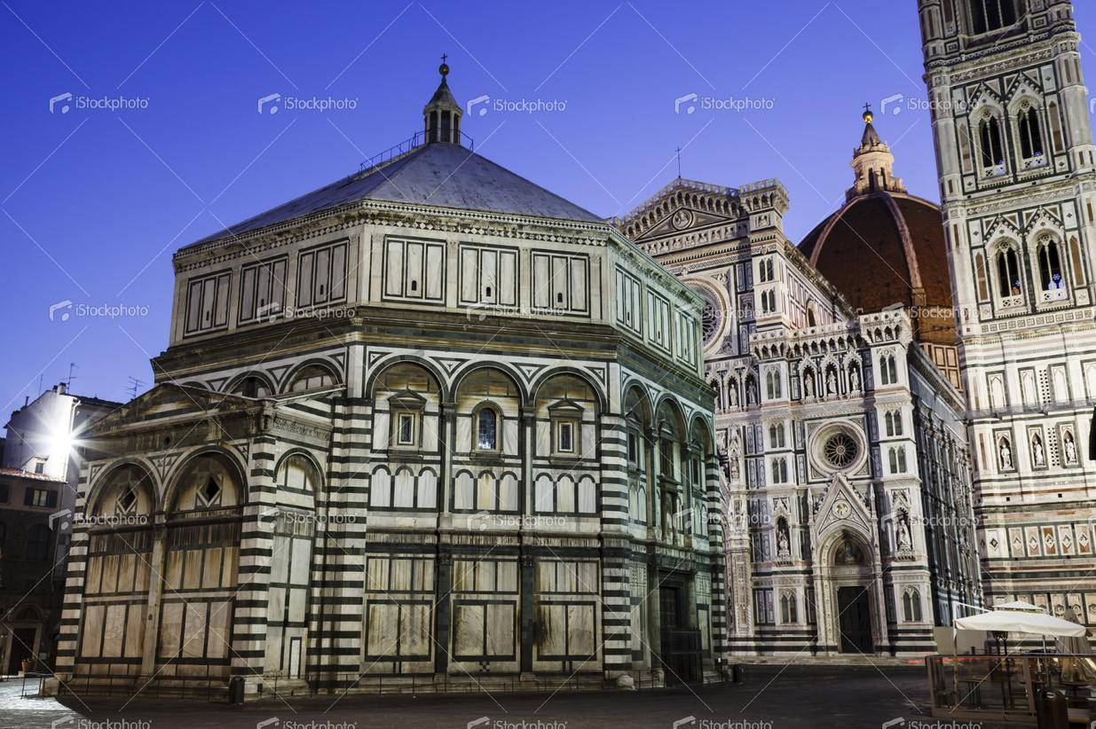 | Baptistry of Florence | istockphoto.com  File #23394682  XXXLarge  5616 x 3744  17.64 MB  18 Credits | $18
 | The Parthenon
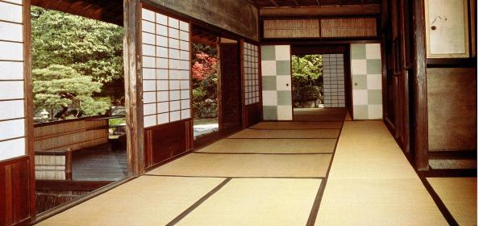 | Katsura Palace
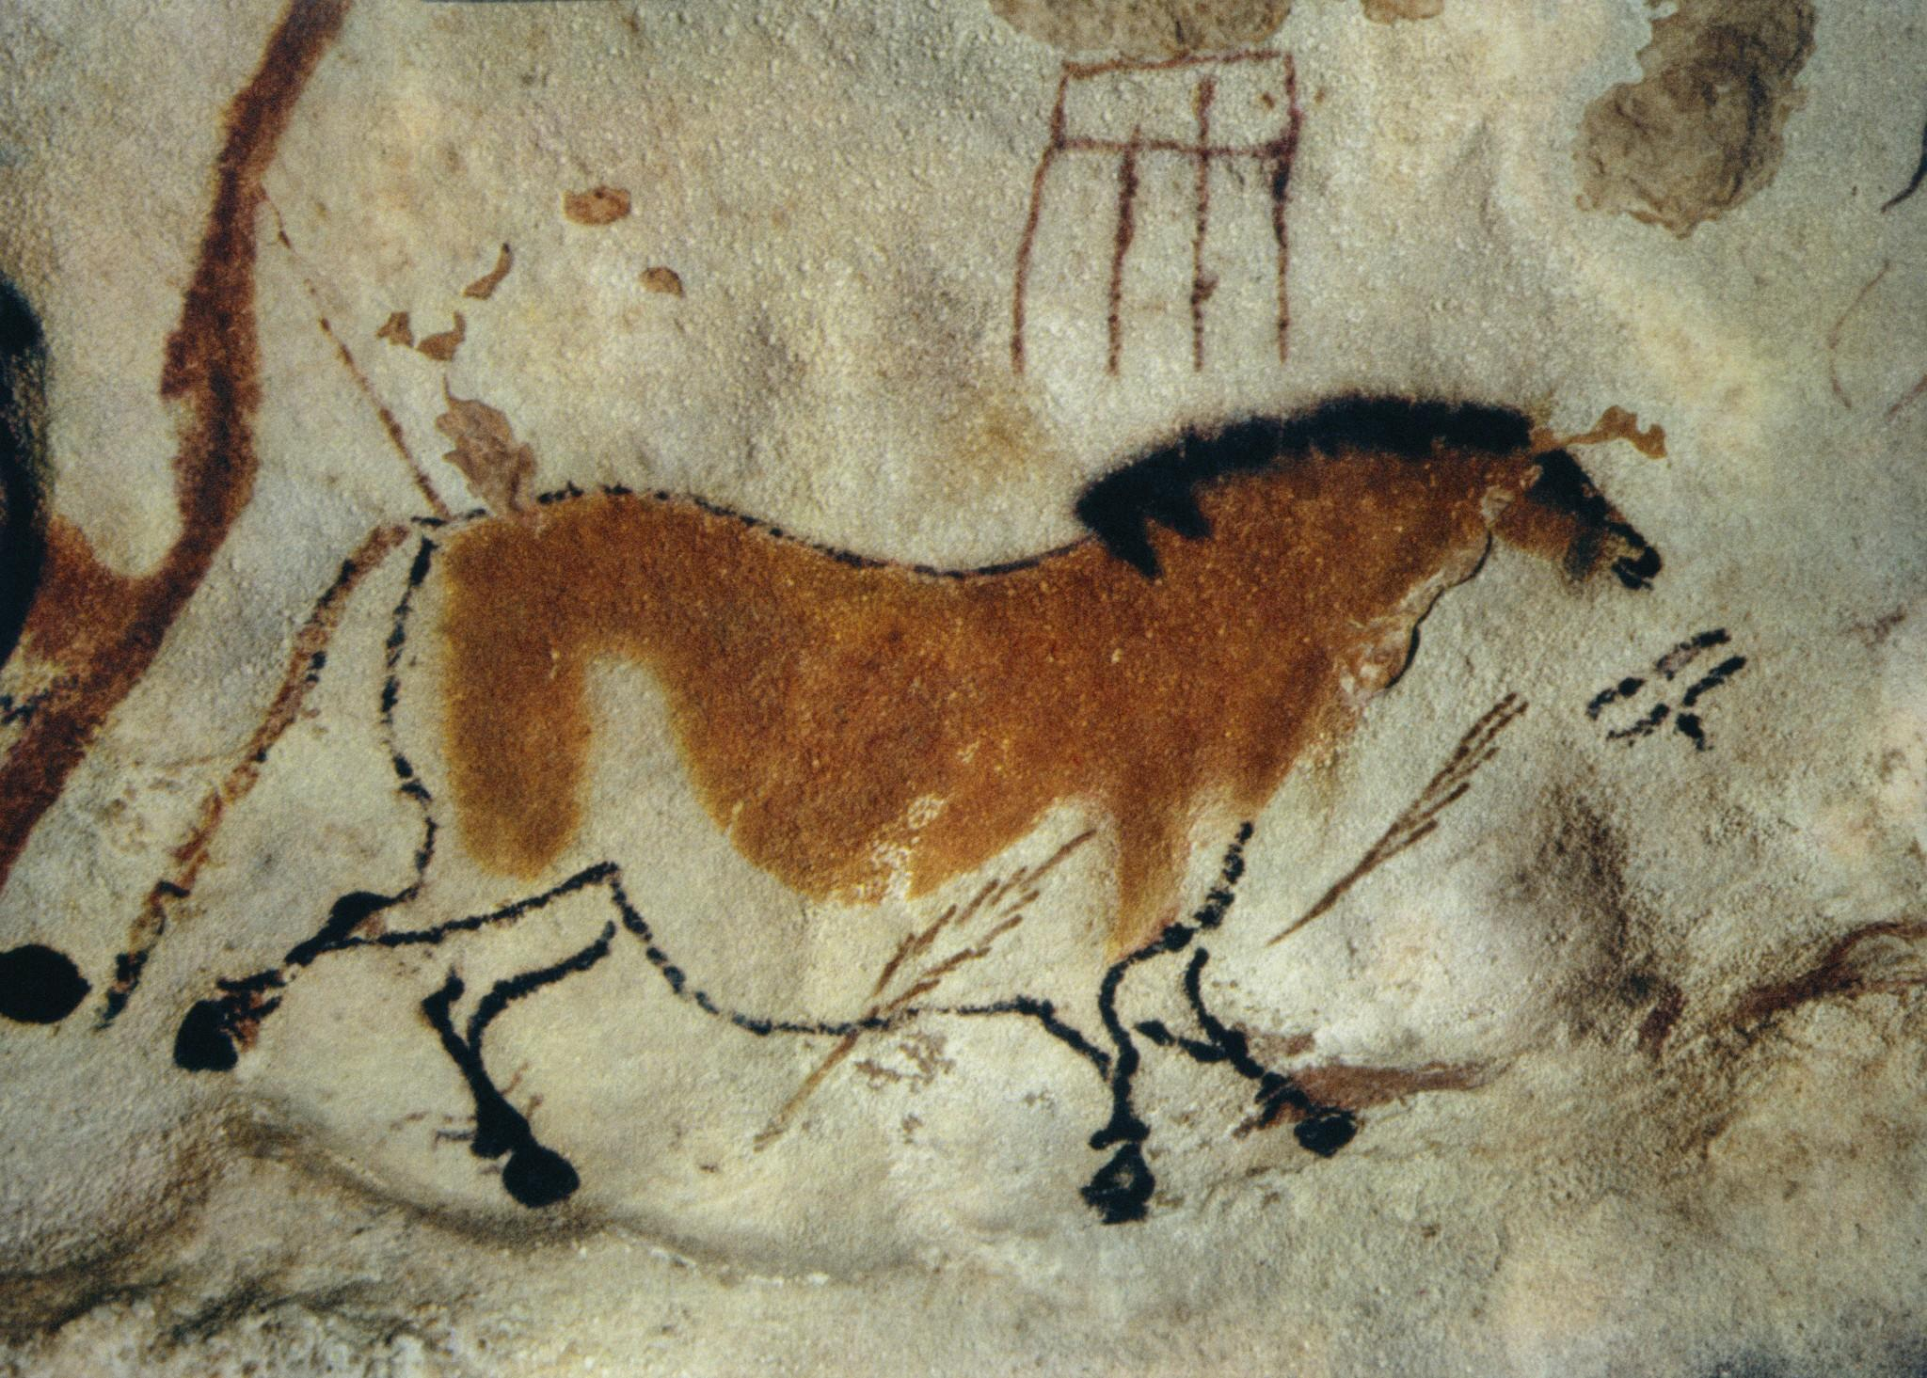 | Lascaux Cave Horse Painting | Corbis  42-18372237  or  University of York | $332  $0?
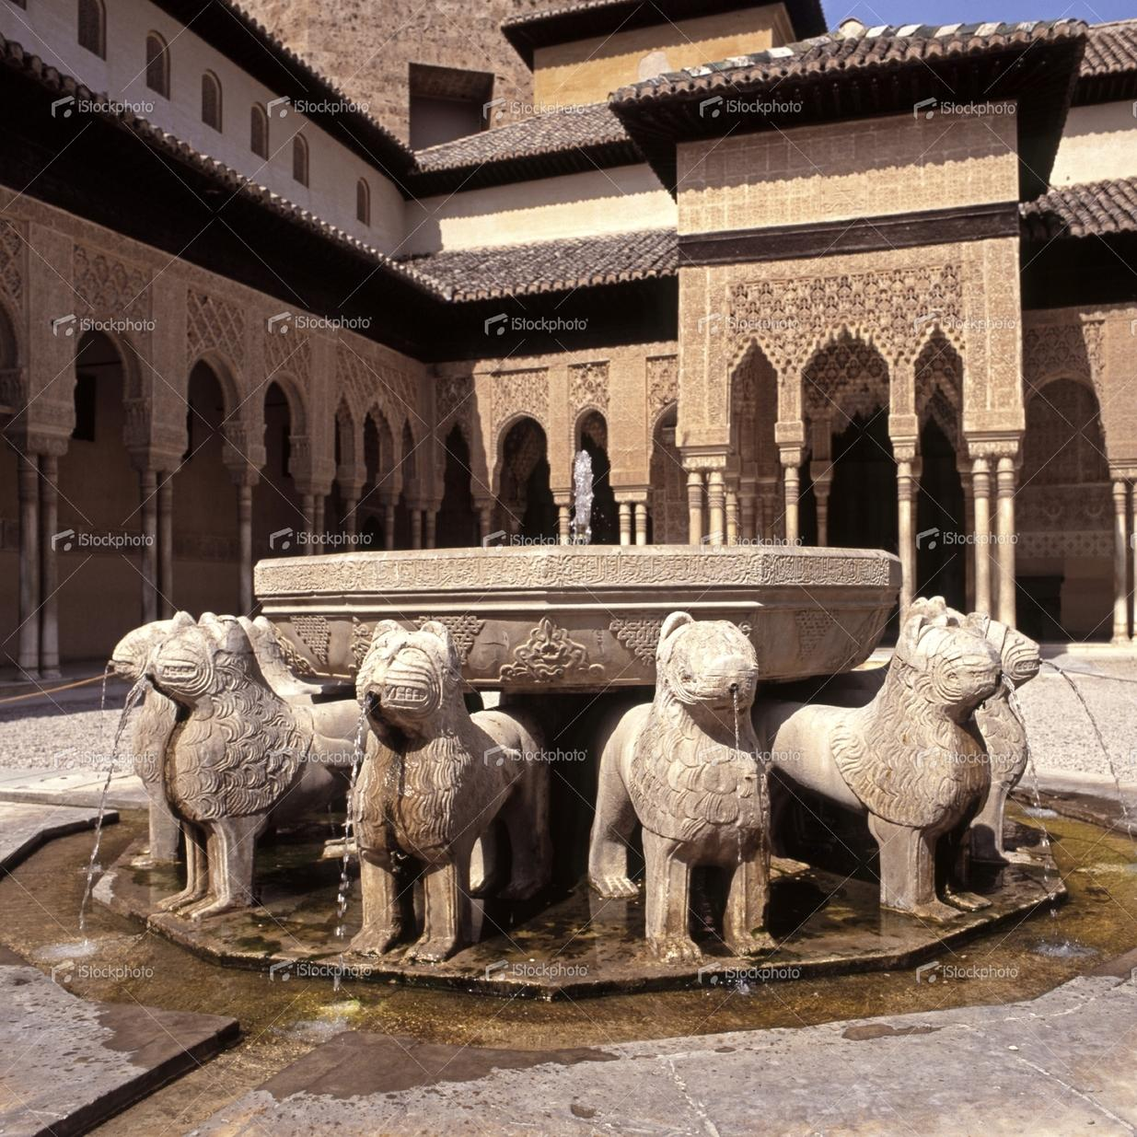 | Lion fountain, Alhambra Palace, Granada, Spain. | istockphoto.com  File #22129042  Large  3000 x 3000 px @ 300 dpi  6.22 MB  10 Credits | $10

Answers

A.

The cave paintings of Lascaux are objects of aesthetic experience, irrespective of time, place, purpose, style, or genre.

It is at least arguable that the purely formal element in art does not change; that the same basic principles of harmony and proportion are present in primitive art, in Greek art, in Gothic art, in Renaissance art, and in the art [and design, traditional or trivial] of the present day.

Aesthetics is the standard by which a work of art is judged. It is essentially the study of the ways in which form and content interact.
How skillfully form and content are fused will determine the aesthetic quality of the work in question.
To this one may add the basic principles of:
order, unity, variety, contrast,
grace, symmetry, asymmetry,
rhythm, rhyme, regularity,
movement, interval, coherence,
dissonance, balance, tension,
space, scale, weight,
texture, line, mass, shape,
light, shade, color,
ad infinitum.
These are among the tools of form —by design, by chance, by improvisation.
The endless conflicts between
the spiritual and material,
between ends and means,
form and content,
form and function,
form and facture,
form and purpose,
form and meaning,
form and idea,
form and expression,
form and illusion,
form and habit,
form and scale,
form and style
need to be resolved.
It is the merging of these conflicts that determines the aesthetic quality of a painting, a design, a building, a sculpture, or a printed piece.

“The Designer’s Problem”
Paul Rand, Thoughts on Design, 3rd Edition, 1970

An erroneous conception of the graphic designer’s function is to imagine that in order to produce a “good layout” all he need do is make a pleasing arrangement of miscellaneous elements. What is implied is that this may be accomplished simply by pushing these elements around, until something happens. At best, this procedure involves the time-consuming uncertainties of trial and error, and at worst, an indifference to plan, order or discipline.
The designer does not, as a rule, begin with some preconceived idea. Rather, the idea is (or should be) the result of careful study and observation, and the design a product of that idea. In order, therefore, to achieve an effective solution to his problem, the designer must necessarily go through some sort of mental process.
Consciously or not, he analyzes, interprets, formulates.
He is aware of the scientific and technological developments in his own and kindred fields.
He improvises, invents or discovers new techniques and combinations.
He co-ordinates and integrates his material so that he may restate the problem in terms of ideas, signs, symbols, pictures.
He unifies, simplifies, and eliminates superfluities.
He symbolizes — abstracts from his material by association and analogy.
He intensifies and reinforces his symbol with appropriate accessories to achieve clarity and interest.
He draws upon instinct and intuition.
He considers the spectator, his feelings and predilections.

Examples to use
Image | Label | Owner | Cost
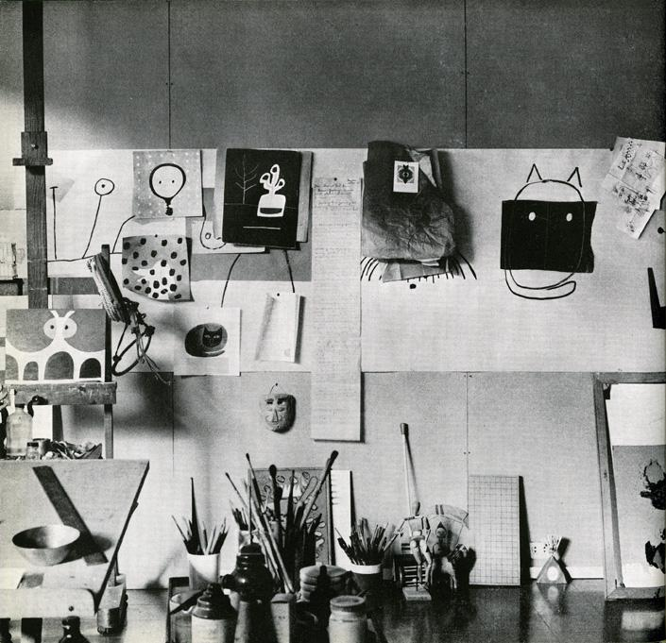 |  | Yale/Rand Estate

The Symbol in Advertising/Versatility of the Symbol

LARGE QUOTE ON WALL: Good design adds value of some kind, gives meaning, and, not incidentally, can be sheer pleasure to behold; it respects the viewer’s sensibilities and rewards the entrepreneur.
Paul Rand, Design Form and Chaos, 1993

“The Symbol in Visual Communication”
Paul Rand, A Designer’s Art, 1985
It is in symbolic, visual terms that the designer ultimately realizes his perceptions and experiences; and it is in a world of symbols that man lives. The symbol is thus the common language between artist and spectator.
Words like simplified, stylized, geometric, abstract, two-dimensional, flat, non-representational, non-mimetic are commonly associated, sometimes incorrectly, with the term symbol.
In essence, it is not what it looks like but what it does that defines a symbol. A symbol may be depicted as an “abstract” shape, a geometric figure, a photograph, an illustration, a letter of the alphabet, or a numeral. Thus, a five-pointed star, the picture of a little dog listening to his master's voice, a steel engraving of George Washington, or the Eiffel Tower itself—are all symbols!
… In these illustrations the form is intensified by dramatic narrative association. The literal meaning changes according to context; the formal quality remains unchanged.

Versatility of the Symbol
Paul Rand, Thoughts on Design, 3rd Edition, 1970
The same symbol is potentially a highly versatile device, which can be used to illustrate many different ideas. By juxtaposition, association, and analogy, the designer is able to manipulate it, alter its meaning, and exploit its visual possibilities.
The circle as opposed to the square, for instance, as a pure form evokes a specific esthetic sensation; ideologically it is the symbol for eternity, without beginning or end. A red circle may be interpreted as the symbol of the sun, the Japanese battle flag, a stop sign, an ice-skating rink, or a special brand of coffee…depending on its context.

Should we say something about the images that illustrate this? I think it’s important to connect words with images. Not everyone will be able to do that on their own and we’ve set a kind-of precendent above.

Examples to use
Image | Label | Owner | Cost
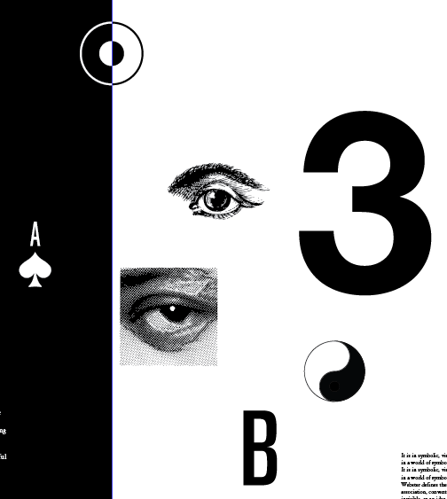 |  | Yale/Rand Estate
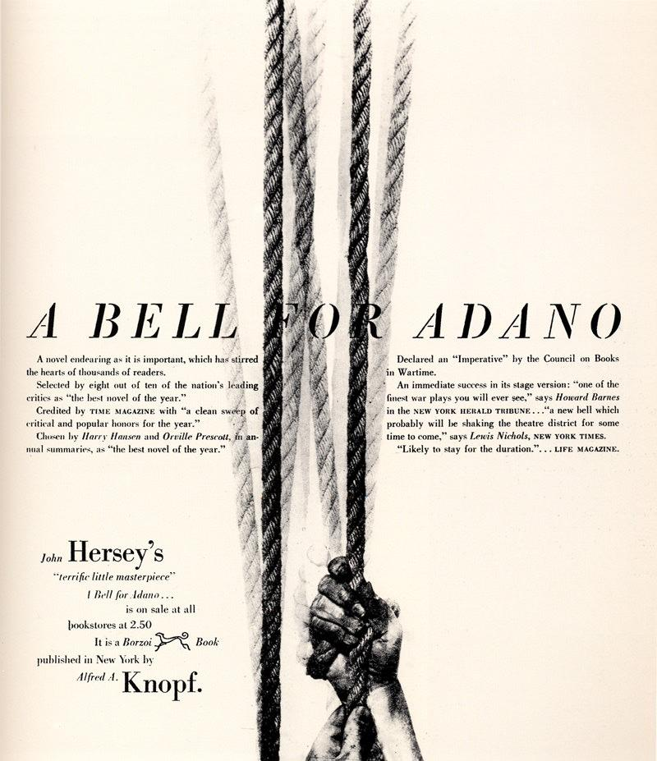
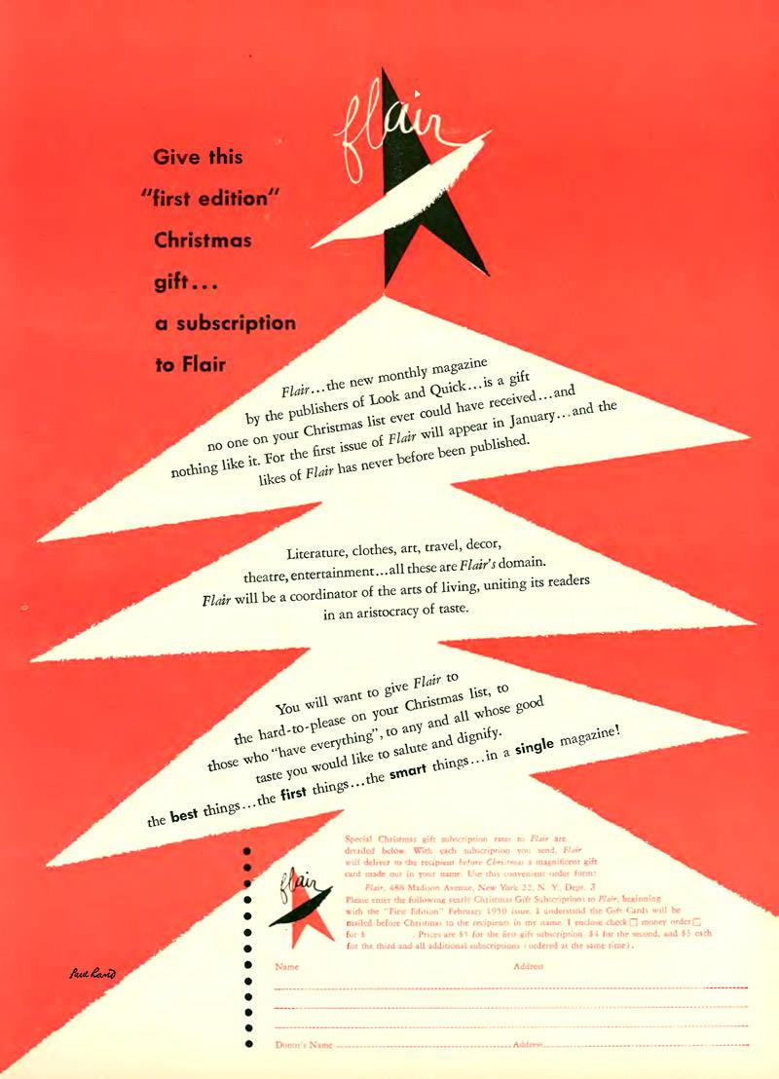
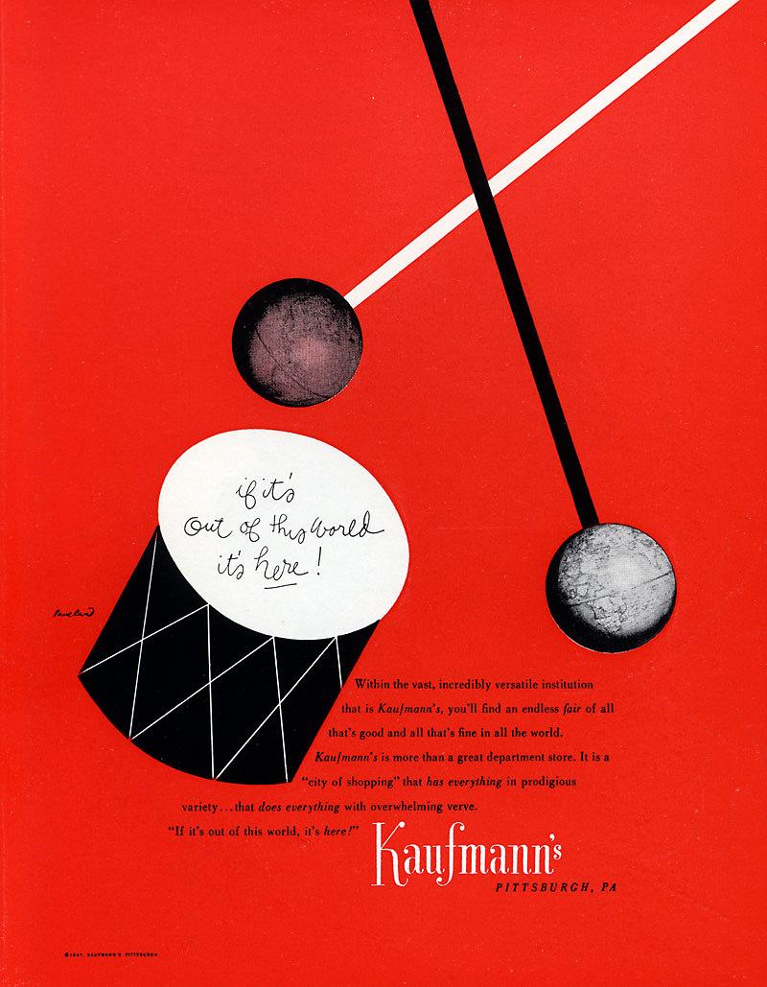
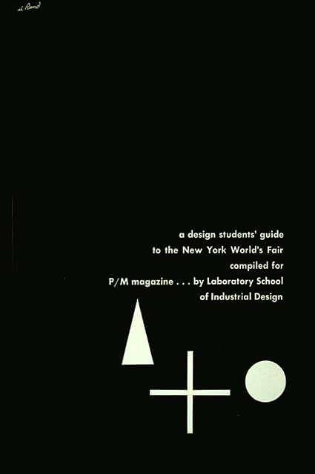
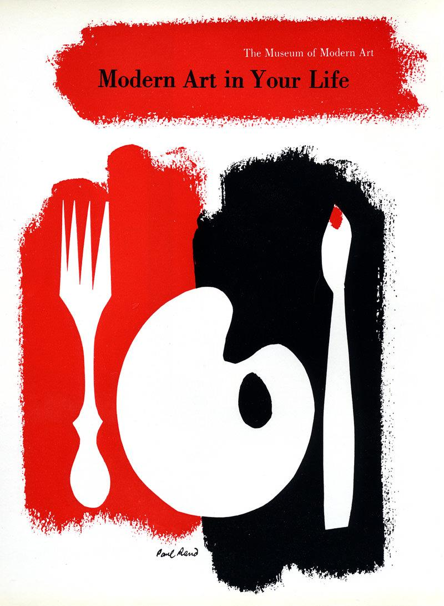
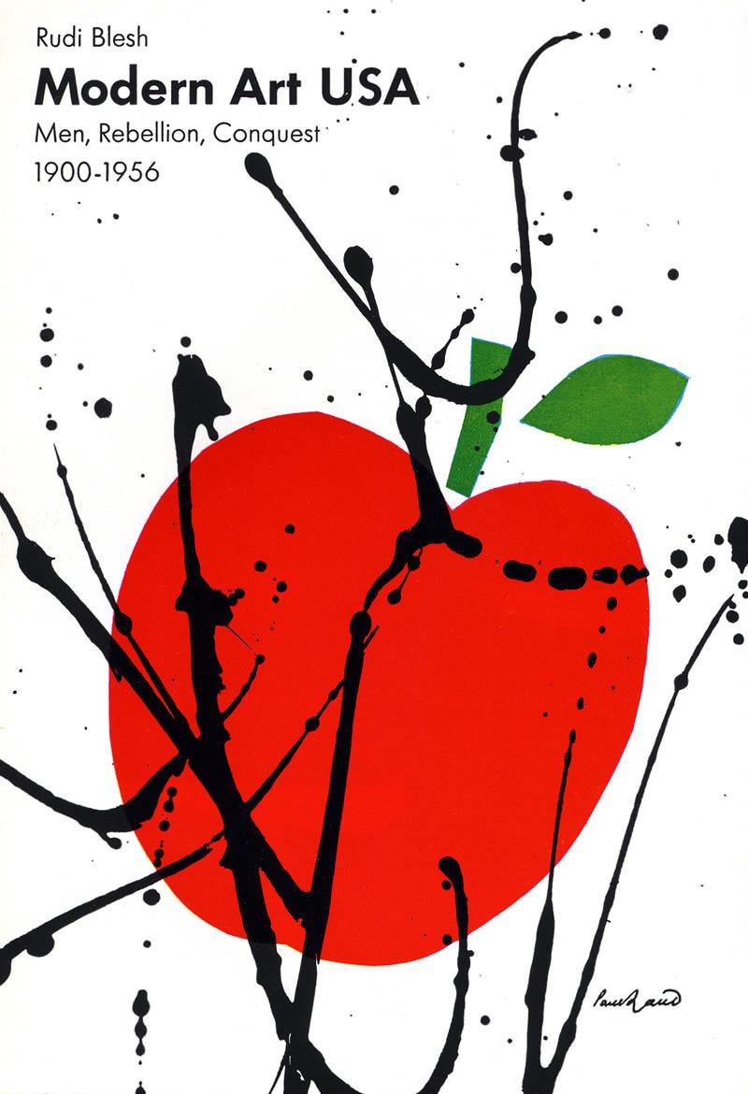
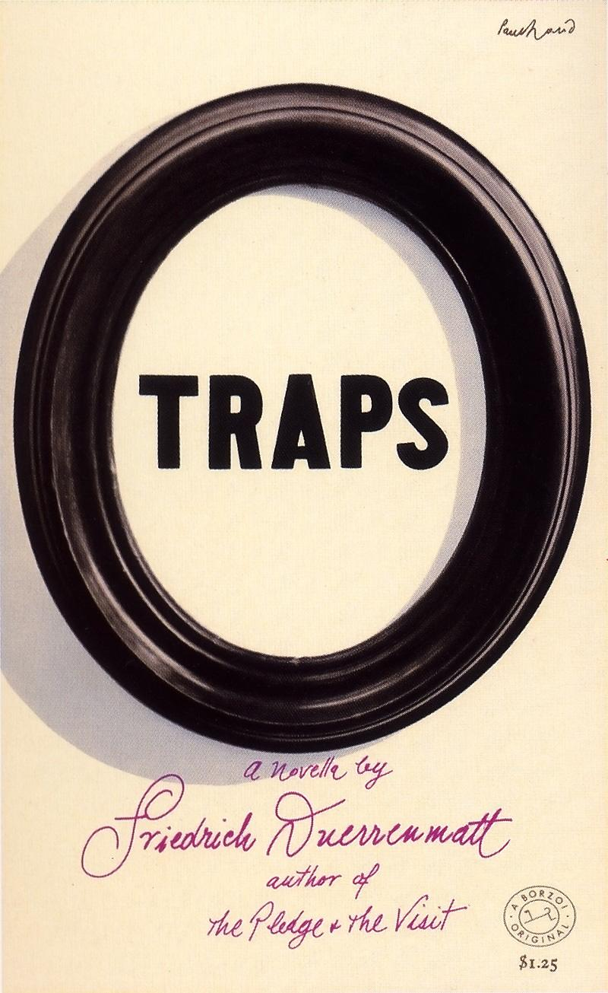
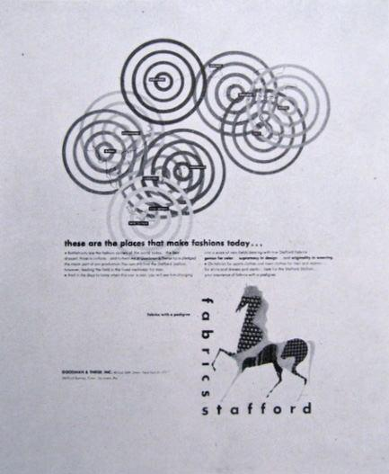
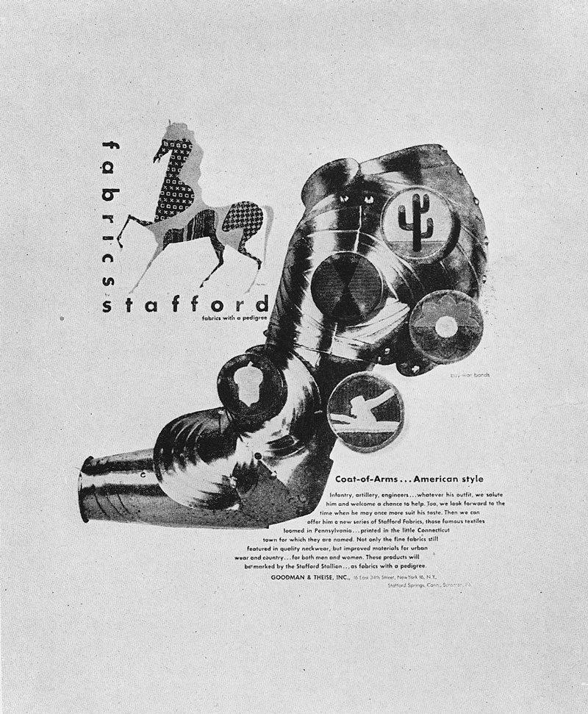
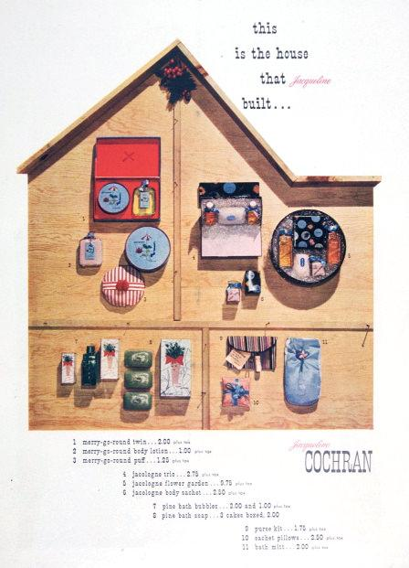
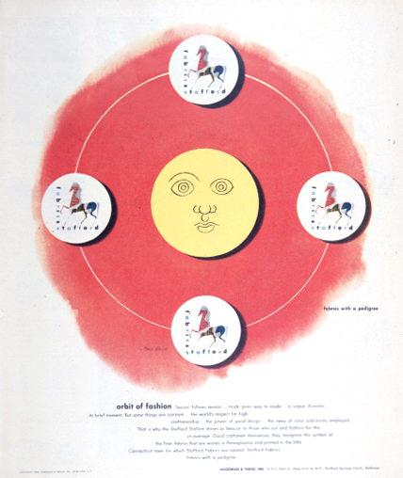
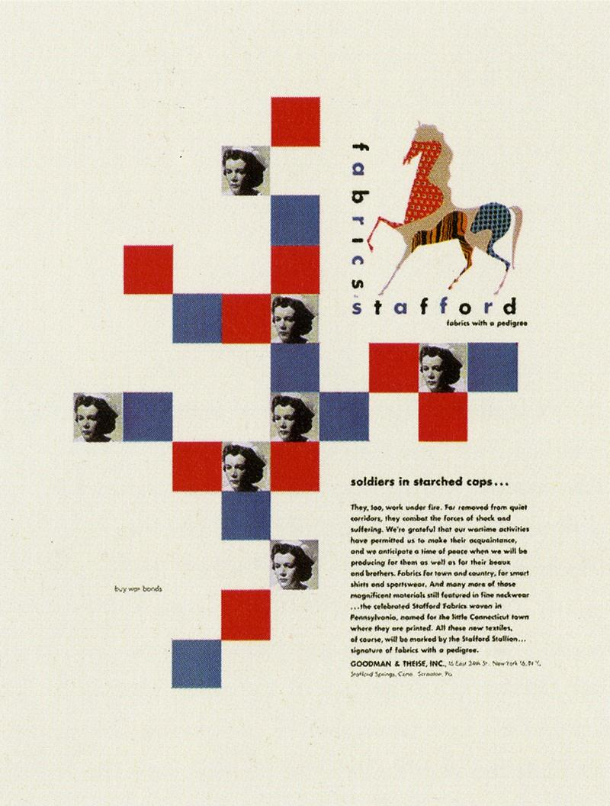
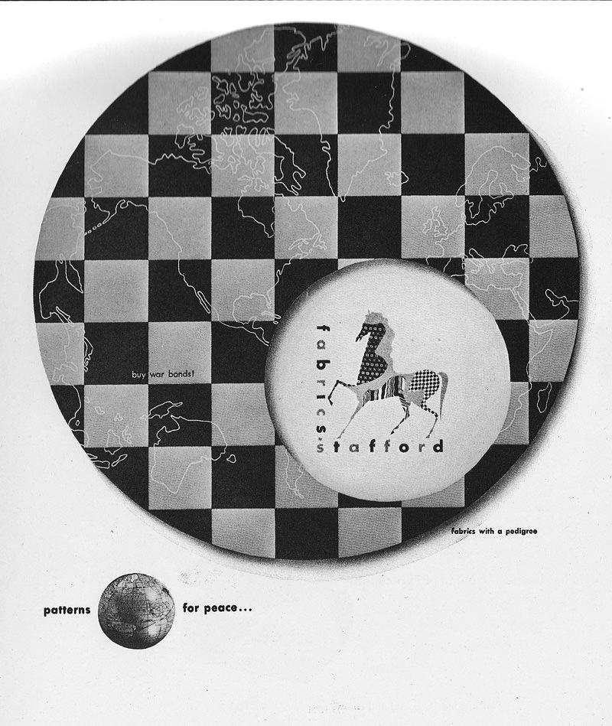

Collage and Montage
Paul Rand, A Designer’s Art, 1985

It is a truism that the fundamental problem of the advertiser and publisher is to get the message into the readers mind. Commonplace images and unimaginative visualization afford the spectator little reason to become engrossed in an advertiser’s product.
Collage and montage permit the integration of seemingly unrelated objects or ideas in a single picture; they enable the designer to indicate simultaneous events or scenes which by more conventional methods would result in a series of isolated pictures. The complex message presented in a single picture more readily enables the spectator to focus his attention on the advertiser’s message.
In one sense montage and collage are integrated visual arrangements in space, and in another sense they are absorbing visual tests that the spectator may perceive and decipher for himself. He may thus participate directly in the creative process.
Should we say something about the images that illustrate this? I think it’s important to connect words with images. Not everyone will be able to do that on their own

Examples to use
Image | Label | Owner | Cost
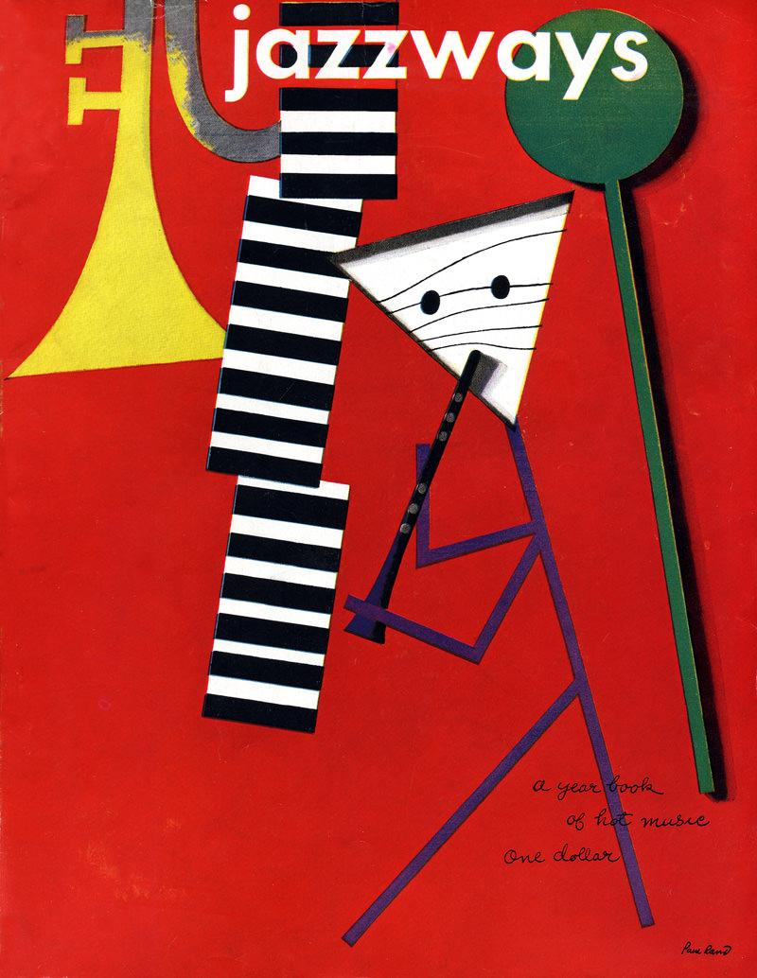 | Jazzways Cover | Danny | $0
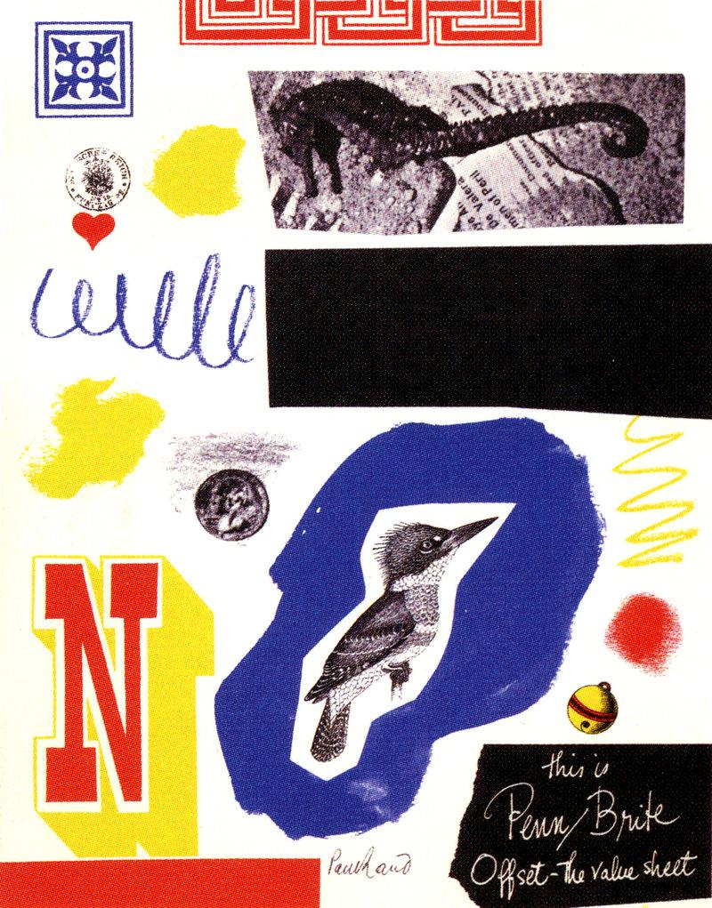
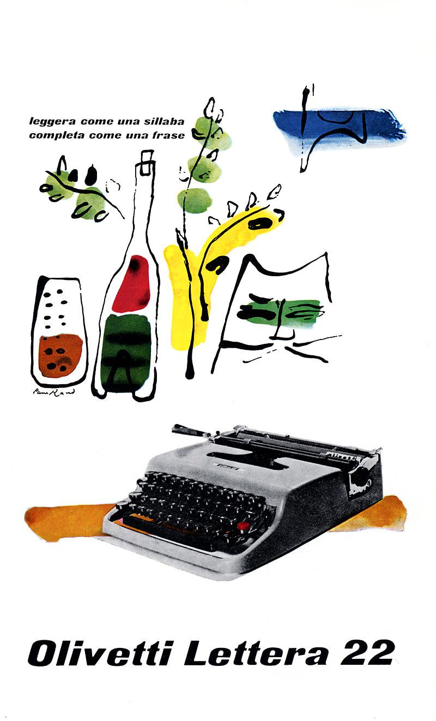
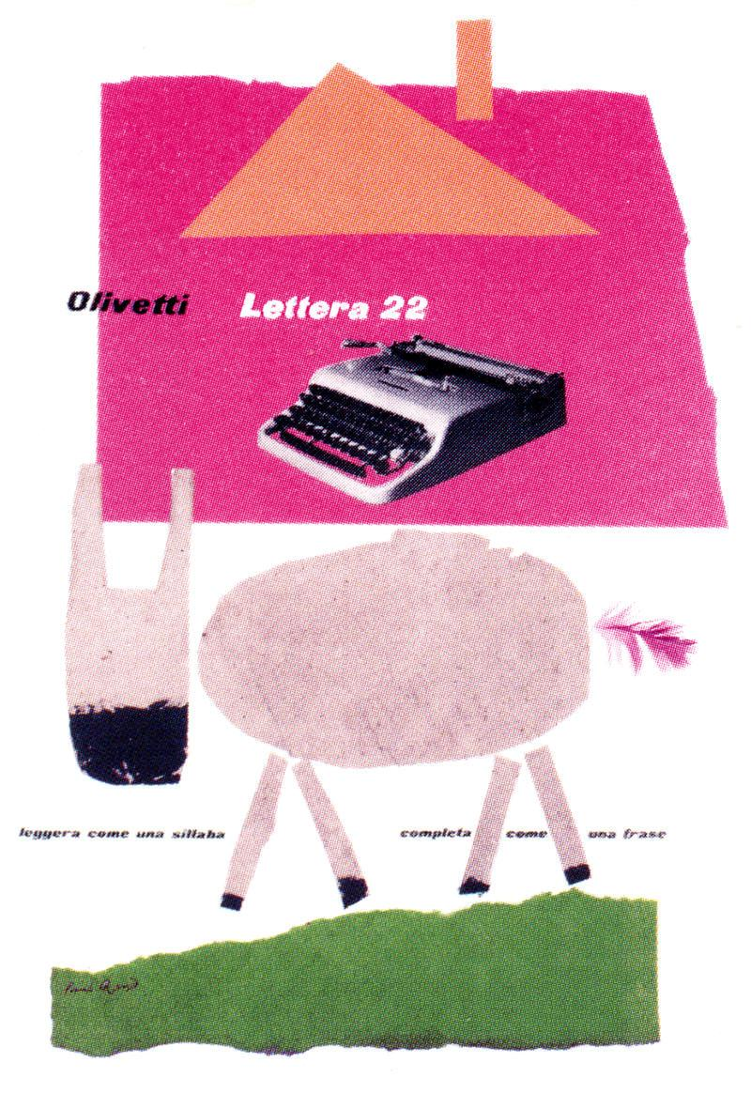
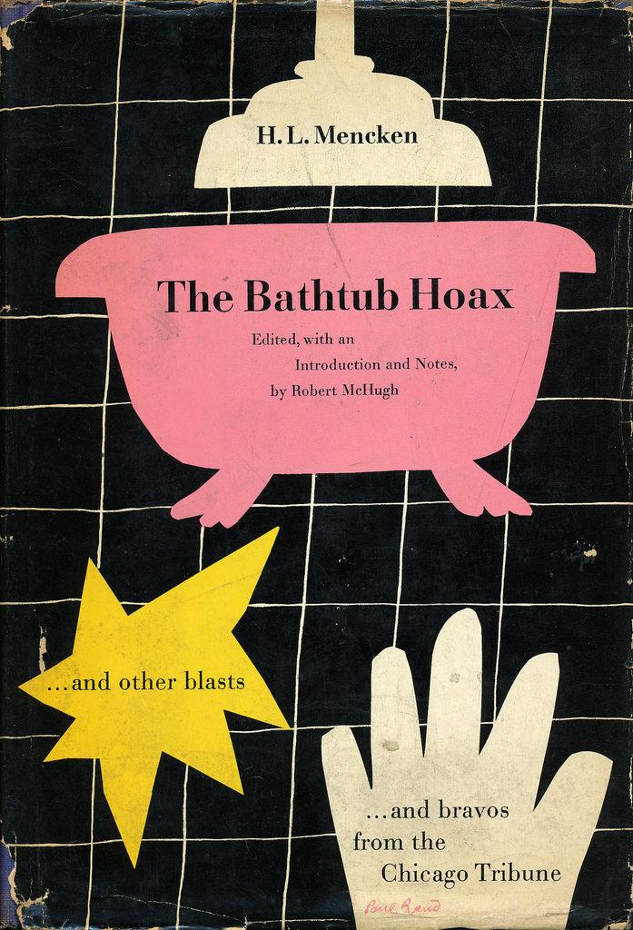
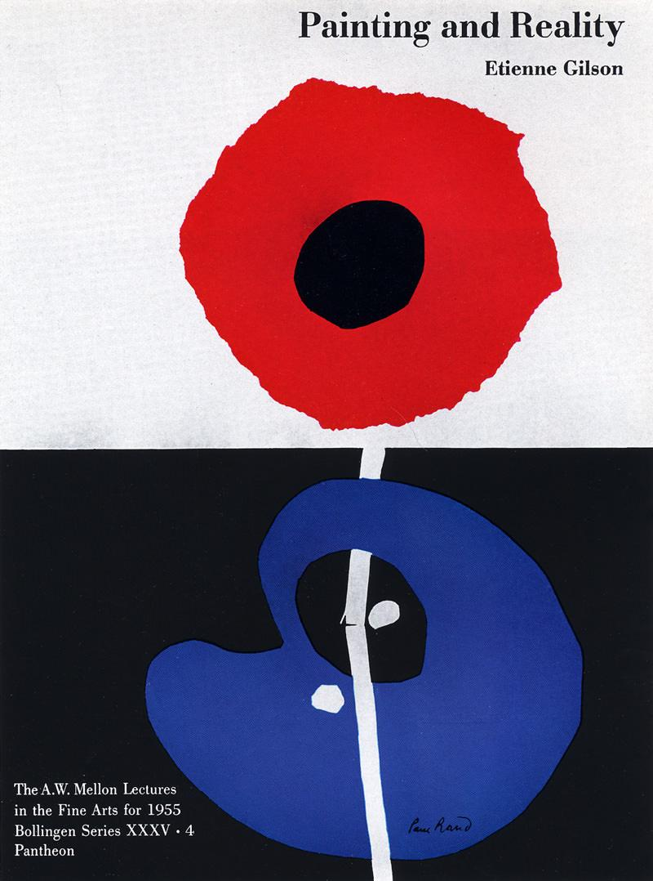
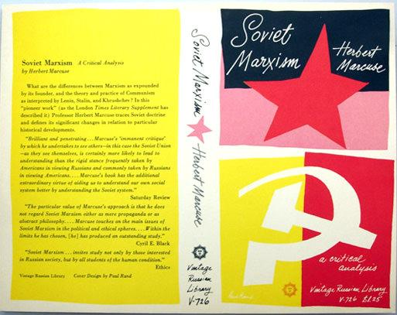
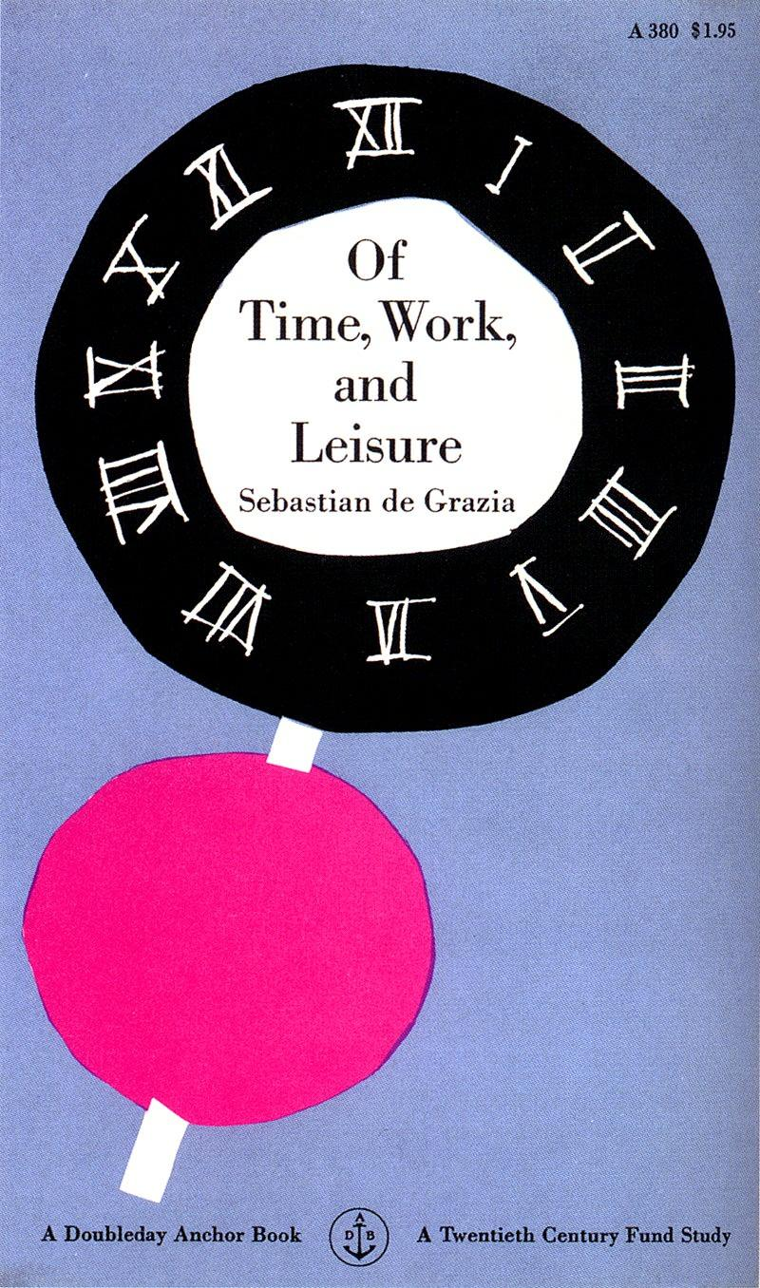
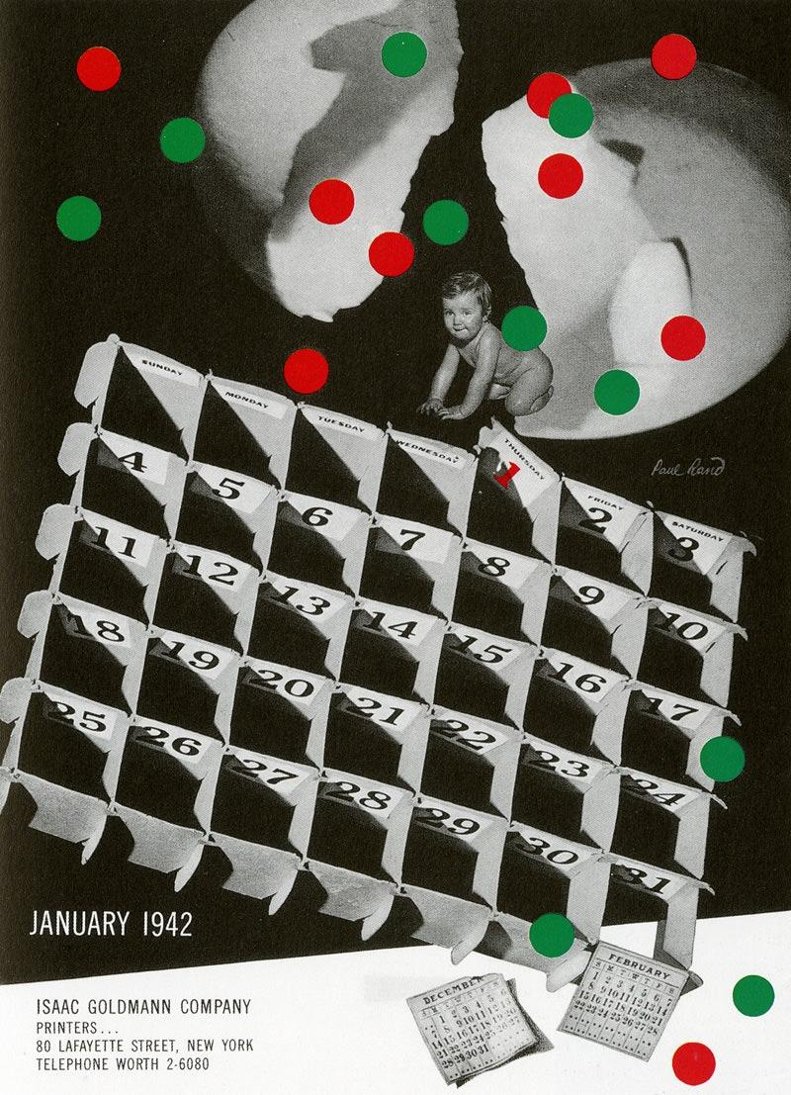
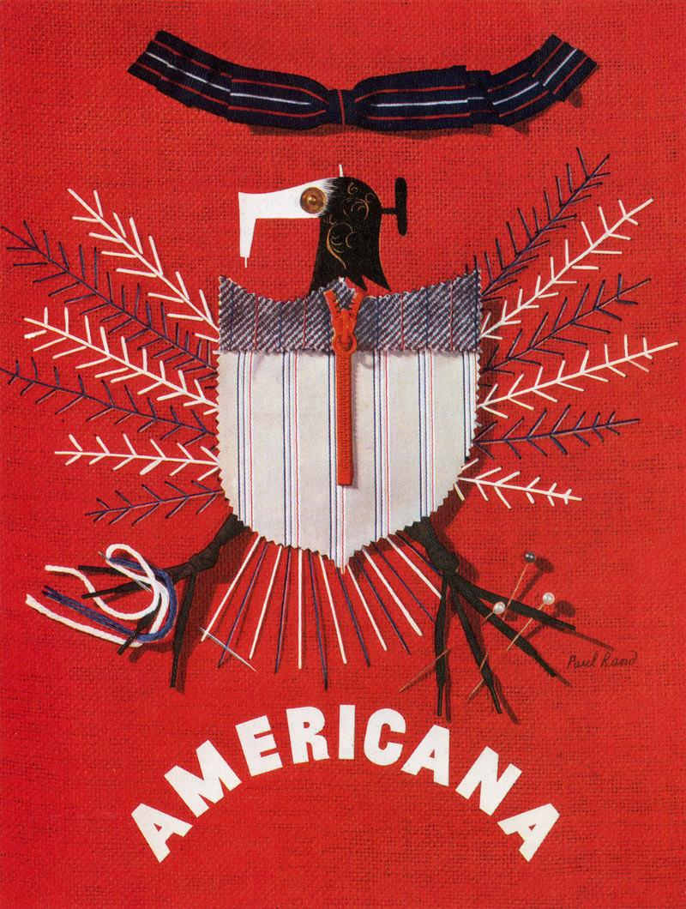
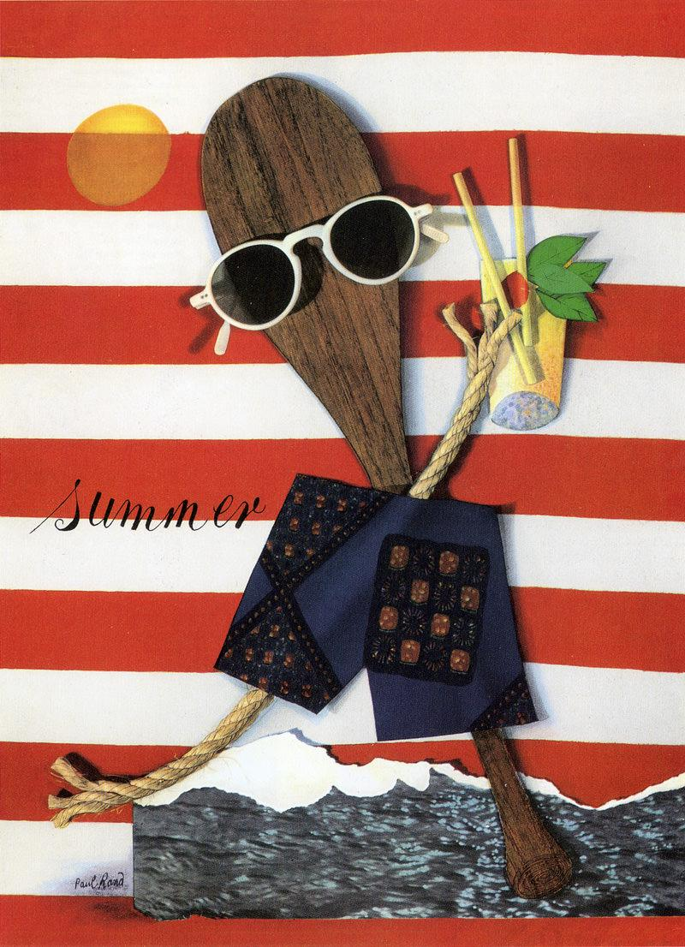
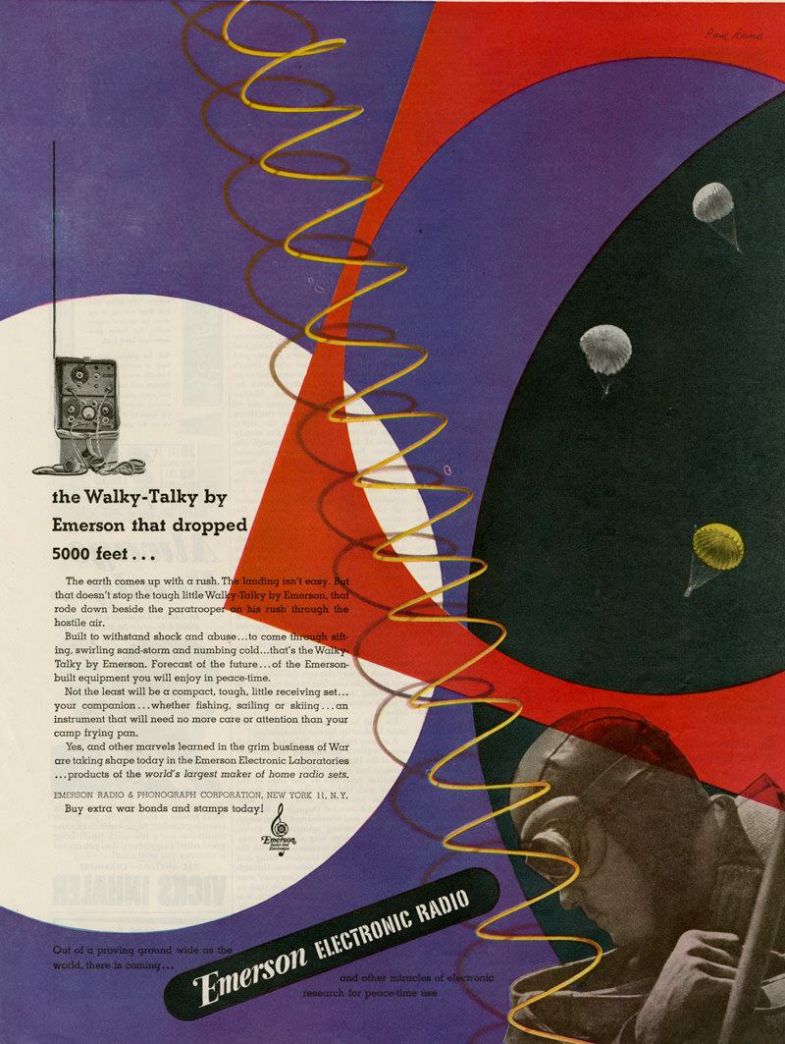

Ideas About Ideas
Paul Rand, A Designer’s Art, 1985

The source of the creative impulse is a mystery. Where do ideas come from?
The artist takes note of that which jolts him into visual awareness. Without the harvest of visual experience he would be unable to cope with the plethora of problems, mundane or otherwise, that confronts him in his daily work. Ideas may also grow out of the problem itself which in turn becomes part of the solution.
This profile with a staring eye, which I recalled seeing in a book on Etruscan art, prompted the idea for the illustration of this 1946 Container Corporation advertisement. The haunting eyes are germane to the message the advertisement is designed to convey.

This was one of about four or five ads I did for Container Corp.’s “Great Ideas of Western Man” series. It was actually done on a piece of decayed wood. It was not a photograph. I presented the design on a piece of wood with a real nail going through the photostat of the imprint, and then it was photographed by the printer.
The Etruscans painted portraits of people who were dead on pieces of wood and used them as grave markers. It was these paintings that generated this idea. The stare on the face is one of fear, and the paper is nailed over the person’s mouth. So it convey the idea of what censorship is all about.

Examples to use
Image | Label | Owner | Cost
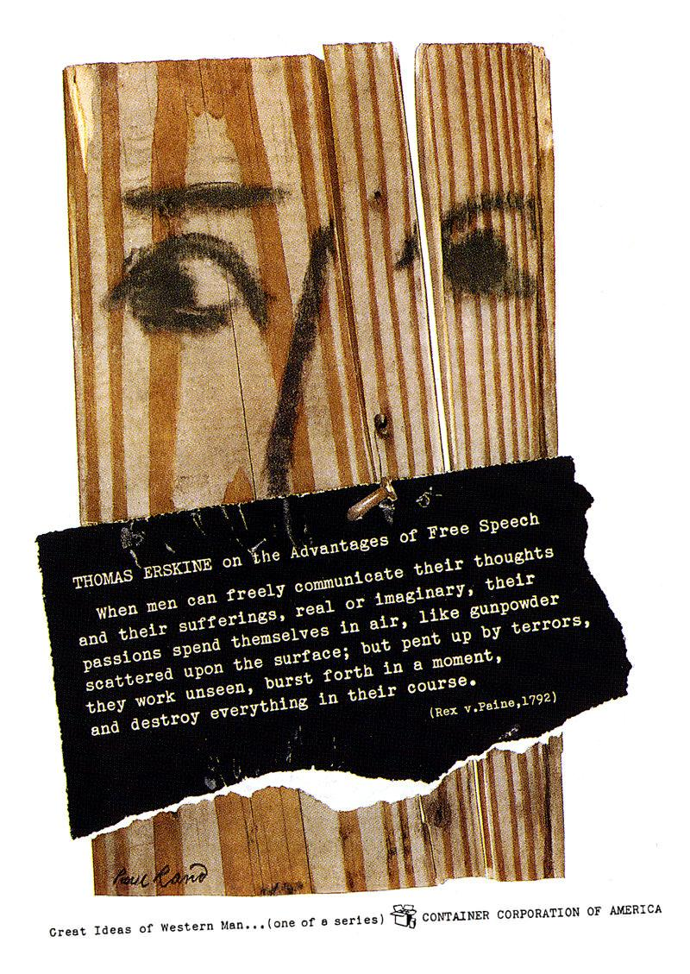

Integrating Form and Content
Paul Rand, Thoughts on Design, 3rd Edition, 1970.

“Originality is a product, not an intention.”
Graphic Wit “Paul Rand: The Play Instinct,” 1991
What we commonly understand as “originality” depends on the successful integration of the symbol as a visual entity with all other elements, pointed to a particular problem, performing a specific function consistent with its form. Its use at the proper time and place is essential and its misuse will inevitably result in banality or mere affectation. The designer’s capacity to contribute to the effectiveness of the basic meaning of the symbol, by interpretation, addition, subtraction, juxtaposition, alteration, adjustment, association, intensification, and clarification, is parallel to those qualities that we call “original.”

In the examples that follow, the abstract, geometric forms (attention-arresting devices) tend to dominate, while the representational images play a supporting role. The complementary relationship between these two types of images is dramatized when human expression is introduced.
OBJECT LABEL: The Coronet Brandy advertisements are based on a common object – the brandy snifter in animated form. The dot pattern of the soda bottle was designed to suggest effervescence; the dotted background is a visual extension of the bottle; the waiter is a variation of the snifter glass; the oval tray individualizes for Coronet the silver tray we used to see in liquor advertisements.

OBJECT LABEL: The dividing line between representational and nonrepresentational images is often very slim. In this advertisement for Ohrbach’s, the window shade acts as a formal as well as a poignantly suggestive image (1946).
OBJECT LABEL: Occasionally purely nonrepresentational images function even more effectively without the support of explanatory illustrations which tend to confine an idea and limit the imagination. The spectator is thus able to see more than is actually portrayed.

Examples to use
Image | Label | Owner | Cost
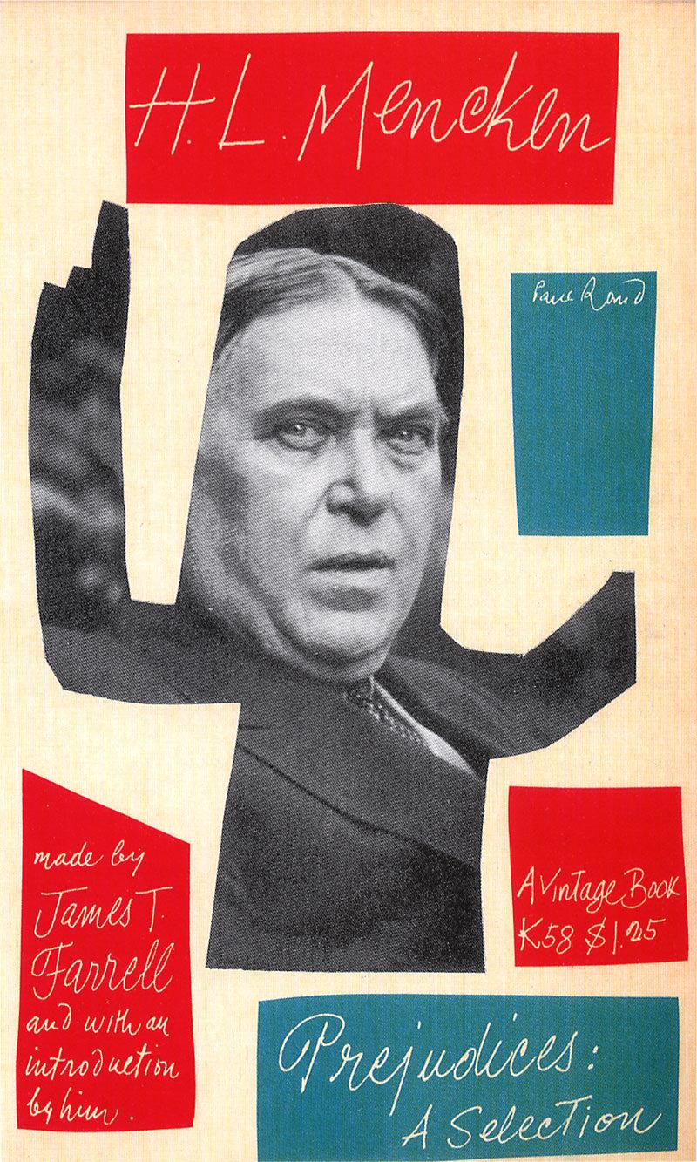

Seeing Stripes
Paul Rand, A Designer’s Art, 1985.

Nature has striped the zebra. Man has striped his flags and awnings, ties and shirts. For the typographer, stripes are rules; for the architect they are a means of creating optical illusions. Stripes are dazzling, sometimes hypnotic, usually happy. They are universal. They have adorned the walls of houses, churches, and mosques. Stripes attract attention.
The stripes of the IBM logo serve primarily as an attention getting device. They take commonplace letters out of the realm of the ordinary. They are memorable. They suggest efficiency and speed. The recent spate of striped logos in the marketplace attests to their effectiveness.
Visually, stripes superimposed on a cluster of letters tend to tie them together. This is especially useful for complex groupings such as the letters IBM, in which each character gets progressively wider, thereby creating a somewhat uncomfortable, open-ended sequence.
Examples to use
Image | Label | Owner | Cost
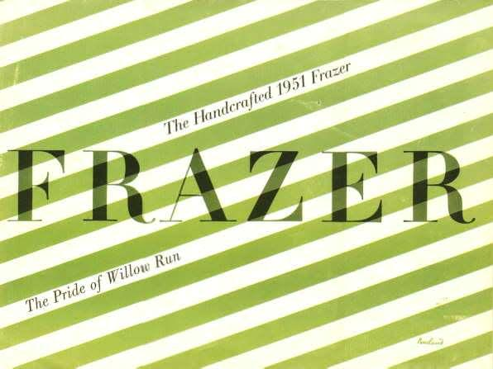
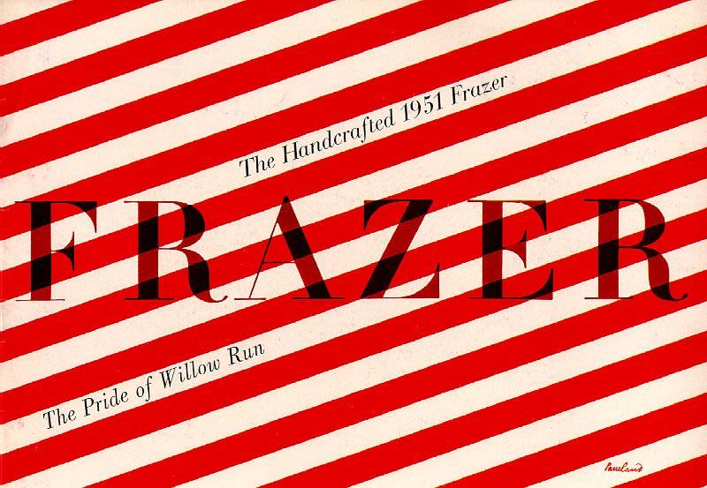
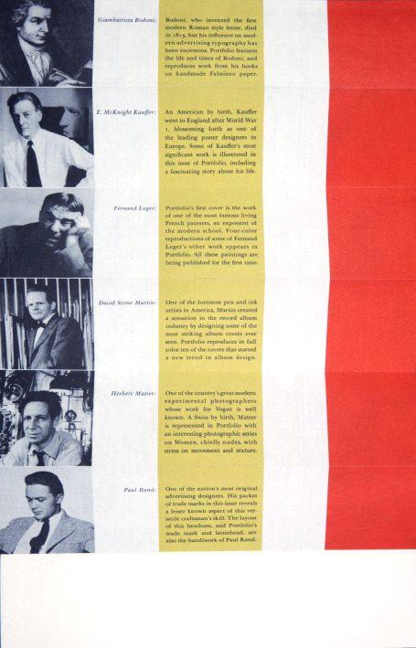
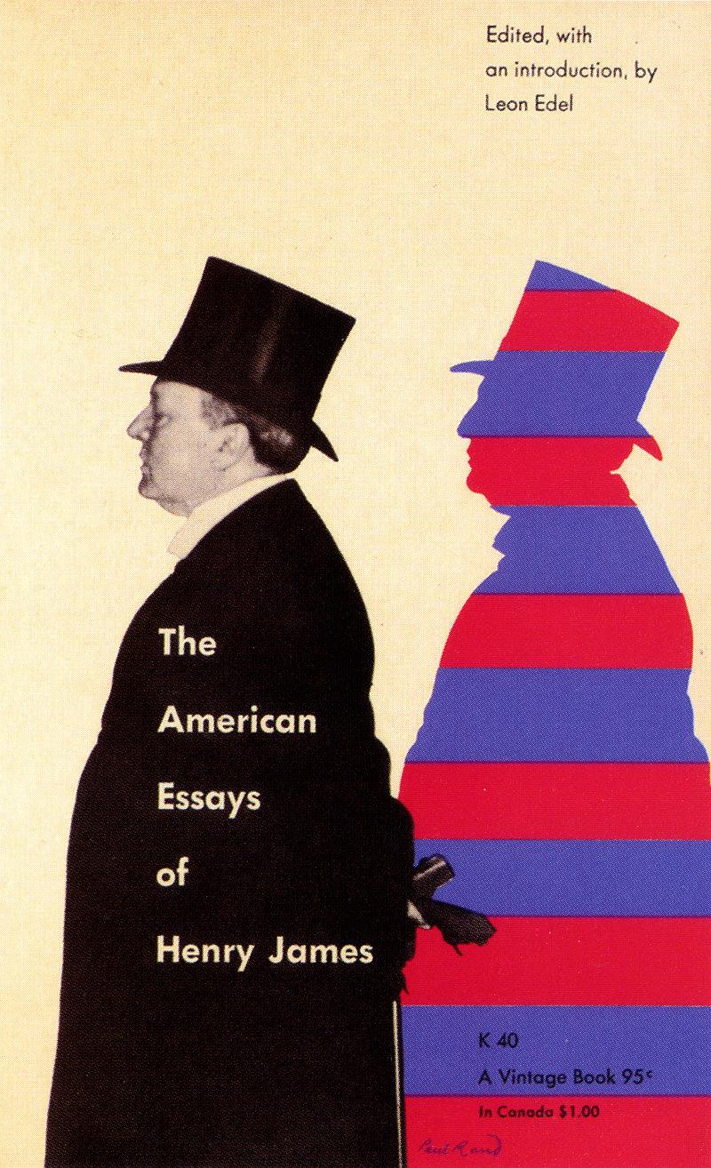
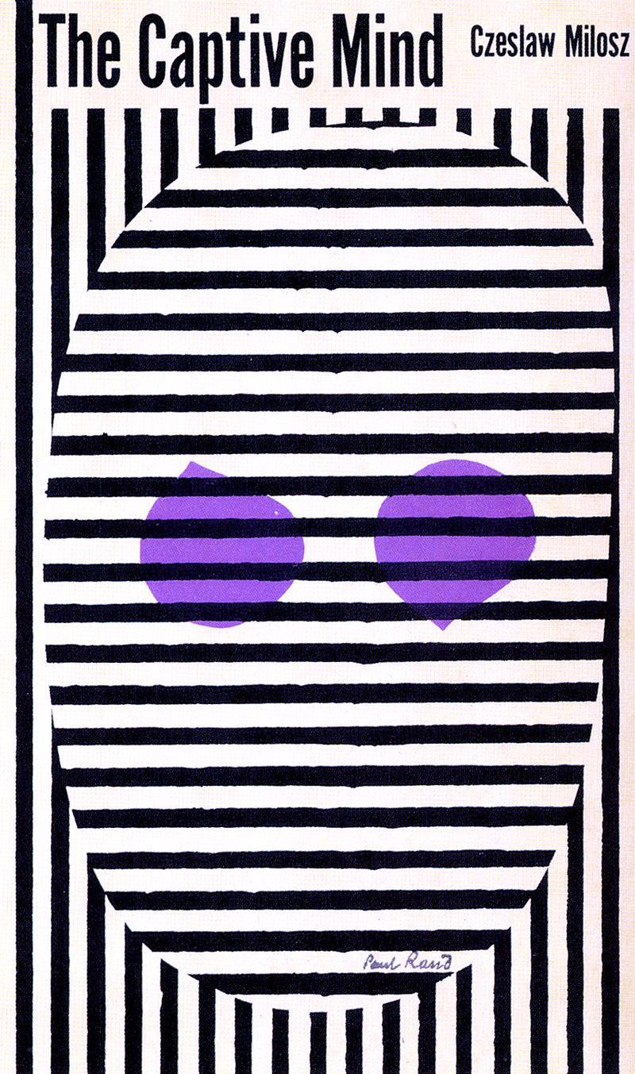
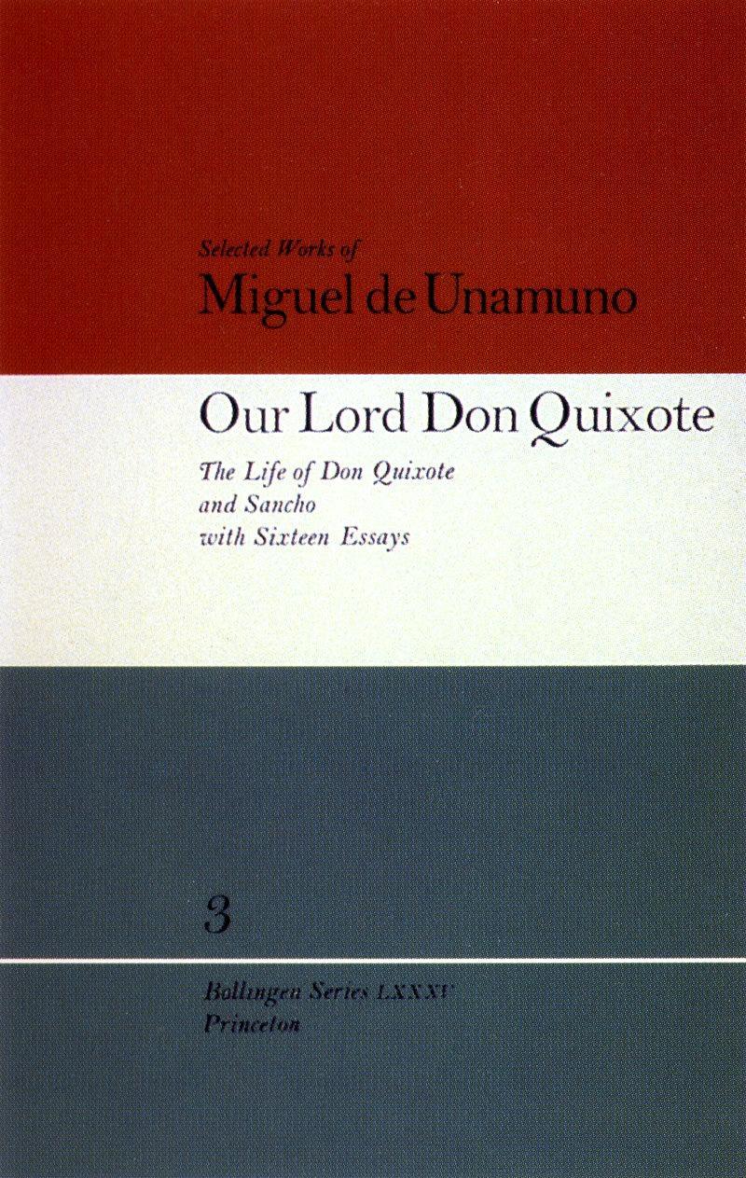
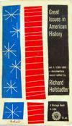
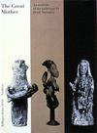
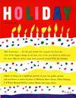
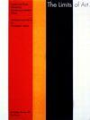
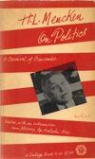
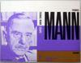
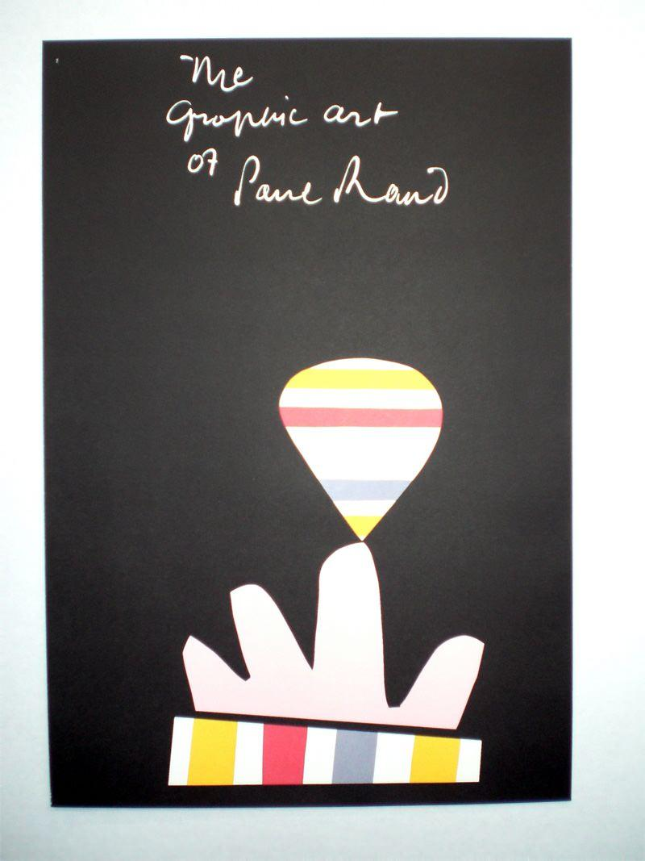
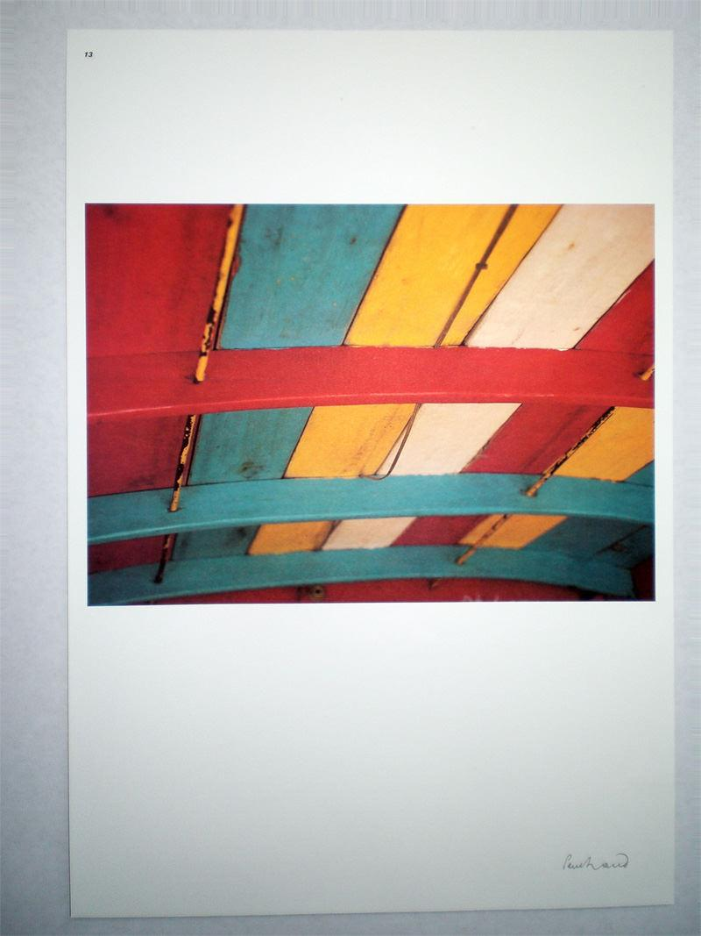
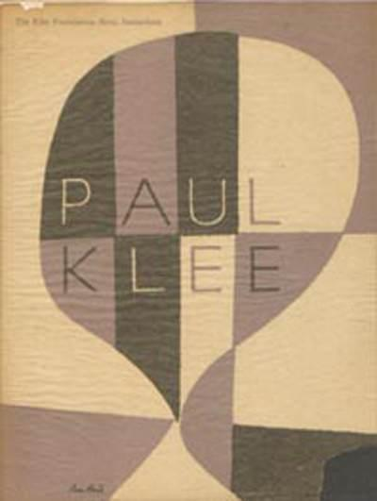
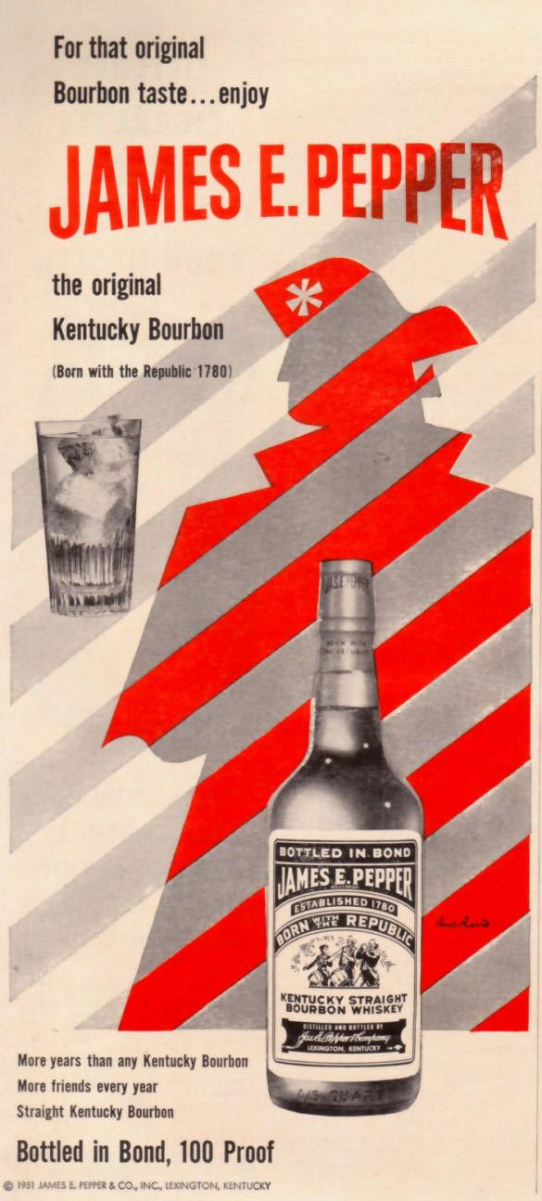
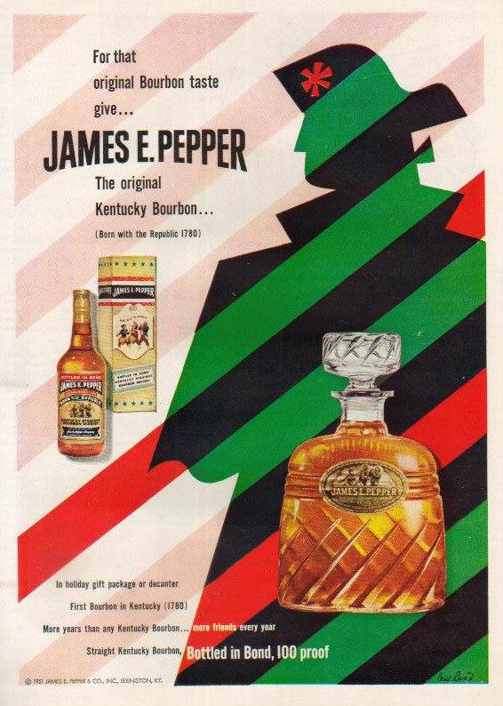
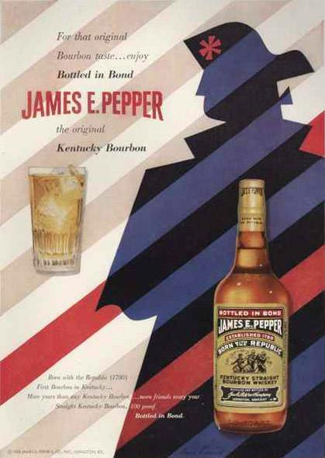

The Meaning of Repetition
Paul Rand, A Designer’s Art, 1985.

The emotional force generated by the repetition of words or pictures and the visual possibilities (as a means of creating texture, movement, rhythm, indicating equivalences of time and space) should not be minimized. The possibilities of repetition are limitless. Repeat patterns are only one familiar form. There is repetition of color, direction, weight, texture, dimension, movement, expression, shape, and so on. Repetition is an effective way of achieving unity.
Repetition also means remembrance. The efficacy of a trademark, for example, is dependent less on its design than on its repeated exposure to public view. Familiar things, as well as a touch of humor, are effective mnemonic devices.

Examples to use
Image | Label | Owner | Cost
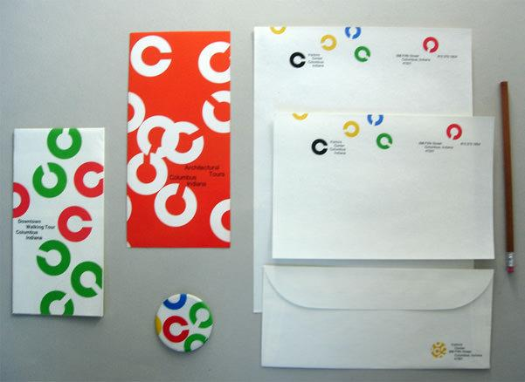
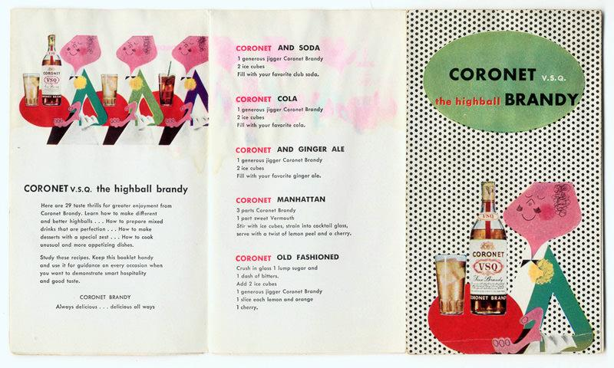
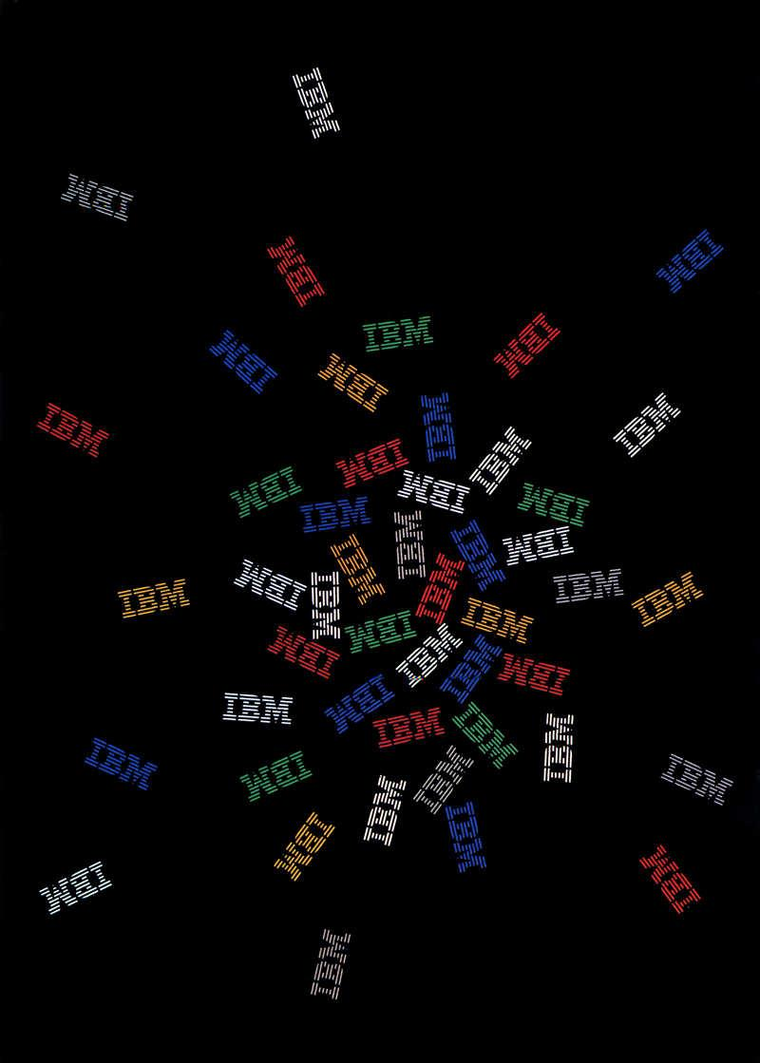
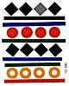
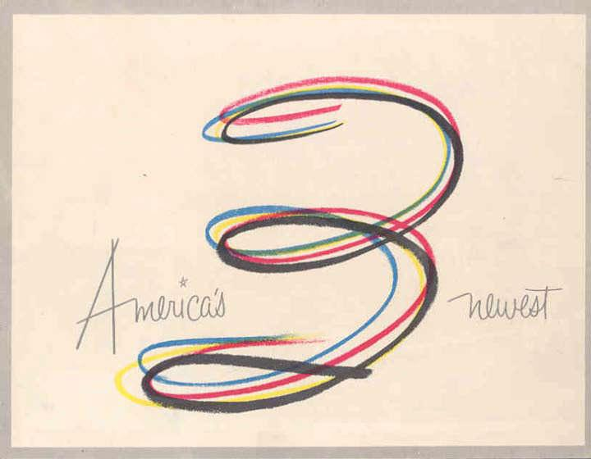
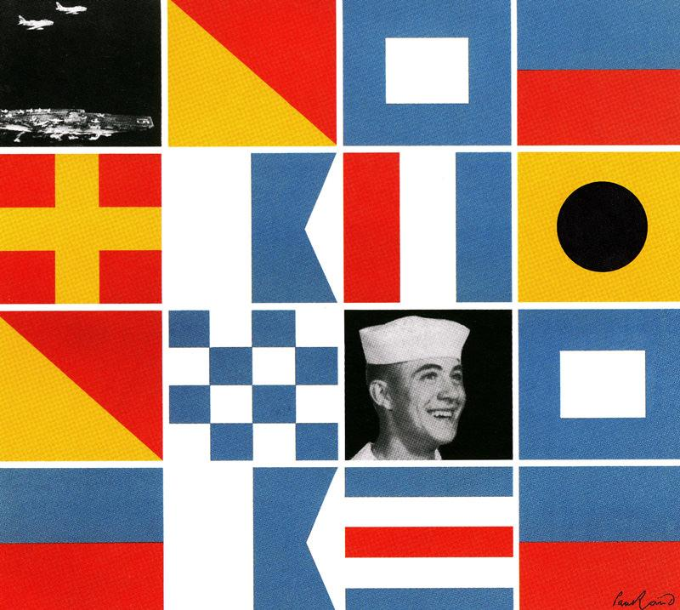
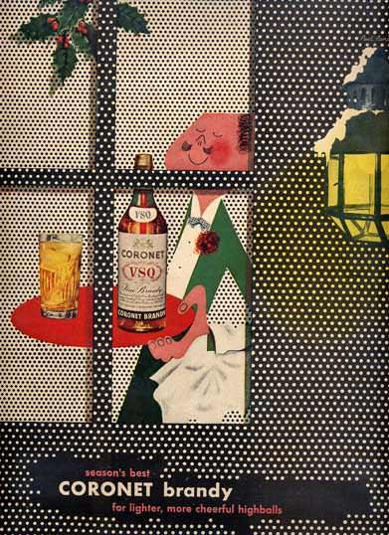
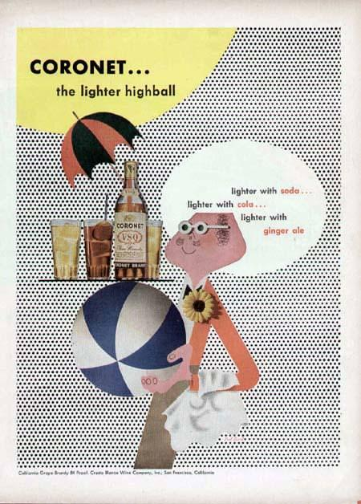
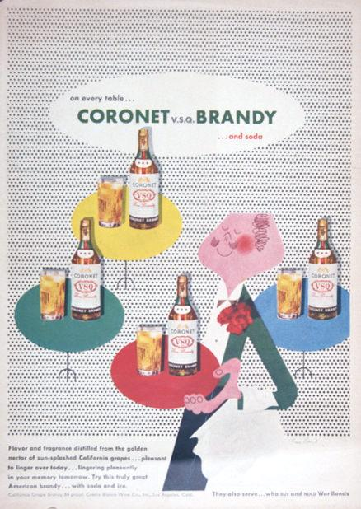
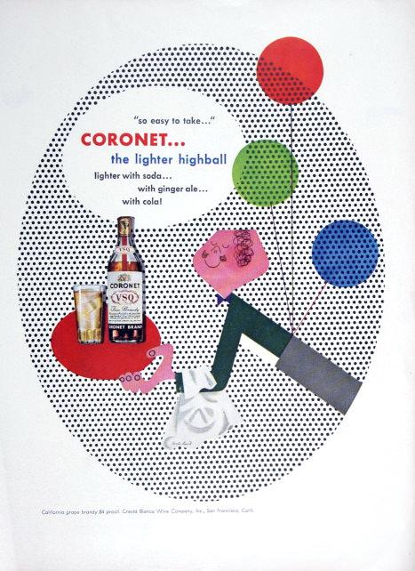
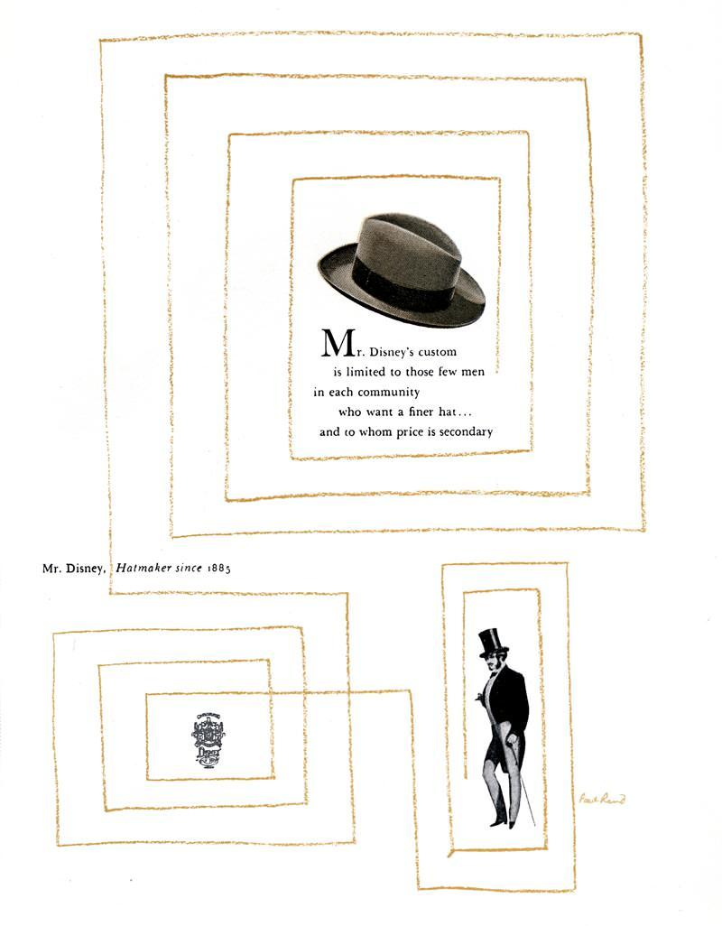
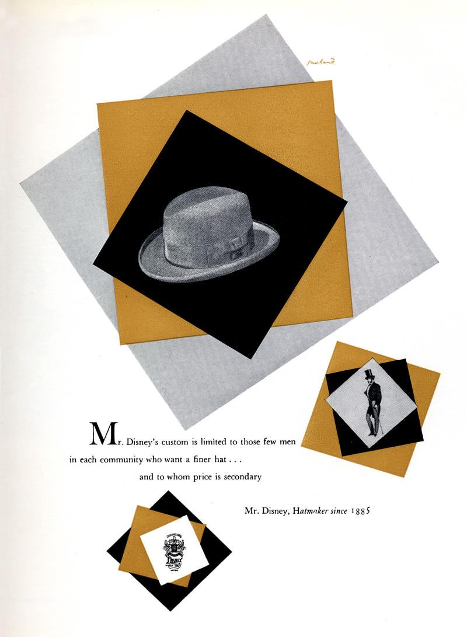
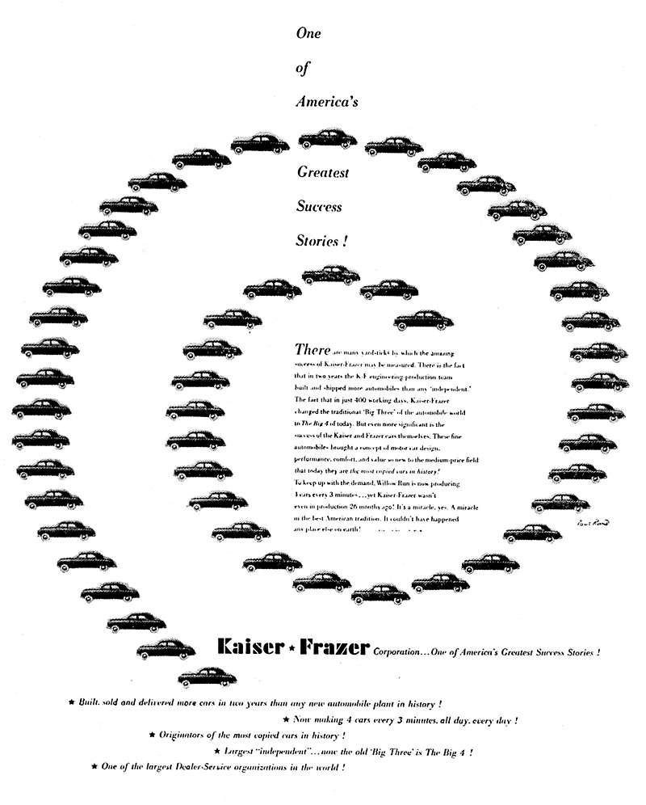
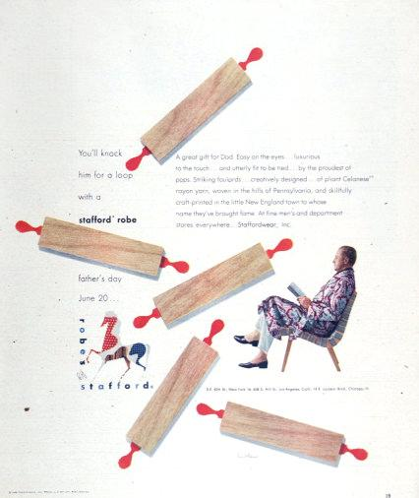
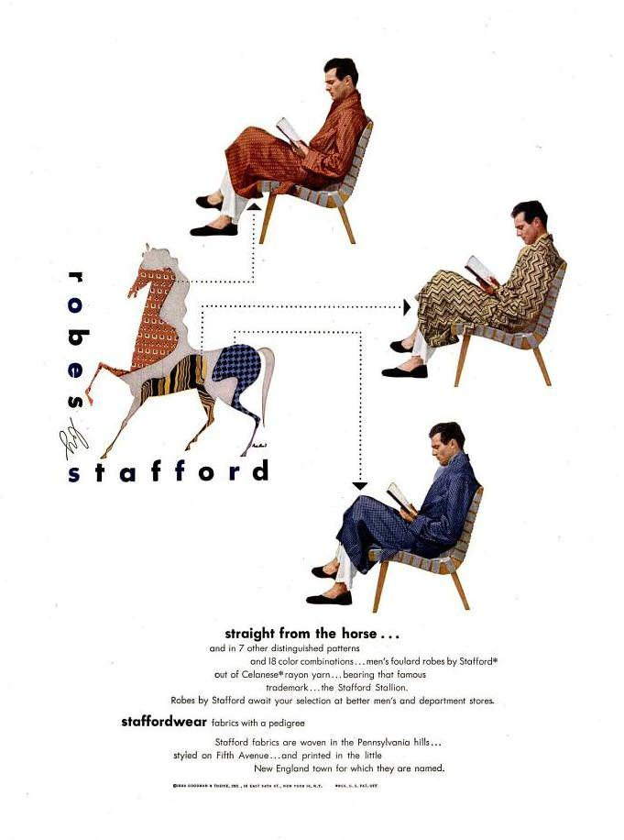
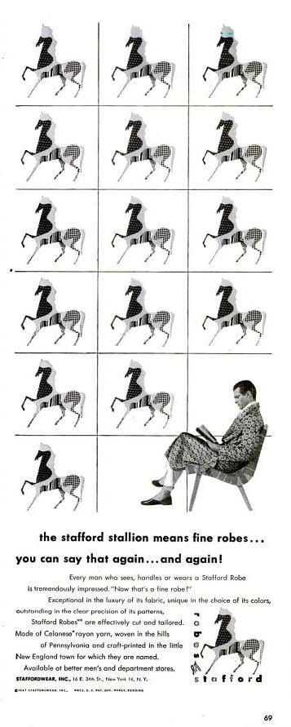
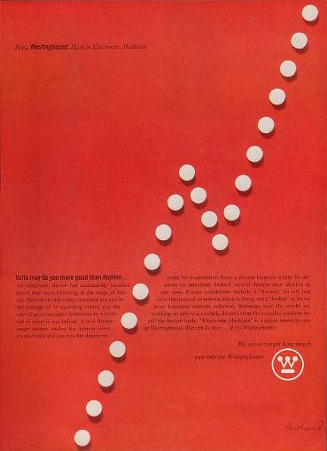

The Rebus and the Visual Pun
Paul Rand, A Designer’s Art, 1985.

A single letter says more than a thousand words. The dual reading is what makes such images memorable. They amuse as they inform. The U symbol is an experiment in visual puns, as is the cover design for AIGA, which combines a rebus (the eye for the letter l) and a collection of letters to produce a mask. Of the twenty-six letters of the alphabet, the letters B and l are clearly the most graphic and least subject to misinterpretation. The rebus is a mnemonic device, a kind of game designed to engage the reader and, incidentally, lots of fun.
The development of any visual image must begin with some tangible idea, conscious or otherwise. It should come as no surprise that, more often than not, creative ideas are the product of chance, intuition, or accident, later justified to fit some prevailing popular theory, practical need, or formal obsession.

Eye-Bee-M Rebus Poster
(OBJECT LABEL FOR REBUS POSTER)

In 1981, Rand designed this image of the IBM logo as a poster to be given away to the design staff during the Golden Circle Award, an in-house IBM event. It has become an historic example of how a company’s humanity and personality can be represented through the combination of a single idea captured in a unique form.

However, this rebus poster was met with great resistance by management who thought that the image was damaging to the IBM brand and would open the door for others to change the logo however they’d like. After years of resistance, the image was resurrected in the poster shown here, with the addition of the text in the bottom left corner to explain the meaning of each symbol.

In the end, good design prevailed and the rebus is now a cornerstone of Rand’s design legacy. It has also found a permanent place in the IBM lexicon and has been used on everything from coffee mugs to stuffed animals.

Examples to use
Image | Label | Owner | Cost
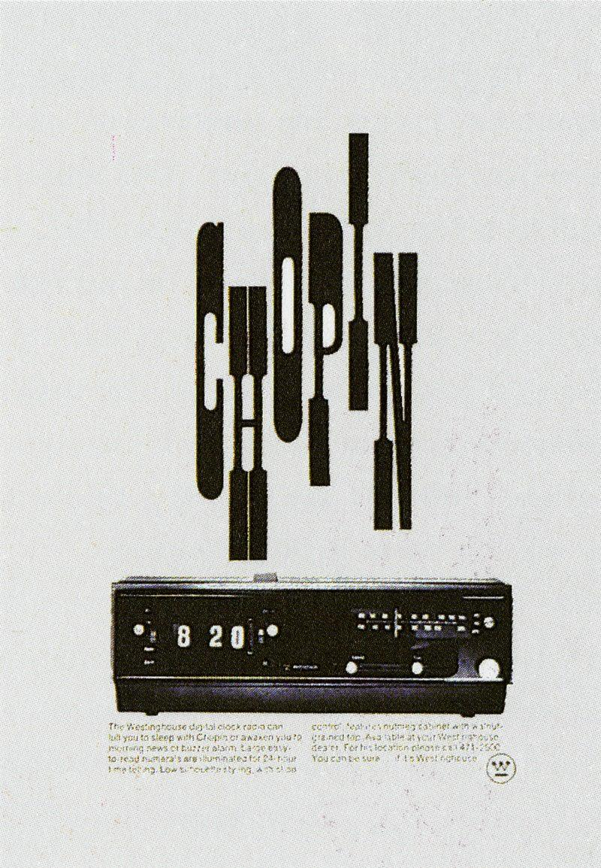

The Role of Humor
Paul Rand, A Designer’s Art, 1985

“I just like things that are playful;
I like things that are happy;
I like things that will make the client smile…
Lecture, A Paul Rand Retrospective
Cooper Union, October 3rd, 1996

Readership surveys demonstrate the significance of humor in the field of visual communication. The reference is not principally to cartoon strip advertisements or to out-and-out gags, but to a more subtle variety, one indigenous to the design itself and achieved by means of association, juxtaposition, size, relationship, proportion, space, or special handling.
The visual message that professes to be profound or elegant often boomerangs as mere pretension; and the frame of mind that looks at humor as trivial and flighty mistakes the shadow for the substance. In short, the notion that the humorous approach to visual communication is undignified or belittling is sheer nonsense. This misconception has been discredited by those entrepreneurs who have successfully exploited humor as a means of creating confidence, goodwill, and a receptive frame of mind toward an idea or product.
1. Printers’ Ink, December 28, 1946.
2. Roger Fry, “Some Aspects of Chinese Art, Transformations, 79 81.

Examples to use
Image | Label | Owner | Cost
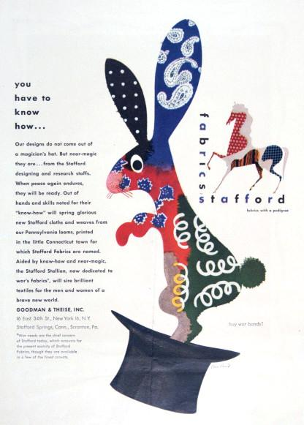
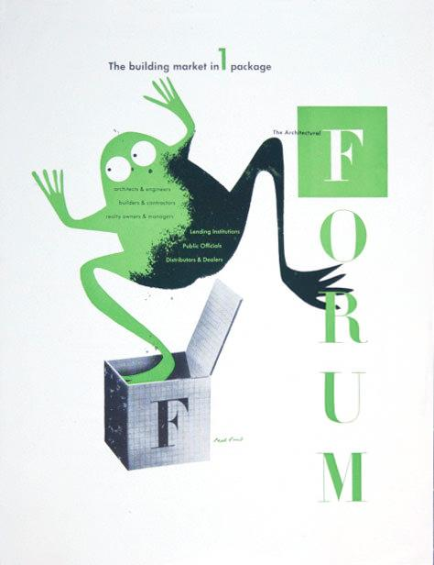
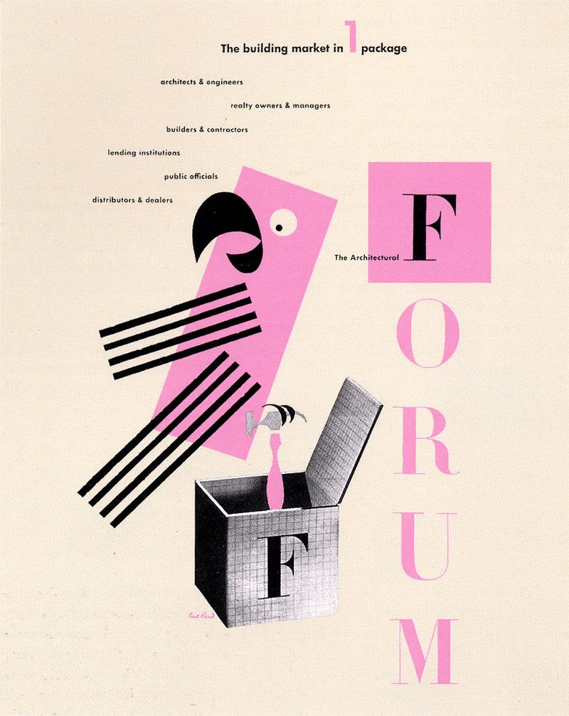
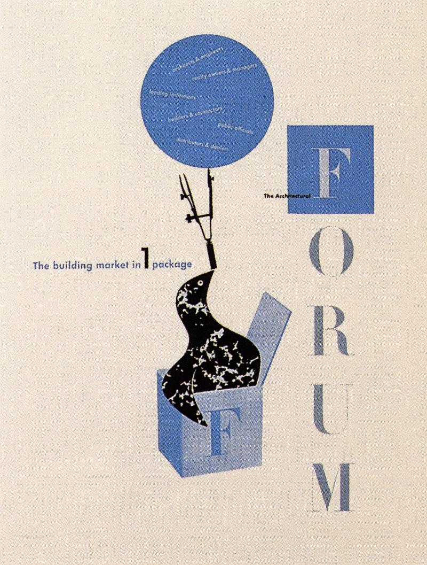
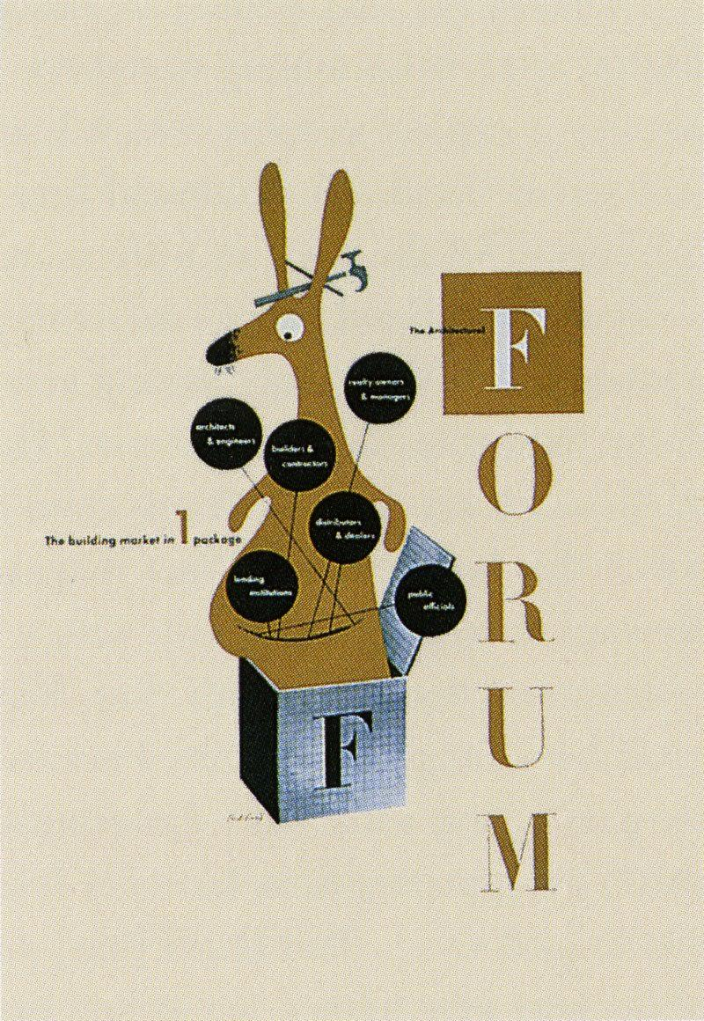
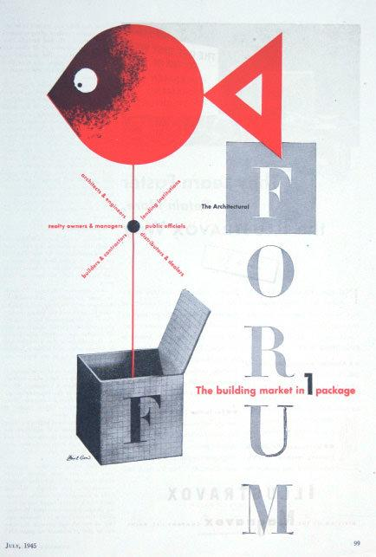
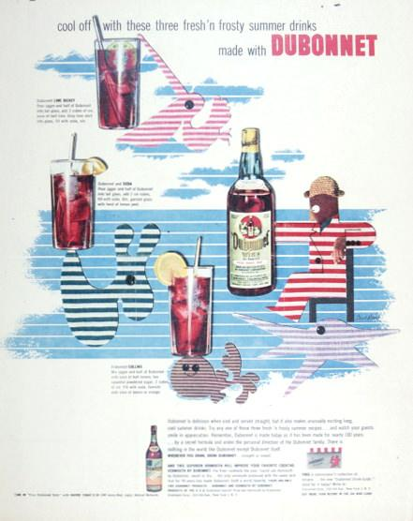
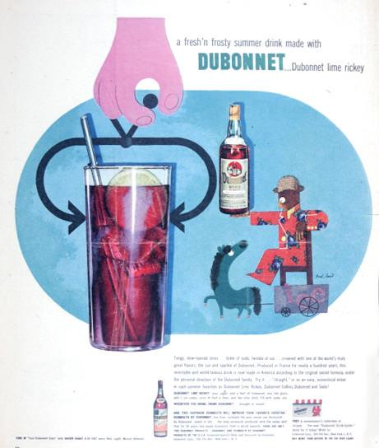
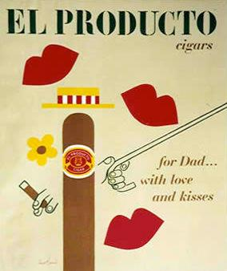
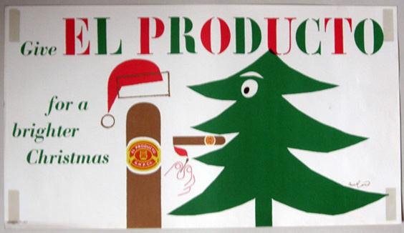
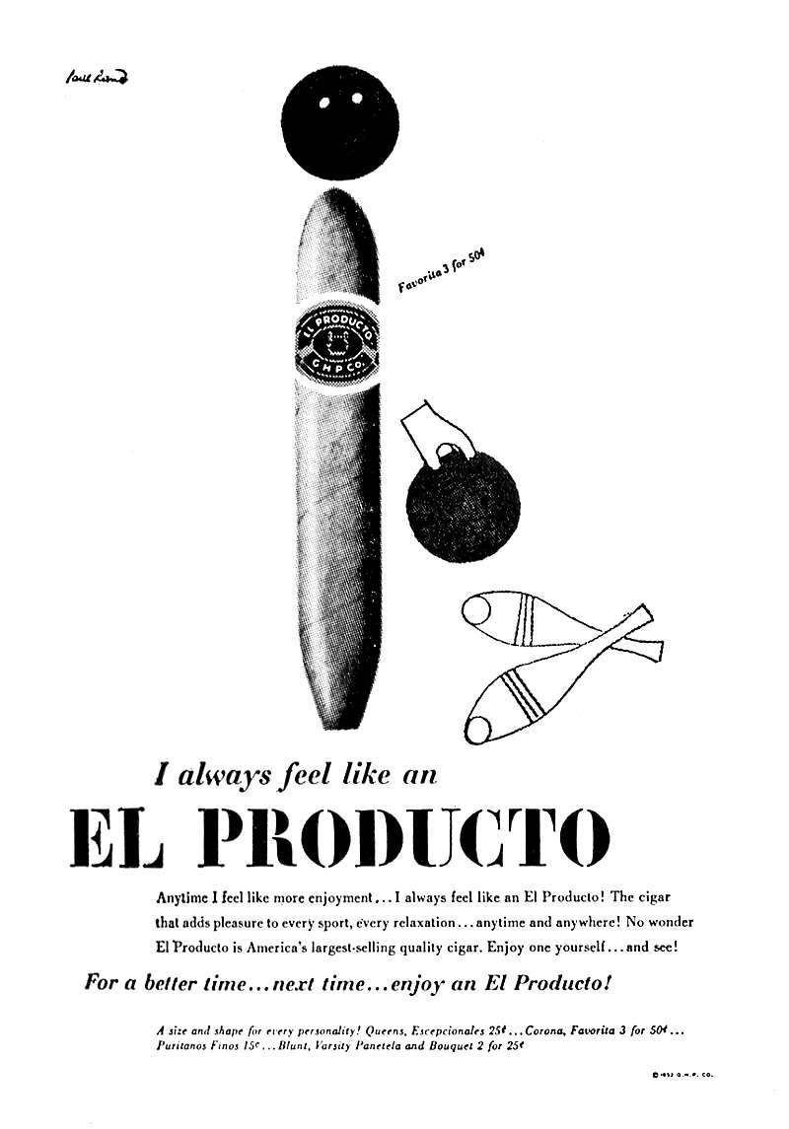
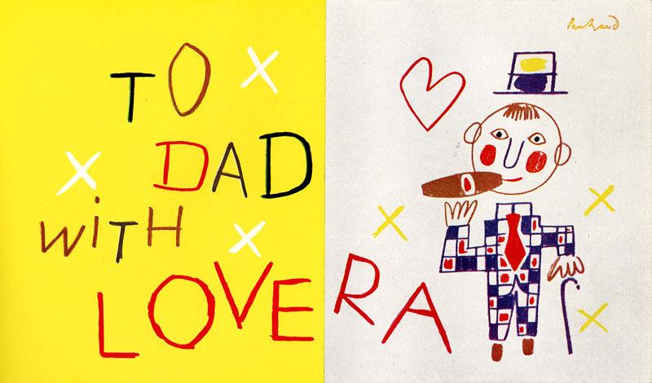
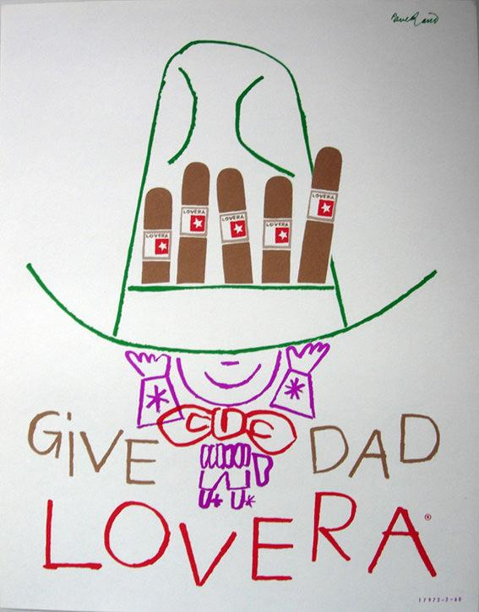

The Trademark
Paul Rand, A Designer’s Art, 1985

The principal role of a logo is to identify, and simplicity is its means… Its effectiveness depends on distinctiveness, visibility, adaptability, memorability, universality, and timelessness.
Paul Rand: Design Form and Chaos, 1993

A trademark
is a picture.
It is a symbol
a sign
an emblem
an escutcheon
…an image.
There are
good symbols…
like the cross.
There are others…
like the swastika.
Their meanings
are taken
from reality.
Symbols
are a duality.
They take on
meaning
from causes
…good or bad.
And they give
meaning
to causes
…good or bad.
The flag
is a symbol
of a country.
The cross
is a symbol
of a religion.
The swastika
was a symbol
of good luck
until
its meaning
was changed.
The vitality
of a symbol
comes
from effective
dissemination…
by the state
by the community
by the church
by the corporation.
It needs attending
to get
attention.
The trademark
is a symbol
of a corporation.
It is not
a sign of
quality…
it is a sign of
the quality.
The trademark
for Chanel
smells
as good as
the perfume
it stands for.
This
is the blending
of form
and content.
Trademarks
are animate
inanimate
organic
geometric.
They are letters
ideograms
monograms
colors
things.
Ideally
they do not
illustrate
they indicate
…not represent
but suggest…
and are stated
with brevity
and wit.
A trademark
is created
by a designer
but made
by a corporation
A trademark
is a picture
an image…
the image
of a corporation.
OBJECT LABEL (WESTINGHOUSE): The symbol for Westinghouse, created by Rand in 1960,as it appears today is an adaptation of an earlier trademark. The problem was to transform an existing lackluster emblem, consisting of a circle, a W, and an underscore, into something unique. Updating and modernization were a byproduct and not the focus of this program. The final design, which comprises a circle, a series of dots, and lines, was intended to suggest a printed circuit.

OBJECT LABEL (ABC): The need for simplicity is demonstrated in the blurred image of the ABC trademark. How far out of focus can an image be and still be recognized? A trademark, which is subject to an infinite number of uses, abuses, and variations, whether for competitive purposes or for reasons of “self-expression,“ cannot survive unless it is designed with utmost simplicity and restraint – keeping in mind that seldom is a trademark favored with more than a glance. Simplicity implies not only an aesthetic ideal, but a meaningful idea, either of content or form, that can be easily recalled.

Examples to use
Image | Label | Owner | Cost
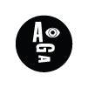
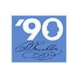
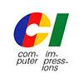
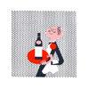
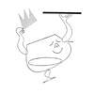
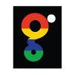
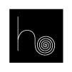
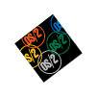
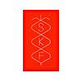
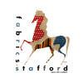
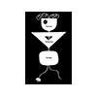
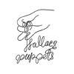
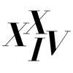
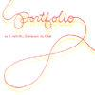

Typographic Form and Expression
Paul Rand, A Designer’s Art, 1985

One of the objectives of the designer who deals with type matter involves readability. Unfortunately, however, this function is often taken too literally and overemphasized at the expense of style, individuality, and the very effectiveness of the printed piece itself. By carefully arranging type areas, spacing, size, and color, the typographer is able to impart to the printed page a quality that helps to dramatize the contents.
With asymmetric balance, he is able to achieve greater interest. Bilateral symmetry offers the spectator too simple and too obvious a statement. It offers little or no intellectual pleasure, no challenge. The pleasure derived from observing asymmetric arrangements lies partly in overcoming resistances which, consciously or not, the spectator has in his own mind, and in thus acquiring some sort of aesthetic satisfaction.

OBJECT LABEL: Two letters from a Cresta Blanca Wine logotype (1943) demonstrate how the simple addition of ornament changes a commonplace letter (associated more with bold newspaper headlines than with delicate vintage wines) to a memorable image. Here, contrast plays a significant role.

OBJECT LABEL: By contrasting type and pictorial matter, the designer is able to create new combinations and elicit new meanings. For instance, in the Air-Wick newspaper advertisement, the old and the new are brought into harmony by contrasting two apparently unrelated subjects – nineteenth-century wood engravings and twentieth-century typewriter type.
OBJECT LABEL: The surrounding white space helps to separate the advertisement from its competitors, and produces a sense of cleanliness and freshness.

OBJECT LABEL: The numeral possesses many of the same qualities as the letter. It can also be the visual equivalent of time, space, position, and quantity; and it can help to impart to a printed piece a sense of rhythm and immediacy.

OBJECT LABEL: The isolated letter affords a means of visual expression that other kinds of imagery cannot quite duplicate. Letters in the forms of trademarks, seals, and monograms-on business forms, identification tags, athletic jerseys, and even handkerchiefs-possess some magical quality. They serve not only as status symbols but have the virtue of brevity as well.

Examples to use
Image | Label | Owner | Cost
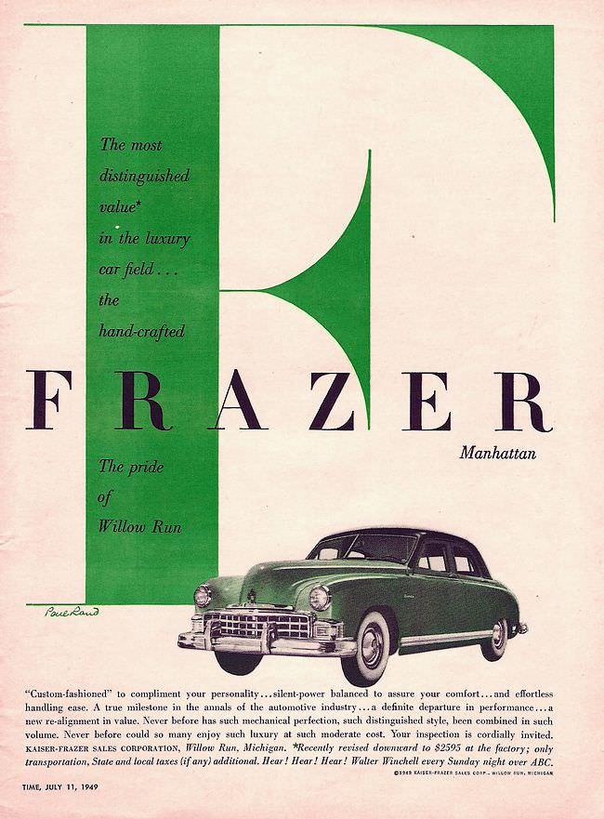
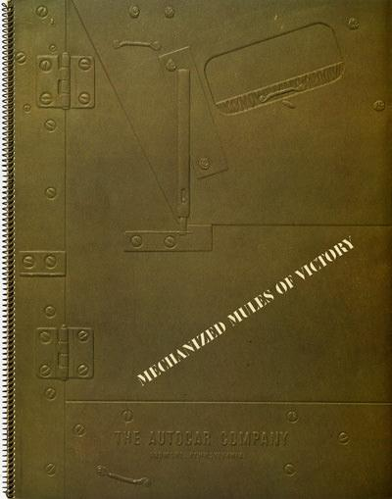
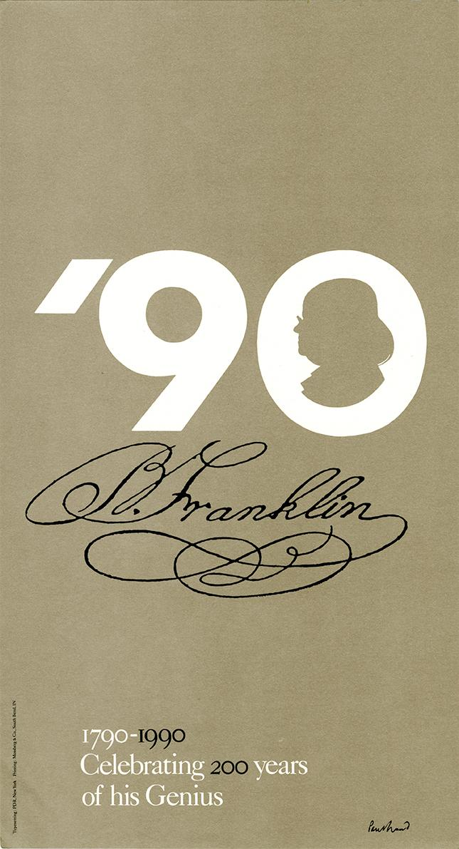
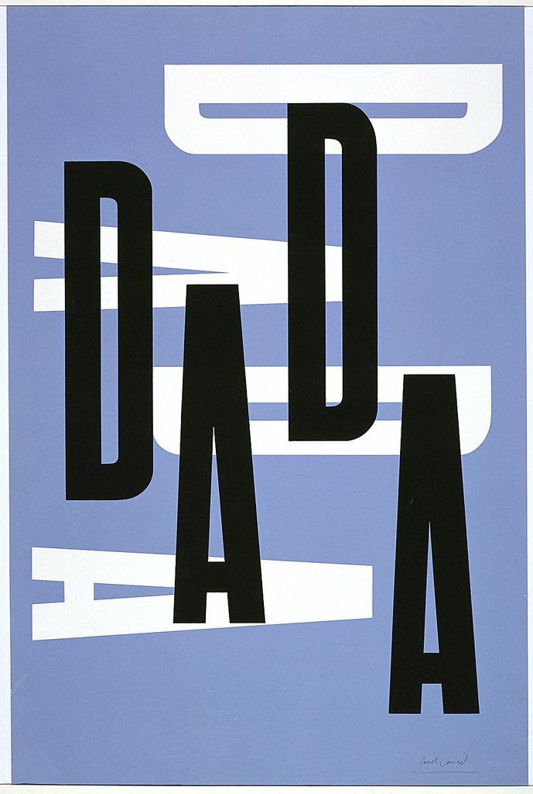
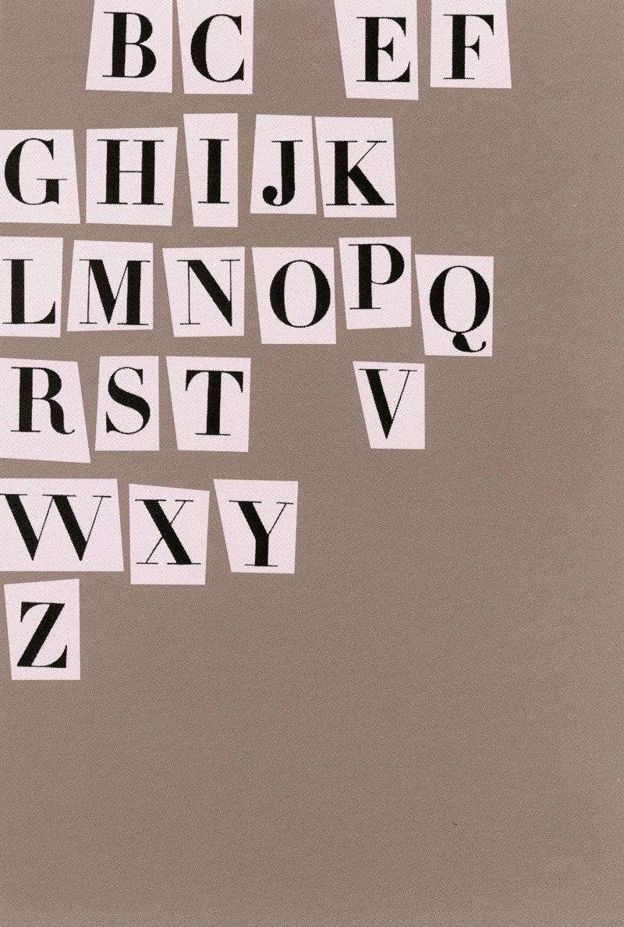
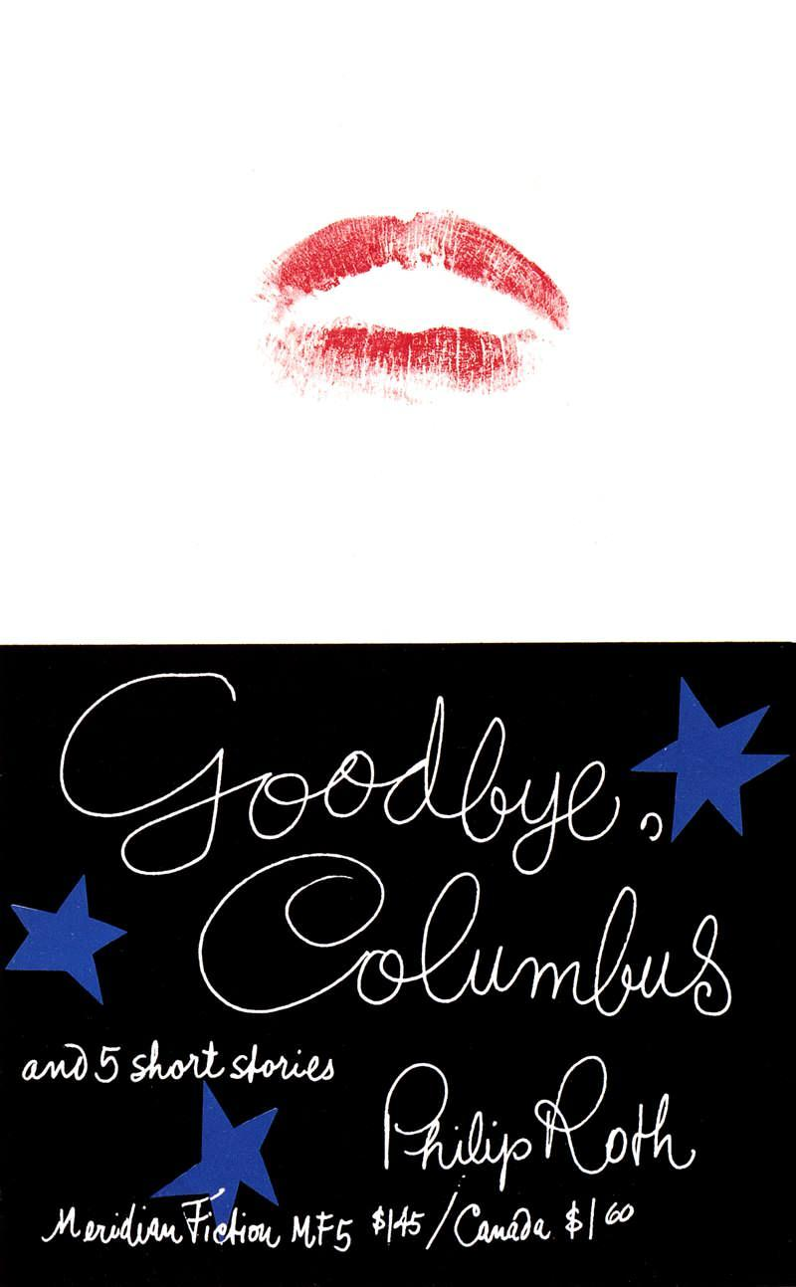
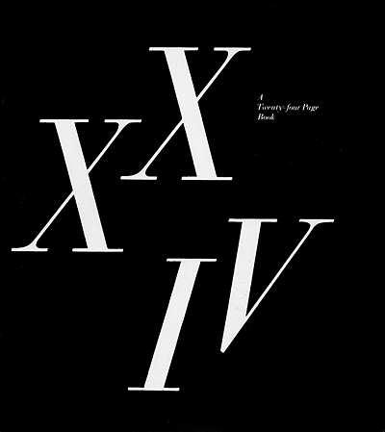
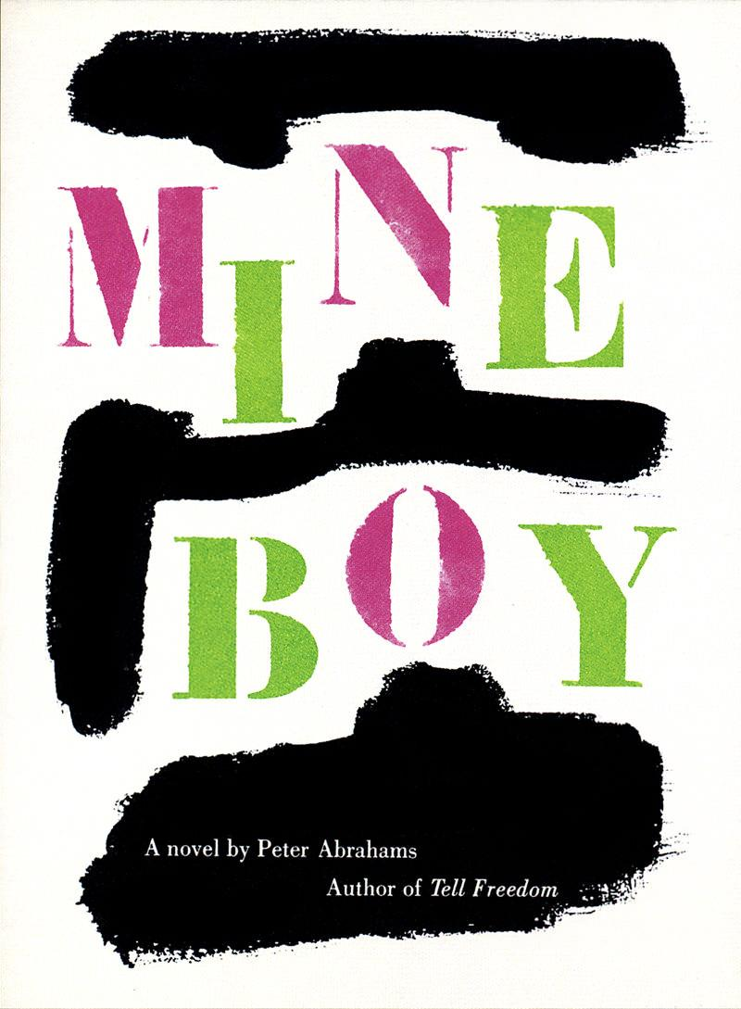
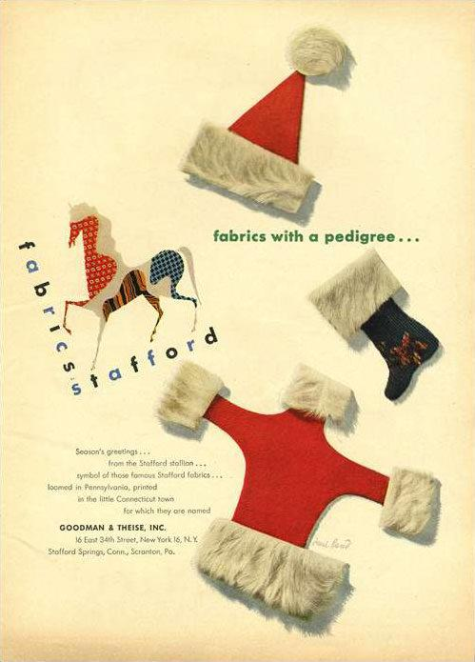
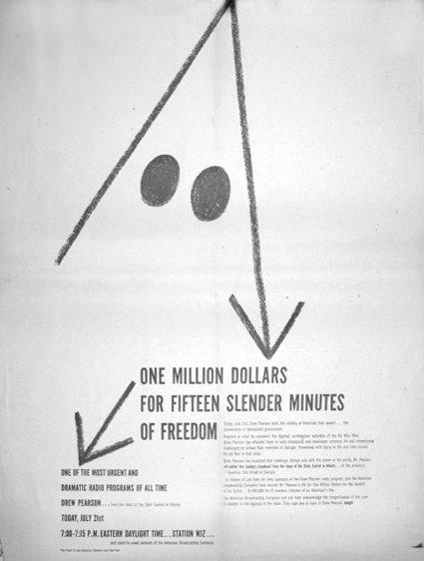
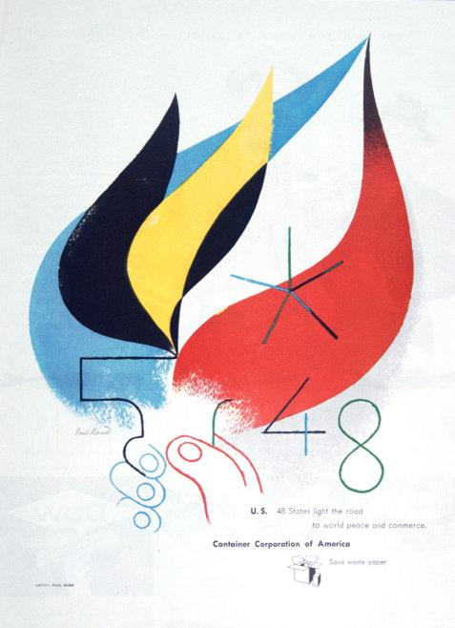
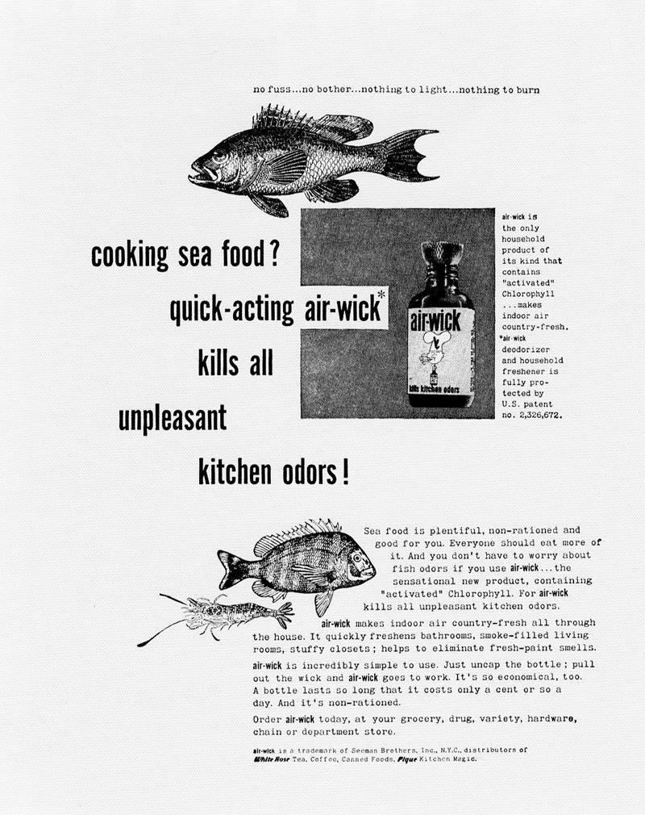

A House to Live With
From Esquire Magazine, August 1953
A man who knew the secrets of living, Henry David Thoreau, once wrote: “I sometimes dream of a … house, standing in a golden age, of enduring materials, and without gingerbread work…containing all the essentials of a house, and nothing for housekeeping…”
Ann and Paul Rand wanted such a house, too, an enduring, essential house, built for beauty and privacy, security and shelter, peace and an intimacy with its surroundings. So they designed theirs as if this were the first house ever built.
Within commuting distance of New York City, the compact and spacious modern home of Paul and Ann Rand takes issue with Connecticut’s rustic traditions.
The Rand home is set in wooded Connecticut acreage, and by coincidence meets the formula of the ideal setting defined by the Japanese; a hill to the north, a brook to the east, a road to the west, looks to the south. Compact, spacious, it neither tosses the inhabitants out into the open by too much “picture-window” exposure, nor shuts them off from the outdoors by conventional barriers.

Examples to use
Image | Label | Owner | Cost
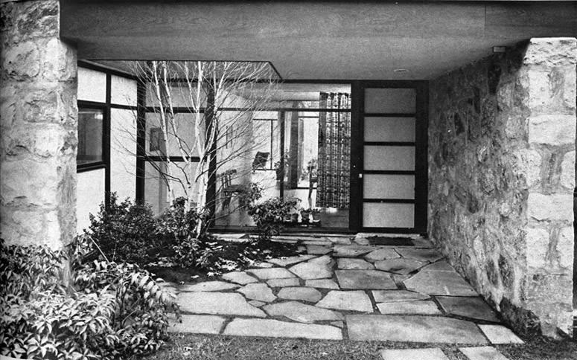
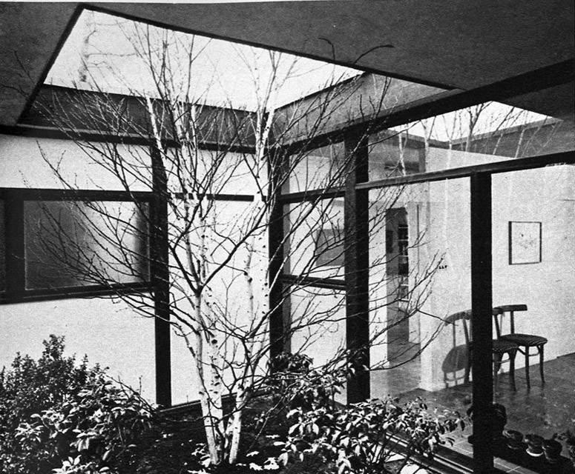
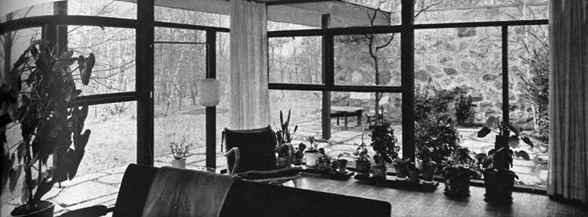
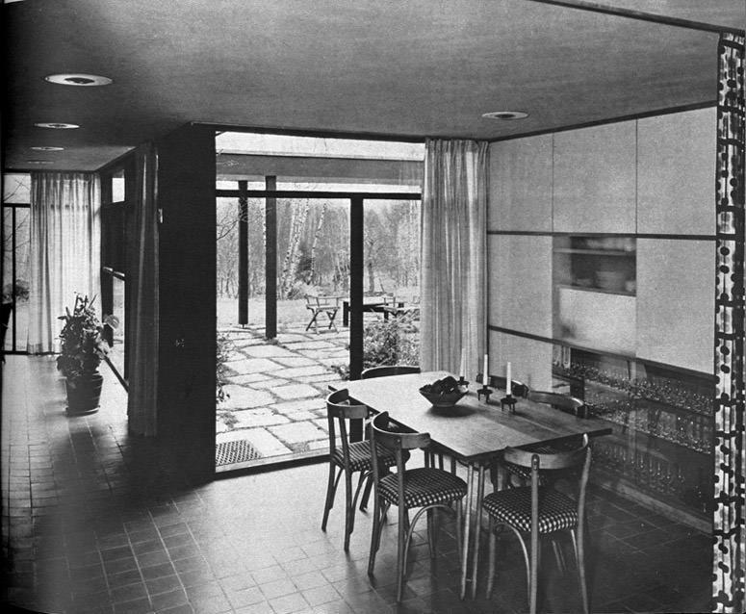
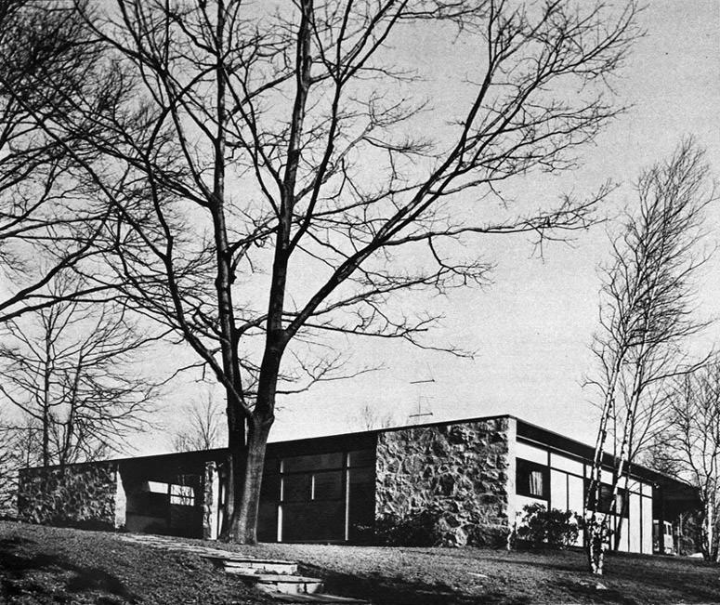
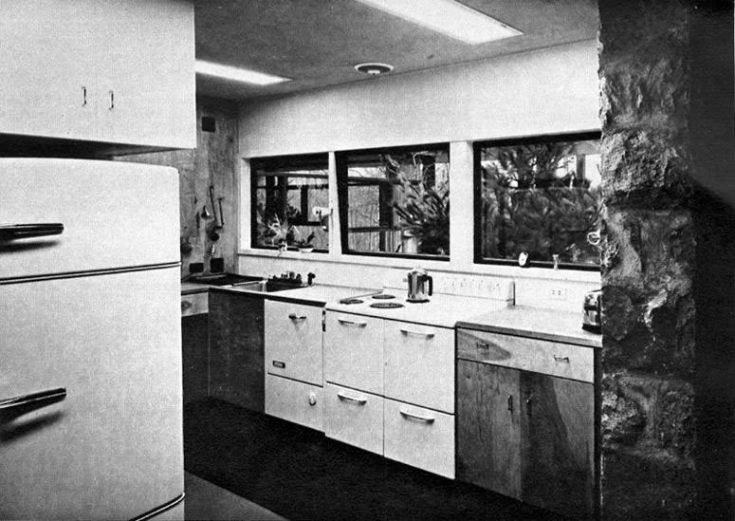
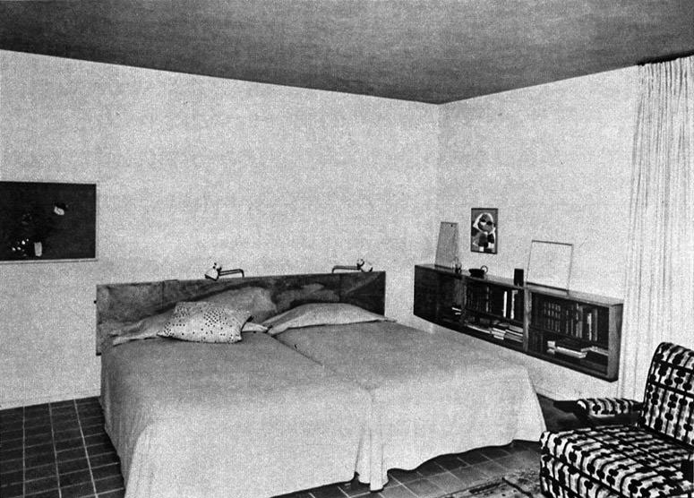
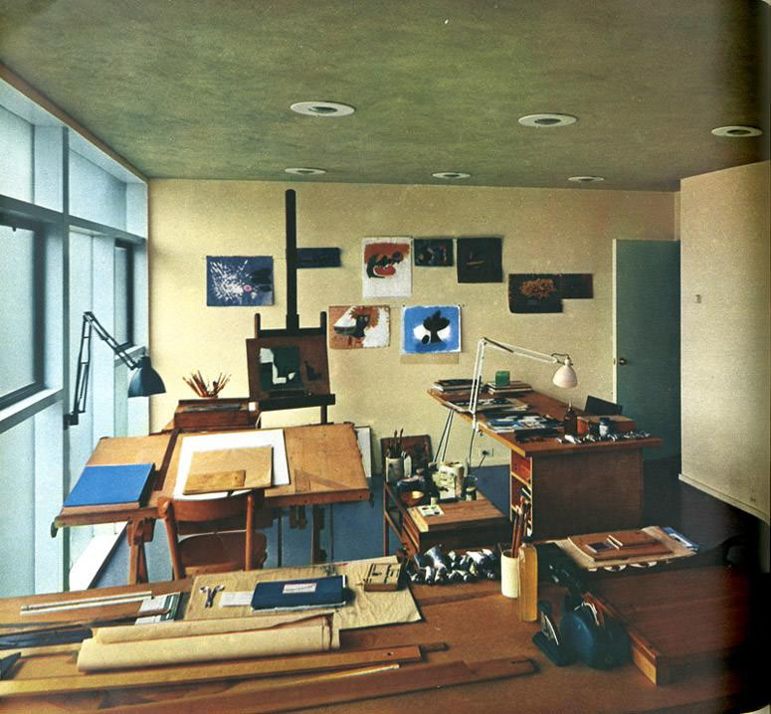
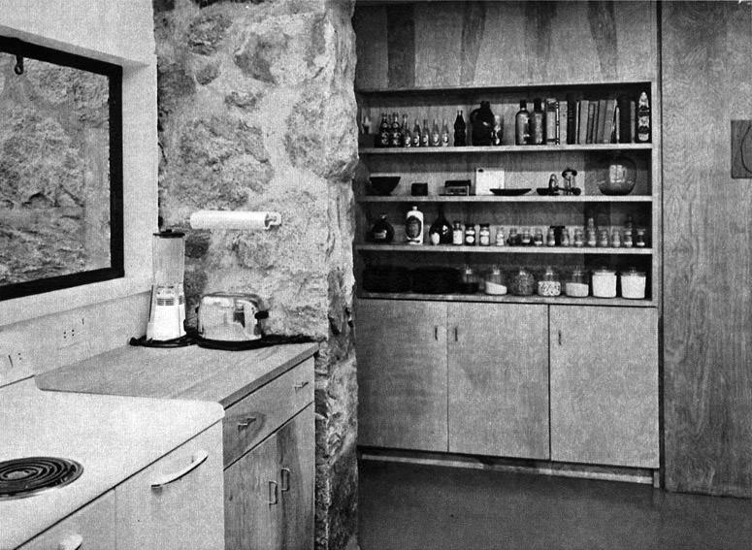

Presentation
Paul Rand, Design, Form, and Chaos, 1993

Canned presentations have the ring of emptiness. The meaningful presentation is custom designed — for a particular purpose, for a particular person. How to present a new idea is, perhaps, one of the designer’s most difficult tasks. This is not only a design problem, it also pleads for something novel. Everything a designer does involves presentation of some kind — not only how to explain (present) a particular design to an interested listener (client, reader, spectator), but how the design may explain itself in the marketplace. Not all assignments are equally interesting. The designer is expected to be inspired by the most mundane subject matter, no less by a dead fish than by a beautiful race horse. But subject matter in itself is not always inspirational. The relevant idea and its formal interpretation become the decisive factors.
The following brochures seen here were designed for the purpose of presentation. They follow a simple pattern, with generous use of white space and color to establish certain rhythms and to leave room for necessary pauses and logical transitions. White space is used as a functional not as an arbitrary device. It indicates timing and pacing and may be a determining factor in a given presentation. Its purpose is to help dramatize — a kind of backdrop separating one scene from another. To encourage reading, text is kept as brief and as readable as possible, with no attempt to confuse the reader with picturesque, typographic trickery. If type is shown in color, it is for reasons of emphasis, not theatrics.

LARGE QUOTE: A presentation is the musical accompaniment of design. A presentation that lacks an idea cannot hide behind glamorous photos, pizzazz, or ballyhoo.
Paul Rand, Design, Form, and Chaos, 1993

Examples to use
Image | Label | Owner | Cost
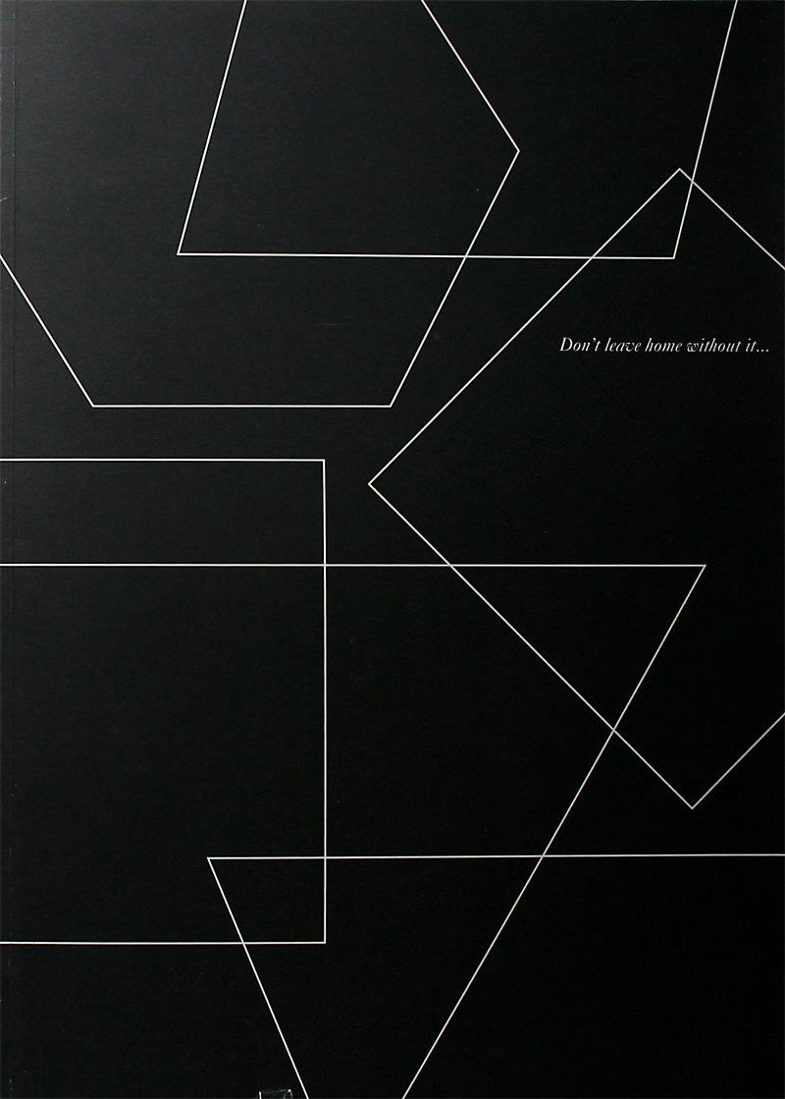
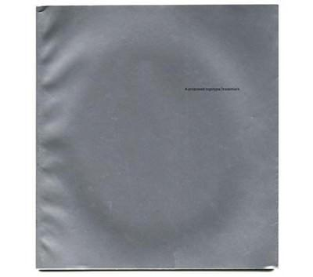
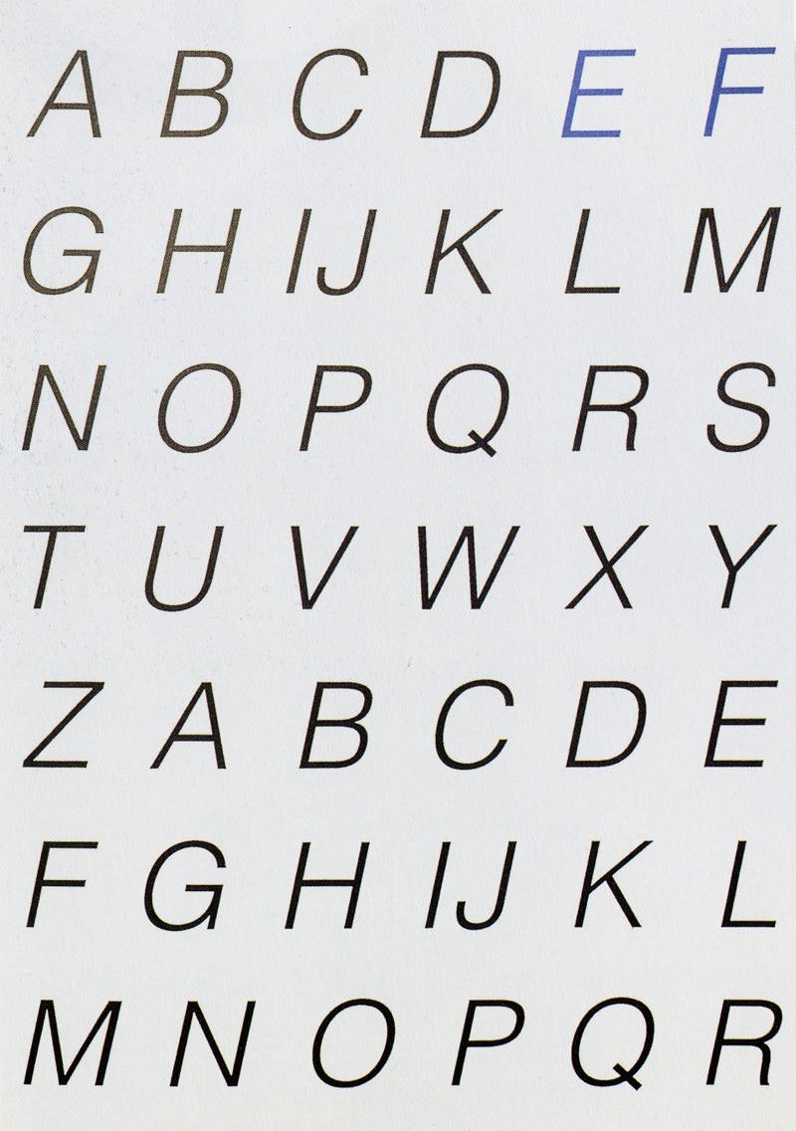
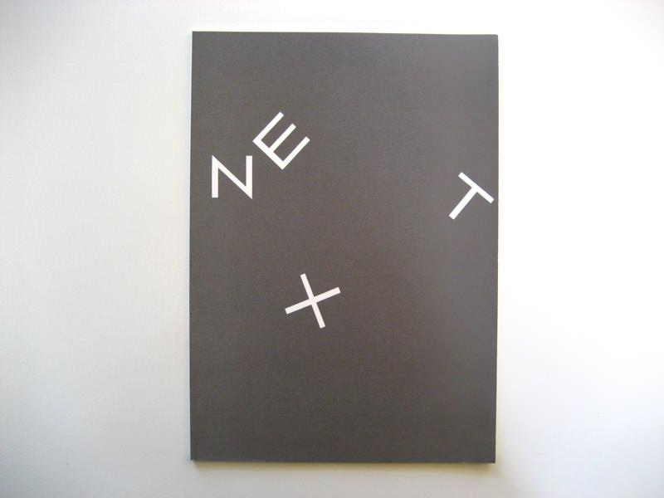
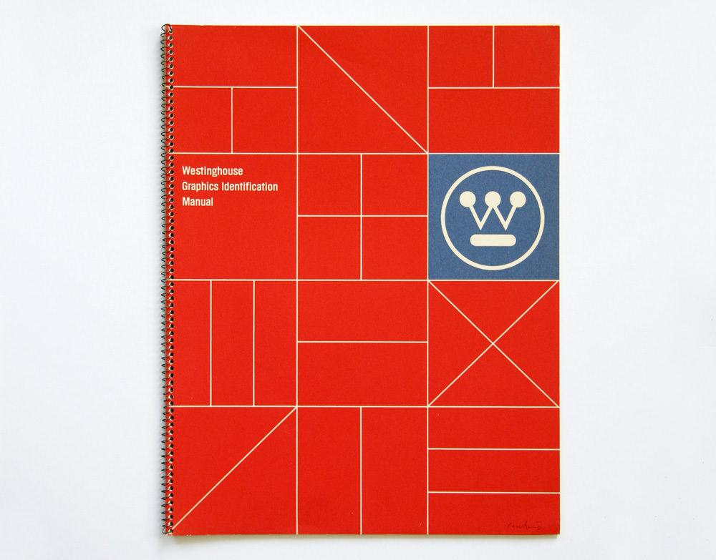

Writing

Image | Label | Owner | Permission | Cost
 | This is…the Stafford Stallion  1944 | Michael | Y | $0
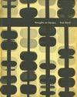 | Thoughts on Design  1947, 1950 & 1970 | Danny | Y | $0
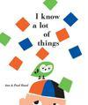 | I Know A Lot of Things  1956 | Danny | Y | $0
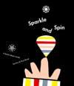 | Sparkle and Spin  1957 | Danny | Y | $0
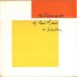 | The Trademarks of Paul Rand  1960 | Michael | Y | $0
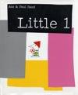 | Little 1  1962 | Danny | Y | $0
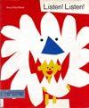 | Listen! Listen!  1970 | Danny | Y | $0
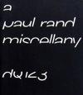 | A Paul Rand Miscellany  Design Quarterly  1984 | Danny | Y | $0
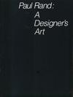 | Paul Rand: A Designer’s Art  1985 | Danny | Y | $0
 | Good Design is Good Will  1987 | Danny | Y | $0
 | Some Thoughts… and Some Logos  1991 | Danny | Y | $0
 | Some Thoughts… and Some Tribulations about the Design of a Logo  1991 | Danny | Y | $0
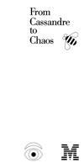 | From Cassandre to Chaos  1992 | Danny | Y | $0
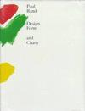 | Design Form And Chaos  1993 | Danny | Y | $0
 | From Lascaux to Brooklyn  1996 | Danny | Y | $0

Direction Magazine

Direction was a groundbreaking magazine that dealt with artistic, social and political issues and featured many famous contributors including architect Le Corbusier and artist William Gropper. It was published and edited by Marguerite Tjader Harris from 1938-1945, between the time of the invasion of Czechoslovakia, and the end of World War II.

In 1938, a 24-year-old Rand was asked to design the covers of Direction, and did most of them for free in exchange for complete creative control. This was the most experimental period of Rand’s career. “In a country that was used to decorative work, the common sense way to have what I was doing accepted was to do it for free,” he explained.¹ Working with little or no budget, he used his own handwriting along with other found elements to create images that were engaging and immediate.

Each of the covers represented major themes of the time. For his first cover, a geometric pair of scissors cuts through a map of Czechoslovakia, symbolizing the Nazi invasion tearing the country apart. Another is the 1940 “Merry Christmas” cover. Using a photograph of barbed wire (representing ribbon) and red dots created by a hole punch (representing spilled blood), these simple elements combined to create a powerful symbol of oppression.

Rand was the first to confess that these breakthrough covers were not entirely unique.
“I never claimed that this was great original stuff,” he confided. “Other guys in Europe were doing this kind of thing.² By finding inspiration in European painting and design, Rand created a variant of Modernism which was not only “a sampling of foreign influences, but rather a synthesis of European formalism and design philosophy fused with American vernacular – function and wit – which ultimately became Rand’s signature.”³

Between a limited budget and unlimited creative freedom, he was able to uniquely combine many of the timeless design principles of symbolism, contrast, texture and others with the subject matter of the moment to create a collection of some of his finest works.

1, 2. Steven Heller, “Direction,” Design Literacy, Allworth Press, 1997
3. Steven Heller, “Paul Rand,” 1999

Examples to use
Image | Label | Owner | Permission | Cost
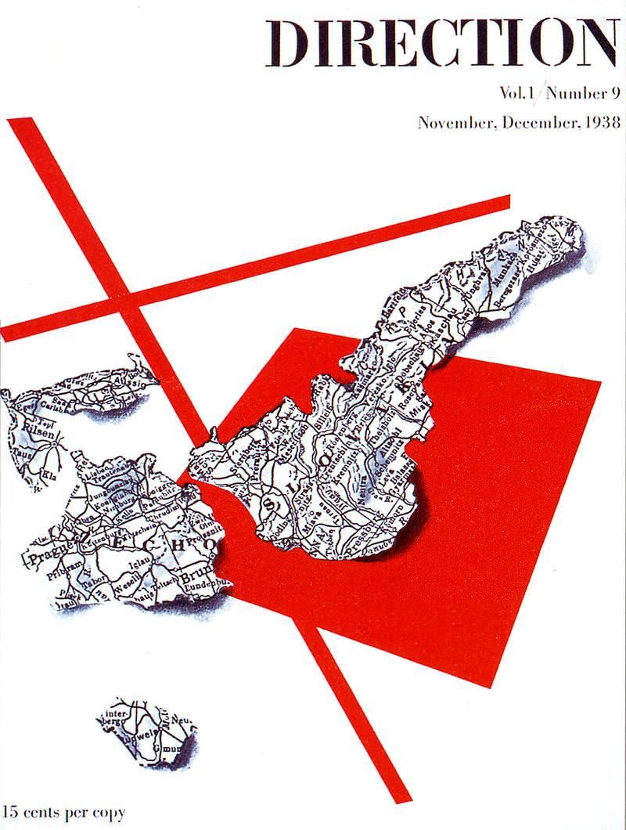 | November/December  1938 | Danny | Y | $0
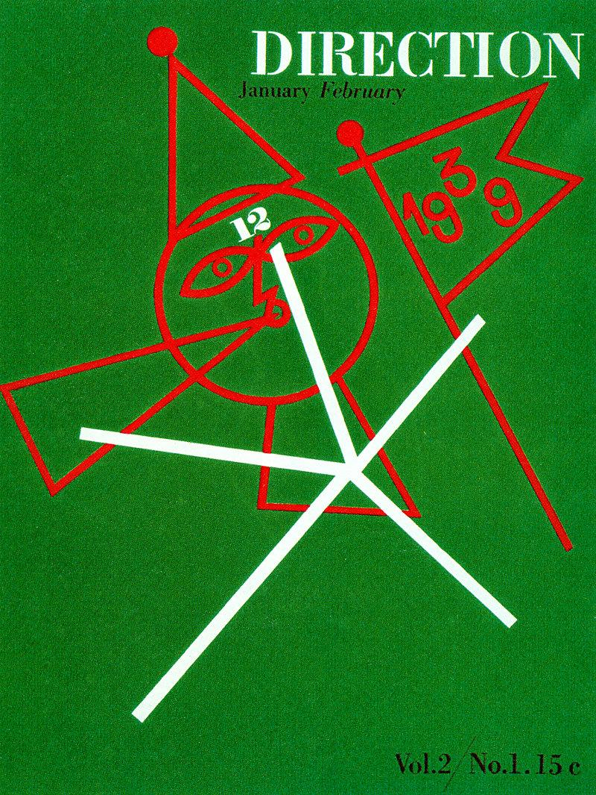 | January/February  1939 | Danny | Y | $0
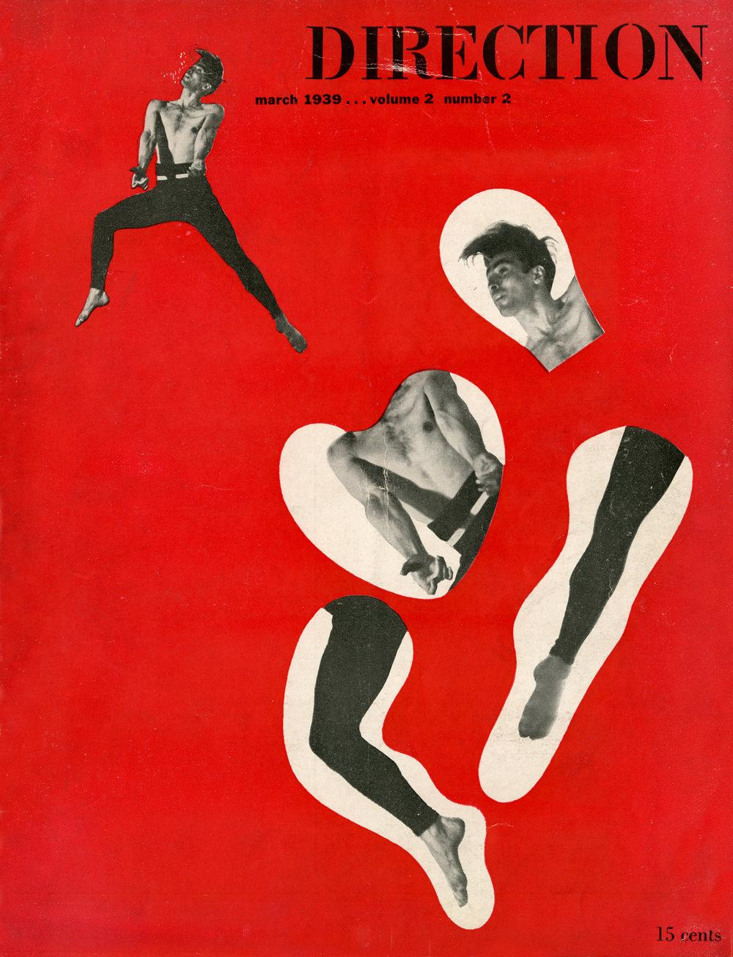 | March  1939 | Danny | Y | $0
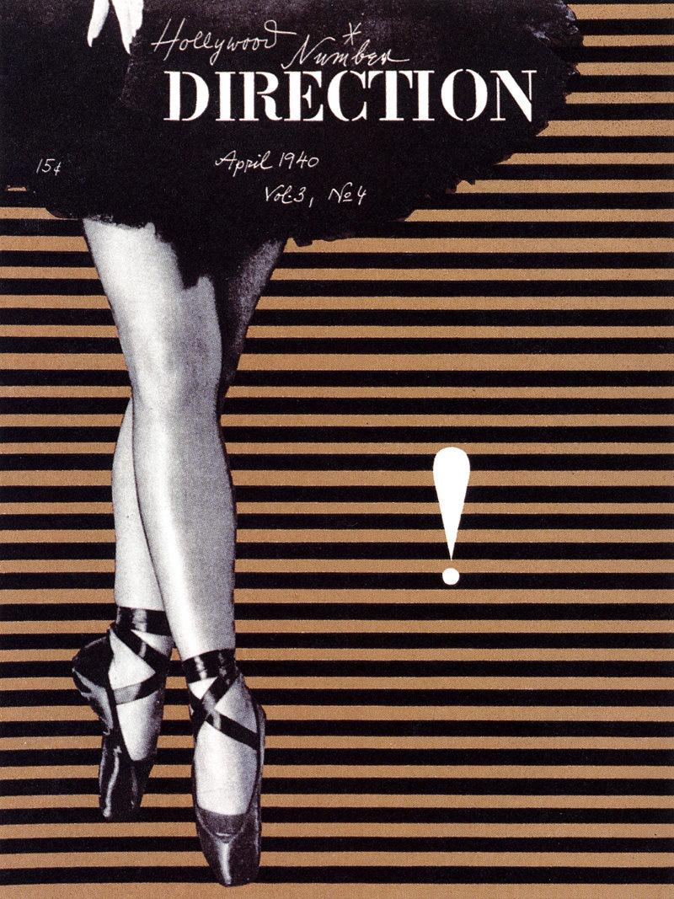 | April  1940 | Danny | Y | $0
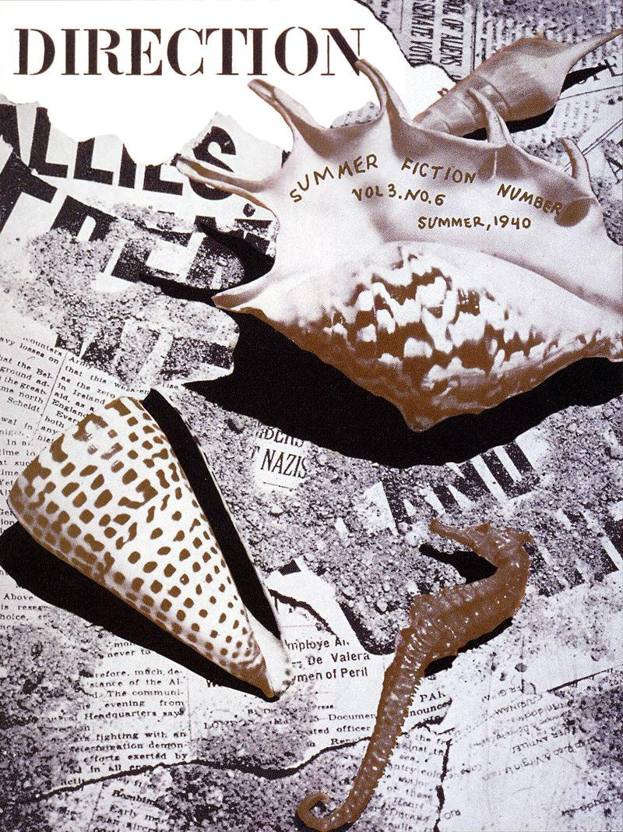 | Summer  1940 | Danny | Y | $0
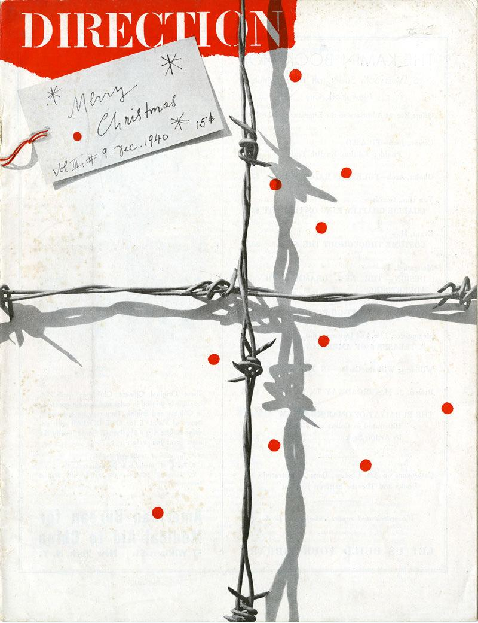 | December  1940 | Danny | Y | $0
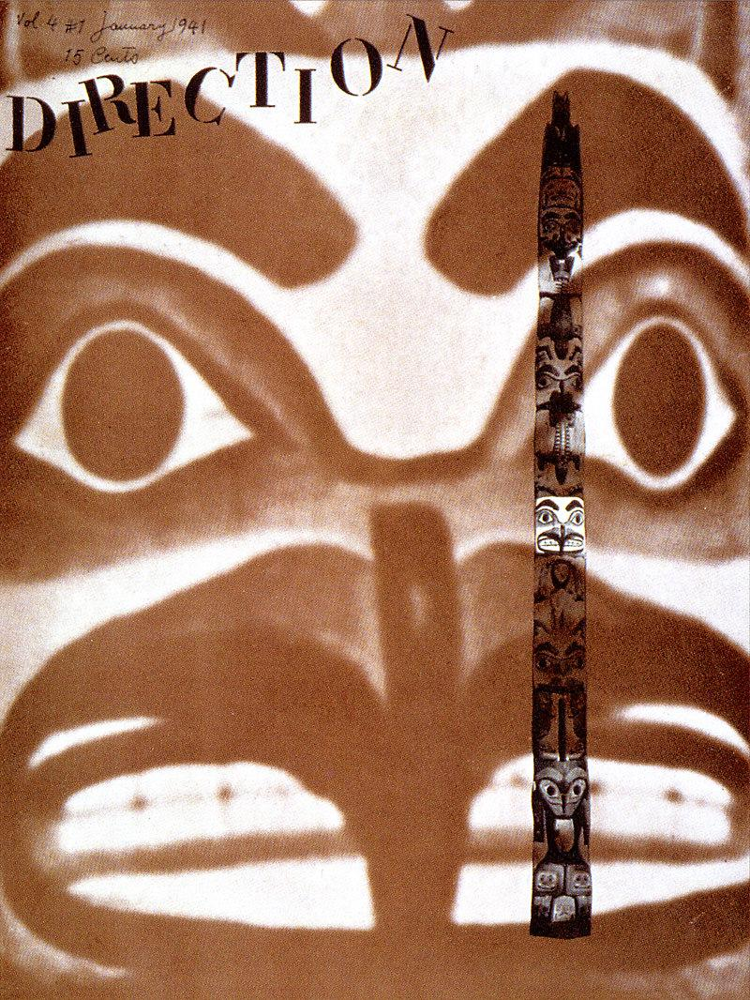 | January  1941 | Danny | Y | $0
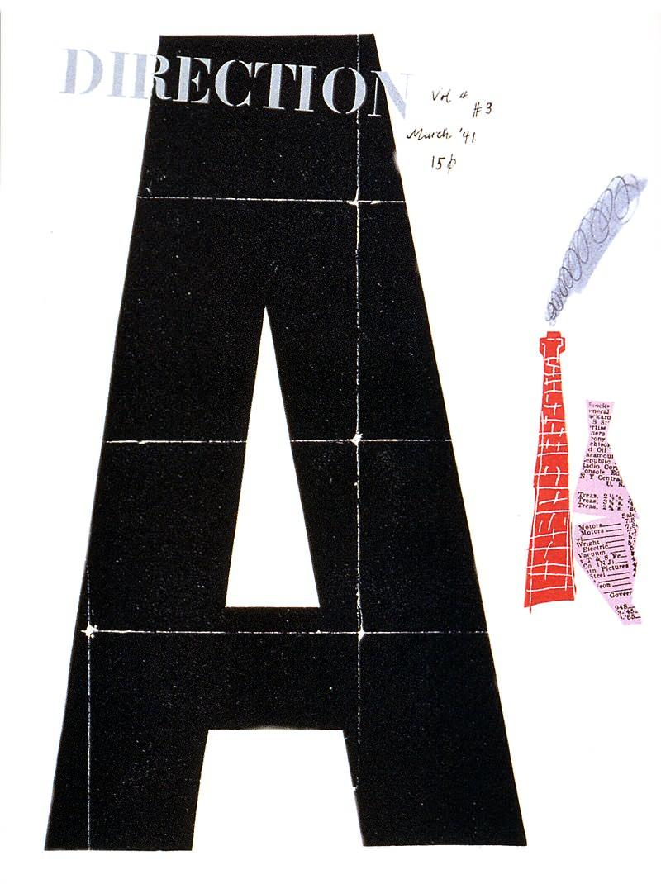 | March  1941 | Danny | Y | $0
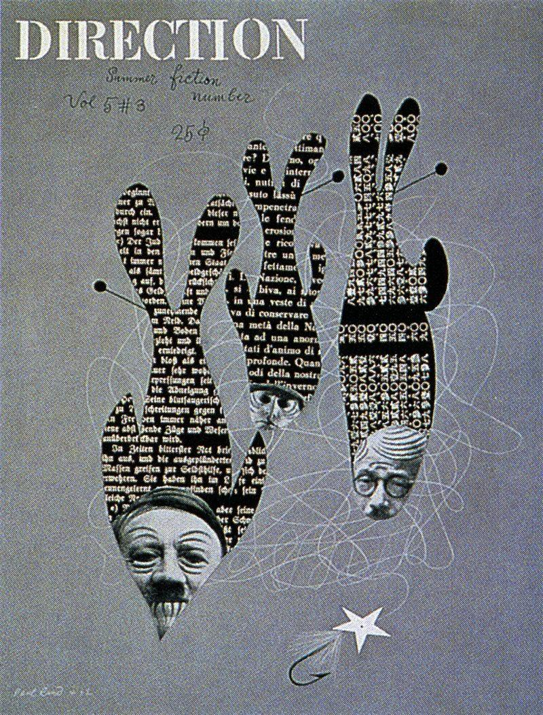 | Summer  1942 | Danny | Y | $0
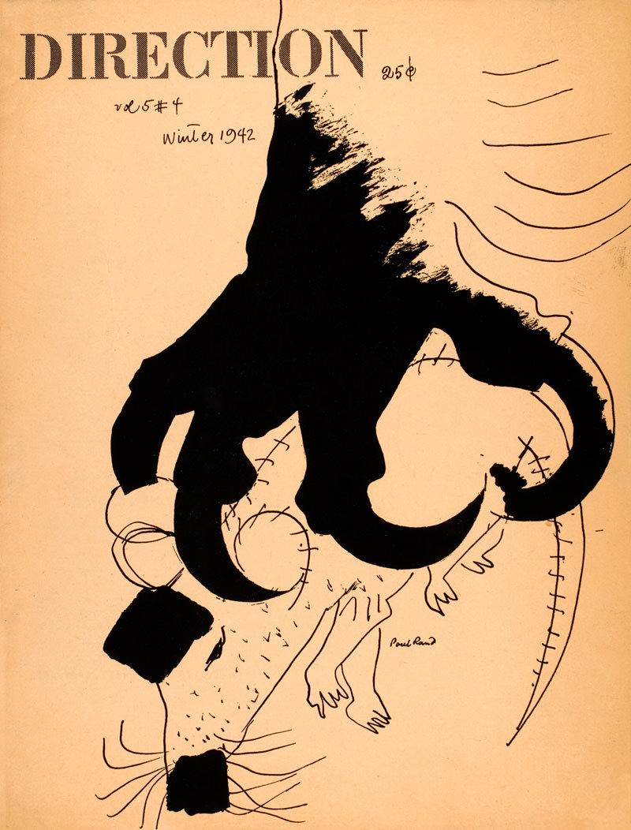 | Winter  1942 | Danny | Y | $0
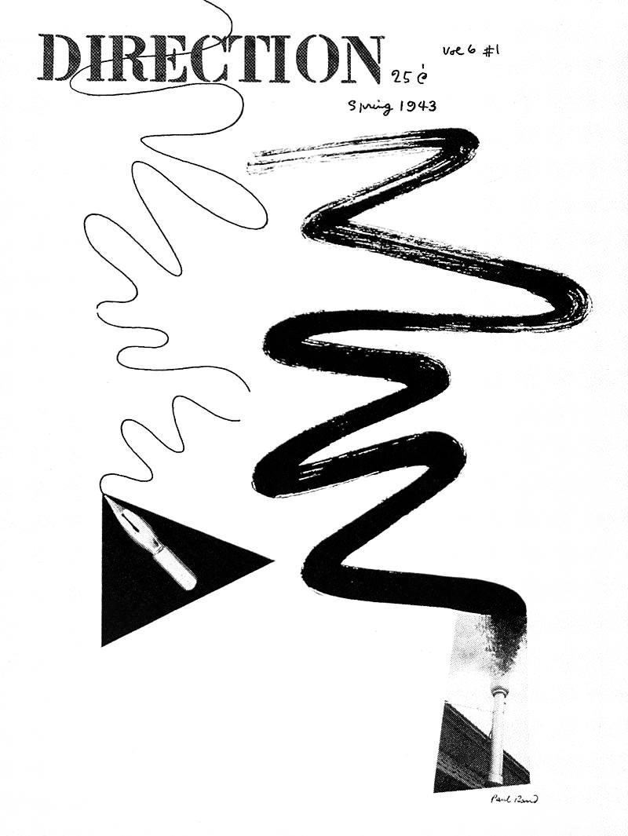 | Spring  1943 | Danny | Y | $0
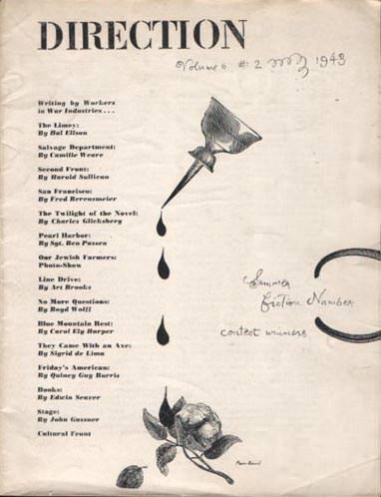 | Summer  1943 | Danny | Y | $0
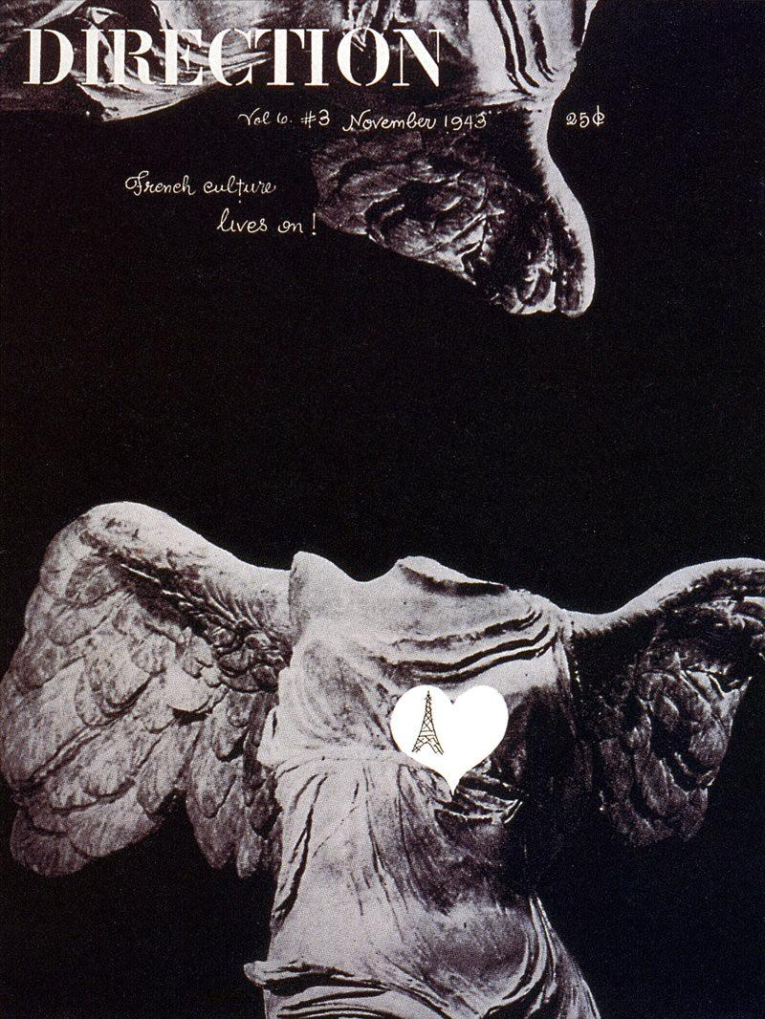 | November  1943 | Danny | Y | $0
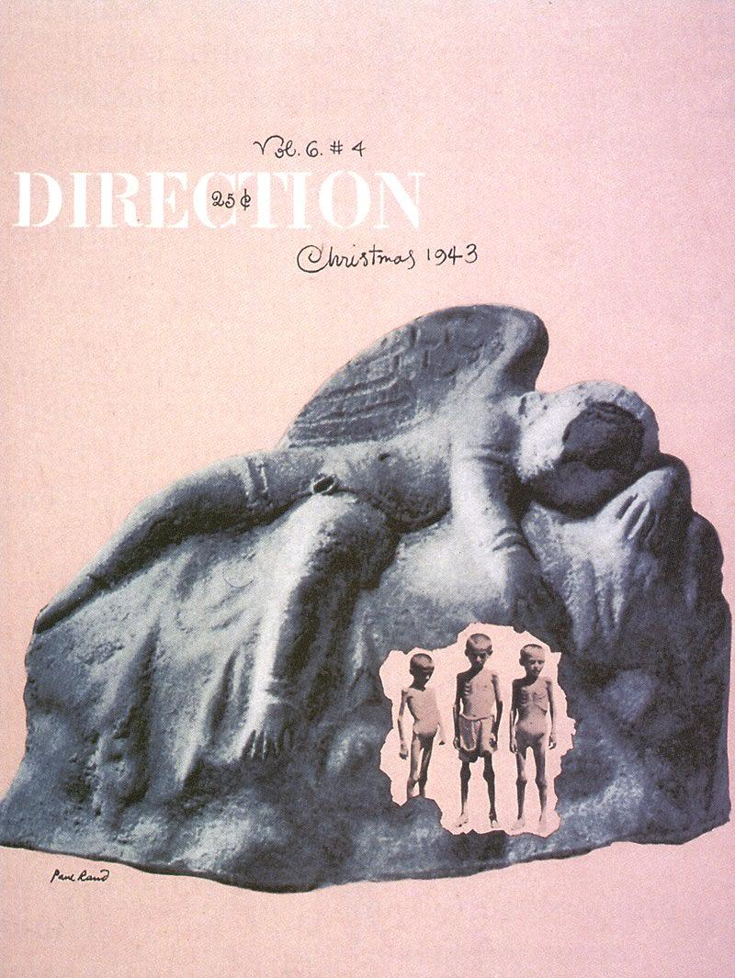 | December  1943 | Danny | Y | $0
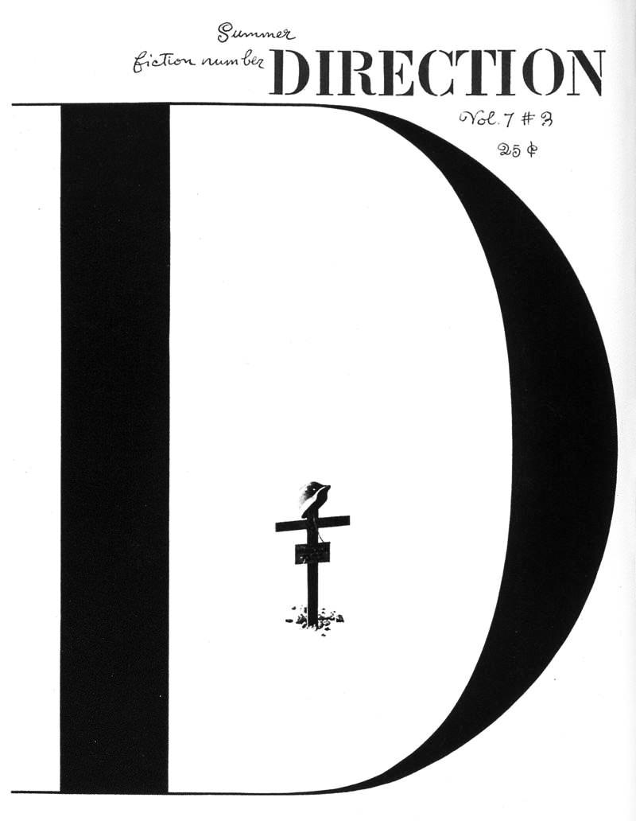 | Summer  1944 | Danny | Y | $0
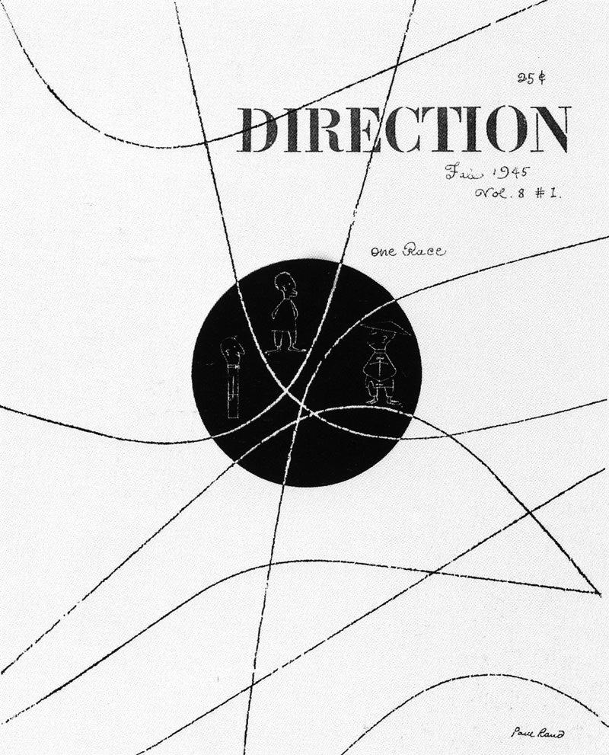 | Fall  1945 | Danny | Y | $0

RCA

“Design is a way of life, a point of view. It involves the whole complex of visual communications: talent, creative ability, manual skill, and technical knowledge. Aesthetics and economics, technology and psychology are intrinsically related to the process.”
Graphis “Politics of Design” 1981

The ad that Paul Rand created for Radio Corporation of America (RCA) in 1954 revolutionized advertising by changing the methods by which agencies pitched ideas to clients. While Rand was Creative Director at Weintraub, he learned that RCA was looking for a new ad agency to handle their account. In order to win the account, Rand wanted to create an unconventional pitch that would catch the attention of the executives at RCA, so Weintraub purchased space on the back page of the New York Times, allowing themselves three days to design an ad that would attract RCA’s attention.

Knowing that RCA’s chief executive officer, General David Sarnoff, was once a Morse code operator inspired Rand to use Morse code to get the attention of the executives at RCA. Rand stated that “while a million eyes might see that copy of the Times, the only eyes that mattered were [General Sarnoff’s].”

To catch the attention of the chief executive, Rand designed a message in Morse code. The message read “RCA! We want your business.” The dots and dashes created a strong graphic element, while also conveying the secret message. The dot dash of the last letter was turned upside down to create an exclamation point, adding emphasis and enthusiasm. While Weintraub didn’t get the RCA account, they did catch the attention of readers. Their switchboard was inundated with phone calls from Times readers trying to discover what the meaning of the message.

